**Location Selection for Toronto Central Library**

**Data:**

Based on definition of the problem, factors that will influence this decision are:

1. Different neighborhoods in Toronto with information containing Postal Code, Borough Name for each neighborhood (Fig. 1)
2. Geographic Coordinates of the Neighborhoods (Fig. 2)
3. Common Venues with proximity to the neighborhoods (Fig. 3)
4. List of Existing libraries in the region under consideration (Toronto) (Fig. 4)
5. Distance from the neighborhoods to the closest existing library (Fig. 5)

The data is obtained from various sources as follows:

1. List of Neighborhoods (beginning with ‘M’) scraped from Wikipedia webpage https://en.wikipedia.org/wiki/List_of_postal_codes_of_Canada
2. Coordinates of Neighborhoods using **Google Maps GeoCoding API**
3. Coordinates of the Libraries in the vicinity of Toronto central location using **Foursquare API**
4. Top 10 most common venues in every candidate neighborhood using **Foursquare API**
5. Distance between each candidate Neighborhood location and the nearest Library using Haversine formula

**Data Samples:**

1. Neighborhood candidates

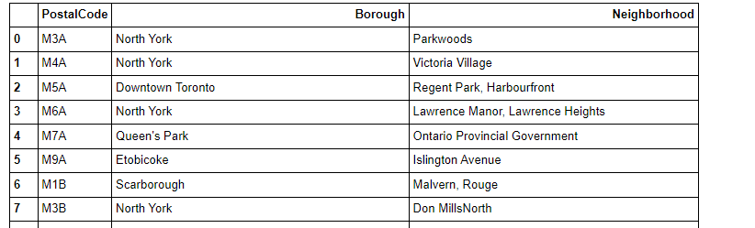

2. Geographic coordinates of candidate neighborhoods

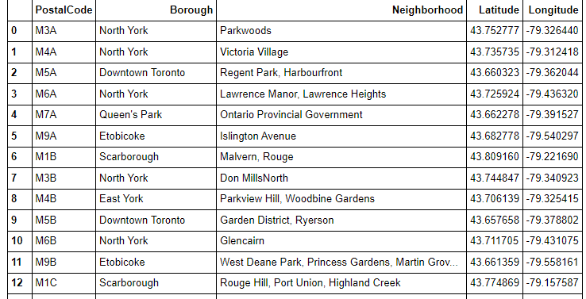

3. Common Venues with proximity to the neighborhoods

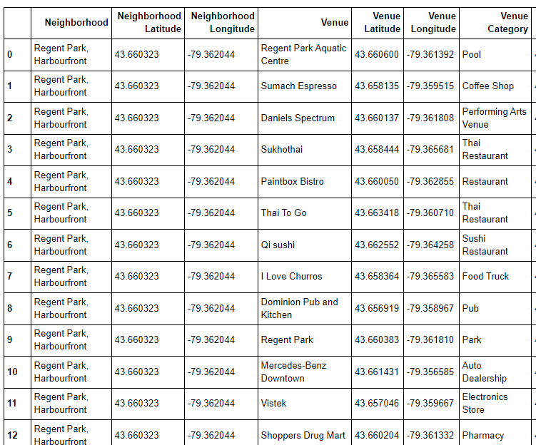

4. List of Existing libraries in the region under consideration (Toronto)

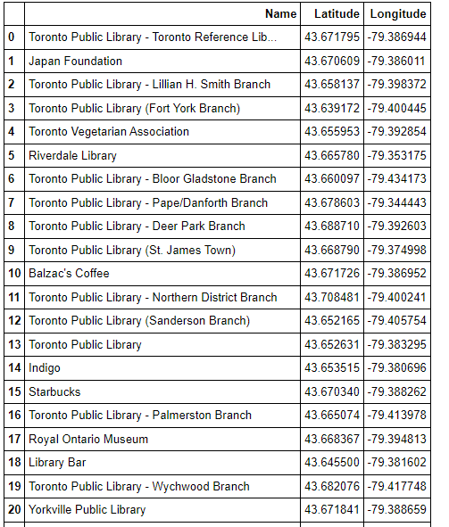

5. Distance from the neighborhoods to the closest library (in km)

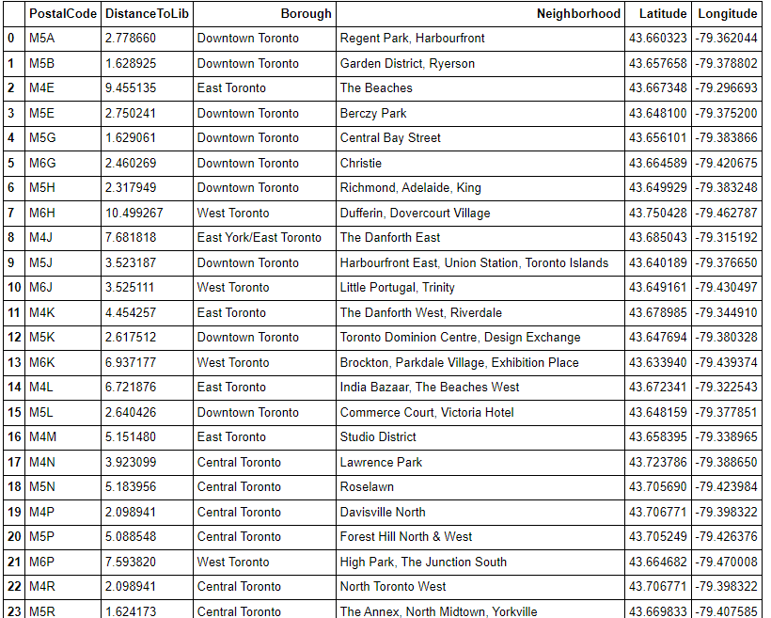

**Assumptions:**

For the sake of the project, some requirements have been simplified. However, the project can be extended to achieve the complex requirements in reality.

1. Neighborhoods in Toronto starting with M alone have been considered
2. Distance between Neighborhood and nearest library is calculated based on Aerial Distance (Bird flying distance, not road distance)