PROJECT 8: DISASTER RECOVERY WITH IBM CLOUD VIRTUAL SERVERS.

**Project Title :** IBM Disaster Recovery

**Phase 3 :** Development Part 1

**Problem Statement :** Safeguard business operations with IBM Cloud Virtual Servers. Create a disaster recovery plan for an on-premises virtual machine, ensuring continuity in unforeseen events. Test and validate the recovery process to guarantee minimal downtime. Become the guardian of business continuity, securing the future of the organization.

**Required Libraries :**

**Numpy :**

NumPy is a fundamental library for numerical computing in Python. It’s crucial for performing mathematical and statistical operations on large datasets.

**Pandas :**

Pandas is a powerful data manipulation library for handling structured data. It provides data structures like Data Frames and tools for data cleaning and analysis.

**Seaborn :**

These libraries are used for data visualization. Matplotlib is a versatile library for creating various types of plots, while Seaborn is built on Matplotlib and simplifies creating aesthetically pleasing statistical visualizations.

**Datetime :**

DateTime is a Robot Framework standard library . Python's built-in datetime library is one of the most common modules to manipulate date and time object data. You can create date and datetime objects, loop through a range of dates, parse and format date strings, and more.

**OS :**

Python get the name of the underlying operating system. The OS module in Python provides functions for interacting with the operating system. OS comes under Python's standard utility modules. This module provides a portable way of using operating system-dependent functionality. The os and *os.

**Method of Approach with Implementation :**

**Step 1 :**

Downloading the csv file or the Dataset.

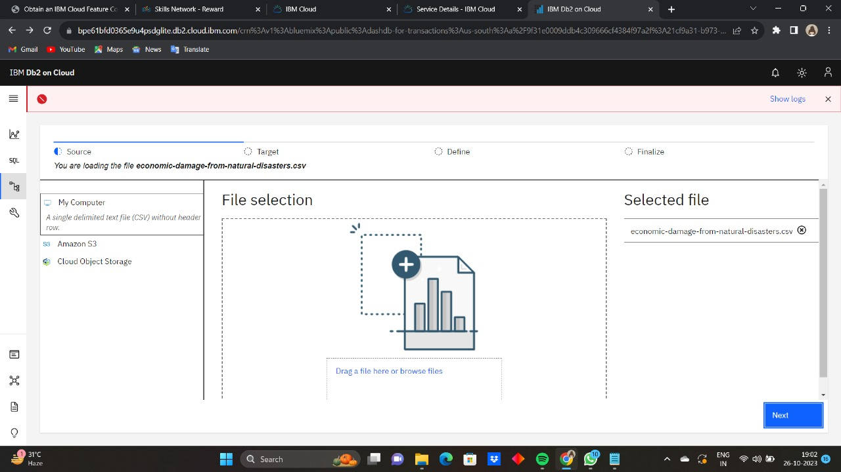

**Step 2 :**

Upload the dataset into db2 cloud.

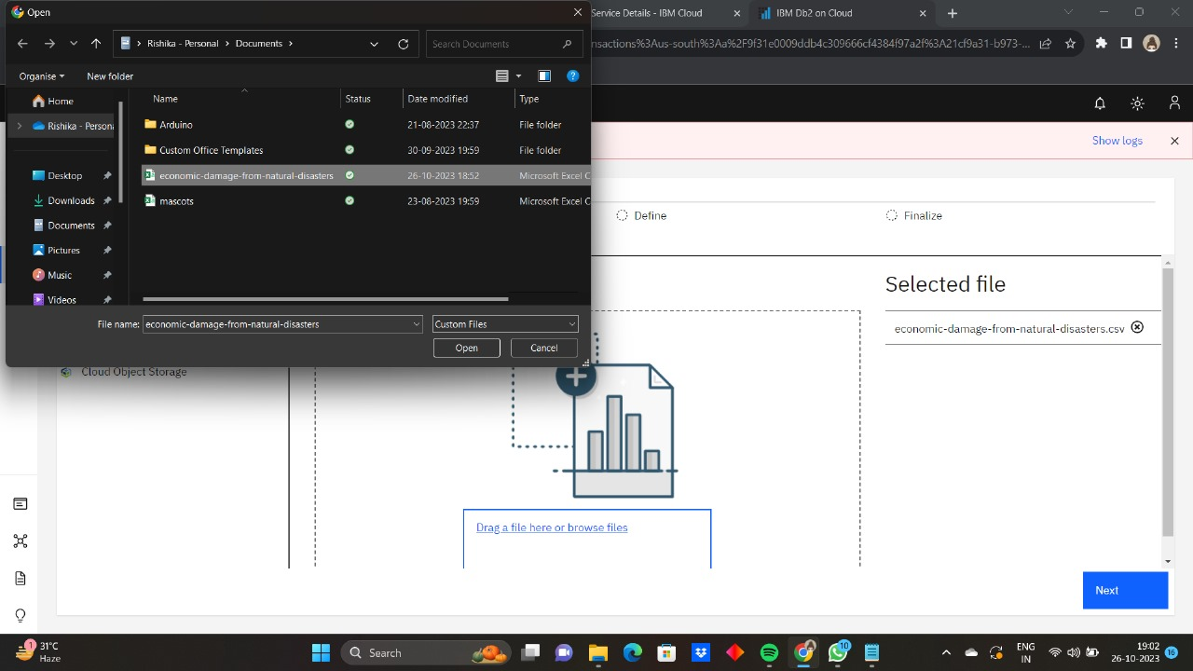

**Step 3 :**

Selecting and Uploading into Db2 Cloud.

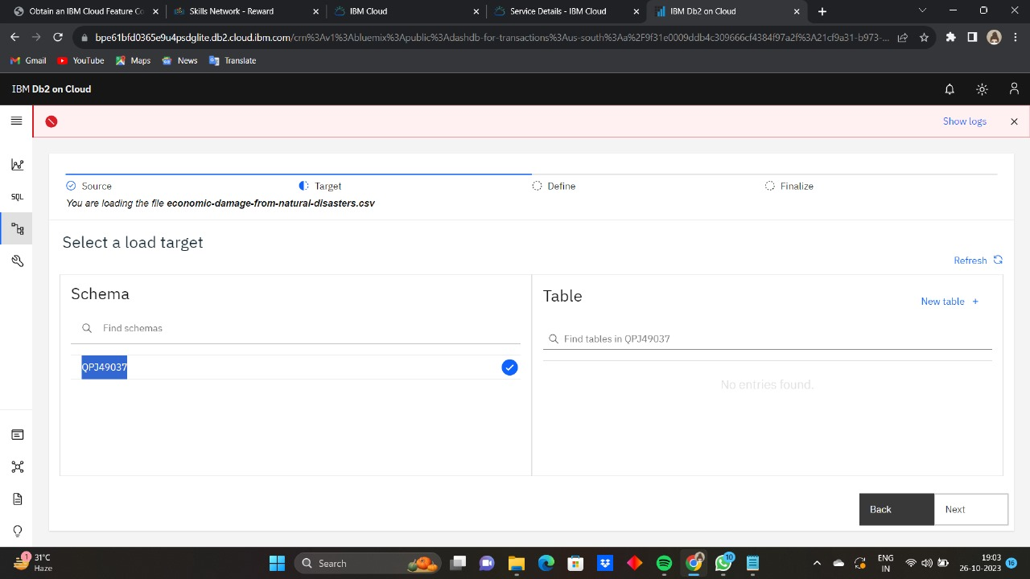

**Step 4 :**

Giving connection to Db2 cloud

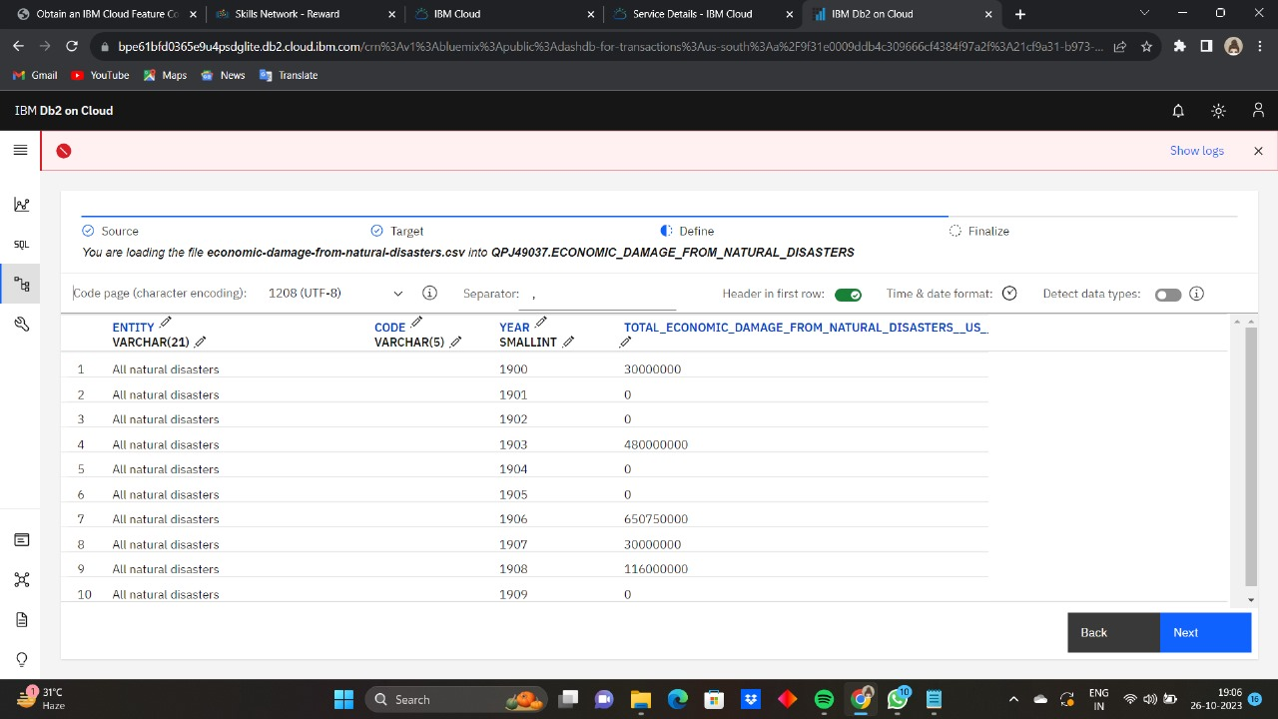

**Step 5 :**

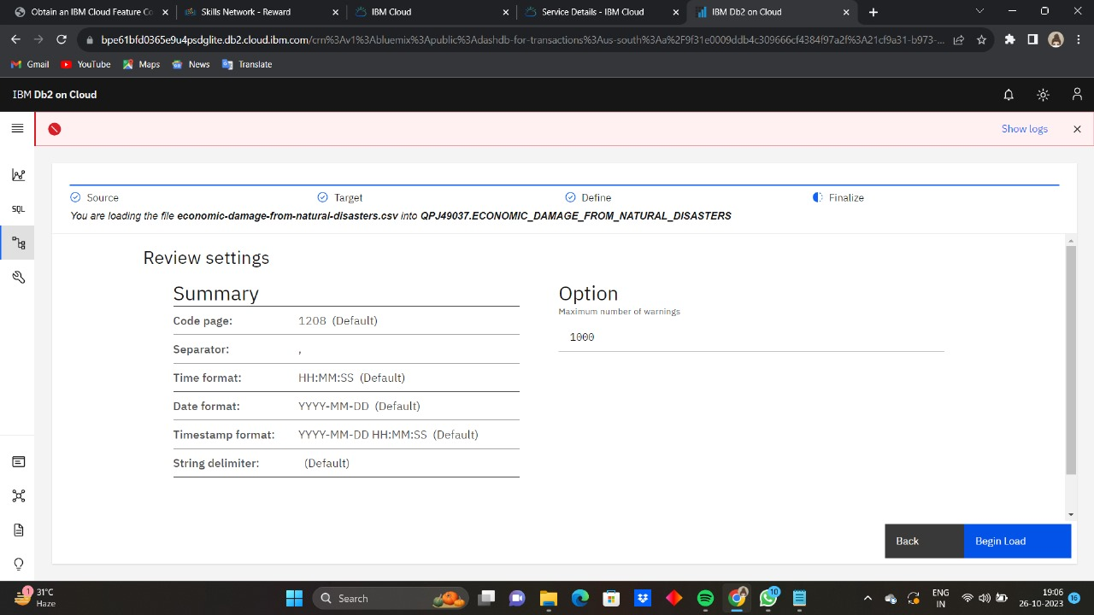

**Step 6 :**

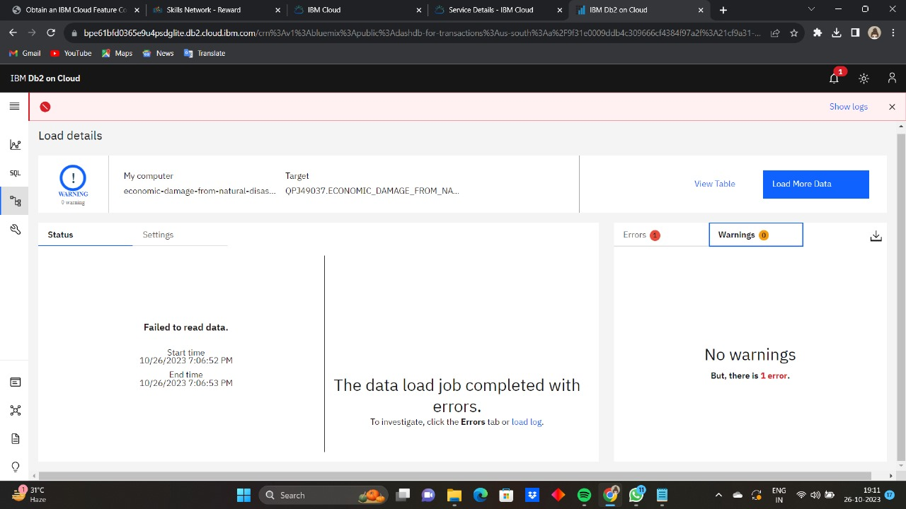

**Step 7 :**

