**TASK-2 :- HOME AUTOMATION**

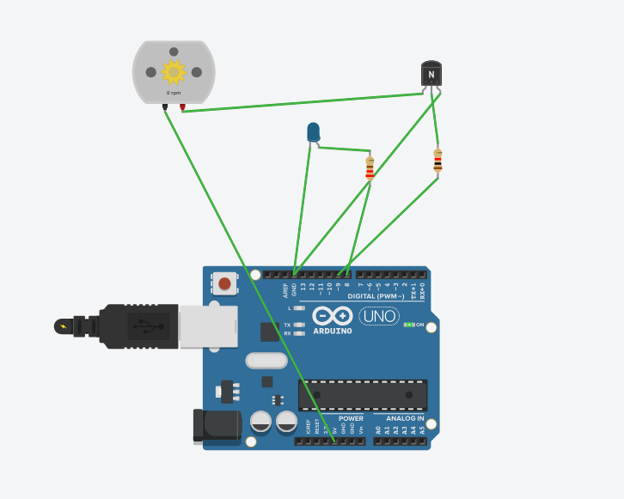

**Code :-**

int ledPin = 8;

int fanPin = 9;

String inputString = "";

void setup() {

Serial.begin(9600);

pinMode(ledPin, OUTPUT);

pinMode(fanPin, OUTPUT);

}

void loop() {

if (Serial.available()) {

inputString = Serial.readStringUntil('\n');

if (inputString == "LIGHT_ON") {

digitalWrite(ledPin, HIGH);

} else if (inputString == "LIGHT_OFF") {

digitalWrite(ledPin, LOW);

} else if (inputString == "FAN_ON") {

digitalWrite(fanPin, HIGH);

} else if (inputString == "FAN_OFF") {

digitalWrite(fanPin, LOW);

}

}

}