Title Page of the Project Work
STUDENT STUDY PATTERN VS EXAM
PERFORMANCE ANALYSIS
A Machine Learning Classification Approach

Submitted by
Thrisha D S Ullal
25251315

MSc. Big Data Analytics
AIMIT & St. Aloysius College (Autonomous)
Mangalore

TABLE OF CONTENTS
Chapter | Title | Page No.
1 | Abstract | 1
2 | Introduction | 2
 | 2.1 Problem Description | 2
 | 2.2 Project Objective | 2
 | 2.3 Scope and Significance | 2
3 | Materials and Methods | 3
 | 3.1 Dataset Description | 3
 | 3.2 Data Preprocessing | 3
 | 3.3 Exploratory Data Analysis (EDA) | 4
 | 3.4 Machine Learning Approach | 7
4 | Results | 8
 | 4.1 Model Training and Comparison | 8
 | 4.2 Model Evaluation | 8
 | 4.3 Confusion Matrix Analysis | 9
5 | Dashboard in Power BI | 10
6 | Conclusion | 11
7 | References | 12

Chapter 1
Abstract
Academic success is shaped by the everyday study habits, lifestyle choices, and behavioral patterns that students adopt over time. This project investigates the relationship between student study patterns and exam performance using machine learning classification techniques. The dataset was collected through a direct survey of classmates at AIMIT, St. Aloysius College (Autonomous), Mangalore, and includes features such as daily study hours, class attendance rates, sleep duration, distraction levels, revision frequency, study days per week, and mobile usage habits.
The target variable is a binary classification: High Performance (score ≥80) and Low Performance (score <80). Data preprocessing steps including ordinal encoding, label encoding, and feature engineering were applied to prepare the dataset for modeling. Exploratory Data Analysis (EDA) revealed important patterns linking study habits to academic outcomes.
Four classification models — Random Forest, Gradient Boosting, SVM, and KNN — were trained and evaluated. The best-performing model, KNN, achieved a test accuracy of approximately 63.6% with an AUC-ROC score of 0.5938. Results indicate that study quality, study efficiency, and study hours are the most influential predictors of exam performance, while attendance and distraction levels also play a meaningful role.

Chapter 2
Introduction
In today's competitive academic environment, understanding the factors that drive student success has become more critical than ever. Students often experience a disconnect between the time they invest in studying and the grades they ultimately achieve. While some students study intensively and still underperform, others seem to achieve high scores with relatively moderate effort. This disparity suggests that raw study time alone is insufficient to explain academic performance — the quality, consistency, and context of studying also play significant roles in determining outcomes.
The problem of predicting academic performance is not merely theoretical. Universities, instructors, and students themselves would benefit enormously from data-driven insights that reveal which study behaviors lead to success and which habits hinder progress. Traditional approaches rely on subjective assessments or generalized guidelines, but these fail to account for individual behavioral patterns. Machine learning offers a powerful alternative — by analyzing real survey data collected from students, we can build models that objectively identify the most influential habits.
This project focuses on binary classification: given a set of study habits and lifestyle features, can we predict whether a student will be a High Performer (score ≥80) or a Low Performer (score <80)? By framing the problem as a classification task, predictions become actionable — educators can use model outputs to identify at-risk students and recommend evidence-based interventions.

2.1 Problem Description
Students often feel lost when there is a gap between how much they study and the grades they receive. Some pour hours into their books and still walk away disappointed, while others achieve high scores with seemingly less effort. This unpredictability makes it hard to identify what really works. Figuring out which study habits make a difference is not just academically interesting — it is practically valuable. If we analyze how students study day by day, we can identify patterns that genuinely help, rather than relying on guesswork. This project digs into everyday academic behavior and connects it directly to exam results using real survey data instead of gut feelings.

2.2 Project Objective
The primary objective is to determine how study habits link to exam performance and build a classification model that predicts whether a student will achieve high or low performance. Specifically, the project aims to:
- Identify and analyze the most influential study-related features affecting exam performance.
- Apply data preprocessing — encoding, feature engineering, and missing value imputation.
- Perform comprehensive EDA to uncover patterns and relationships in the dataset.
- Train and compare multiple supervised classifiers to find the best-performing model.
- Provide actionable, interpretable insights for students and educators.

2.3 Scope and Significance
The scope covers students from AIMIT, St. Aloysius College (Autonomous), Mangalore, with self-reported data on daily study behaviors linked to actual exam scores. Institutions can use such models to flag at-risk students before final exams, enabling timely interventions. Feature importance analysis provides transparent, interpretable guidance on which behaviors matter most — directly actionable for students and instructors alike.

Chapter 3
Materials and Methods

3.1 Dataset Description
The dataset was collected directly through a survey of classmates, ensuring real, unidealized study behaviors. The final dataset contains 107 student records and 13 original columns, with the target variable derived from the Score column.
The dataset includes the following variables:
Feature | Description | Type
Name | Student name (dropped in modeling) | Categorical
Grade | Academic grade/program (dropped) | Categorical
StudyHours | Daily hours spent studying (ordinal) | Categorical
StudyDays | Days per week dedicated to studying | Categorical
LastMinuteStudy | Frequency of last-minute cramming | Categorical
Revision | How often the student revises material | Categorical
Attendance | Class attendance rate (%) | Categorical
SleepHours | Average nightly sleep duration | Categorical
Distraction | Distraction frequency during study | Categorical
DistractionType | Primary source of distraction | Categorical
MobileHours | Daily mobile/screen time | Categorical
Score | Exam score (used to derive target) | Numerical
HabitImpact | Self-assessed habit impact (dropped) | Categorical
Table 1: Dataset Feature Descriptions
The target variable performance_class was derived using threshold 80: scores ≥80 → Class 1 (High Performance); scores <80 → Class 0 (Low Performance). The dataset has 66 High and 41 Low Performance records.

3.2 Data Preprocessing
Before applying machine learning algorithms, the dataset underwent preprocessing using Pandas, NumPy, and Scikit-learn. Steps included target variable creation, categorical encoding, feature engineering, and missing value imputation.
3.2.1 Encoding
Ordinal Encoding was used for variables with a natural ordering:
Variable | Encoding Mapping
StudyHours | Less than 1 hr → 1, 1–2 hrs → 2, 2–4 hrs → 3, More than 4 hrs → 4
SleepHours | Less than 5 hrs → 1, 5–6 hrs → 2, 7–8 hrs → 3, More than 8 hrs → 4
Attendance | Below 60% → 1, 60–75% → 2, 75–90% → 3, Above 90% → 4
Distraction | Never → 0, Sometimes → 1, Often → 2, Very often → 3
Table 2: Ordinal Encoding Mappings
Label Encoding (Scikit-learn's LabelEncoder) was applied to StudyDays, LastMinuteStudy, Revision, DistractionType, and MobileHours.
3.2.2 Handling Missing Values
Only the Score column had 2 missing values, imputed with the column mean to preserve dataset size without introducing bias. All other features were complete.
Feature | Missing Values | Action
Name | 0 | No action required
Grade | 0 | No action required
StudyHours | 0 | No action required
StudyDays | 0 | No action required
LastMinuteStudy | 0 | No action required
Revision | 0 | No action required
Attendance | 0 | No action required
SleepHours | 0 | No action required
Distraction | 0 | No action required
DistractionType | 0 | No action required
MobileHours | 0 | No action required
Score | 2 | Imputed with column mean
HabitImpact | 0 | No action required
Table 3: Missing Values Count per Feature

3.3 Exploratory Data Analysis (EDA)
EDA was performed to understand variable distributions and identify patterns relevant to performance prediction. All visualizations were created using Matplotlib and Seaborn.
3.3.1 Score Distribution
The score distribution is roughly bell-shaped with a slight right skew, indicating most students scored in the moderate-to-high range (65–90). The mean score (~79) is very close to the classification threshold of 80.
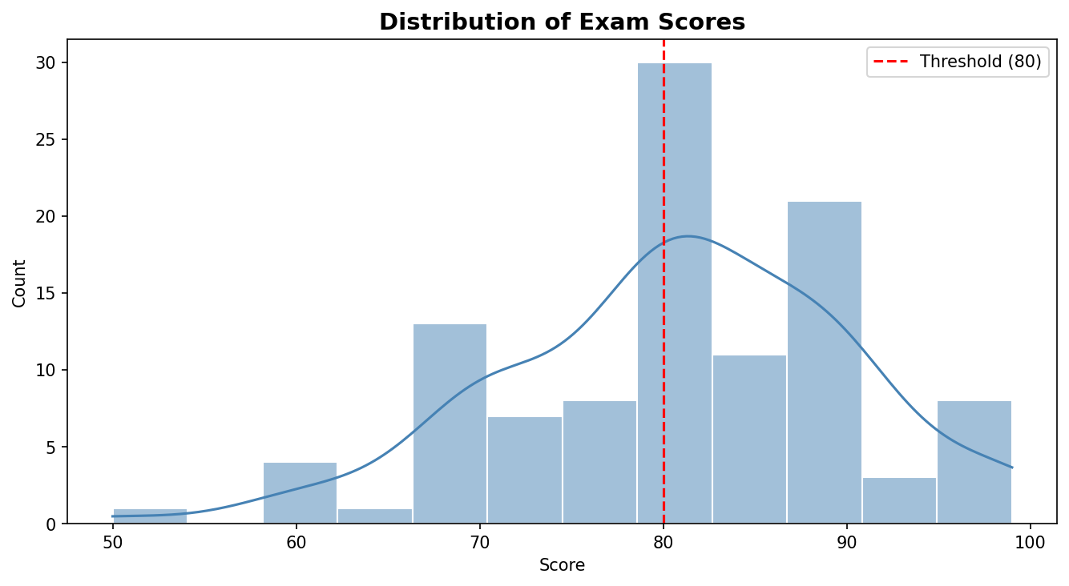
Figure 1: Distribution of Exam Scores with KDE Curve
3.3.2 Study Hours Analysis
The largest group studied less than 1 hour per day, followed by 1–2 hour students. A box-plot shows a positive trend — more study hours correlate with higher scores — though considerable variation exists within each category.
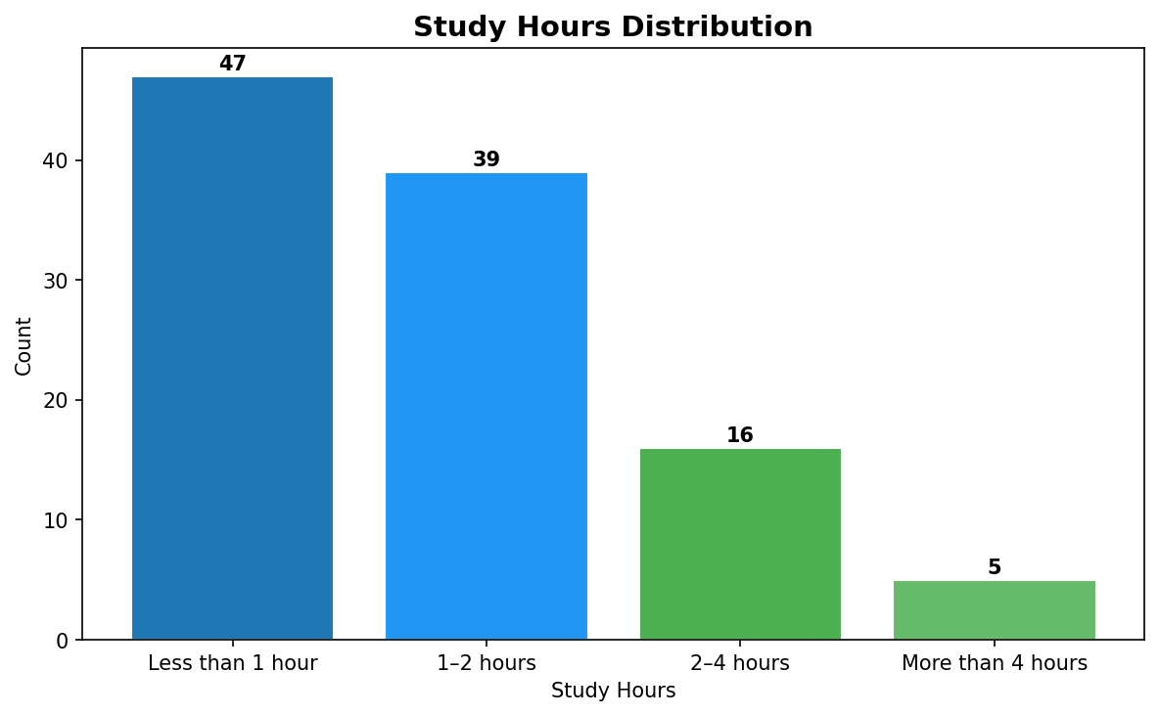
Figure 2: Study Hours Distribution
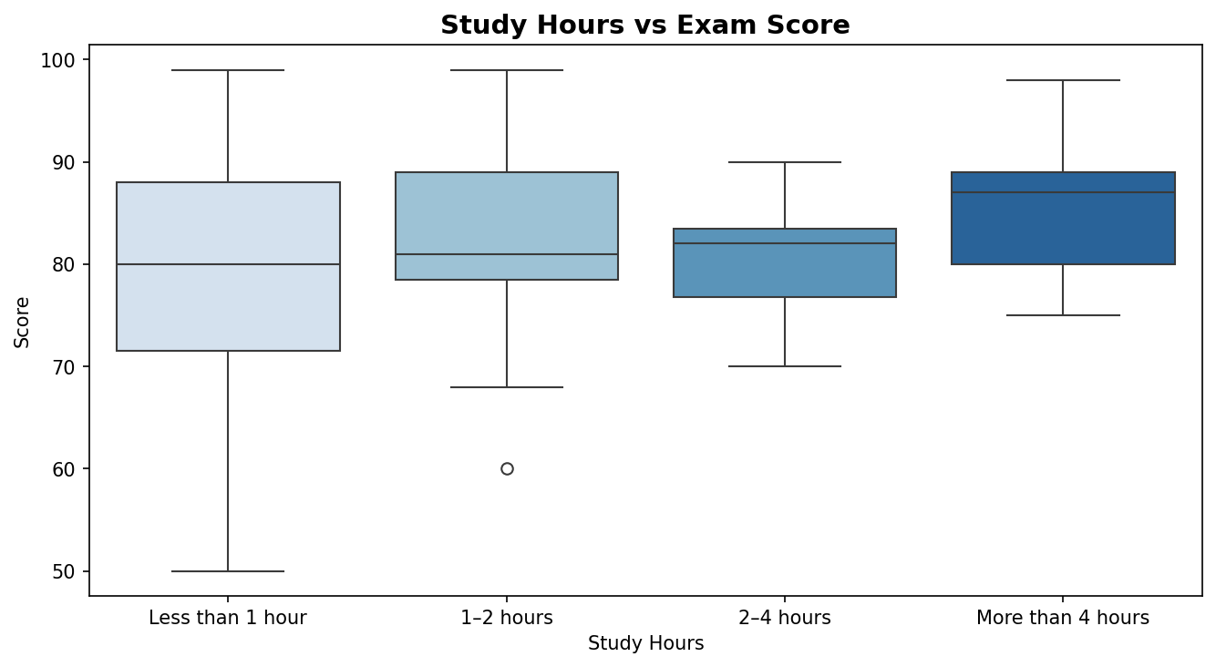
Figure 3: Study Hours vs Exam Score (Box Plot)
3.3.3 Attendance Distribution
The majority reported attendance in the 75–90% range. A significant proportion reported above 90%, while a smaller fraction fell below 60%. High attendance is strongly linked to better academic outcomes.
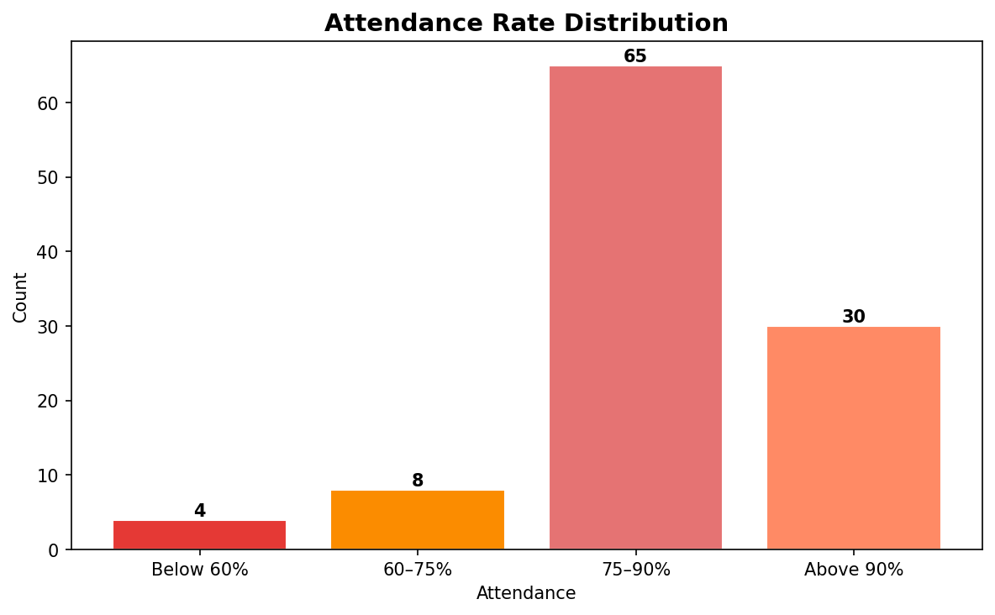
Figure 4: Attendance Rate Distribution
3.3.4 Sleep Hours Distribution
The majority reported sleeping 7–8 hours per night, aligning with medically recommended guidelines. A notable subset slept only 5–6 hours, which may negatively impact cognitive performance.
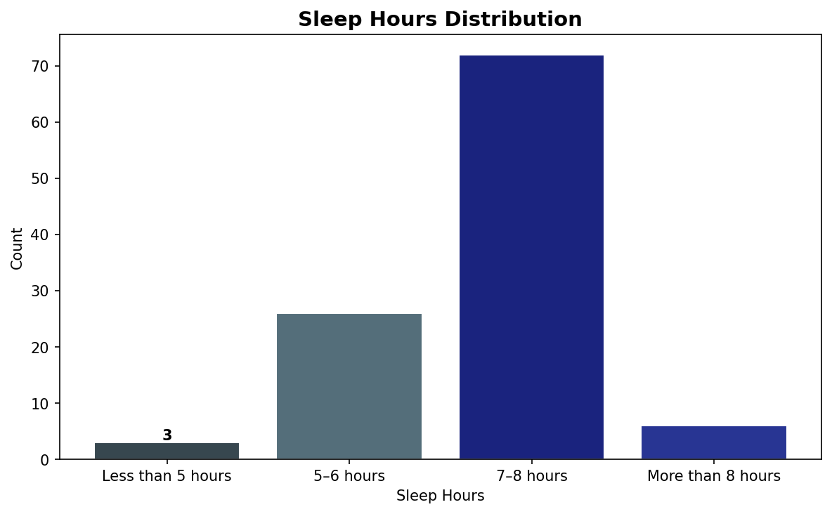
Figure 5: Sleep Hours Distribution
3.3.5 Distraction Level Analysis
The majority reported being distracted 'Sometimes' during study. High distraction levels negatively correlate with effective study time and consequently impact exam performance.
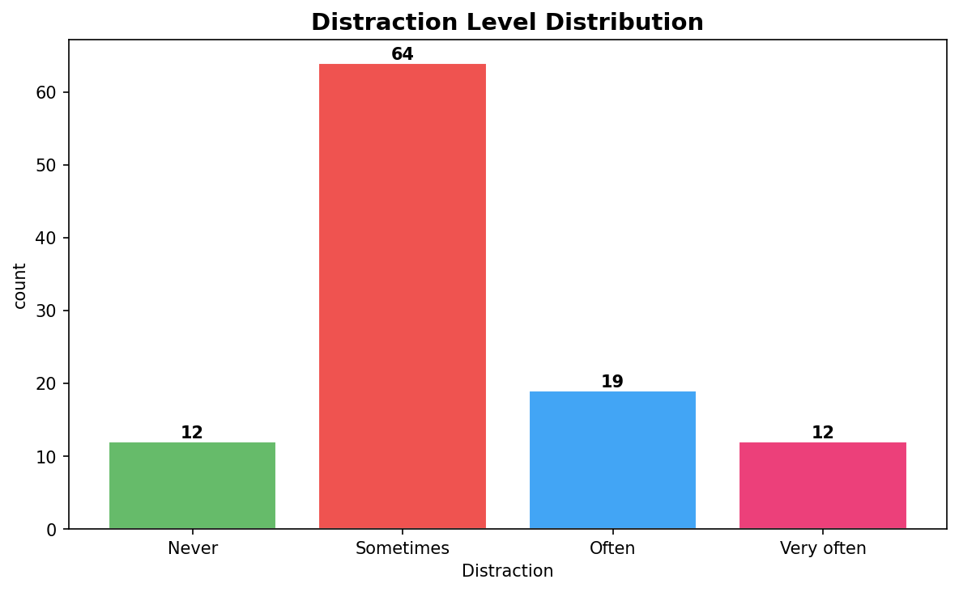
Figure 6: Distraction Level Distribution

3.3.6 Performance Class Distribution
After applying the threshold (score ≥80), the distribution shows 66 High Performance (61.7%) and 41 Low Performance (38.3%) records. Since the minority class ratio (38.3%) exceeded 35%, SMOTE was not applied. Stratified splitting was used instead.
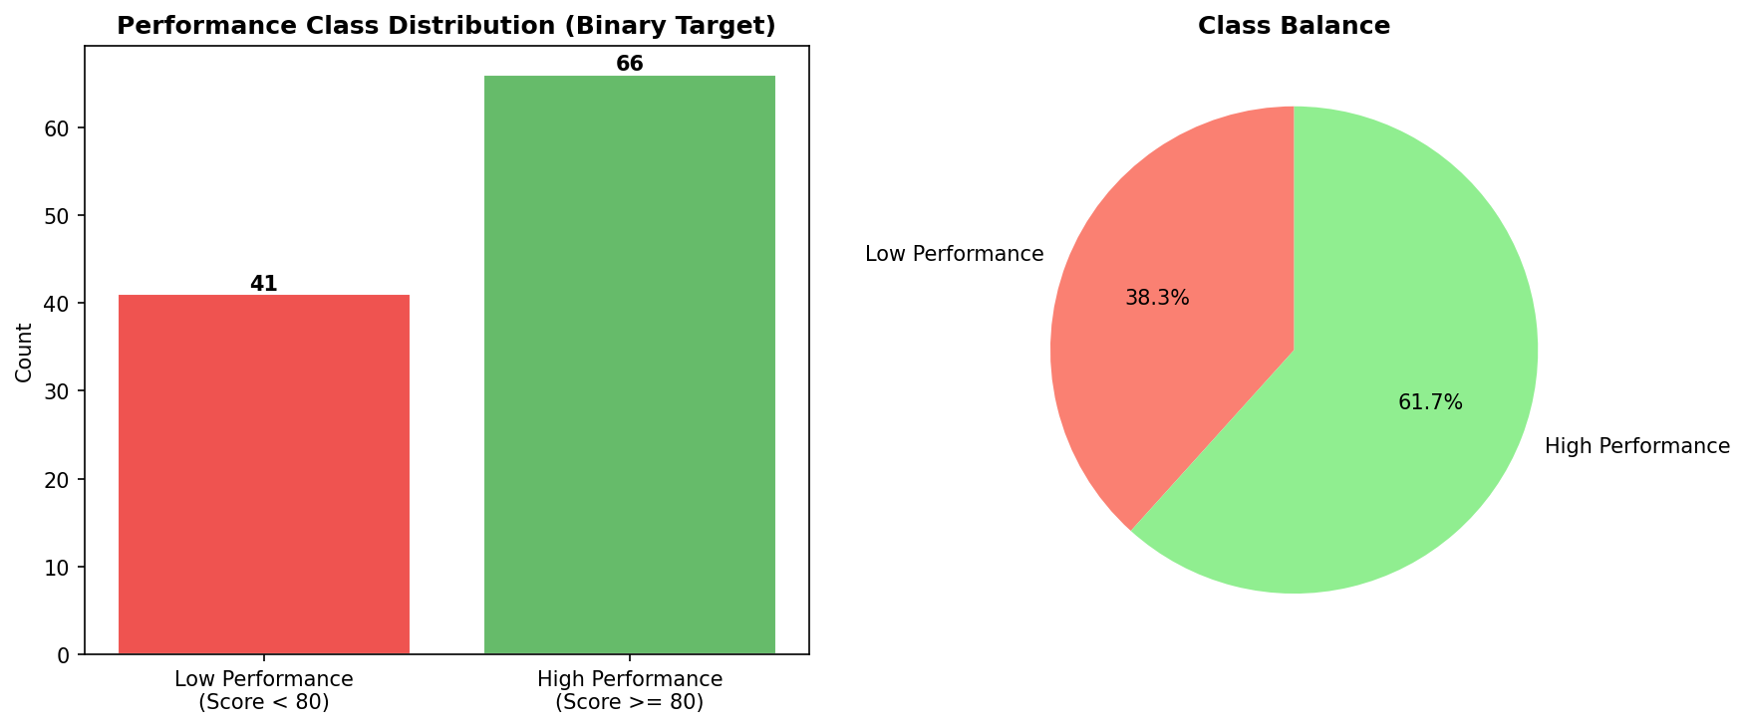
Figure 7: Performance Class Bar Chart (left) | Figure 8: Class Balance Pie Chart (right)
3.3.7 Correlation Heatmap
The correlation heatmap reveals pairwise linear relationships among all encoded features. study_efficiency and study_quality show very strong positive correlations (r≈1.00) with each other and with study_hours_encoded. distraction_impact shows moderate positive correlation with distracted_level, while MobileHours_encoded shows slight negative correlation with study variables.
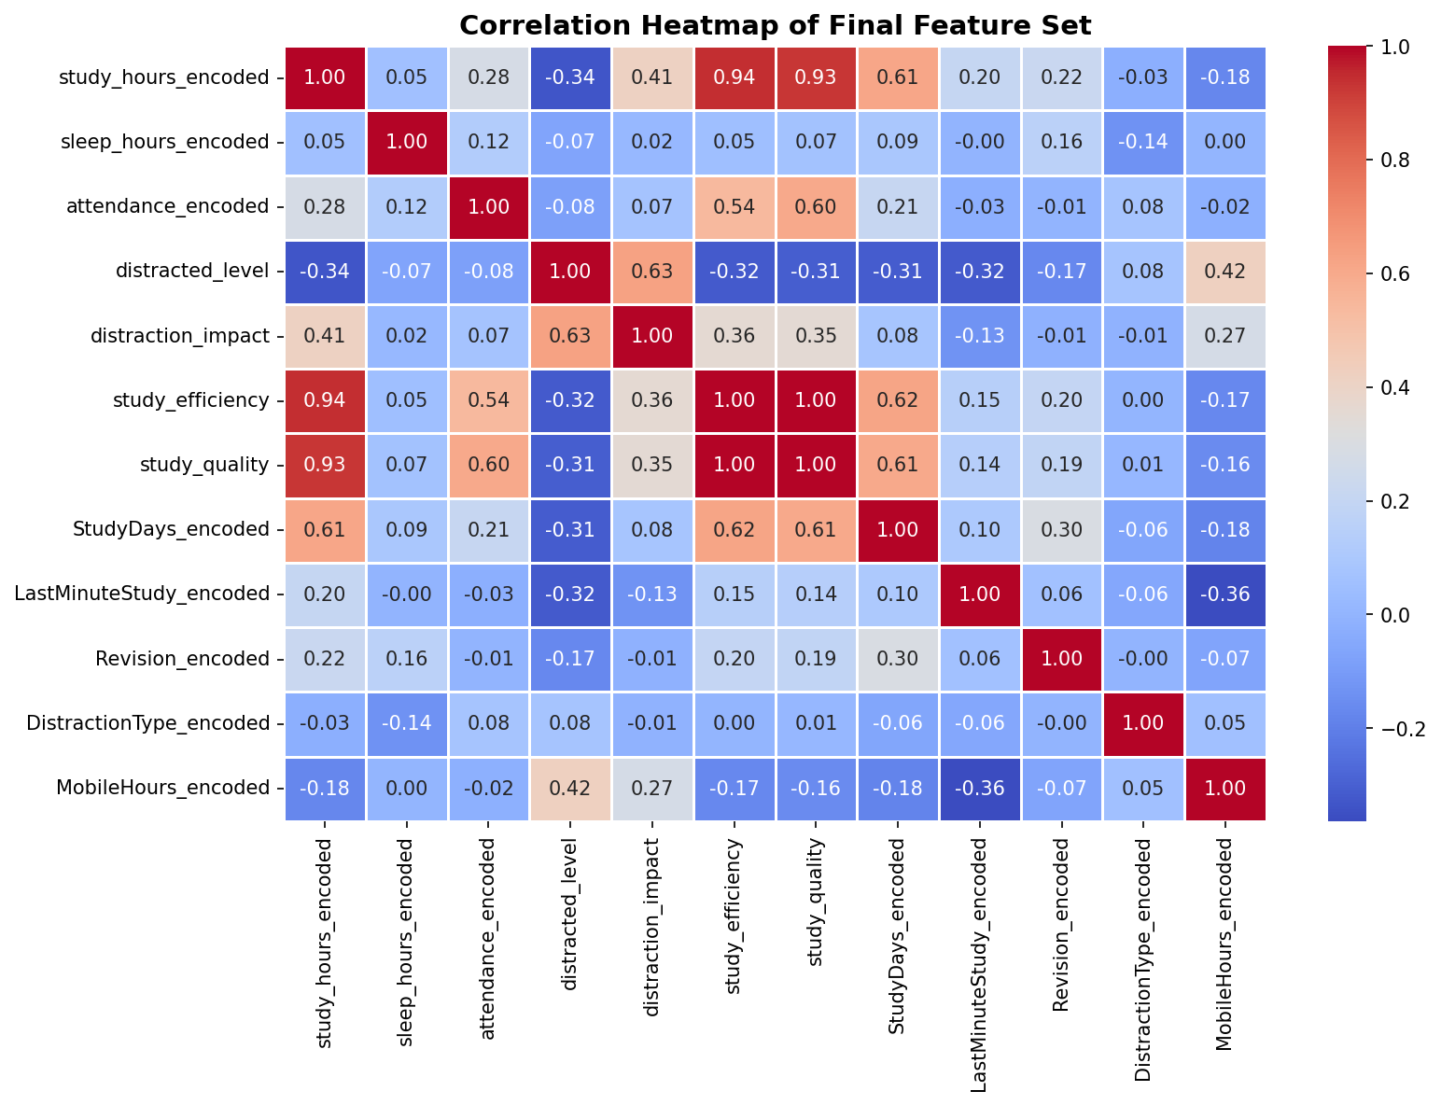
Figure 9: Correlation Heatmap of Final Feature Set
3.3.8 Engineered Feature Analysis
Three interaction features were engineered to capture composite behavioral signals:
Box-plots confirm that High Performance students (Class 1) consistently show higher median study_quality and study_efficiency values, validating these features.
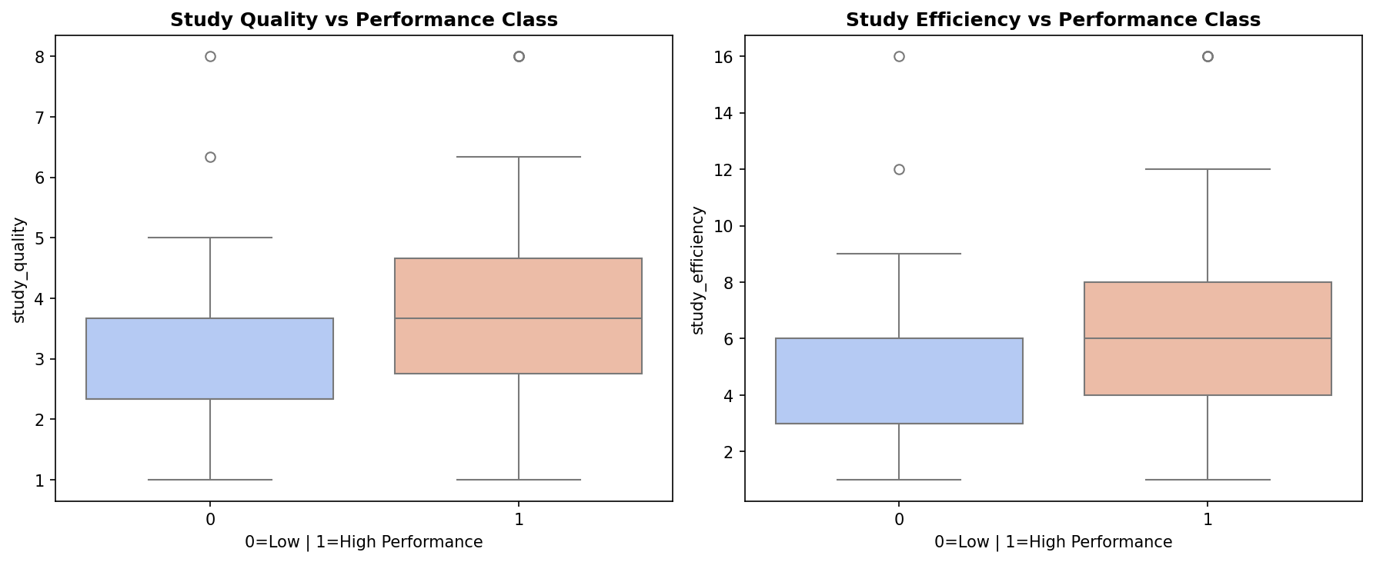
Figure 10: Study Quality vs Performance Class (left) | Figure 11: Study Efficiency vs Performance Class (right)

3.4 Machine Learning Approach
A supervised binary classification framework was used. The final feature matrix contained 12 features and 107 records after dropping identifiers and the raw Score column. An 80/20 stratified split (85 train, 22 test, random_state=42) was applied. Four classifiers were trained: Random Forest (n_estimators=200), Gradient Boosting, SVM (with StandardScaler), and KNN (with StandardScaler). 5-fold stratified cross-validation and GridSearchCV hyperparameter tuning were also applied.

Chapter 4
Results

4.1 Model Training and Comparison
All four classifiers were trained on the same stratified training set and evaluated on the held-out test set of 22 records.
Model | Test Accuracy | Rank
Random Forest | 0.5000 | 3
Gradient Boosting | 0.5000 | 4
SVM | 0.5909 | 2
KNN | 0.6364 | 1 (Best)
Table 5: Model Accuracy Comparison
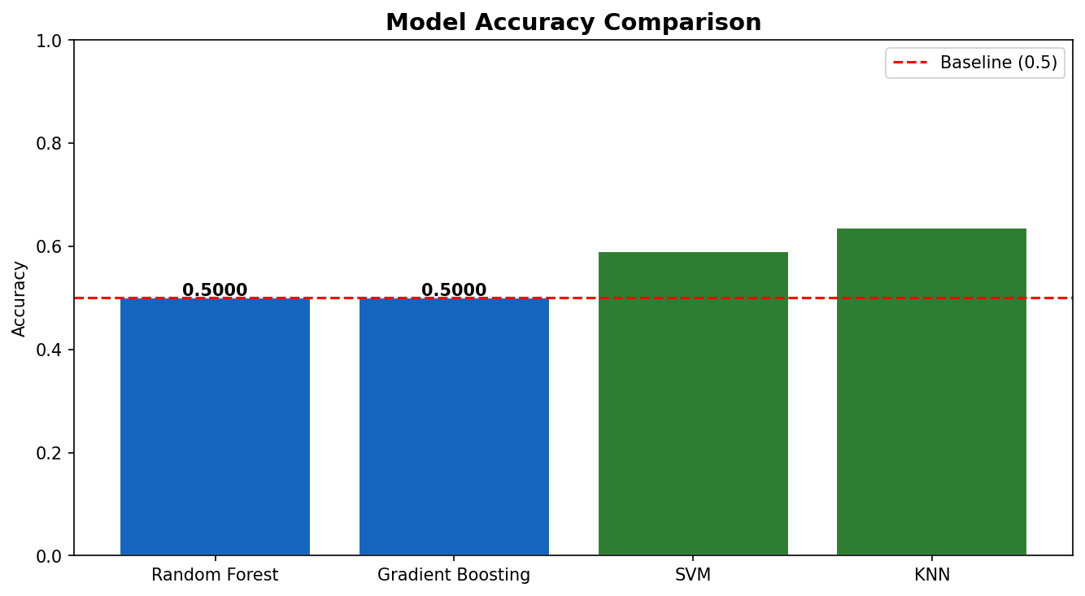
Figure 12: Model Accuracy Comparison Across All Classifiers
KNN achieved the highest test accuracy of 63.6% and was selected as the final model. The modest performance difference between models is consistent with the small dataset size of 107 records.

4.2 Model Evaluation
The final model was evaluated using Accuracy, Precision, Recall, F1-Score, and AUC-ROC:

Class | Precision | Recall | F1-Score | Support
Class 0 (Low Performance) | 0.50 | 0.62 | 0.56 | 8
Class 1 (High Performance) | 0.75 | 0.64 | 0.69 | 14
Accuracy |  |  | 0.64 | 22
Macro Avg | 0.62 | 0.63 | 0.62 | 22
Weighted Avg | 0.66 | 0.64 | 0.64 | 22
Table 6: Classification Report for Best Model (KNN)

Metric | Value
Best Model | KNN
Test Accuracy | 63.6%
AUC-ROC Score | 0.5938
Precision (Macro Avg) | 0.62
Recall (Macro Avg) | 0.63
F1-Score (Macro Avg) | 0.62
Training Set Size | 85 records
Test Set Size | 22 records
Table 7: Summary of Best Model Performance Metrics

4.3 Confusion Matrix Analysis
The confusion matrix provides a granular breakdown of correct and incorrect predictions.
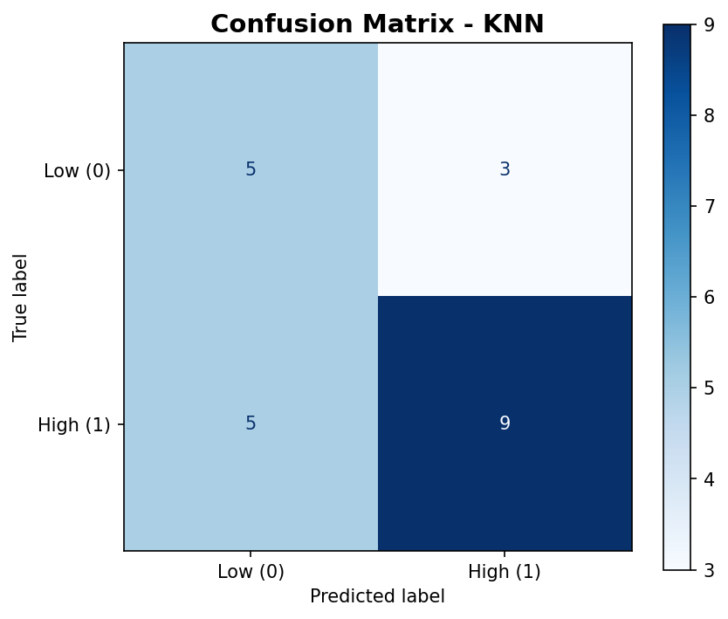
Figure 14: Confusion Matrix — KNN

Metric | Class 0 (Low) | Class 1 (High)
True Positives / Negatives | TN = 5 | TP = 9
False Predictions | FN = 3 (Low pred. as High) | FP = 5 (High pred. as Low)
Table 8: Confusion Matrix Breakdown
The model correctly identified 9/14 high performers and 5/8 low performers. Misclassifications are primarily attributed to the small dataset size and overlapping behavioral patterns between performance groups.

Chapter 5
Dashboard in Power BI
Finally, we built an interactive dashboard in Power BI to present insights visually.

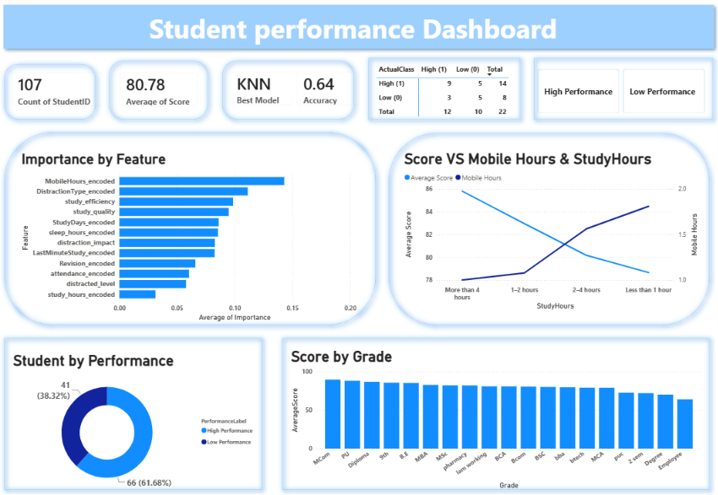

Chapter 6
Conclusion
This project successfully demonstrated supervised machine learning classification for predicting student exam performance based on real, self-reported study habits. By collecting authentic survey data and applying systematic preprocessing, feature engineering, and multi-model comparison, a predictive system was built that goes beyond simple intuition.
The best-performing model — KNN — achieved a test accuracy of 63.6% and an AUC-ROC of 0.5938. All four classifiers produced broadly similar performance, suggesting the dataset size is the primary limiting factor rather than model choice.

5.1 Key Findings
- Study Quality & Efficiency are the Strongest Predictors: The engineered features study_quality and study_efficiency are the top predictors, confirming that consistent, attendance-backed study hours matter more than raw time alone.
- Study Hours Matter, But Quality Outweighs Quantity: More study hours correlate with higher scores, but considerable variation within each category confirms that how one studies matters as much as how long.
- Class Attendance is a Key Amplifier: Regular attendance strongly amplifies the effectiveness of study time and is consistently associated with better academic outcomes.

5.2 Limitations
- Small Dataset (107 records): Constrains model generalization and increases variance in evaluation metrics.
- Self-Reported Data: Potential response bias — students may over/under-report habits due to social desirability.
- Binary Threshold (80): Somewhat arbitrary; may not capture full complexity of academic performance.

5.3 Future Work
- Expand the dataset by surveying students across multiple institutions and academic programs.
- Use multi-class classification (Poor / Average / Good / Excellent) for finer-grained predictions.

5.4 Discussion
Results show that consistent study habits and class attendance are the strongest predictors of academic performance. The distraction_impact interaction feature was more informative than distraction level alone, highlighting the value of feature engineering in behavioral data. The model's ~64% accuracy is consistent with similar educational prediction studies using survey-based data, and can serve as an early warning system for academic support.

5.5 Ethical Considerations
Predictions should be used to support students, never to label or stigmatize them. Transparency in feature importance builds trust. All student data must be anonymized and handled per applicable data protection regulations. Human oversight must accompany any automated prediction system to ensure fairness.
In conclusion, this project demonstrates that machine learning is a viable and insightful approach to understanding student academic behavior. Even with a modest dataset, the models revealed interpretable patterns aligned with established educational research. With larger, richer datasets, such systems could play a meaningful role in early academic intervention programs.

Chapter 7
References
[1] Scikit-learn Developers (2024). Machine Learning in Python — Official Documentation. Available at: https://scikit-learn.org. (Model implementation, preprocessing, evaluation.)
[2] Hunter, J. D. (2024). Matplotlib Documentation. Available at: https://matplotlib.org. (Data visualization.)
[3] Pandas Development Team (2024). Pandas Documentation. Available at: https://pandas.pydata.org. (Data manipulation and preprocessing.)
[4] Kaggle Inc. (2024). Kaggle Notebooks & AI Assist. Available at: https://kaggle.com. (ML workflows and dataset handling reference.
[5] OpenAI (2024). ChatGPT. Used for conceptual guidance and report drafting support. Final implementation and analysis were performed by the student.

