MACHINE LEARNING IN CLIMATE AND WEATHER
THRISHA REDDY KUMBAM
making informed decisions in various sectors, including agriculture, energy, and public health.

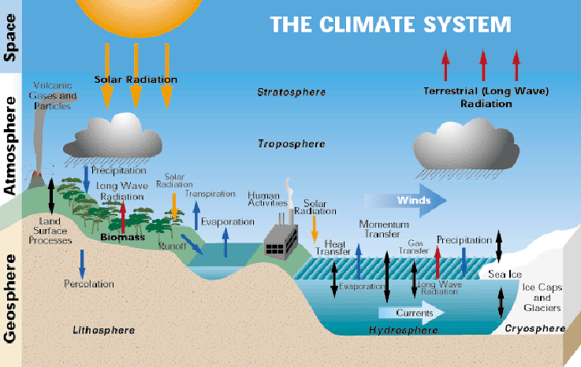
Fig: The Climate System[2]

- ROLE OF ML IN CLIMATE AND WEATHER
Machine Learning has emerged as a powerful tool for analyzing and interpreting large volumes of climate and weather data. ML algorithms can identify complex patterns and relationships within datasets that traditional statistical methods may overlook. In climate science, ML techniques are being employed for tasks such as climate modeling, weather forecasting, extreme event prediction, and climate impact assessment. By integrating ML into existing weather prediction models, scientists can improve the accuracy and reliability of forecasts, leading to better preparedness and mitigation strategies for weather-related disasters.

Abstract-
The integration of Machine Learning (ML) techniques in the field of climate and weather science has emerged as a promising avenue for enhancing predictive capabilities, understanding complex climate patterns, and improving early warning systems. This project explores the application of ML algorithms in analyzing climate and weather data to predict future trends and events. By leveraging large datasets and advanced algorithms, this project aims to contribute to the development of more accurate and efficient weather forecasting models. Through the implementation of code, we demonstrate the potential of ML in revolutionizing the way we perceive and interact with climate and weather data.
Index Terms-
Machine Learning, Climate Science, Weather Forecasting, Predictive Modeling, Data Analysis, Python, Dataset
- INTRODUCTION TO CLIMATE AND WEATHER
Climate and weather are fundamental aspects of Earth's natural systems, influencing various aspects of human life, from agriculture and transportation to disaster preparedness. Climate refers to long-term patterns of temperature, precipitation, humidity, wind, and other atmospheric conditions in a particular region, while weather refers to short-term variations in these conditions. Understanding and predicting climate and weather patterns are crucial for

The "Weather Prediction NB" dataset provides a comprehensive set of features related to weather conditions, making it suitable for predictive modeling tasks. By leveraging this dataset and employing machine learning techniques, it is possible to build models that can accurately predict whether it will rain the next day based on various weather parameters. Through data analysis, preprocessing, model training, and evaluation, this project aims to demonstrate the effectiveness of machine learning in weather prediction applications.
For this project to build I have used multiple libraries. Below screenshot shows all the libraries that I have imported and used.
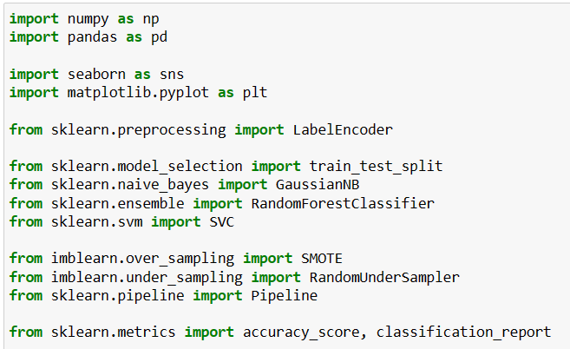
Import Libraries Fig. 1
Next I will read the dataset and using info function I have checked the attributes of the dataset.
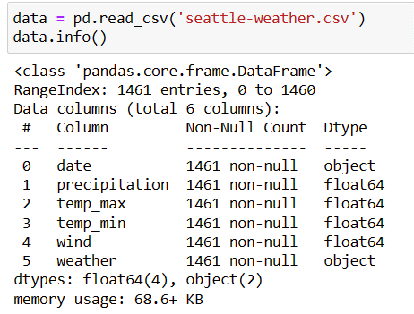
Load Dataset Fig. 2

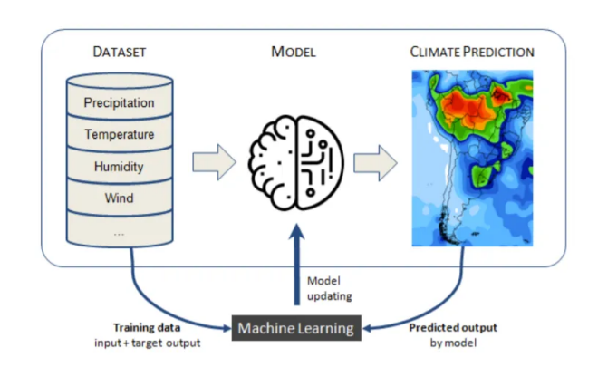
Fig: Machine Learning in Climate Prediction Analytics [4]

- TECHNICAL DETAILS
Programming Language:
For this project, we utilize Python[1] as the primary programming language. Python offers a wide range of libraries and frameworks for machine learning, data analysis, and visualization, making it an ideal choice for implementing ML algorithms in climate and weather research.
Python is used as the primary programming language for data analysis, preprocessing, model building, and evaluation in this project. Python offers a rich ecosystem of libraries and tools for machine learning and data analysis, making it suitable for handling diverse datasets and implementing predictive models.
Dataset:
The dataset used for this project is titled "Weather Prediction NB" [5]and is contributed by Kavya Sasikumar. It is available on Kaggle and is intended for weather prediction tasks. The dataset contains various features related to weather conditions along with the target variable indicating whether it will rain the next day or not.

For data preprocessing I will check the duplicates present in the dataset using duplicated function. Also I will check unique values present in the target attributes.
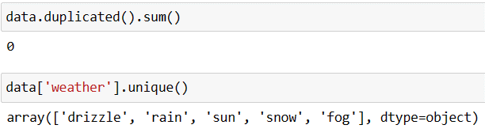
Duplicate data Fig. 3
Now find the outlier I will plot the boxplot for the dataset and it seems are not much present in the dataset and there is no need to process this dataset.
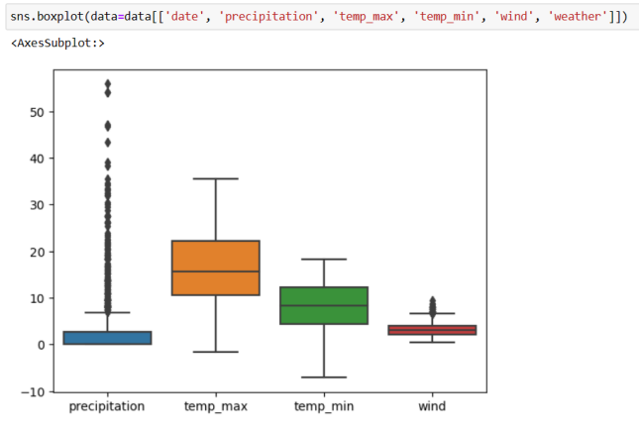
Box Plot Fig. 4
Using histogram plot I will check the distribution of the maximum temperature vs frequency.
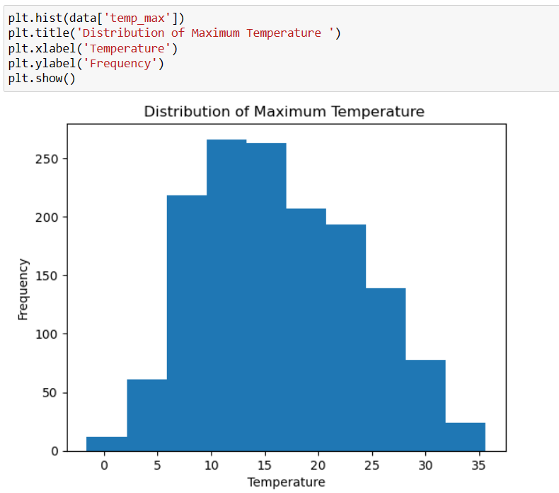
Histogram Plot Fig. 5
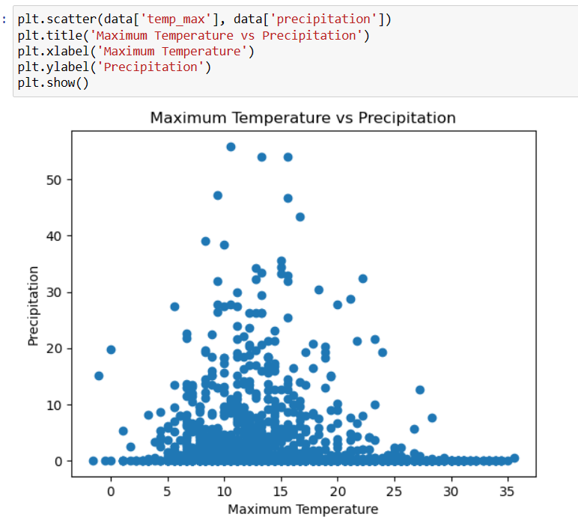
Fig. 6

Using scatter plot I will visualize for maximum temperature what is precipitation values and well it is scattered across the temperature values and from the graph it looks well scattered.

Scatter Plot – Precipitation vs Maximum Temperature Fig. 6
Similarly I will plot precipitation vs minimum temperature and by looking at the graph it can be seen that precipitation values quite scattered for minimum temperature values as well.
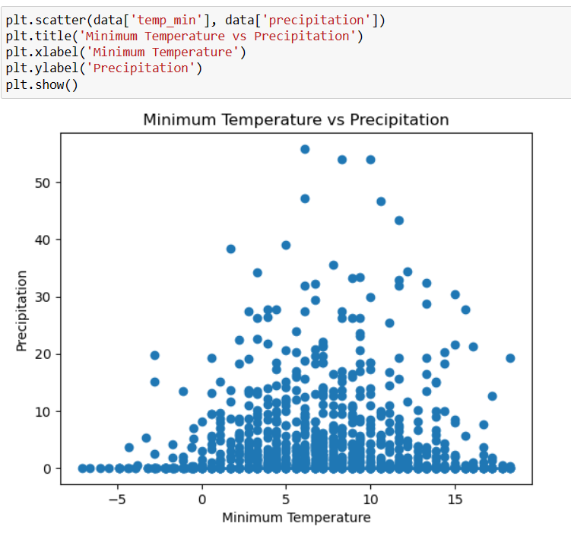
Scatter Plot – Precipitation vs Minimum Temperature Fig. 7

Now I will convert the dataset into numerical format using label encoder so that model can understand the data.
Target attribute is in textual format and needs to be converted to numerical format.
As shown in the below screenshot using labelencoder I have transformed the target attribute “weather” and get the numerical data stored in the weather_label attribute.
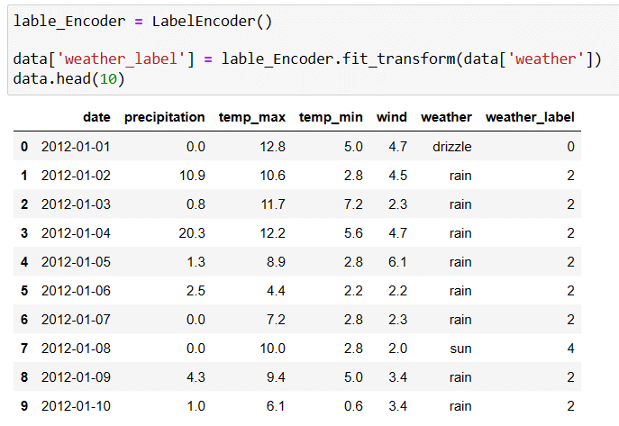
Label Encoder Fig. 11
Now mapping the numerical weather label to weather textual data as shown in the below screenshot.
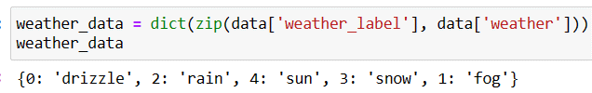
Weather Label Mapping Fig. 12
Date attribute data needs to converted into date, month and year data and for this I have decalred a function named date_and_time and passed data which will transform date into day, month and year.
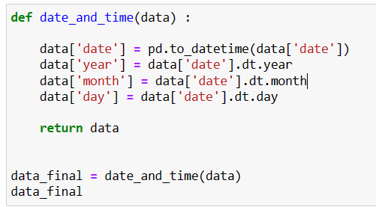
Date tranformation Fig. 13

Now using the bar graph I will visualize the target data and its union values frequency. It seems from the graph that rain and sun has the more data compare to fog, drizzle and snow.
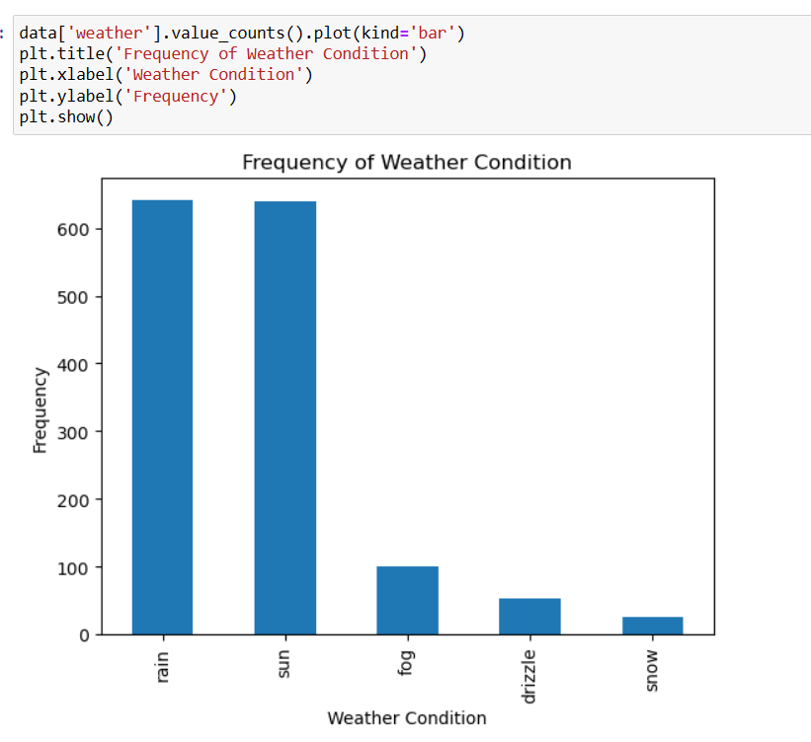
Bar Graph Fig. 8
Again visualizing the maximum temperature over the time frame to see at what the temperature is rising.
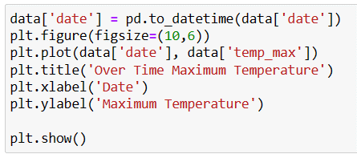
Time vs temperature plotting Fig. 9
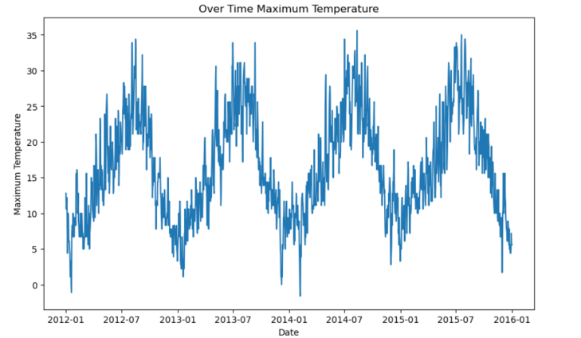
Maximum Temperature vs Date Fig. 10

splitted for testing data and rest 75% data will be used for training the model.
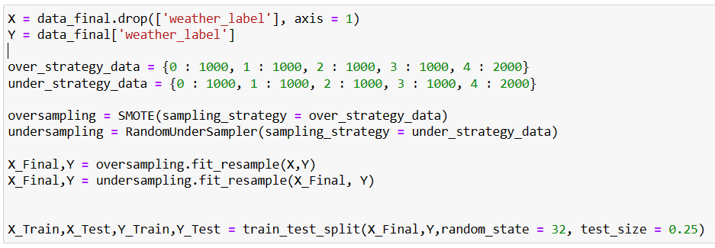
Data Sampling Fig. 16
Now using this training data I will build the Gaussian Navie Bais model.
Using the predict function I tested the model on all the three dataset, sampled data, training data amd test data and find the accuracy for each and accuracy I got is 74% for each which quite descent.
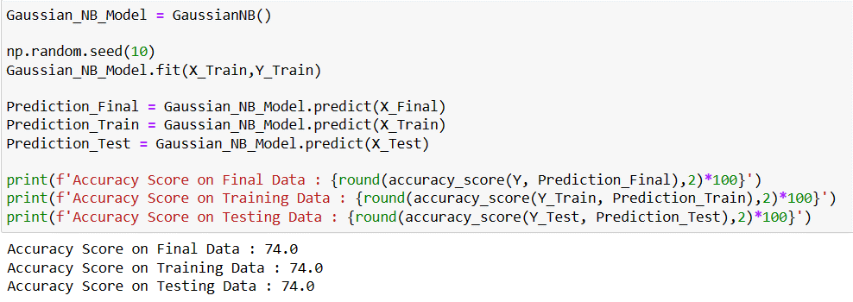
Gaussian Model Fig. 17
Printing the classification report for gaussian model for sampled test data.
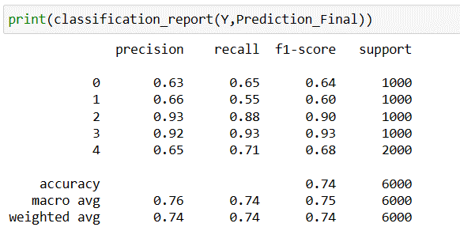
Classification Report for Gaussian Model Fig. 18
Buidling the Random Forest Classifier for the training dataset and the testing model for all the three data. Accuracy I got for this model is more than 95% for all three types dataset.

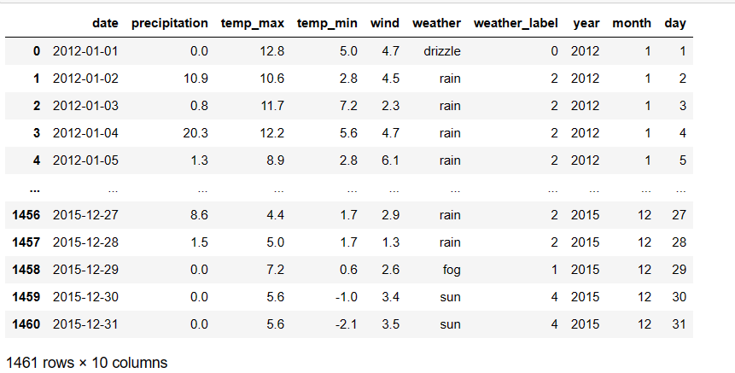
Data Visulization Fig. 14
Now the weather attribute is still present in the data which needs to be dropped from the dataset using drop function.
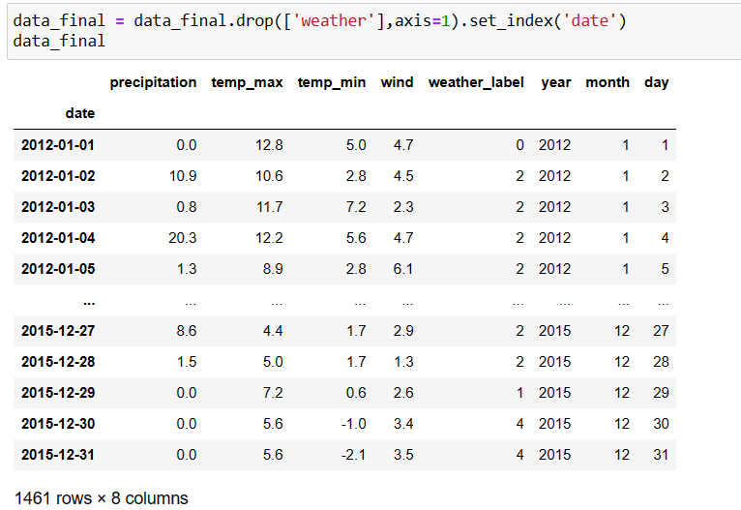
Dropping weather attribute Fig. 15

- Data Modelling
In this chapet I will disucss about how I built different models on the top of the data prepared.
Before modelling, I will divide the dataset into the train and test dataset. Dropping weather_label which is the target attribute and storing rest of the dataset in the X varibale and Y variable stores the weather_label data. Using SMOTE, I will do the oversampling of the data to make the distribution of the data normal and then using under sampling terchnique I will reduce the data size to avoid the chance of over modelling.
Using the sampled data I have splitted the data into training and test data. 25% of the data

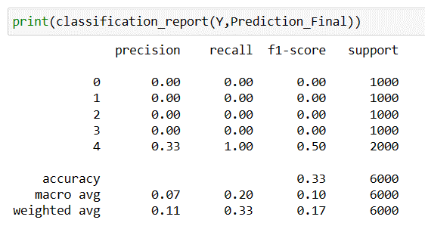
Classification Report for SVC Fig. 22
I will try one more model to see if I can get a better model then random Forest Classifier. I will train the CatBoost Classifier and build the MLP Classifier for training dataset.
After testing the MLP classifier model on the testing dataset accuracy I got is less than 45%.
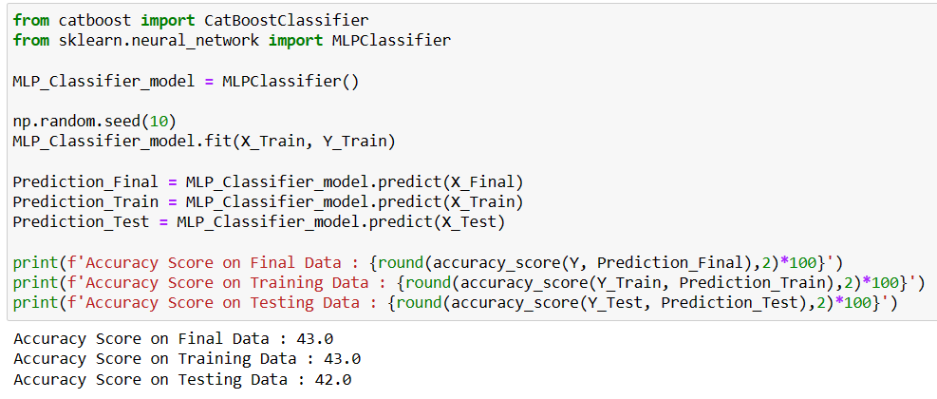
MLP Classifier Fig. 23
Classification reports shows the detailed output for the model and it looks better than SVC but not as good as Random Forest Classifer.
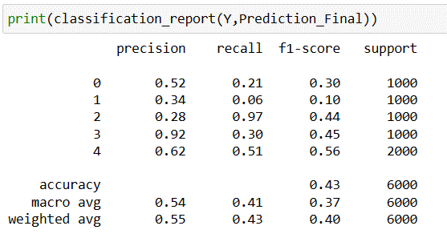
Classification Report for MLP Classifier Fig. 24

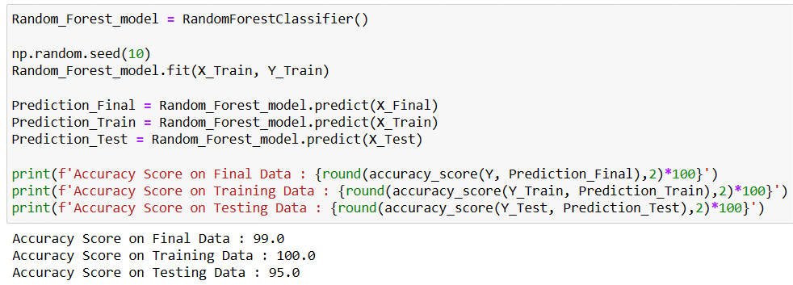
Random Forest Classifier Fig. 19
Printing the classification report for Random Forest Classifier model for predicted data to get more detailed explanation.
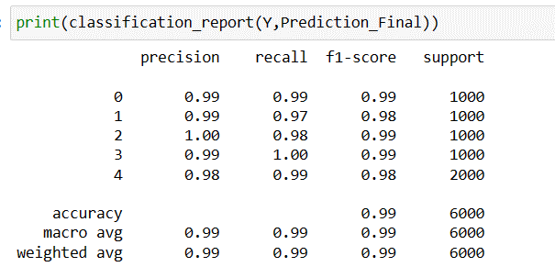
Classification Report for Random Forest Classifier Fig. 20

Even though Random Forest Classifier gives 95% accuracy, I will check for more robust model by training SVC model and testing the model.
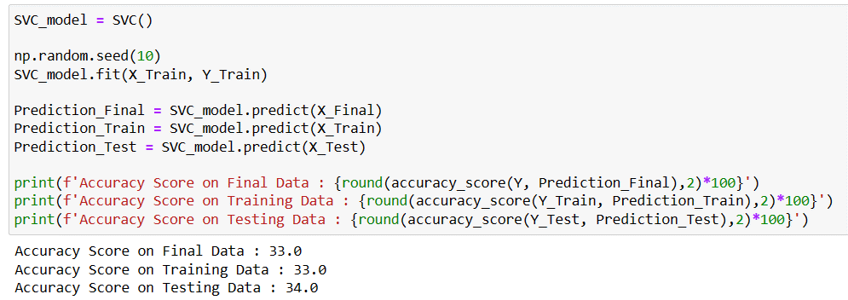
SVC Fig. 21

SVC model is behaving good for our dataset, 35% accuracy is what I got for the test dataset and classification report gives more detailed output of the model which doesn’t looks good.

[6] Sole Galli , “Exploring Oversampling Techniques for Imbalanced Datasets”,
Exploring Oversampling Techniques for Imbalanced Datasets - Train in Data's Blog
[7] Naveenraj, “Label Encoder In Machine Learning”, https://www.codersarts.com/forum/machine-learning/label-encoder-in-machine-learning
[8] Official Documentation on “Model Building Guidelines”, https://scikit-learn.org/stable/index.htm
[9] Kenny Miyasato, “Classification Report: Precision, Recall, F1-Score, Accuracy” , https://medium.com/@kennymiyasato/classification-report-precision-recall-f1-score-accuracy-16a245a437a5
[10] “NN - Multi-layer Perceptron Classifier (MLPClassifier)” , https://michael-fuchs-python.netlify.app/2021/02/03/nn-multi-layer-perceptron-classifier-mlpclassifier/

[11] “Create Python Scatter Plot & Python BoxPlot” , https://data-flair.training/blogs/python-scatter-plot/#google_vignette

[12] Elena Kosourova, “How to Plot a Bar Graph in Matplotlib: The Easy Way” , https://www.dataquest.io/blog/how-to-plot-a-bar-graph-matplotlib/
VI. Conclusion
After visualizing and preprocessing the weather dataset, I did the label enconding on the dataset to prepare it for modelling and did the oversampling and under sampling to normalize the dataset and then train different models on the top of training dataset. Out of Gaussian Navie Bais, SVC, Random Forest Classifier and MLP Classifier, Random Forest Classifier gave the good accuracy of 99%. Random Forest Classifier can be used to predict the weather forecast and get to know about the weather details in advance to prepare for the bad weather and alert the people for any uncertain natural calamities.

VII. References

[1] Python official Website, “Python” , https://www.python.org/
[2] Kathleen Miller, “An idealized graphic of the climate system (from Bureau of Meteorology, Australia)”, https://www.researchgate.net/figure/An-idealized-graphic-of-the-climate-system-from-Bureau-of-Meteorology-Australia_fig1_242180386
[3] Karen Chen, “Machine Learning Applications in Climate Prediction Analytics”, https://medium.com/@sej.uoft/machine-learning-applications-in-climate-prediction-analytics-60456d6c6a85
[4] Karen Chen, “Machine Learning Applications in Climate Prediction Analytics”, https://miro.medium.com/v2/resize:fit:828/format:webp/0*Ibv4SFoStHNEpXoa
[5] Kavya Sasikumar, "Weather Prediction NB." https://www.kaggle.com/code/kavyas21itr052/weather-prediction-nb/input

