FPGA-Based Traffic Light Controller with Priority System
RTL Design, FSM Simulation and Emergency Vehicle Priority Override
Project | 1 – FPGA-Based Traffic Light Controller with Priority System
HDL | Verilog
Simulation | EDA Playground + Icarus Verilog 12.0 + EPWave
Student | Thrisha DS

1. Abstract
This project presents a digital traffic-light controller for two intersecting roads using Verilog HDL. The controller is implemented as a finite-state machine (FSM) with four normal traffic states: Road A Green, Road A Yellow, Road B Green and Road B Yellow. An emergency input provides priority to an emergency vehicle by forcing the controller into the Road B Green state, thereby making Road A Red. Reset returns the controller to its initial Road A Green state. The design was functionally simulated using Icarus Verilog 12.0 on EDA Playground and the resulting waveforms were inspected in EPWave. The simulation demonstrates clock, reset, emergency input, FSM state transitions, and all six traffic-light outputs.

2. Project Objectives
- Design a two-road traffic-light controller using Verilog HDL.
- Use an FSM to sequence the traffic lights safely.
- Provide Red, Yellow and Green outputs for both Road A and Road B.
- Implement an emergency-vehicle priority override.
- Provide asynchronous reset to return the controller to a known state.
- Verify the design through RTL simulation and waveform analysis.
- Produce simulation evidence suitable for documentation and GitHub/LinkedIn publication.

3. System Requirements and Tools
Category | Selection
HDL | Verilog / SystemVerilog-compatible RTL
Simulation | Icarus Verilog 12.0
Waveform viewer | EPWave
Online environment | EDA Playground
Inputs | clk, reset, emergency
Outputs | Road A/B Red, Yellow, Green; FSM state debug

4. System Architecture
The controller receives clock, reset and emergency inputs. The clock drives the FSM and timing counter. Reset initializes the system to A_GREEN. During normal operation the FSM cycles through four states. When emergency is asserted, priority logic selects B_GREEN, making Road A Red and Road B Green.
Clock / Reset / Emergency → FSM + Counter → State Decoder → Road A & Road B Lights

5. FSM State Definition
Code | State | Road A | Road B | Purpose
00 | A_GREEN | Green | Red | Normal traffic on Road A
01 | A_YELLOW | Yellow | Red | Transition from Road A to Road B
10 | B_GREEN | Red | Green | Normal traffic on Road B / emergency priority
11 | B_YELLOW | Red | Yellow | Transition from Road B to Road A
Normal sequence: A_GREEN → A_YELLOW → B_GREEN → B_YELLOW → A_GREEN. Emergency override selects B_GREEN and resets the timing counter.

6. Priority Override and Reset
Reset has the highest priority in the sequential logic. When emergency is active, the normal FSM progression is bypassed and the controller moves to B_GREEN. When emergency is released, normal traffic sequencing resumes.

7. RTL Implementation
Main design module:
module traffic_light_controller (
input wire clk,
input wire reset,
input wire emergency,
output reg roadA_red,
output reg roadA_yellow,
output reg roadA_green,
output reg roadB_red,
output reg roadB_yellow,
output reg roadB_green,
output reg [1:0] state_debug
);
parameter A_GREEN = 2'b00;
parameter A_YELLOW = 2'b01;
parameter B_GREEN = 2'b10;
parameter B_YELLOW = 2'b11;
reg [1:0] state;
reg [3:0] counter;
always @(posedge clk or posedge reset) begin
if (reset) begin
state <= A_GREEN;
counter <= 0;
end
else if (emergency) begin
state <= B_GREEN;
counter <= 0;
end
else begin
case (state)
A_GREEN: begin
if (counter == 4) begin
counter <= 0;
state <= A_YELLOW;
end else counter <= counter + 1;
end
A_YELLOW: begin
if (counter == 1) begin
counter <= 0;
state <= B_GREEN;
end else counter <= counter + 1;
end
B_GREEN: begin
if (counter == 4) begin
counter <= 0;
state <= B_YELLOW;
end else counter <= counter + 1;
end
B_YELLOW: begin
if (counter == 1) begin
counter <= 0;
state <= A_GREEN;
end else counter <= counter + 1;
end
default: begin
state <= A_GREEN;
counter <= 0;
end
endcase
end
end
always @(*) begin
roadA_red = 0; roadA_yellow = 0; roadA_green = 0;
roadB_red = 0; roadB_yellow = 0; roadB_green = 0;
case (state)
A_GREEN: begin roadA_green = 1; roadB_red = 1; end
A_YELLOW: begin roadA_yellow = 1; roadB_red = 1; end
B_GREEN: begin roadA_red = 1; roadB_green = 1; end
B_YELLOW: begin roadA_red = 1; roadB_yellow = 1; end
default: begin roadA_red = 1; roadB_red = 1; end
endcase
end
always @(*) state_debug = state;
endmodule

8. Testbench and Waveform Generation
The testbench generates a 10 ns clock, applies reset, allows normal operation, asserts emergency for 30 ns, then releases it. A VCD file is generated for EPWave.
`timescale 1ns/1ps
module traffic_light_controller_tb;
reg clk;
reg reset;
reg emergency;
wire roadA_red, roadA_yellow, roadA_green;
wire roadB_red, roadB_yellow, roadB_green;
wire [1:0] state_debug;
traffic_light_controller DUT (
.clk(clk),
.reset(reset),
.emergency(emergency),
.roadA_red(roadA_red),
.roadA_yellow(roadA_yellow),
.roadA_green(roadA_green),
.roadB_red(roadB_red),
.roadB_yellow(roadB_yellow),
.roadB_green(roadB_green),
.state_debug(state_debug)
);
always #5 clk = ~clk;
initial begin
clk = 0;
reset = 1;
emergency = 0;
#20 reset = 0;
#100 emergency = 1;
#30 emergency = 0;
#100 $finish;
end
initial begin
$monitor(
"TIME=%0t | RESET=%b | EMERGENCY=%b | STATE=%b | "
"A_RED=%b A_YELLOW=%b A_GREEN=%b | "
"B_RED=%b B_YELLOW=%b B_GREEN=%b",
$time, reset, emergency, state_debug,
roadA_red, roadA_yellow, roadA_green,
roadB_red, roadB_yellow, roadB_green
);
end
initial begin
$dumpfile("traffic_light_controller.vcd");
$dumpvars(0, traffic_light_controller_tb);
end
endmodule

9. Simulation Environment
The design was executed in EDA Playground using Icarus Verilog 12.0 with EPWave enabled.
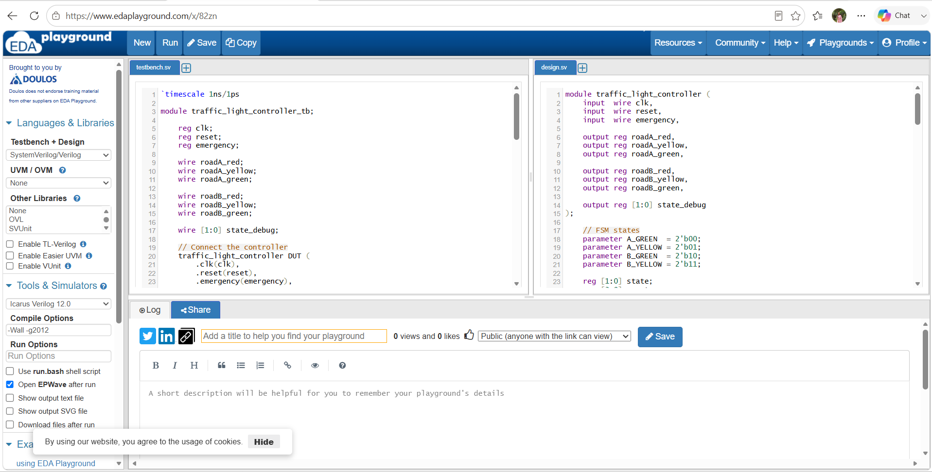
Figure 1. EDA Playground configuration showing Icarus Verilog 12.0 and EPWave enabled.

10. Simulation Results
The EPWave result contains the clock, reset, emergency input, counter, FSM state signals and all six traffic-light outputs.
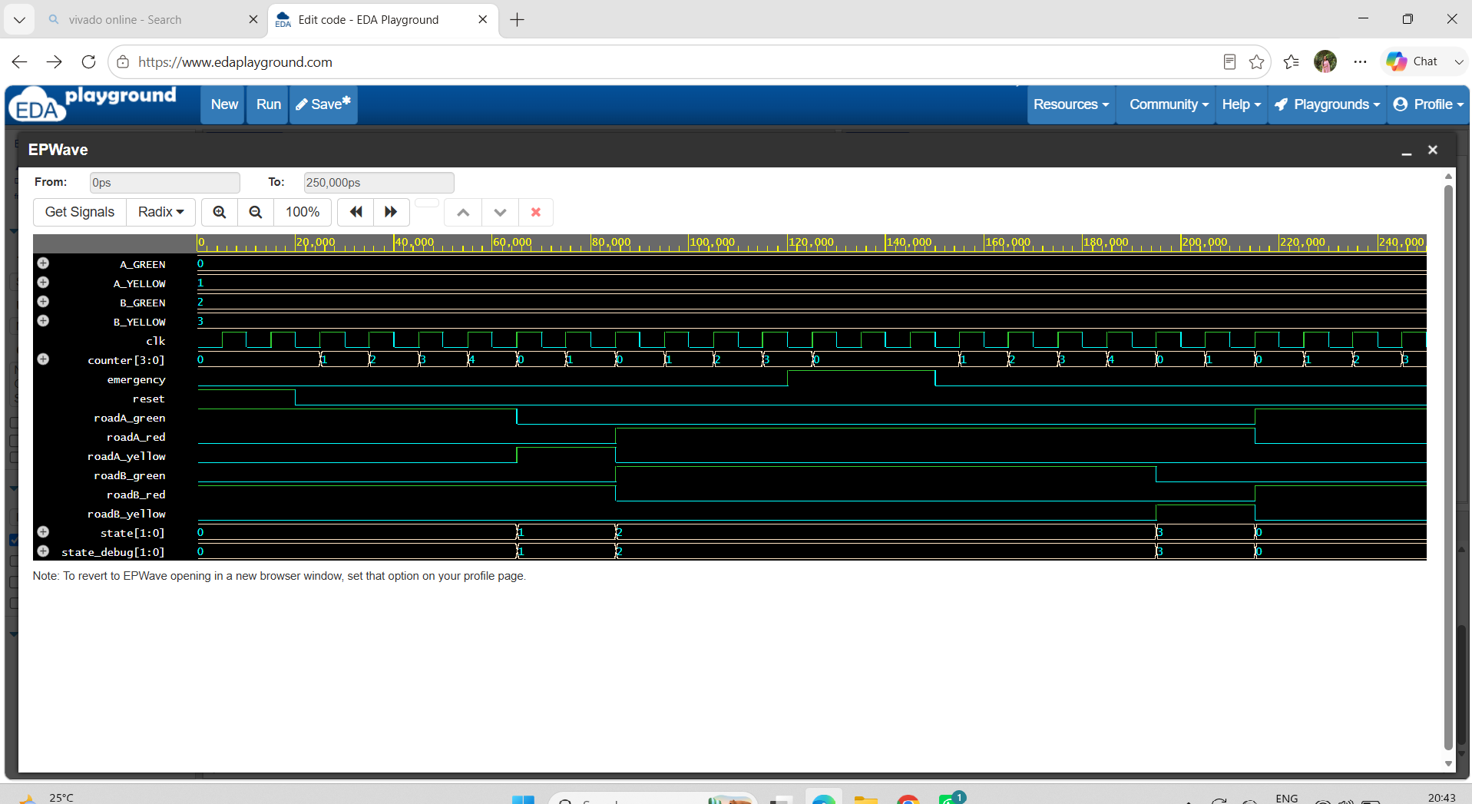
Figure 2. EPWave simulation waveform showing clock, reset, emergency input, counter, Road A/Road B lights, and FSM state transitions.

11. Verification Test Cases
Test | Condition | Expected Result | Status
Reset | reset = 1 | State 00; Road A Green, Road B Red | Pass
Normal A phase | reset = 0, emergency = 0 | A_GREEN → A_YELLOW | Pass
Normal B phase | reset = 0, emergency = 0 | A_YELLOW → B_GREEN → B_YELLOW | Pass
Emergency override | emergency = 1 | B_GREEN; Road A Red, Road B Green | Pass
Emergency release | emergency = 0 | Normal FSM resumes | Pass

12. Results and Discussion
The waveform confirms the intended four-state traffic sequence. Reset returns the controller to state 00, the FSM progresses through 01, 10 and 11, and the emergency input selects state 10 (B_GREEN), producing Road A Red and Road B Green.

13. FPGA Implementation Considerations
The RTL is synthesizable and suitable as a baseline for FPGA implementation. Physical deployment would require a board-specific top module, clock divider, pin constraints and LED/GPIO connections. This project evidence is based on RTL simulation; physical FPGA-board validation was not performed.

14. Limitations
No post-synthesis timing, FPGA resource utilization, bitstream generation or physical-board measurements are included. Simulation timing is intentionally short for easy waveform observation.

15. Future Enhancements
- Add an FPGA clock divider for human-visible traffic-light timing.
- Add configurable emergency priority for either road.
- Add pedestrian crossing and all-red safety intervals.
- Synchronize and debounce physical emergency inputs.
- Synthesize in Vivado and record LUT, flip-flop, timing and power estimates.
- Deploy on a supported FPGA development board.

16. Conclusion
A two-road FPGA-oriented traffic-light controller with emergency priority was designed in Verilog and successfully verified through RTL simulation. The four-state FSM controls both roads, while the emergency input overrides the normal sequence by selecting B_GREEN. The EPWave waveform provides evidence for the required clock, reset, emergency, FSM and traffic-light signals.

17. Publication/Submission Checklist
- Save design.sv and testbench.sv.
- Keep the EP Wave waveform screenshot.
- Upload source files and report to GitHub.
- Optionally publish a project post on LinkedIn.
- Share the GitHub/LinkedIn link with the offer letter as required.

