PROJECT REPORT
Design and Simulation of UART Protocol in VHDL
Project 5 – Internship Project
Project Title | Design and Simulation of UART Protocol in VHDL
HDL Used | VHDL
Simulation Tool | EDA Playground with GHDL and EPWave
UART Configuration | 8-bit data; configurable clock frequency and baud rate
Result | Successfully simulated and verified using waveform analysis

1. Introduction
UART (Universal Asynchronous Receiver/Transmitter) is a serial communication protocol used to exchange data between digital systems. This project implements a UART transmitter and receiver in VHDL and verifies their operation through simulation. The design uses state-machine control, timing counters and shift registers to generate and recover serial data.

2. Objectives
- Design a UART transmitter and receiver using VHDL.
- Implement start-bit, 8 data-bit and stop-bit handling.
- Use configurable clock-frequency and baud-rate parameters.
- Create a VHDL testbench for functional verification.
- Analyze the design using EPWave waveform simulation.

3. Design Description
The transmitter accepts an 8-bit parallel input and converts it into a serial UART frame. The receiver detects the incoming frame, samples the data bits at the required timing intervals, reconstructs the byte and asserts rx_valid when a complete byte is available. The tx_busy signal indicates an active transmission.

4. Transmitter Operation
When tx_start is asserted, the selected data byte is loaded into the transmitter register. The transmitter generates the start bit followed by eight data bits and a stop bit. A baud-rate counter controls the duration of each transmitted bit, while a bit counter tracks the current data position.

5. Receiver Operation
The receiver monitors the RX input for the start of a UART frame. Timing counters determine when the incoming bits are sampled. The sampled bits are shifted into a receive register. After the complete frame is received, rx_data contains the reconstructed byte and rx_valid provides a valid-data indication.

6. Testbench and Simulation
The VHDL testbench generates clock and reset signals and sends the hexadecimal test value A5 through the UART interface. The design was compiled and simulated using GHDL on EDA Playground. The resulting VCD waveform was opened in EPWave for detailed signal-level verification.

7. Simulation Result
The waveform shows correct clock and reset operation, transmission initiation through tx_start, active tx_busy during transmission, serial TX activity, and reception on RX. The transmitted value A5 is visible on tx_data and the same A5 value is reconstructed on rx_data. The rx_valid pulse confirms successful reception.
Figure 1. EDA Playground VHDL design and testbench
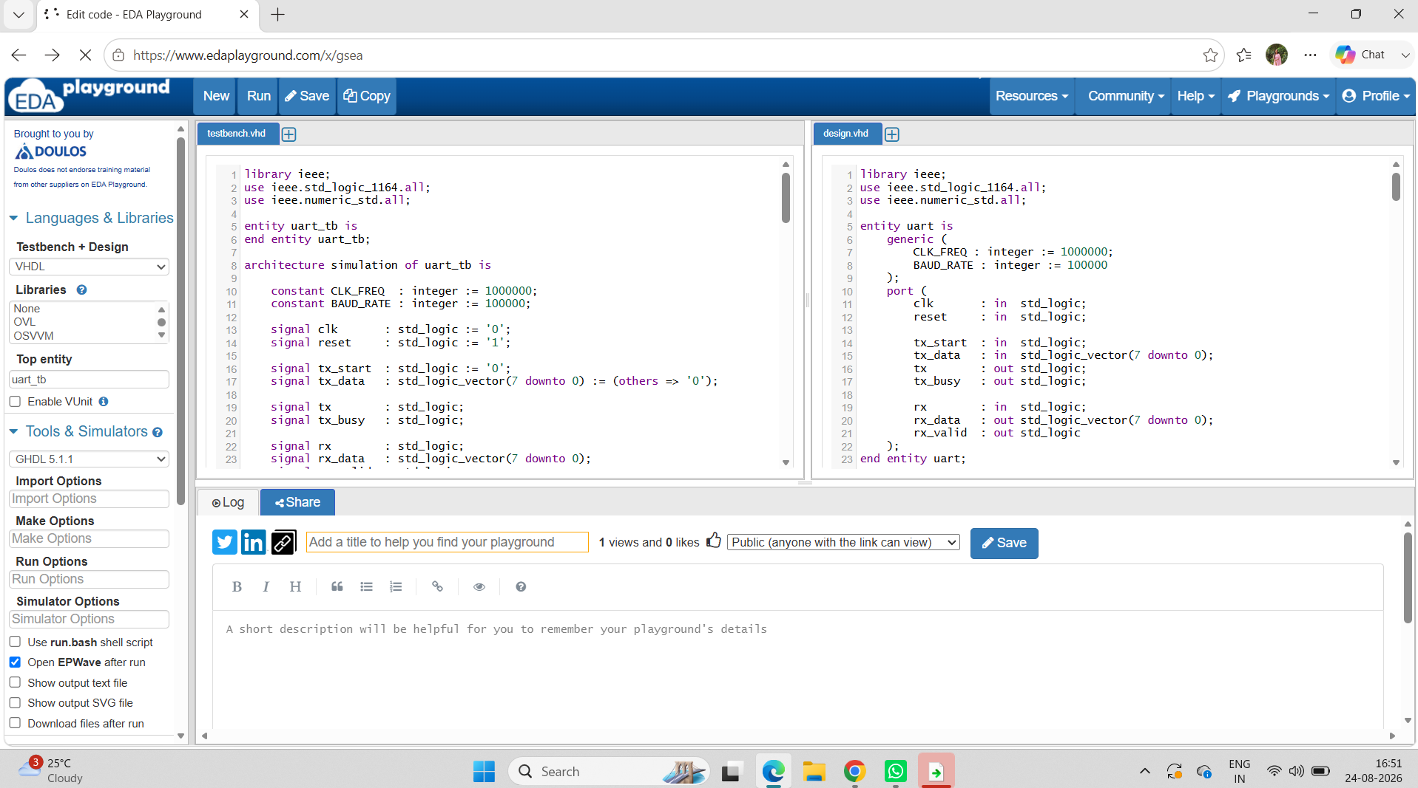

Figure 2. EPWave UART simulation waveform
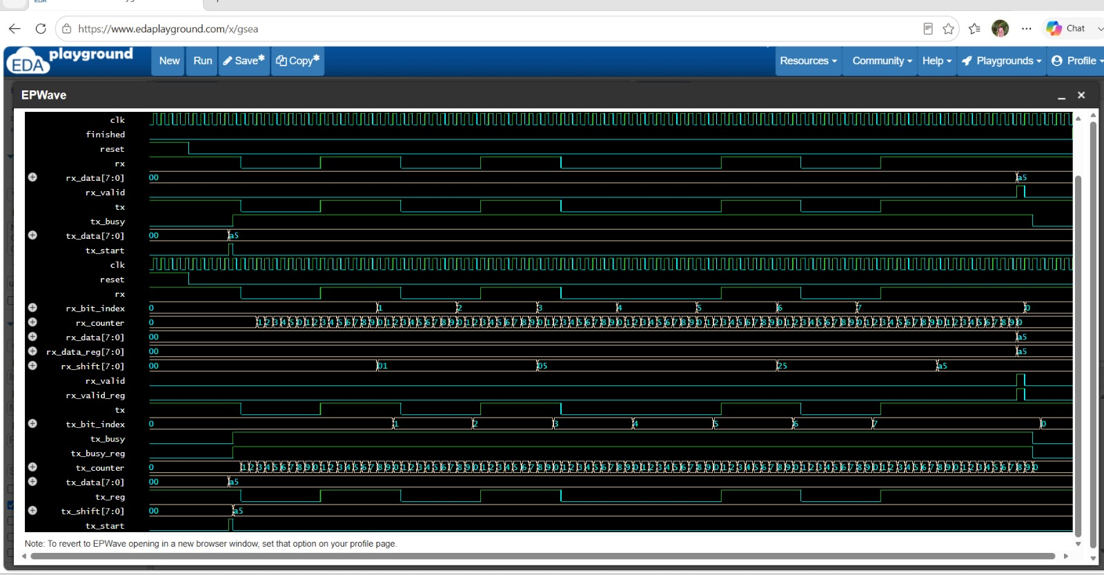

8. Key Observations
- Clock and reset signals operate correctly.
- tx_start initiates the UART transmission.
- tx_busy remains active during the transfer.
- tx_data shows the hexadecimal value A5.
- The serial TX waveform contains the UART frame.
- The receiver samples the incoming RX waveform.
- rx_data reconstructs A5.
- rx_valid indicates that the received byte is valid.
- Internal counters and shift registers demonstrate bit-by-bit operation.

9. Conclusion
The UART protocol was successfully designed and simulated in VHDL. The transmitter and receiver were verified using a dedicated testbench, and EPWave confirmed correct serial communication. The successful transfer and reception of the A5 test byte demonstrates that the UART design operates as intended. The project provided practical experience in VHDL, finite-state machines, timing counters, serial communication and waveform analysis.

10. Tools and Technologies
- VHDL
- EDA Playground
- GHDL
- EPWave
- Finite State Machines
- Counters and Shift Registers

11. EDA Playground Project Link
https://www.edaplayground.com/x/J66T

12. Recommended GitHub Contents
- design.vhd
- testbench.vhd
- simulation_waveform.png
- README.md

13. VHDL Design Code
The following is the UART design code used for the project. It implements both the transmitter and receiver using finite-state machines, counters and shift registers.
library ieee;
use ieee.std_logic_1164.all;
use ieee.numeric_std.all;
entity uart is
generic (
CLK_FREQ : integer := 1000000;
BAUD_RATE : integer := 100000
);
port (
clk : in std_logic;
reset : in std_logic;
tx_start : in std_logic;
tx_data : in std_logic_vector(7 downto 0);
tx : out std_logic;
tx_busy : out std_logic;
rx : in std_logic;
rx_data : out std_logic_vector(7 downto 0);
rx_valid : out std_logic
);
end entity uart;
architecture rtl of uart is
constant BIT_CYCLES : integer := CLK_FREQ / BAUD_RATE;
type tx_state_type is (
TX_IDLE_STATE, TX_START_STATE, TX_DATA_STATE, TX_STOP_STATE
);
type rx_state_type is (
RX_IDLE_STATE, RX_START_STATE, RX_DATA_STATE, RX_STOP_STATE
);
signal tx_state : tx_state_type := TX_IDLE_STATE;
signal rx_state : rx_state_type := RX_IDLE_STATE;
signal tx_counter : integer range 0 to BIT_CYCLES := 0;
signal rx_counter : integer range 0 to BIT_CYCLES := 0;
signal tx_bit_index : integer range 0 to 7 := 0;
signal rx_bit_index : integer range 0 to 7 := 0;
signal tx_shift : std_logic_vector(7 downto 0) := (others => '0');
signal rx_shift : std_logic_vector(7 downto 0) := (others => '0');
signal tx_reg : std_logic := '1';
signal tx_busy_reg : std_logic := '0';
signal rx_data_reg : std_logic_vector(7 downto 0) := (others => '0');
signal rx_valid_reg : std_logic := '0';
begin
tx <= tx_reg;
tx_busy <= tx_busy_reg;
rx_data <= rx_data_reg;
rx_valid <= rx_valid_reg;
tx_process : process(clk)
begin
if rising_edge(clk) then
if reset = '1' then
tx_state <= TX_IDLE_STATE;
tx_counter <= 0;
tx_bit_index <= 0;
tx_shift <= (others => '0');
tx_reg <= '1';
tx_busy_reg <= '0';
else
case tx_state is
when TX_IDLE_STATE =>
tx_reg <= '1';
tx_busy_reg <= '0';
tx_counter <= 0;
tx_bit_index <= 0;
if tx_start = '1' then
tx_shift <= tx_data;
tx_busy_reg <= '1';
tx_state <= TX_START_STATE;
end if;
when TX_START_STATE =>
tx_reg <= '0';
if tx_counter = BIT_CYCLES - 1 then
tx_counter <= 0;
tx_bit_index <= 0;
tx_state <= TX_DATA_STATE;
else
tx_counter <= tx_counter + 1;
end if;
when TX_DATA_STATE =>
tx_reg <= tx_shift(tx_bit_index);
if tx_counter = BIT_CYCLES - 1 then
tx_counter <= 0;
if tx_bit_index = 7 then
tx_state <= TX_STOP_STATE;
else
tx_bit_index <= tx_bit_index + 1;
end if;
else
tx_counter <= tx_counter + 1;
end if;
when TX_STOP_STATE =>
tx_reg <= '1';
if tx_counter = BIT_CYCLES - 1 then
tx_counter <= 0;
tx_busy_reg <= '0';
tx_state <= TX_IDLE_STATE;
else
tx_counter <= tx_counter + 1;
end if;
end case;
end if;
end if;
end process;
rx_process : process(clk)
begin
if rising_edge(clk) then
if reset = '1' then
rx_state <= RX_IDLE_STATE;
rx_counter <= 0;
rx_bit_index <= 0;
rx_shift <= (others => '0');
rx_data_reg <= (others => '0');
rx_valid_reg <= '0';
else
rx_valid_reg <= '0';
case rx_state is
when RX_IDLE_STATE =>
rx_counter <= 0;
rx_bit_index <= 0;
if rx = '0' then
rx_state <= RX_START_STATE;
end if;
when RX_START_STATE =>
if rx_counter = (BIT_CYCLES / 2) then
if rx = '0' then
rx_counter <= 0;
rx_bit_index <= 0;
rx_state <= RX_DATA_STATE;
else
rx_state <= RX_IDLE_STATE;
end if;
else
rx_counter <= rx_counter + 1;
end if;
when RX_DATA_STATE =>
if rx_counter = BIT_CYCLES - 1 then
rx_counter <= 0;
rx_shift(rx_bit_index) <= rx;
if rx_bit_index = 7 then
rx_state <= RX_STOP_STATE;
else
rx_bit_index <= rx_bit_index + 1;
end if;
else
rx_counter <= rx_counter + 1;
end if;
when RX_STOP_STATE =>
if rx_counter = BIT_CYCLES - 1 then
rx_counter <= 0;
rx_data_reg <= rx_shift;
rx_valid_reg <= '1';
rx_state <= RX_IDLE_STATE;
else
rx_counter <= rx_counter + 1;
end if;
end case;
end if;
end if;
end process;
end architecture rtl;

14. VHDL Testbench Code
The testbench generates the clock and reset, performs a TX-to-RX loopback, transmits hexadecimal A5, and verifies the received value with assertions.
library ieee;
use ieee.std_logic_1164.all;
use ieee.numeric_std.all;
entity uart_tb is
end entity uart_tb;
architecture simulation of uart_tb is
constant CLK_FREQ : integer := 1000000;
constant BAUD_RATE : integer := 100000;
signal clk : std_logic := '0';
signal reset : std_logic := '1';
signal tx_start : std_logic := '0';
signal tx_data : std_logic_vector(7 downto 0) := (others => '0');
signal tx : std_logic;
signal tx_busy : std_logic;
signal rx : std_logic;
signal rx_data : std_logic_vector(7 downto 0);
signal rx_valid : std_logic;
signal finished : boolean := false;
begin
clock_process : process
begin
while not finished loop
clk <= '0';
wait for 500 ns;
clk <= '1';
wait for 500 ns;
end loop;
wait;
end process;
rx <= tx;
DUT : entity work.uart
generic map (
CLK_FREQ => CLK_FREQ,
BAUD_RATE => BAUD_RATE
)
port map (
clk => clk,
reset => reset,
tx_start => tx_start,
tx_data => tx_data,
tx => tx,
tx_busy => tx_busy,
rx => rx,
rx_data => rx_data,
rx_valid => rx_valid
);
test_process : process
begin
reset <= '1';
wait for 5 us;
reset <= '0';
wait for 5 us;
tx_data <= x"A5";
tx_start <= '1';
wait until rising_edge(clk);
tx_start <= '0';
wait until tx_busy = '0';
wait for 5 us;
assert rx_valid = '1'
report "ERROR: RX valid signal was not detected."
severity error;
assert rx_data = x"A5"
report "ERROR: Received data is incorrect."
severity error;
report "SUCCESS: UART transmitted and received 0xA5 correctly."
severity note;
finished <= true;
wait;
end process;
end architecture simulation;

