Jira Lab Experiments Report (Experiments 1, 9, 11, 12 & 13)

Experiment 1
Description: Create a Kanban Board to Visualize the Tasks.
Aim: To create a Kanban board with To Do, In Progress and Done columns and simulate workflow.

Procedure / Steps
- Open Jira and create a Kanban project.
- Create To Do, In Progress and Done columns.
- Add at least five tasks.
- Move tasks across the columns.
- Capture the board screenshot.

Output
Kanban board created successfully with tasks moving across workflow.

Screenshot
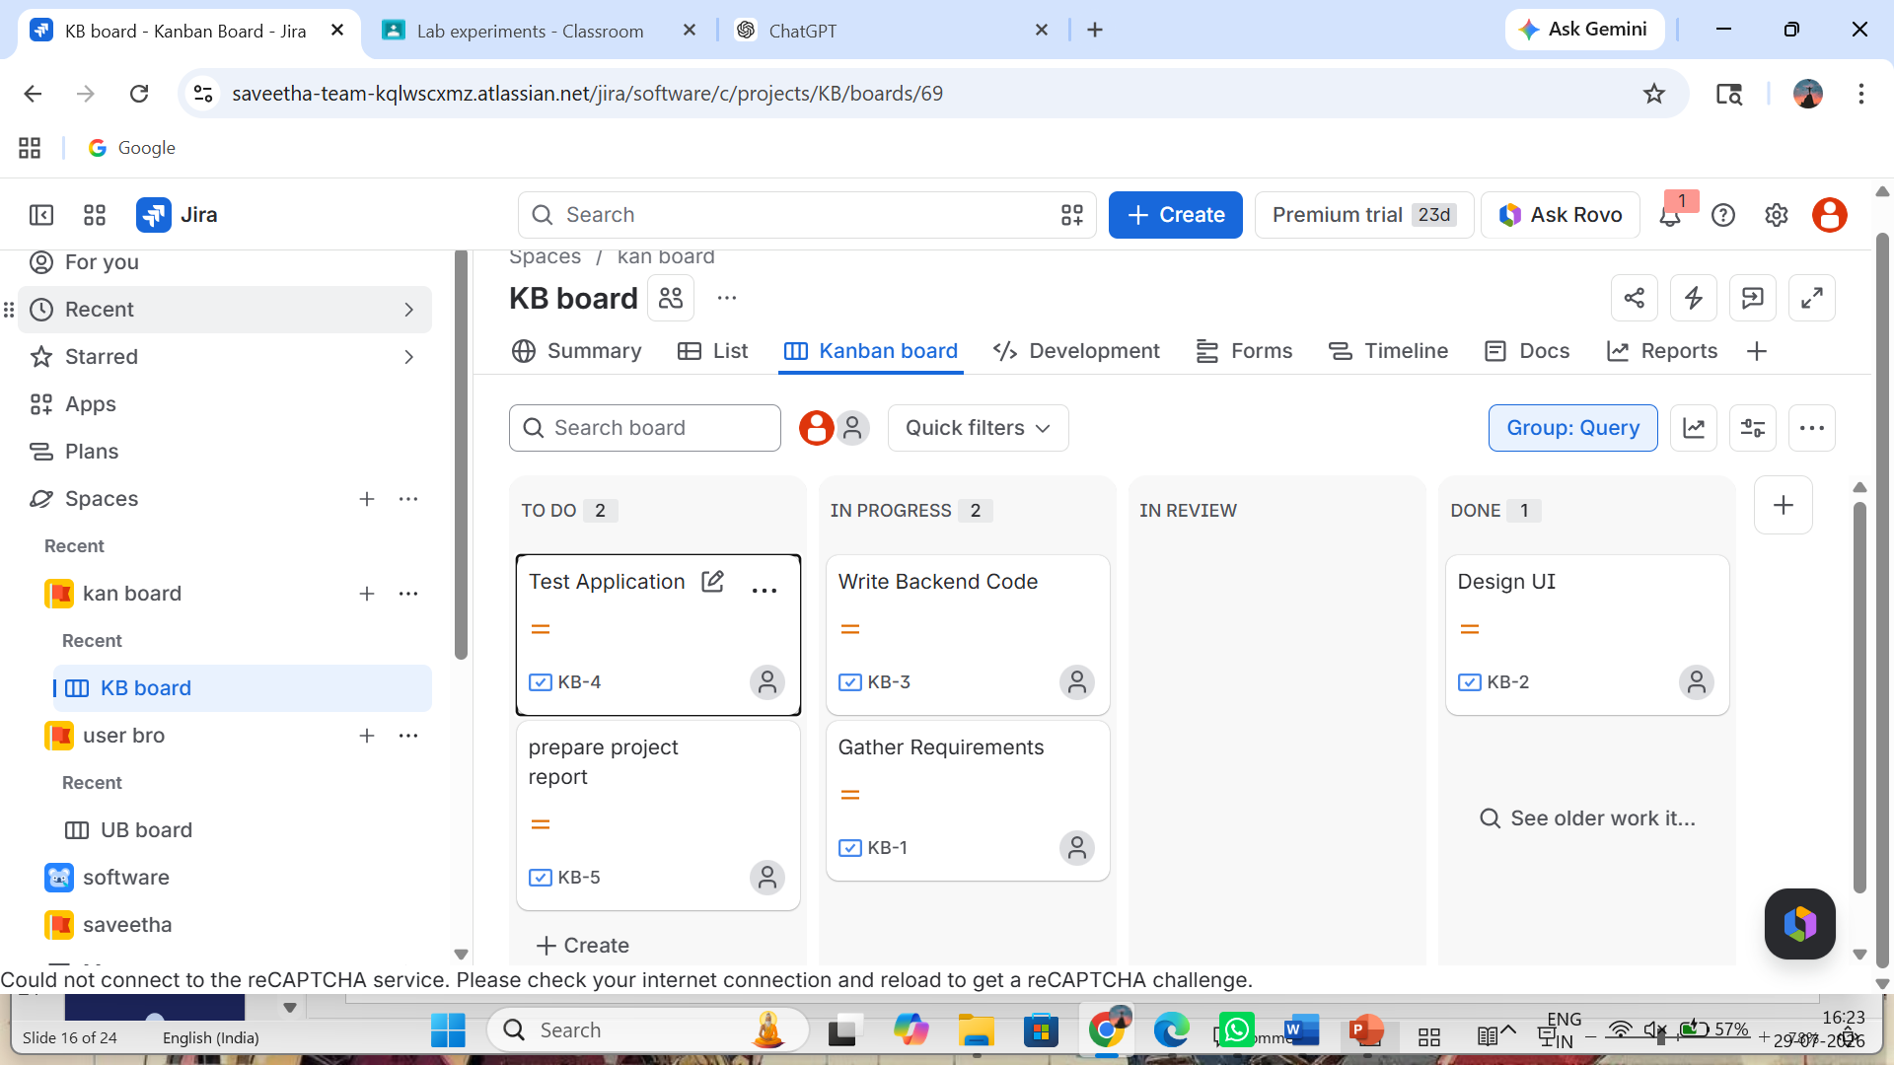

Experiment 9
Description: Create a Scrum Project in Jira.
Aim: To create a Scrum project with backlog and sprint management.

Procedure / Steps
- Create a Scrum project.
- Add five backlog items.
- Prioritize backlog.
- Create a 1-week sprint.
- Start the sprint and move backlog items.
- Capture screenshots at the start and end of the sprint.

Output
Scrum sprint created and executed successfully.

Screenshot

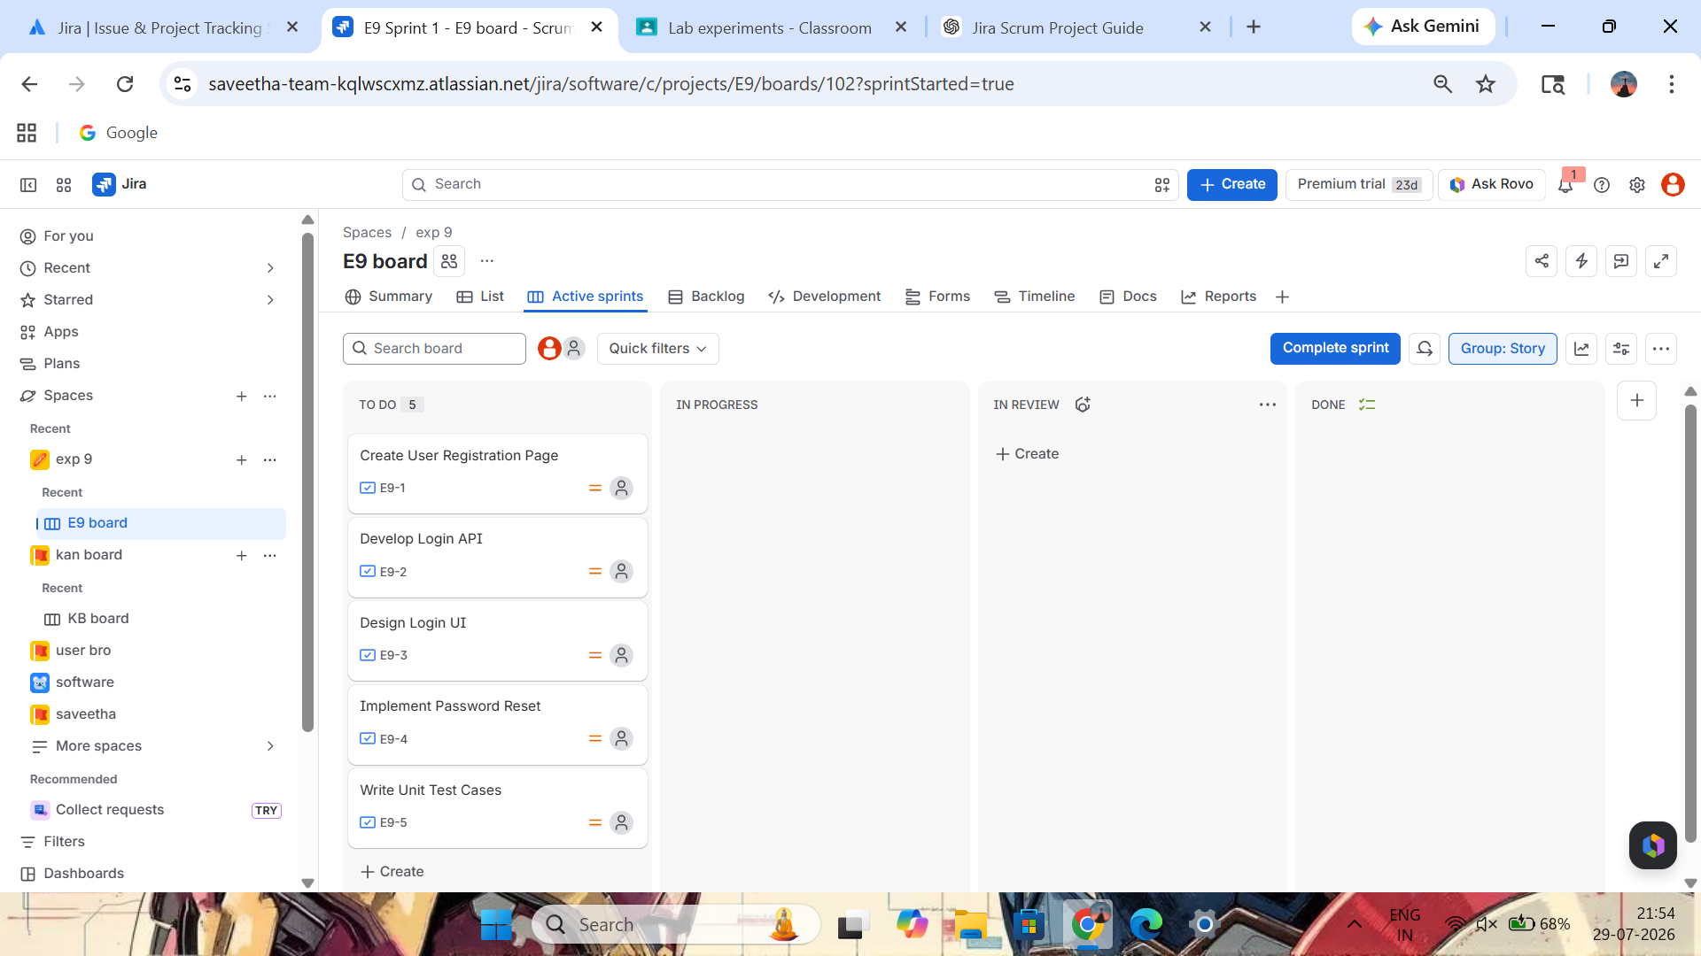

Experiment 11
Description: Link Jira Tasks with Confluence.
Aim: To integrate Jira issues with Confluence for project tracking.

Procedure / Steps
- Create a Confluence page.
- Insert Jira Issues macro.
- Embed five Jira issues.
- Add sprint progress section.
- Capture the Confluence page.

Output
Jira issues successfully linked with Confluence.

Screenshot
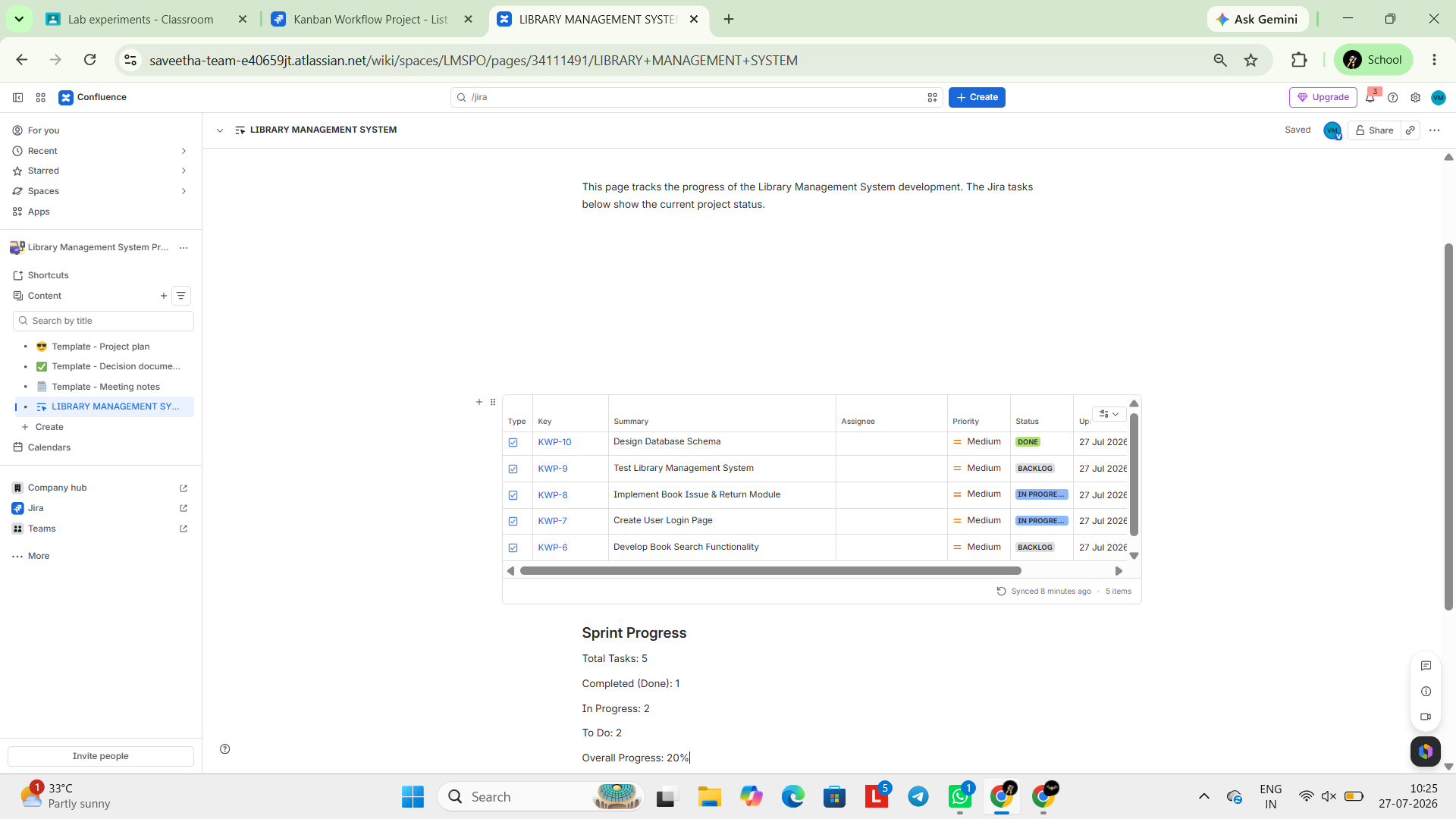

Experiment 12
Description: Task Management System Prioritization.
Aim: To prioritize requirements using MoSCoW and Kano models.

Procedure / Steps
- Create project.
- Add requirements.
- Assign MoSCoW priorities.
- Assign Kano categories.
- Capture the board.

Output
Requirements prioritized successfully.

Screenshot
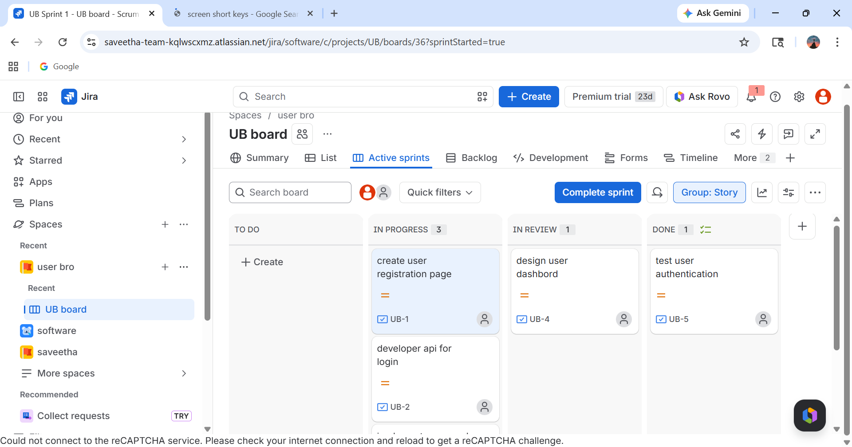

Experiment 13
Description: Online Learning Platform Prioritization.
Aim: To categorize and prioritize requirements using MoSCoW and Kano models.

Procedure / Steps
- Create project.
- Add six requirements.
- Apply MoSCoW labels.
- Apply Kano categories.
- Filter using labels.
- Capture the board.

Output
Requirements categorized successfully.

Screenshot
