CUSTOMER TABLE

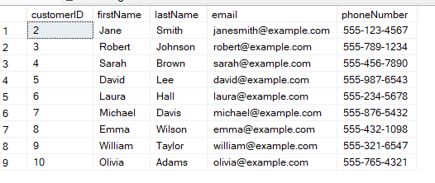

VEHICLE TABLE

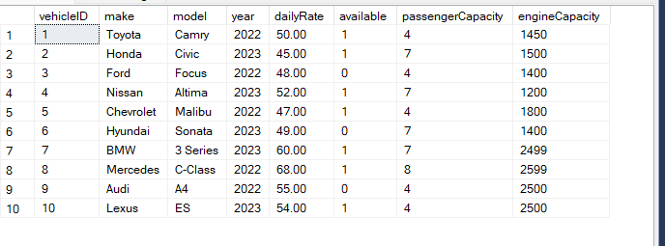

LEASE TABLE

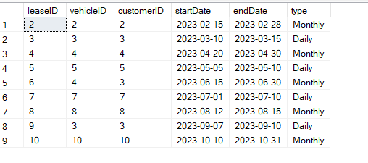

PAYMENT TABLE

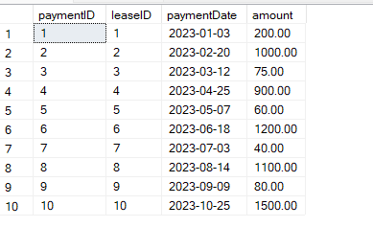

QUERY_1

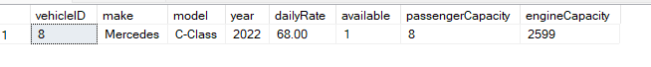

QUERY_2

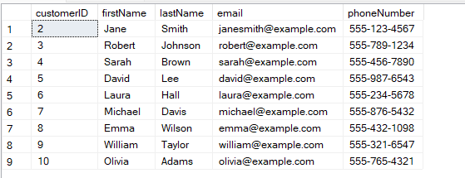

QUERY_3

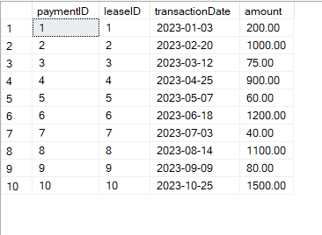

QUERY_4

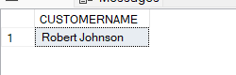

QUERY_5

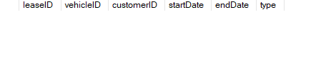

QUERY_6



QUERY_7



QUERY_8



QUERY_9

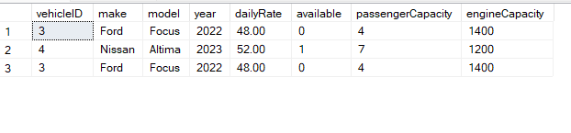

QUERY_10

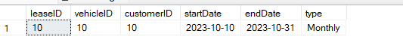

QUERY_11

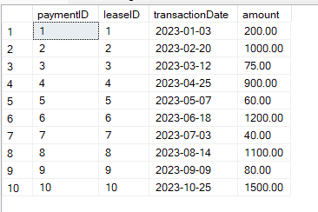

QUERY_12

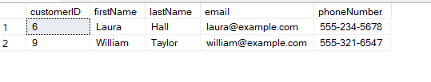

QUERY_13

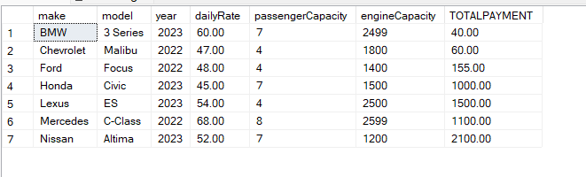

QUERY_14

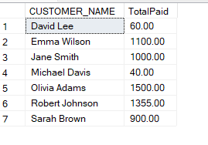

QUERY_15

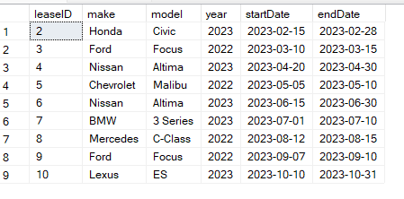

QUERY_16

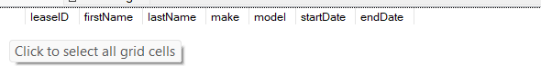

QUERY_17

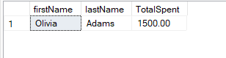

QUERY_18

