 PUBLIC TRANSPORT OPTIMISATION 

**PROJECT REPORT**

**Submitted by**

**DEEPALAKSHMI S 811221106005**

**JAYA KAMAKSHERADHA S P 811221106012**

**PARKAVI S 811221106022**

**THRISHA S 811221106034**

**BACHELOR OF ENGINEERING**

**IN**

**ELECTRONICS AND COMUNICATION ENGINEERING**

**INDRA GANESAN COLLEGE OF ENGINEERING,TRICHY**

**NAAN MUDHALVAN**

ABSTRACT

With the expansion of bus transit plays an increasing important role in urban transportation reasonable network design is of great important to the operation of bus transit system, while irrational layout of bus routes leads to the poor operation and a low service quality of bus transit system for example much overlapping amount routes would lead to the traffic jam and low network density reveals the low accessibility of bus in areas without routes passing by .Now a days factors for bus network planning become more complex with the construction of rail transmit the integration of the bus and rail network is a new challenge in transit planing. Based on passenger travel impedance travel path probability and passenger travel demand the links are weight and the network efficiency as the objective function. In order to verify the effectiveness of the model and the solution method .the efficiency of the optimized network is 8.5% higher than of the original network. Generalized cost is used to comprehensively consider the impedance of bus travel from the origin and destination of various main factors. Generalized travel cost=waiting time +in vehicle time+transfer time. It is necessary to further expolre the impact of different transfer modes on the networkThe objective of this research is to optimize the layout of the bus routes in using a GIS based platform "transit net" to alleviate or slave the problem exposed from the layout of current existing the network coverage, and reducing the burden of main road this research has employed a method for multi modal transit design based on stop ,which treals certain rail routes

LITERATURE REVIEW

1)Research On Optimization Of Urban “Public Transport Network” Based On Complex Network Theory

By “Zhongylin” & “Yang Cao”(2021) **.**

**ABSTRACT :**

Objective is to calculate the probability of passengers choosing different routes in the public transit network according to passenger travel impedance . The technique used is complex network theory and the symmetry of the up and down bus routes and station to establish an urban public transit network model . Passenger travel impedance ,travel path probability and passenger travel demandare the various metrics used.

**Limitations :**

Passenger travel impedance only considers time cost without considering money cost and comfort . Only pedestrian transfer is considered.

2)Optimization of “urban public transportation” considering the model fleet size: A case study from Palestine

By “Abdullah Abuaisha” & “Sameer abu-eisheh” (2023).

**ABSTRACT :**

Objective is to determine the optimal numbers of public transportation trips and vehicles by mode ,required to meet the expected passenger demand . The optimal combination of different vehicle classes and the number of trips are determined. Passenger demand , Initial cycle time ,capacity , optimal number of trips for each vehicle classes are determined .

**Limitations :**

The model could also be improved by minimizing the total system costs by including user costs ;such as carbon footprint in the objective function in additional to the operational costs .

3)Travel times transfers in public transport :comprehensive accessibility analysis based on pareto-optimal journeys

By “Rainer Kujala”(2017).

**ABSTRACT :**

Objective is to develop efficient public transport network planning and management.Fastest-path temporal distance profiles and computation of pareto-optimal journeys are determined. Waiting time to departure ,journey duration and the number of required transfers are some of the important parameters .

**Limitation:**

Could be improved by giving certain wait to the pre-journey waiting time based on user preferences.

4)Discussion on optimization of public transportation network setting considering three-state reliability

By “Zhang Xiaoliang”(2021).

**ABSTRACT**:

The transit network is abstracted into series-parallel system and parallel-series system model from the three states of normal , short circuited and open circuited failure. Road network reliability ,network connectivity , reliability of running time, evaluation indexes of bus operation reliability and so forth are very important.

**Limitation:**  Improvement should be made based on the actual road network foundation conditions, road operation conditions, transportation capacity of the actual line operation enterprises.

PROBLEM IDENTIFICATION:

In the daily operation of bus transport systems mainly that of buses, the movement of vehicles is affected by different. Uncertain conditions as the day progresses , such as;

* Traffic congestion
* Unexpected delays
* Vehicle dispatching times
* Other incidents

Many students are late for classes because they decide to wait for the bus instead of just simply using a alternate transportation.

PROPOSED WORK :

CONTROLLER:

Tracking unit inside bus that request position data and processing using IOT and displaying the current location of the bus.

INPUT PARAMETER:

Position data processing by tracking device IOT(ESP32).

OUTPUT PARAMETER:

IOT processed data gives Current location of the bus with ETA.

EXECUTE BLOCK DIAGRAM:

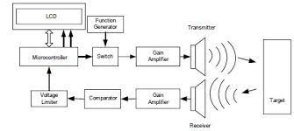

FLOW DIAGRAM**:**

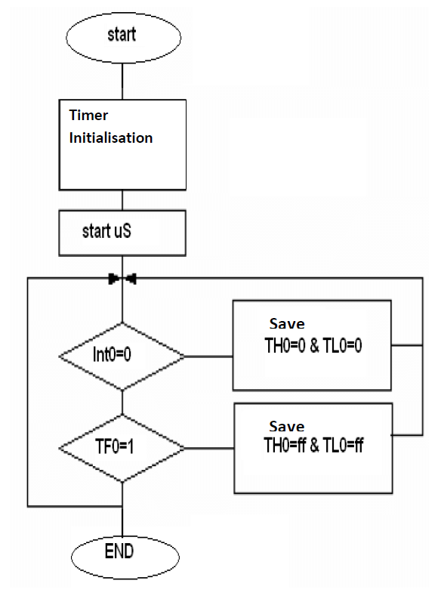

HARDWARECOMPONENTS

* ESP32 – Wifi and Bluetooth enabled microcontroller
* Standard 5mm LED
* Connecting wires
* HC-SR04 Ultrasonic Distance sensor

SOFTWARE COMPONENTS

* Wokwi

CIRCUIT DIAGRAM

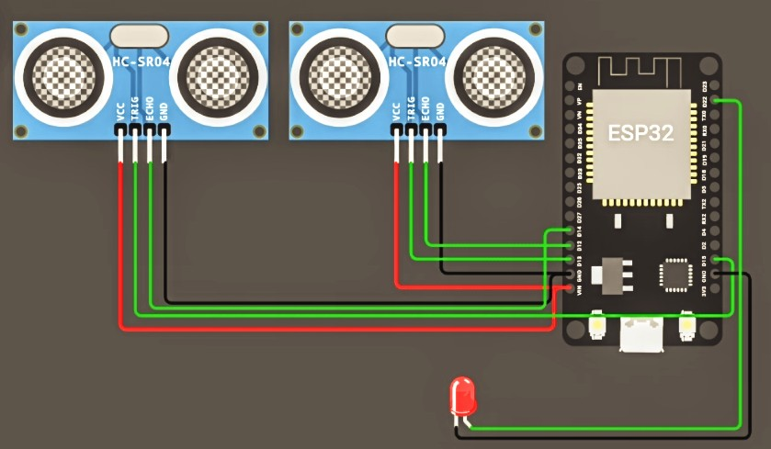

DESCRIPTION

To start a new distance measurement set the TRIG pin to high for 10us or more. When ECHO pin goes high, count the time it stays high (pulse length).

ECHO high pulse is proportional to distance.

Centimeters - Pulse Micros/58

Inches - Pulse Micros/148

PROGRAM

#define BLYNK_TEMPLATE_ID "TMPL26V4fGv5q"

#define BLYNK_TEMPLATE_NAME "Test"

#define BLYNK_AUTH_TOKEN "XEHxNF_Ur1Nt2p7wB5B20dNI1ZUwj34P"

#include<WiFi.h>

#include<WiFiClient.h>

#include<BlynkSimpleEsp32.h>

int duration1 = 0;

int distance1 = 0;

int duration2 = 0;

int distance2 = 0;

int dis1 = 0;

int dis2 = 0;

int dis_new1 = 0;

int dis_new2 = 0;

int entered = 0;

int left = 0;

int inside = 0;

#define LED 2

#define PIN_TRIG1 15

#define PIN_ECHO1 14

#define PIN_TRIG2 13

#define PIN_ECHO2 12

BlynkTimer timer;

charauth[] = BLYNK_AUTH_TOKEN;

charssid[] = "Wokwi-GUEST";   // your network SSID (name)

char pass[] = "";

#define BLYNK_PRINT **Serial**

long get_distance1() {

  // Start a new measurement:

  digitalWrite(PIN_TRIG1, HIGH);

  delayMicroseconds(10);

  digitalWrite(PIN_TRIG1, LOW);

  // Read the result:

  duration1 = pulseIn(PIN_ECHO1, HIGH);

  distance1 = duration1 / 58;

  return distance1;

}

long get_distance2() {

  // Start a new measurement:

  digitalWrite(PIN_TRIG2, HIGH);

  delayMicroseconds(10);

  digitalWrite(PIN_TRIG2, LOW);

  // Read the result:

  duration2 = pulseIn(PIN_ECHO2, HIGH);

  distance2 = duration2 / 58;

  return distance2;

}

voidmyTimer() {

**Serial**.println("100");

  dis_new1 = get_distance1();

  dis_new2 = get_distance2();

  if (dis1 != dis_new1 || dis2 != dis_new2){

**Serial**.println("200");

    if (dis1 < dis2){

**Serial**.println("Enter loop");

      entered = entered + 1;

      inside = inside + 1;

      digitalWrite(LED, HIGH);

      Blynk.virtualWrite(V0, entered);

      Blynk.virtualWrite(V2, inside);

      dis1 = dis_new1;

      delay(1000);

      digitalWrite(LED, LOW);

    }

    if (dis1 > dis2){

**Serial**.println("Leave loop");

      left = left + 1;

      inside = inside - 1;

      Blynk.virtualWrite(V1, left);

      Blynk.virtualWrite(V2, inside);

      dis2 = dis_new2;

      delay(1000);

    }

  }

}

 voidsetup() {

**Serial**.begin(115200);

  pinMode(LED, OUTPUT);

  pinMode(PIN_TRIG1, OUTPUT);

  pinMode(PIN_ECHO1, INPUT);

  pinMode(PIN_TRIG2, OUTPUT);

  pinMode(PIN_ECHO2, INPUT);

  Blynk.begin(auth, ssid, pass, "blynk.cloud", 8080);

  timer.setInterval(1000L, myTimer);

}

voidloop() {

  Blynk.run();

  timer.run();

}

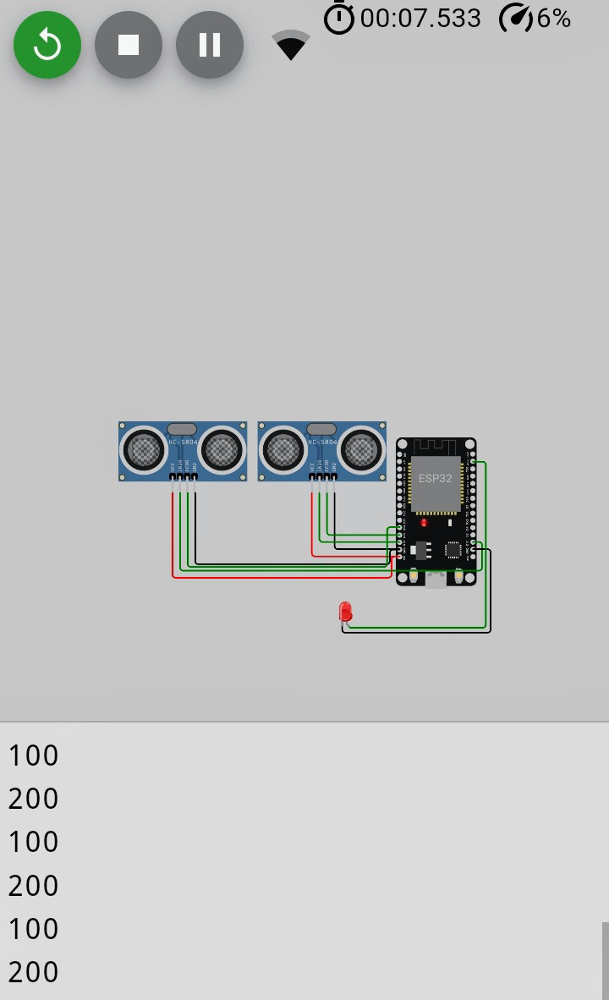OUTPUT:

CONCLUSION

In this project public transport optimisation has been achieved using Ultrasonic distance sensors. Public transport optimisationis important in improving the accessibility and efficiency of transport facilities. It plays a key role in time management and conservation which is very crucial in today’s society.

FUTURE SCOPE

Accuracy can be improved further by adding location information from satellite system through GPS and GSM modules.

REFERENCE

1. Research On Optimization Of Urban “Public Transport Network” Based On Complex Network Theory - By “Zhongylin” & “Yang Cao”(2021) .
2. Optimization of “urban public transportation” considering the model fleet size :A case study from Palestine - By “Abdullah Abuaisha” & “Sameer abu-eisheh” (2023).
3. Travel times transfers in public transport :comprehensive accessibility analysis based on pareto-optimal journeys -By “Rainer Kujala”(2017)
4. Discussion on optimization of public transportation network setting considering three-state reliability - By “Zhang Xiaoliang”(2021).