//size of array

#include <stdio.h>

int main()

{

int a[]={10,78,80};

int size = sizeof(a)/sizeof(a[0]);

printf("%d",size);

return 0;

}

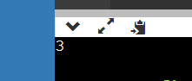

//print and display the 1D array

#include <stdio.h>

int main()

{

int n,i;

printf("enter size ");

scanf("%d",&n);

int a[n];

printf("enter the elements");

for(i=0;i<n;i++)

scanf("%d",&a[i]);

printf("elements are ");

for(i=0;i<n;i++)

printf("%d ",a[i]);

// int size = sizeof(a)/sizeof(a[0]);

// printf("%d",size);

return 0;

}

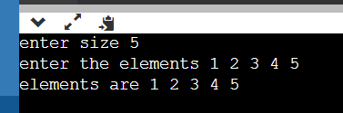

//reversing the array

#include <stdio.h>

int main()

{

int n,i,temp,j;

printf("enter size ");

scanf("%d",&n);

int a[n];

printf("enter the elements");

for(i=0;i<n;i++)

scanf("%d",&a[i]);

// a[i]=a[0];

// a[j]=a[n-1];

for(i=0, j=n-1;i<n/2;i++,j--)

{

temp=a[i];

a[i]=a[j];

a[j]=temp;

a[i]=(a[i]+a[j])- (a[j]=a[i]);

}

printf("elements are ");

for(i=0;i<n;i++)

printf("%d ",a[i]);

return 0;

}

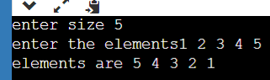

//swaping 2 values in single line of code

#include <stdio.h>

int main()

{

int x=10,y=20;

**x=(x+y)-(y=x);**

printf("%d %d",x,y);

return 0;}

linear search

#include <stdio.h>

#include<stdlib.h>

int main()

{

int n,ele;

scanf("%d",&n);

int a[n];

for(int i=0;i<n;i++)

{

scanf("%d",&a[i]);

}

printf("enter the element to be searched");\

scanf("%d",&ele);

for(int i=0;i<n;i++)

{

if(ele==a[i])

{

printf("element fouend");

exit(0);

}

}

printf("not found");

}

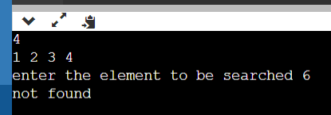

//frequency of number

#include <stdio.h>

int main()

{

int n,ele,c=0;

scanf("%d",&n);

int a[n];

for(int i=0;i<n;i++)

{

scanf("%d",&a[i]);

}

printf("enter the element to be searched");\

scanf("%d",&ele);

for(int i=0;i<n;i++)

{

if(ele==a[i])

{

c=c+1;

}

}

printf("frequency=%d",c);

}

