//students details

#include<stdio.h>

void main()

{

int rollno,pmarks,cmarks,camarks,total;

float avg;

char division;

char name[20];

printf("enter the name: \n");

scanf("%s",name);

printf("enter the roll no:\n");

scanf("%d",&rollno);

printf("enter the marks of physics,chemistry,computer application:\n");

scanf("%d%d%d",&pmarks,&cmarks,&camarks);

total=pmarks+cmarks+camarks;

avg=total/3.0;

printf("Roll No:%d\n",rollno);

printf("Name of Student:%s\n",name);

printf("Marks in physics:\n%d",pmarks);

printf("Marks in chemistry:%d\n",cmarks);

printf("Marks in computer Application:%d\n",camarks);

printf("Total:%d\n",total);

printf("Percentage:%2.f\n",avg);

if(avg>80)

printf("Division:first\n");

else if(avg>60)

printf("Division:second");

else if(avg>40)

printf("Division:third");

else

printf("No Division");

}

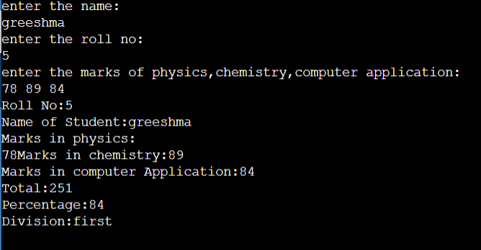

//temperature

#include<stdio.h>

void main()

{

float temp;

printf("enter the temperature\n");

scanf("%f",&temp);

if(temp>=40)

printf("Its very hot");

else if(temp>30)

printf("Its hot");

else if(temp>20)

printf("noraml temperature ");

else if(temp>10)

printf("cold weather");

else if(temp>0)

printf("very cold weather");

else if (temp<=0)

printf("frezzing weather");

}

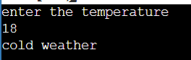

//triangle

#include<stdio.h>

void main()

{

int a,b,c;

printf("enter the 3 side of triangle\n");

scanf("%d %d %d",&a,&b,&c);

if(a==b&&b==c)

printf("Equilateral trinagle");

else if ((a==b&&b!=c)||(a!=b&&b==c))

printf("Isosceles trinagle");

else

printf("Scalene");

}

