#include <stdio.h>

void main()

{

int digit;

printf("enter the Digit(0-9) : ");

scanf("%d",&digit);

switch(digit)

{

case 0:printf("Zero\n");

break;

case 1:printf("one\n");

break;

case 2:printf("Two\n");

break;

case 3:printf("Three\n");

break;

case 4:printf("Four\n");

break;

case 5:printf("Five\n");

break;

case 6:printf("Six\n");

break;

case 7:printf("Seven\n");

break;

case 8:printf("Eight\n");

break;

case 9:printf("Nine\n");

break;

default:printf("invalid digit. \n");

}

}

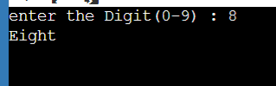

#include <stdio.h>

void main()

{

int month;

printf("enter Month No : ");

scanf("%d",&month);

switch(month)

{

case 1:

case 3:

case 5:

case 7:

case 8:

case 10:

case 12:

printf("Month have 31 days. \n");

break;

case 2:

printf("Month have 28 days. \n");

printf("in leap year Month Have 29 days.\n");

break;

case 4:

case 6:

case 9:

case 11:

printf("Month have 30 days. \n");

break;

default:

printf("invalid Month number.\n");

break;

}

}

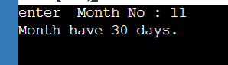

#include <stdio.h>

void main()

{

int i,n,a[100],sum=0;

float avg;

printf("enter number of elemnts : \n");

scanf("%d",&n);

printf("enter the numbers\n");

for(i=0;i<n;i++)

{

scanf("%d",&a[i]);

}

for (i=1;i<n;i++)

{

sum=sum+a[i];

}

avg=sum/n;

printf("The sum of no is : %d\nThe Average is : %f\n",sum,avg);

}

