#include <stdio.h>

int main()

{

int i,j,m,Count=0;

printf("\n Enter Number of elements in an array ");

scanf("%d", &m);

int a[m];

printf("\n enter the elements");

for (i=0;i<m;i++)

{

scanf("%d", &a[i]);

}

for (i=0;i<m;i++)

{

for(j=i+1;j<m;j++)

{

if(a[i] == a[j])

{

Count++;

break;

}

}

}

if(Count==0)

{

printf("no duplicate elemnets\n");

}

else {

printf("\n Total Number of Duplicate Elements in Array = %d ", Count);

}

return 0;

}

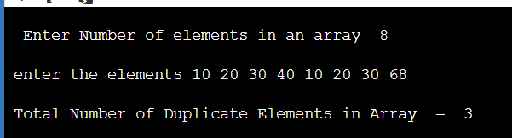

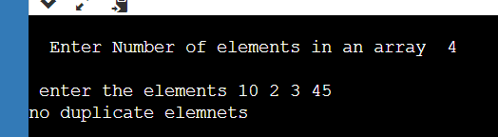

#include <stdio.h>

int main()

{

int i, j, Count, Size;

printf("Enter Number of elements in an array");

scanf("%d", &Size);

int a[Size],b[Size];

printf("\n Enter elements of an Array");

for (i = 0; i < Size; i++)

{

scanf("%d",&a[i]);

b[i] = -1;

}

for (i = 0; i < Size; i++)

{

Count = 1;

for(j = i + 1; j < Size; j++)

{

if(a[i] == a[j])

{

Count++;

b[j] = 0;

}

}

if(b[i]!= 0)

{

b[i] = Count;

}

}

printf("\n List of Unique Array Elemnts in this Array are : ");

for (i = 0; i < Size; i++)

{

if(b[i] == 1)

{

printf("%d\t", a[i]);

}

}

return 0;

}

