SOFTWARE ENGINEERING

NAME : B THRIVIKRAM
SRN : PES1UG24AM423
SECTION : H
LAB : 06

CODE COVERAGE
BEFORE
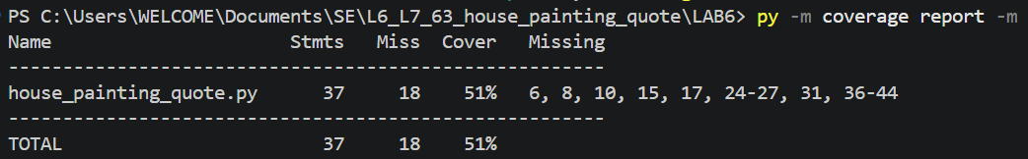

AFTER
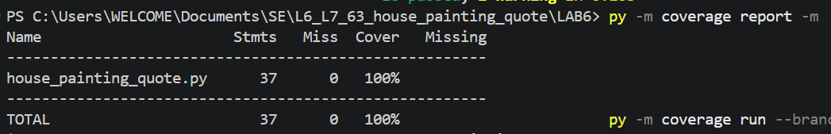

BRANCH COVERAGE
BEFORE
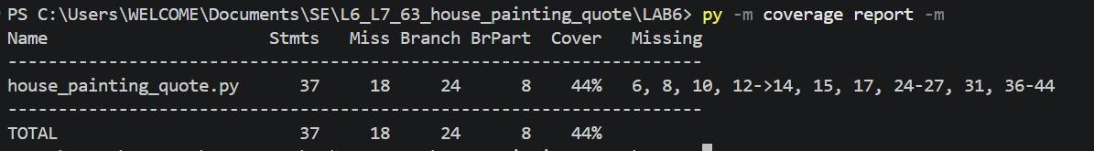

AFTER


