SOFTWARE ENGINEERING

NAME : B THRIVIKRAM
SRN : PES1UG24AM423
SECTION : H
LAB : 07

SS1
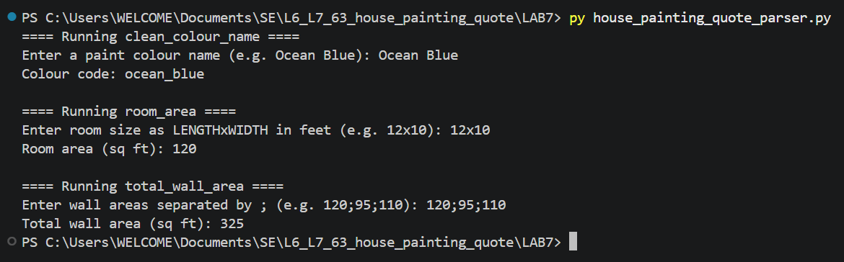

SS2
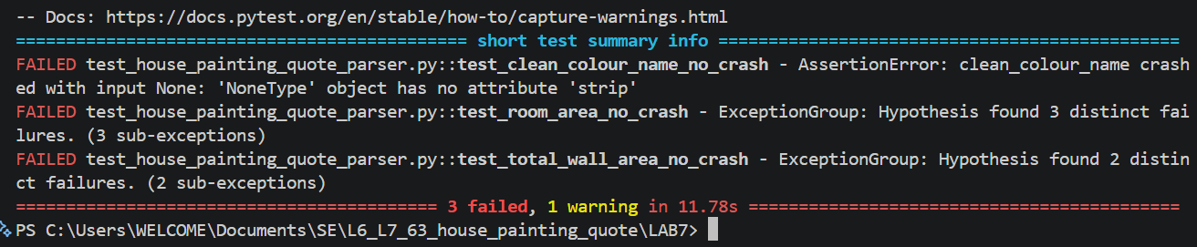

SS3
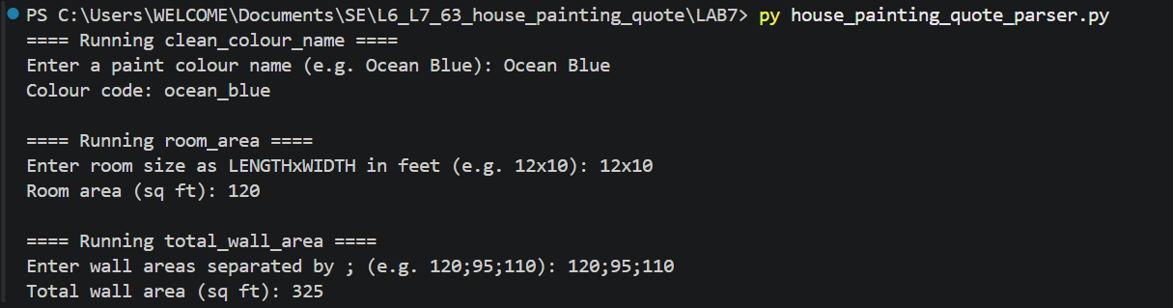

SS4


