Software Architecture and Design Specification
Project: Railway Reservation System
Field | Value
Project | Railway Reservation System
Version | 1.0
Authors | B Thrivikram,Mutturaj Angadi,Haneesh,Baby
Date | 12/10/2026
Status | Draft

Revision History
Version | Date | Author | Change Summary | Approval
1.0 | 12/10/2026 | B Thrivikram,Mutturaj Angadi,Haneesh,Baby | Initial project document | Approved

Approvals
Role | Name | Signature/Date
Project Guide / Instructor | Prof.Arpitha K | 12/10/2026
Team Lead | B Thrivikram | 12/10/2026

1. Introduction

1.1 Purpose
This document specifies the architecture and detailed design of the Railway Reservation System and provides the bridge between the SRS requirements and implementation modules.

1.2 Scope
The design covers passenger web interactions, authentication, train search, availability, booking/seat allocation, payment simulation, cancellation/refund, notifications, administration, audit logging, REST APIs, MySQL persistence, error handling and security.

1.3 Audience
Developers, QA engineers, project guide/instructor, evaluators and future maintainers.

1.4 Definitions
Term | Definition
Controller | REST endpoint layer responsible for request/response handling.
Service | Business-logic component implementing a domain operation.
Repository/DAO | Persistence component used to access MySQL.
PNR | Unique booking reference generated after successful reservation.
RBAC | Role-based access control for Passenger/Admin permissions.
ADR | Architecture Decision Record.
DTO | Data Transfer Object used for API payloads.

2. Document Overview

2.1 How to Use this Document
Use the SRS for what the system must do, this SAD for how the system is structured and designed, and the STP for how the implementation will be verified.

2.2 Related Documents
Railway Reservation System SRS v1.0; Railway Reservation System Software Test Plan v1.0; RTM contained in the SRS.

3. Architecture

3.1 Goals & Constraints
- Goals: modularity, maintainability, data integrity, secure authorization, predictable booking behavior and easy testing.
- Constraint: mini-project scope favors a modular monolith/layered architecture instead of distributed microservices.
- Constraint: MySQL is the system of record; payment and railway inventory are simulated/local to the project.
- Constraint: the application must be deployable and demonstrable using a normal development laptop.

3.2 Stakeholders & Concerns
Stakeholder | Primary Concerns
Passenger | Correct availability, simple booking, privacy, clear cancellation/refund information.
Administrator | Accurate master-data management, controlled access, auditability.
Developer | Separation of concerns, testability, maintainable modules.
QA / Evaluator | Traceable requirements, repeatable test cases, observable errors.
Project Guide / Instructor | Scope compliance, design quality, documentation completeness.

3.3 Component (UML) Diagram
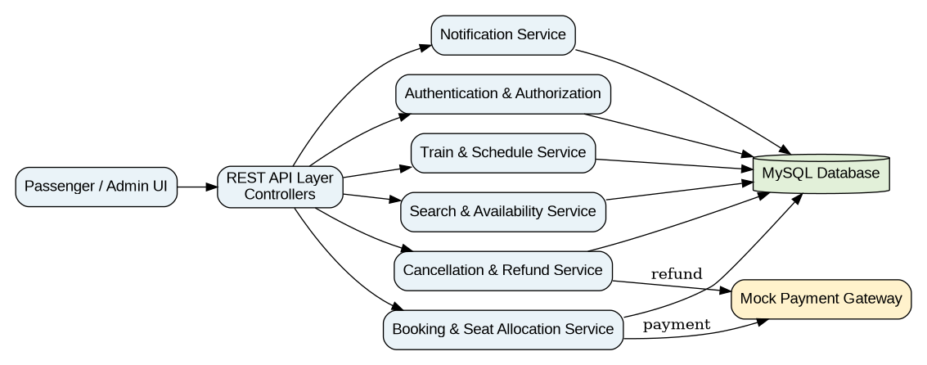
The system is designed as a layered modular monolith: Presentation/API → Business Services → Data Access → MySQL, with a mock payment interface and notification component.

3.4 Component Descriptions
Component | Responsibilities
Web UI | Search forms, authentication screens, train results, passenger details, booking/cancellation and admin screens.
API / Controllers | Validate request shape, authenticate requests, call services and return standardized HTTP/JSON responses.
Authentication & Authorization | Registration, password verification, session/token handling and Passenger/Admin RBAC.
Train & Schedule Service | Train master data, routes, stations, schedules, classes and admin schedule operations.
Search & Availability Service | Route/date search, fare display and current seat availability.
Booking & Seat Allocation Service | Passenger validation, fare confirmation, PNR creation, seat assignment and transactional booking.
Cancellation & Refund Service | Eligibility checks, cancellation state transition, seat release and refund calculation.
Notification Service | Generates confirmation/cancellation messages; on-screen notification is sufficient for the mini-project.
Admin Service | Train/schedule/fare/inventory management and booking lookup.
Audit Service | Optional internal logging support for security events; not a separate user-facing module.
MySQL Database | Persistent storage with primary/foreign keys, constraints and transaction support.
Payment Simulator | Returns configurable success/failure for payment/refund testing.

3.5 Chosen Architecture Pattern and Rationale
Layered modular-monolith architecture is selected. It separates UI/API, business logic and persistence while keeping deployment simple for a course project. A microservices architecture is not selected because independent deployment, service discovery, distributed transactions and operational overhead are unnecessary for the expected scale.

3.6 Technology Stack & Data Stores
Layer | Recommended Technology | Purpose
Frontend | React or HTML/CSS/JavaScript | Responsive passenger/admin UI.
Backend | Node.js + Express (or equivalent approved stack) | REST API and business logic.
Database | MySQL 8.x | Users, trains, schedules, seats, bookings, payments, cancellations, audit logs.
Authentication | Session or JWT + bcrypt/Argon2 | Secure account authentication.
API Testing | Postman | Manual API verification.
Version Control | Git/GitHub | Source control and collaboration.

3.7 Data Model / Main Entities
Entity | Key Fields / Relationships
User | user_id, name, email, mobile, password_hash, role, created_at; one user has many bookings.
Station | station_id, code, name, city.
Train | train_id, train_number, train_name, active.
Route/Stop | train_id, station_id, sequence_no, arrival_time, departure_time.
Schedule | schedule_id, train_id, journey_date, status.
Coach | coach_id, schedule_id, class_type, coach_number.
Seat | seat_id, coach_id, seat_number, berth_type, status.
Passenger | passenger_id, booking_id, name, age, gender.
Booking | booking_id, pnr, user_id, schedule_id, status, total_fare, created_at.
BookingSeat | booking_id, seat_id, passenger_id, allocation_status.
Payment | payment_id, booking_id, amount, status, reference, created_at.
Cancellation | cancellation_id, booking_id, cancelled_at, refund_amount, refund_status.
AuditLog | audit_id, actor_user_id, action, entity_type, entity_id, timestamp.

3.8 Risks & Mitigations
Risk | Mitigation
Concurrent booking causes duplicate seat allocation | Use DB transaction and unique constraint/locking around seat allocation.
Payment succeeds but booking save fails | Use transaction/state reconciliation and explicit pending/failed payment handling.
Unauthorized admin operation | RBAC middleware on every admin route plus server-side authorization.
Invalid/corrupt master data | Admin validation, FK constraints and deactivation rather than destructive deletion where referenced.
Network/API failure during booking | Return safe error; avoid consuming confirmed inventory unless transaction commits.
Scope expansion | Freeze SRS baseline and classify new features as future enhancements.

3.9 Traceability to Requirements
Requirement Area | Design Components
RRS-F-001..002 | Auth Controller + Auth Service + User Repository
RRS-F-003..004 | Search Controller + Search/Availability Service + Schedule Repository
RRS-F-005 | Booking Service + Seat Allocation + DB transaction
RRS-F-006..011 | Booking Controller + Booking Service + Payment Simulator
RRS-F-012 | Booking Query Service + Authorization middleware
RRS-F-013..014 | Cancellation Service + Refund component + Seat Repository
RRS-F-015 | Admin Controller + Admin Service + RBAC
RRS-NFR-001..005 | API, DB indexing, transaction strategy, security middleware
RRS-SR-001..005 | Authentication, RBAC, TLS, input validation and authorization middleware

3.10 Security Architecture
Security is implemented through authentication, RBAC, password hashing, parameterized SQL/ORM queries, input validation, authorization checks, HTTPS in deployment, secure session/token handling, and audit logging. Sensitive values such as passwords and authentication tokens are excluded from application logs.

4. Design

4.1 Design Overview
Each request follows: UI → Controller → Service → Repository/External Adapter → Database or simulator → Service → Controller → UI. Business rules remain in services rather than controllers, while database operations remain in repositories/DAOs.

4.2 UML Sequence Diagrams

4.2.1 Booking Flow
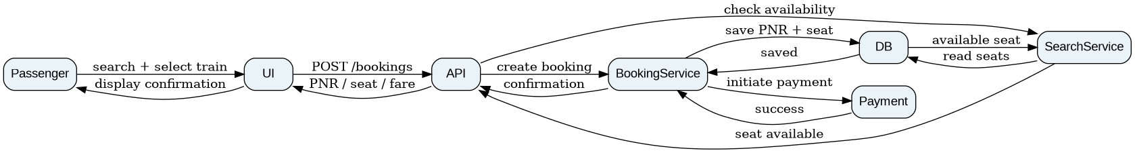
Passenger selects a train → availability is checked → booking is created → simulated payment succeeds → PNR/seat are committed → confirmation is returned.

4.2.2 Cancellation Flow
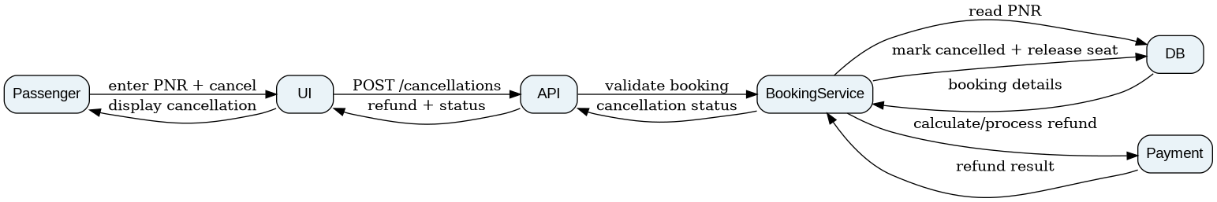
Passenger submits cancellation → booking is validated → booking is cancelled and seat released → refund is calculated/processed → cancellation result is returned.

4.3 API Design
Endpoint | Method | Request | Response / Errors
/api/auth/register | POST | name,email,mobile,password | 201 user; 400 validation; 409 duplicate email
/api/auth/login | POST | email,password | 200 session/token; 401 invalid credentials
/api/trains/search | GET | source,destination,date | 200 matching trains; 400 invalid query
/api/trains/{id}/availability | GET | journey date | 200 classes/seats; 404 schedule not found
/api/bookings | POST | scheduleId,class,passengers,seatIds,paymentToken | 201 PNR/booking; 409 no availability; 402 payment failure
/api/bookings/{pnr} | GET | PNR | 200 booking; 404 not found; 403 unauthorized
/api/bookings/{pnr}/cancel | POST | confirmation flag | 200 cancellation/refund; 400 ineligible
/api/admin/trains | POST/PUT | train master data | 201/200; 401/403 unauthorized; 400 invalid
/api/admin/schedules | POST/PUT | schedule data | 201/200; 400 validation; 409 conflict

4.4 Error Handling, Logging & Monitoring
- Use consistent JSON errors: {code, message, details?}.
- HTTP 400 validation, 401 unauthenticated, 403 unauthorized, 404 missing, 409 business conflict, 500 unexpected server error.
- Do not expose SQL statements, passwords, tokens or stack traces to users.
- Log timestamp, severity, request/correlation ID, endpoint and safe error code.
- Track booking failures, payment failures, cancellation failures, API latency and authentication failures.

4.5 UX Design
- Search page minimizes inputs and provides date validation.
- Availability distinguishes available, selected and booked states.
- Booking has a final review step before payment/confirmation.
- Cancellation clearly states refund amount before final confirmation.
- Admin screens use confirmations for state-changing operations.

4.6 Architecture Decision Records (ADRs)
ADR | Decision | Rationale | Alternatives Rejected
ADR-001 | Layered modular monolith | Simple deployment and clear separation for a mini-project. | Microservices: operationally excessive.
ADR-002 | MySQL as system of record | Reservation data is relational and needs transactions/FKs. | NoSQL: unnecessary for core booking data.
ADR-003 | Payment simulator | Allows deterministic testing without real financial transactions. | Real payment gateway: unsafe/out of scope.
ADR-004 | Transaction/locking for seat allocation | Prevents duplicate confirmed seat assignment. | Application-only locking: unreliable across requests/processes.

4.7 Open Issues & Next Steps
- Finalize exact technology versions and deployment environment.
- Waitlist/RAC is outside the mini-project baseline and may be considered as future enhancement.
- Seed realistic but fictional trains, stations, fares and seat inventory.
- Future: real railway API, live status, real payment gateway, email/SMS and analytics.

5. Appendices

5.1 Glossary
PNR, RBAC, API, DTO, REST, UAT, RTM, NFR, ADR.

5.2 References
Railway Reservation System SRS v1.0; Software Test Plan v1.0; project-approved database/API documentation.

5.3 Tools
draw.io / PlantUML / Graphviz for UML, Postman for API testing, Git/GitHub for version control, MySQL Workbench for database design.

