ISMS – Information Security Management System
Charity Dube
Purdue University Global
IT591: Security Auditing and Assessments
March 18, 2025

Table of Contents
Abstract……………………………………………………………………………………………3
ISMS – Information Security Management System – Pinterest……………………………...…...4
Pinterest Description & Security Policy……………………………………………………….….5
Pinterest Description & Security Policy & High-level Risk Assessment………....…....……...….6
High-level Risk Assessment & Statement of Applicability……………………………………….7
Conclusion……………………………………...…………………………………………………8
References…………………………………………………………………………………………9

Abstract

ISO 27001 is a standard that is used in an information security management system (ISMS). This IT governance framework provides guidelines for organizations on the management of information security. The outline has a cycle of continuity called the Plan-Do-Check-Act (PDCA). Pinterest applies the frameworks on its multiple social platforms and has checks and balances to ensure security. The content highlights the contractual, legal, and regulatory requirements found in Annex A 5.31 of ISO 27001. The organization must continually assess and improve to ensure compliance and build structures against threats and risks.

Keywords: ISO 27001, compliance, risks, threats, frameworks, PDCA, ISMS

ISMS – Information Security Management System – Pinterest

- “ISO 27001 is an international Information Security Management Systems (ISMS) standard. ISO 27001 provides a structured framework for organizations to manage sensitive information, ensuring its confidentiality, integrity, and availability” (Otterloo, 2017). PDCA is the abbreviation for plan-do-check-act, and ISO 27001 is a continuous cycle of improvement. PDCA is considered when changes are made in an organization. With every update on Pinterest like firewall updates or installation, and changes in policies, PDCA needs to be implemented.

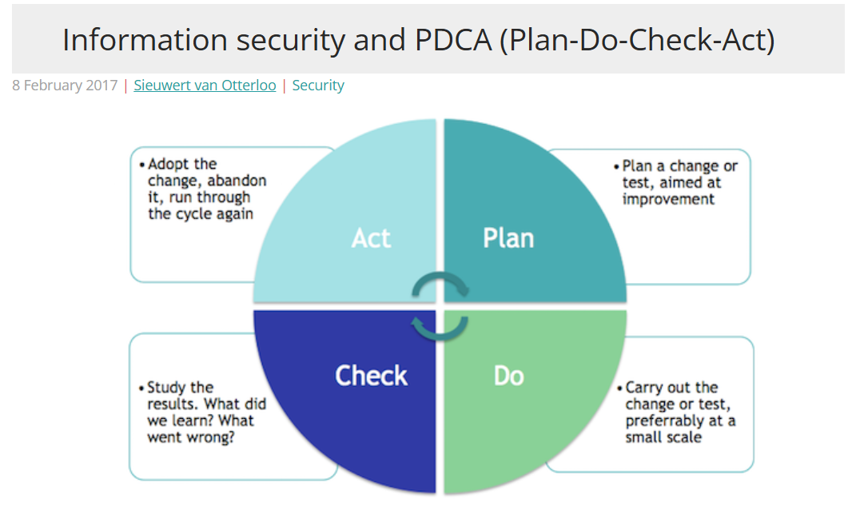

Pinterest Description & Security Policy

- Pinterest is a social media platform that publishes pictures through collages and boards. It is an image-based app that publishes information on pinboards. Pinterest also allows creators to collaborate with the app and serves as a visual search engine. Pinterest has features like home feeds, search bars, pins, and boards. The Pinterest business allows creators, brands, and merchants to set up consumer businesses.
- a) The Pinterest information security direction and policy will be a Privacy Policy that includes Pinterest's processes for collecting and using consumer personal data and the choices that consumers have about their information. The direction must be clear, which platforms are Pinterest platforms, and the privacy policies of each platform, like Pinterest business etc. The guidelines must be about securing Pinterest’s technology information, data, confidentiality, and systems integrity.
b) The objectives that will help guide the company will cover information security goals that need to be met for compliance. The objectives for Pinterest information systems are.
- “Confidentiality: Ensures that only authorized personnel can access and use data.
- Integrity: Guarantees that data is accurate and reliable, preventing unauthorized modifications.
- Availability: Ensures that data and information are accessible when needed” (DataGuard, 2025).
c) The contractual, legal, and regulatory requirements that Pinterest must meet are found in Annex A 5.31 of ISO 27001. There are five requirements that Pinterest needs to meet are;
- “Developing your information security policies and processes.
- Developing or changing your information security controls
- Classifying your data and assets
- Doing risk assessments and risk management
- Performing supplier management and supplier contracts” (Barker, n.d).
d) The statement of commitment to continuous improvement of the information security management system (ISMS) at Pinterest is going to be on an ongoing basis. Pinterest must commit to continually evaluating and auditing the statement. The components of the statement that must be included and continually improved are;
- A process that continuously seeks opportunities to improve ISMS at Pinterest
- Steps to implementing changes and improvements.
- Procedures to monitor and measure whether the improvements are successful.
- Audits and assessments
- Responsibilities for the employees involved in continuous improvement.
- High-level Risk Assessment
The three high-level risk assessments will be risk management methodology, risk assessment implementation, and risk treatment implementation. Risk management methodology is the first step in using ISO 27001. This step outlines the rules and procedures in risk assessment. Risk management methodology needs to be uniform, as all the Pinterest employees need to follow it accordingly. The impact and severity of using the risk management methodology is that documentation of how assessments will be implemented, setting guidelines. The guidelines are comprehensive assessments of risk management.
Risk assessment implementation is the next step after setting the rules with a methodology. Assessment implementation will first look at the potential risk that could happen to the organization. All the assets and platforms that are up to date need to be listed, and with the weaknesses, threats, and treatment plans. The level of risk needs to be continually evaluated, and a risk owner within the organization needs to be assigned. Security testing and auditing are essential in this part of the process.
The risk treatment implementation is the step when the organization manages the identified risks. “During the risk treatment, the organization should focus on those risks that are not acceptable; otherwise, it would be difficult to define priorities and to finance the mitigation of all the identified risks” (Kosutic,n.d). The four treatment options used in risk treatment implementation are to decrease risk, avoid risk, share the risk, and accept the risk.

Statement of Applicability
The Statement of Applicability is the statement that explains the security controls that the organization uses in its information security management system (ISMS). Security controls are chosen by the company according to the risks and the company’s business needs. The first security control is security policy, this policy is a set that is defined and approved by management. These set of policies are communicated to the rest of the organization and employees. It is selected because it applies to business, risk and legal.
The next security control is the information security roles and responsibilities. These security roles and responsibilities are defined and appointed by the company according to the company’s needs. The needs cover the organization’s business and risk management. Threat intelligence control’s main objective is to gather information regarding threats. The information is collected and analyzed for intelligence.

Conclusion
Executing an IT governance strategy for Pinterest, using ISO 27001, Information Security Management System (ISMS), ensures that the organization has a framework that protects sensitive data and information. Following the Plan-Do-Check-Act (PDCA) the company sustains compliance and continuous checks and balances. Pinterest's high-level information security policy defines the objectives to meet the contractual, legal, and regulatory requirements. The checks and balances should be ongoing and continually updated. Prioritizing high-level risk assessments and controls ensures that the company’s information security management system (ISMS) needs are met.

References
Barker, S. (n.d). ISO 27001 Annex A 5.31 Legal, statutory, regulatory and contractual requirements. HighTable.
https://hightable.io/iso-27001-annex-a-5-31-legal-statutory-regulatory-and-contractual-requirements/
Information security at a glance: Definitions, objectives, tasks, jobs. (2025, February 10). DataGuard.
https://www.dataguard.com/blog/information-security-at-a-glance-definitions-objectives-tasks-jobs
Kosutic,D. (n.d). ISO 27001 Risk Assessment, Treatment, & Management: The Complete Guide. Advisera.
https://advisera.com/27001academy/iso-27001-risk-assessment-treatment-management/
Van Otterloo, S. (2017, February 8). Information security and PDCA (Plan-Do-Check-Act). ICT Institute.
https://ictinstitute.nl/pdca-plan-do-check-act/

