Title Generation for Scientific Abstracts Using
Small Language Models: A Partial Replication Study

Anonymous Author
Advanced Applied Machine Learning, 2025

Abstract
This paper presents a partial replication study of "Can Pre-Trained Language Models Generate Titles for Research Papers?" Instead of fine-tuning large or medium-scale transformer models, I investigate whether a 135-million parameter model, called SmolLM-135M, can achieve competitive title generation performance. I experiment with both full fine-tuning (FFT) and Low-Rank Adaptation (LoRA) across two training regimes: a small domain-specific dataset (CSPubSum) and a larger, more diverse dataset comprising over 2.4 million samples drawn from arXiv, Wikipedia, and Medium blog articles. Evaluation is performed on the LREC-COLING 2024 benchmark using ROUGE-1, ROUGE-2, and ROUGE-L scores. My best configuration, full fine-tuning on the large dataset, achieves ROUGE-1/2/L scores of 41.31/22.51/35.21, approaching the performance of fine-tuned large language models at a fraction of the parameter count. In the following, I discuss training dynamics, the effect of dataset scale, and the impact of generation length on evaluation scores. Last but not least, the final model is converted to ONNX format and deployed as a browser-based application using Transformers.js.

1. Introduction
Automatic title generation for scientific papers is a fairly well-studied sequence-to-sequence task with broad practical applications like academic search, recommendation systems, or mobile apps like calendars or To-do apps. A well-formed title should be concise, informative, and factually grounded in the source. At the same time, it is constrained to a relatively short output, typically under 20 tokens, which raises an interesting question: does effective title generation actually require a large language model?
The reference paper by Rehman et al. (2024), "Can Pre-Trained Language Models Generate Titles for Research Papers?", explores this using the models: T5-base, BART-base, PEGASUS-large, LLaMA-3-8B, and GPT-3.5-turbo on the LREC-COLING 2024 benchmarks. However, the study does not examine the low end of the model size spectrum.
Motivated by the hypothesis that title generation is a relatively constrained task that may not require large-scale parametric capacity, this work investigates SmolLM-135M, a decoder-only causal language model with only 135 million parameters. I conduct experiments across two fine-tuning strategies (full fine-tuning and LoRA) and two dataset regimes (domain-specific and large-scale diverse), and report results on the LREC-COLING 2024 test set. The LREC-COLING 2024 dataset was introduced in the reference paper by Rehman et al. (2024). The goal is not to achieve state-of-the-art performance, but to understand how far a small, efficiently deployable model can go, and to identify the conditions under which it succeeds or fails.
As a secondary contribution, I demonstrate practical deployment: the best model is exported to ONNX format and served entirely in the browser via Transformers.js, illustrating that research-quality title generation can run locally without any server infrastructure.

2. Related Work
Title generation has historically been treated as a summarization problem, where the abstract plays the role of the source document and the title is the extreme summary. Early work used extractive approaches and template-based methods. With the rise of neural sequence-to-sequence models, abstractive generation became dominant, with LSTM-based encoder-decoders eventually giving way to transformer architectures (Sutskever et al., 2014).
The reference paper by Rehman et al. (2024) is the most directly relevant work. They benchmark both encoder-decoder models and decoder-only LLMs on CSPubSum and LREC-COLING 2024, finding that fine-tuned T5-base and BART-base yield ROUGE-1 scores around 46-47, while PEGASUS-large reaches nearly 50. Notably, the non-fine-tuned LLaMA-3-8B model in a zero-shot setting scores only 32.92 on ROUGE-1, highlighting the importance of task-specific fine-tuning even for large models.
LoRA (Hu et al., 2021) has emerged as an efficient alternative to full fine-tuning by injecting trainable low-rank matrices into frozen transformer layers. Rather than updating all model weights, LoRA introduces a small number of additional parameters (controlled by rank r) that are sufficient to adapt the model to new tasks. This significantly reduces memory and compute requirements, making it well-suited for consumer hardware.
SmolLM (HuggingFace, 2024) is a family of compact causal language models trained on the SmolLM-Corpus, which includes curated web text and code. The 135M variant, used in this work, uses the Llama 3.2 architecture and tokenizer, making it compatible with standard HuggingFace tooling. To my knowledge, no prior work has evaluated SmolLM-135M on title generation.

3. Data

3.1 Training Datasets
I used two distinct training corpora representing different scales and domains.
CSPubSum. The CSPubSum training dataset contains 8,120 abstract-title pairs from computer science publications. This dataset was used in the original reference paper and represents the primary in-domain training resource for scientific title generation. Cleaning follows the same protocol as the reference paper: title length is constrained to between 3 and 20 tokens, and abstracts must be at least 20 tokens long.

Large Diverse Dataset. To test whether broader training signal can compensate for domain mismatch, I construct a second training corpus by combining three sources: (1) a Kaggle dataset merging arXiv abstracts with Wikipedia articles, totalling approximately 2.65 million entries; (2) the Medium Articles dataset from Kaggle, containing approximately 192,000 blog posts with titles. The two sources are concatenated and subjected to a shared cleaning pipeline.

3.2 Data Cleaning
Both datasets pass through the following cleaning steps. First, duplicates are removed. Second, samples with titles containing LaTeX mathematical expressions (e.g., dollar-sign delimited formulas), numbers greater than 99, or parenthetical expressions are filtered out, as these tend to produce noisy or unpredictable targets. Third, all samples are tokenized using the SmolLM tokenizer, and only those where the concatenated text (abstract + title prompt) fits within 512 tokens are retained. Finally, any samples whose titles appear in the LREC-COLING 2024 test set are removed to prevent data leakage. 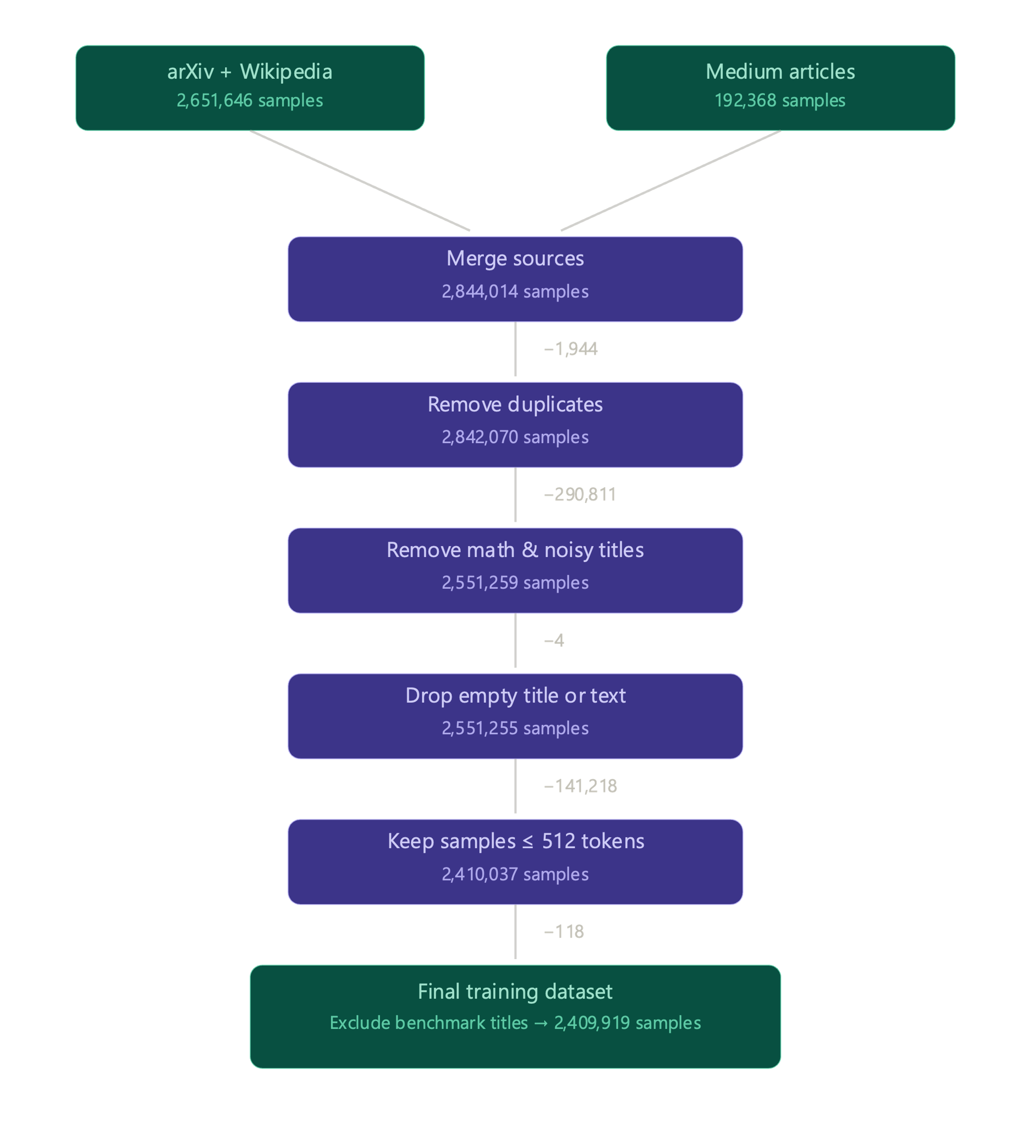
After cleaning, the large dataset contains approximately 2.41 million samples. A notable consequence of the LaTeX filtering is the removal of a substantial fraction of arXiv papers, many of which contain mathematical notation in their titles. This shifts the distribution of the large dataset toward more general-domain content, which may explain some of the generalisation patterns observed in the results.

3.3 Evaluation Dataset
All models are evaluated on the LREC-COLING 2024 test set, a benchmark of scientific paper title-abstract pairs released alongside the reference paper. This set is held out from all training data, as described above. I report macro-averaged F1 scores for ROUGE-1, ROUGE-2, and ROUGE-L using the rouge-score library with stemming enabled.

4. Methodology

4.1 Base Model
All experiments use SmolLM-135M (HuggingFaceTB/SmolLM-135M) as the base model. This is a decoder-only causal language model with 135 million parameters, trained on a mixture of web text and code. It uses the Llama 3.2 tokenizer with a vocabulary size of 49,152. The model is publicly available on HuggingFace.
A key architectural observation, relevant to the LoRA configuration, is that the model contains eight distinct linear layer types: q_proj, k_proj, v_proj, o_proj, gate_proj, up_proj, down_proj, and lm_head. By default, LoRA adapts only q_proj and v_proj; I adopt this default in the experiments due to computation and time constraints. However, I would encourage further experiments which adapt more linear layers as these would likely boost accuracy.

4.2 Prompt Format
I frame title generation as a conditional language modelling task. Each training example is formatted as:
<abstract>\n\nTitle: <title><EOS>
During inference, only the abstract and the "Title:" prompt are provided, and the model generates the title autoregressively. Loss is computed only on the title tokens (the abstract prefix is masked with -100 labels in the full fine-tuning setup). This causal language modelling approach is standard for decoder-only models adapted to generation tasks. When fine-tuning LoRA, no masking was done and the loss was computed on the entire input sequence. This was due to a lack of understanding. Unfortunately, this could have had a negative impact on fine-tuning, as the model gets rewarded to memorize the entire input sequence rather than just focusing on the title.

4.3 LoRA Fine-Tuning
The first experimental setup uses Low-Rank Adaptation (LoRA) via the PEFT library. LoRA is applied with rank r=16, alpha=16, and dropout of 0.05, targeting the default query and value projection layers. The model is trained on the large diverse dataset for 5 epochs using the TRL SFTTrainer. Batch size is 8 with 4 gradient accumulation steps (effective batch size 32), and learning rate is 4e-5 (0,00004). These metrics were taken from the reference paper, but are also considered “sane defaults” in the machine learning community. The SFTTrainer (supervised fine-tuning) operates on raw formatted text strings rather than pre-tokenized sequences, using the text field from the formatted examples, however, during cleaning the actual input size was already measured in tokens.
After training, the LoRA adapter is merged into the base model weights using merge_and_unload(), which produces a standard HuggingFace model that can be distributed independently.

4.4 Full Fine-Tuning (FFT)
In the second experimental setup, all model weights are updated during training. I conduct two FFT runs: one on the small CSPubSum dataset and one on the large diverse dataset.
For the CSPubSum run, training proceeds for 1 epoch using a batch size of 16 with 2 gradient accumulation steps (effective batch size 32), an unchanged learning rate of 4e-5 with a cosine scheduler and 3% warmup ratio. For the large dataset run, the same hyperparameters are used but training is capped at 1 epoch due to the dataset size.

4.5 Generation and Evaluation
Title generation is performed with greedy decoding (do_sample=False) and a maximum of 30 new tokens. The 30-token limit was selected based on empirical observation: using 20 tokens produced significantly worse scores (approximately 20% ROUGE-1 degradation). While the distribution of title token lengths has a mean of 15.27 tokens, it exhibits a right tail, with a non-trivial portion of titles exceeding 20 tokens. When generation is capped at 20 tokens, these longer titles are forcibly truncated before completion. This causes the model to output partial titles that fail to match their full references during ROUGE evaluation. A truncated output structurally cannot recover the tokens it never produced, negatively impacting recall and the F1 score. Extending the limit to 30 tokens covers the overwhelming majority of the distribution, allowing nearly all titles to be generated in full.
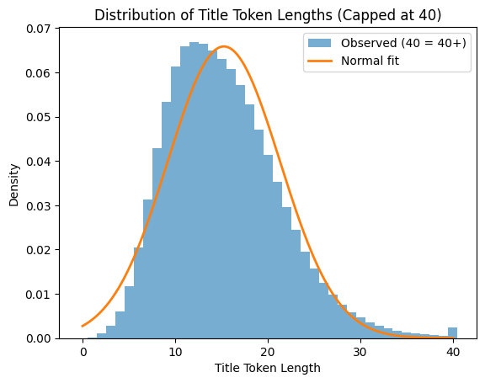
ROUGE scores are computed against lowercased ground-truth titles using F1 measures for ROUGE-1, ROUGE-2, and ROUGE-L. Entity-level factual consistency metrics (precision, recall, F1 over named entities extracted using SciSpaCy) are also computed in the evaluation script, following the methodology of the reference paper, though I focus on ROUGE as the primary comparison metric.

5. Results
Table 1 presents the main results across all experimental configurations alongside the baselines from the reference paper. Our own results are highlighted in bold.

Model | ROUGE-1 | ROUGE-2 | ROUGE-L
T5-base | 46.84 | 28.70 | 41.69
BART-base | 46.87 | 27.66 | 41.89
PEGASUS-large | 49.85 | 30.51 | 43.93
LLaMA-3-8B zero-shot | 32.92 | 16.66 | 27.66
LLaMA-3-8B fine-tuned | 45.30 | 26.53 | 40.51
GPT-3.5-turbo | 45.16 | 23.97 | 38.88
SmolLM-135M FFT CSPubSum | 35.36 | 17.54 | 30.12
SmolLM-135M LoRA Large Dataset | 34.08 | 16.26 | 27.88
SmolLM-135M FFT Large Dataset | 41.31 | 22.51 | 35.21
Table 1: ROUGE-1/2/L F1 scores on the LREC-COLING 2024 test set. Reference results from Rehman et al. (2024). Our results in bold.
The FFT model trained exclusively on CSPubSum (8,120 samples) achieves ROUGE-1/2/L of 35.36/17.54/30.12. While this is below almost all reference models, it is notable that a 135M parameter model fine-tuned on fewer than 10,000 samples produces non-trivial scores at all, suggesting the task is learnable even with minimal data.
The LoRA model trained on the large diverse dataset for 5 epochs achieves 34.04/16.37/28.09, a meaningful improvement over the CSPubSum FFT baseline. The LoRA approach benefits from the broader distribution of the large training corpus while keeping the number of trainable parameters low.
The strongest result is achieved by the FFT model trained on the large diverse dataset: 41.31/22.51/35.21. This is competitive with the zero-shot LLaMA-3-8B baseline (32.92/16.66/27.66) and comes close to models that are 60 times larger. The gap to the best reference model (PEGASUS-large: 49.85/30.51/43.93) remains substantial, but the result illustrates that a 135M model with appropriate training data can perform surprisingly well.

6. Discussion

6.1 Dataset Scale vs. Domain Specificity
The most striking finding is that the large diverse dataset no always outperforms the in-domain CSPubSum dataset, despite the former still containing substantially more scientific content. This suggests that, for a model as small as SmolLM-135M, learning the general task of summarising text into a short, descriptive headline from a large and varied corpus may be too much and more confusing than learning the narrow stylistic conventions of scientific titles.
A possible explanation is that the SmolLM-135M base model has insufficient capacity to strongly memorise domain-specific patterns from a small training set, and therefore benefits from the regularising effect of a more diverse corpus. Larger models, by contrast, may be better positioned to exploit in-domain data efficiently.

6.2 Overfitting and Training Dynamics
A potential weakness of the large dataset experiment is the risk of overtraining. Although the diverse corpus contains over 2.4 million samples, the title length distribution differs substantially from the LREC-COLING evaluation set, which focuses on scientific papers. During the LoRA training (5 epochs), performance was observed to degrade gradually after the first epoch on held-out validation loss. This is consistent with a form of distribution shift: the model adapts increasingly to the style of Medium blog titles and general web content, drifting away from the scientific register expected by the benchmark.
Similarly, the large-scale FFT experiment was restricted to a single epoch to avoid this degradation. Even so, it is possible that the model has not fully converged, and that a more carefully tuned learning rate schedule or earlier stopping criterion could yield further improvements.

6.3 Impact of Generation Length
The choice of maximum generation length (max_new_tokens) has a disproportionate effect on ROUGE scores in this setting. Restricting generation to 20 tokens approximately halved ROUGE-1 performance compared to 30 tokens. This is an artifact of the training data distribution: the large dataset contains many titles substantially longer than those in CSPubSum, so the model learns to generate longer outputs. When the generation is cut short, partially generated titles receive poor ROUGE scores.
This is a methodological weakness relative to the reference paper, which evaluates models trained on domain-matched data with more consistent title lengths. Future work should consider normalising title length either during training (by filtering for length consistency) or during evaluation (by using length-normalised ROUGE variants).

6.4 LoRA vs. Full Fine-Tuning
At this model scale, full fine-tuning outperforms LoRA by a notable margin (41.31 vs. 34.04 ROUGE-1). This is somewhat expected: with only 135M parameters, the model is small enough that full fine-tuning remains computationally feasible, and the flexibility of updating all weights allows the model to better adapt to the target task. The advantage of LoRA lies primarily in memory efficiency and faster training iteration, which becomes more relevant for larger models. At 135M parameters, the memory savings are less critical.

6.5 Limitations
Several limitations should be acknowledged. First, the evaluation is restricted to ROUGE scores; we do not report the full entity-level factual consistency metrics from the reference paper, which would give a more complete picture of output quality. Second, the LREC-COLING test set evaluates performance on computer science papers, but the large training dataset is heavily weighted toward general web content after the LaTeX filtering step, creating a domain mismatch that may suppress performance. Third, no hyperparameter search was conducted; the learning rates, batch sizes, and LoRA rank were chosen based on reasonable defaults rather than systematic optimisation. Fourth, and most fundamentally, SmolLM-135M is a decoder-only causal model, whereas the best-performing reference models (T5, BART, PEGASUS) are encoder-decoder architectures specifically designed for conditional generation. This architectural difference may inherently disadvantage our approach for short, precise generation tasks.

7. Practical Deployment: Browser-Based Demo
As a practical contribution beyond the numerical results, the merged LoRA model was converted to ONNX format using the Optimum library and subsequently deployed as a browser-based application using Transformers.js. ONNX runtime allows model inference to run entirely within the browser via WebAssembly, without requiring any server-side computation or API calls.
The pipeline for deployment is as follows: the LoRA adapter checkpoint is first merged into the base model weights using merge_and_unload(), producing a standard HuggingFace model. This model is then exported to ONNX. The resulting model file, along with the tokenizer configuration, is saved and hosted on HuggingFace Hub under the identifier throvn/abstract-title-generator.
The live demo is accessible at:
https://throvn.github.io/abstract-title-generator-frontend/
Users can paste any scientific abstract (or other text) into the interface and receive a generated title directly in the browser. The model runs locally on the user's machine after the initial download.

8. Conclusion
This work presented a partial replication and extension of the paper "Can Pre-Trained Language Models Generate Titles for Research Papers?" using SmolLM-135M, a 135-million parameter language model. I conducted experiments across two fine-tuning strategies and two dataset regimes, finding that the combination of full fine-tuning and a large diverse training corpus yields ROUGE-1/2/L scores of 41.31/22.51/35.21 on the LREC-COLING 2024 benchmark. This result is competitive with zero-shot LLaMA-3-8B and within reasonable range of fine-tuned models an order of magnitude larger.
Our findings support the hypothesis that title generation, being a relatively constrained and short-form generation task, does not necessarily require large model capacity. The primary bottleneck at the 135M scale appears to be training data quality rather than scale or model size.
Future work could explore the following directions: (1) filtering the large dataset more aggressively for scientific content; (2) using a length-consistent training corpus to avoid the max_new_tokens sensitivity issue; (3) applying instruction tuning rather than pure language modelling to better align the model with the title generation format; and (4) evaluating on entity-level factual consistency metrics to assess output quality beyond surface-level n-gram overlap.

References
Rehman, T., Sanyal, D. K., & Chattopadhyay, S. (2024, December). Can pre-trained language models generate titles for research papers?. In International Conference on Asian Digital Libraries (pp. 154-170). Singapore: Springer Nature Singapore.
Hu, E. J., Shen, Y., Wallis, P., Allen-Zhu, Z., Li, Y., Wang, S., Wang, L., & Chen, W. (2021). LoRA: Low-Rank Adaptation of Large Language Models. arXiv preprint arXiv:2106.09685.
Vaswani, A., Shazeer, N., Parmar, N., Uszkoreit, J., Jones, L., Gomez, A. N., Kaiser, L., & Polosukhin, I. (2017). Attention Is All You Need. Advances in Neural Information Processing Systems, 30.
Allal, L. B., Lozhkov, A., Penedo, G., Wolf, T., & von Werra, L. (2024). SmolLM – Blazingly Fast and Remarkably Powerful. HuggingFace Blog.
Wolf, T., Debut, L., Sanh, V., Chaumond, J., Delangue, C., Moi, A., ... & Rush, A. M. (2020). Transformers: State-of-the-Art Natural Language Processing. In Proceedings of EMNLP 2020: System Demonstrations.
Lin, C. Y. (2004). ROUGE: A Package for Automatic Evaluation of Summaries. In Text Summarization Branches Out (pp. 74-81).

