Art Milestone Document

This document represents a general outline of the artistic objectives for the Throwaway Games vertical slice, while some of the more significant milestones and changes feature their own summaries.

**Artistic Overhaul**

A major problem with our game in its prototype stages was our failure to establish visual consistency between the artists within our group, likely due to not establishing our art style clearly enough from the beginning and thereby lacking a suitable level of communication later on. This will include changes across the board, including to our UI, models, and textures.

To remedy this; the team has had a big meeting on Tuesday to iron out any misunderstandings, and in the process we have migrated to Hack n’ Plan to clearly log our milestones for the team. In addition, the team has worked together to establish a Pinterest page for the group that represents a general style for the sort of art we are trying to output. (<https://www.pinterest.nz/koro194428/legal-substances-2/>)

These images detail various things, such as the style of the games foliage, buildings, the art for the new hostile infection the player works to fight off, the contrast in ambience between day and night, and more.

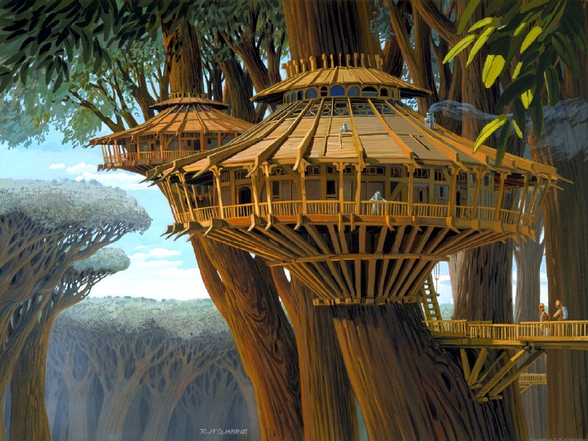

*Image above represents the agreed upon style of friendly buildings; structures integrated with the lush foliage.*

**Infection**

Over the holiday period (and finalized in a Tuesday meeting) the enemy faction’s role and mechanics have been further solidified. The games primary conflict will be generated between the player and an infectious fleshy plague that spawns mutated enemies. Beyond this, the plague will assimilate terrain, and convert the player’s workers and buildings to its mutating mass.

Due to the assimilating nature of this enemy, buildings and friendly units will have alternate art that represent the aforementioned in their assimilated states.

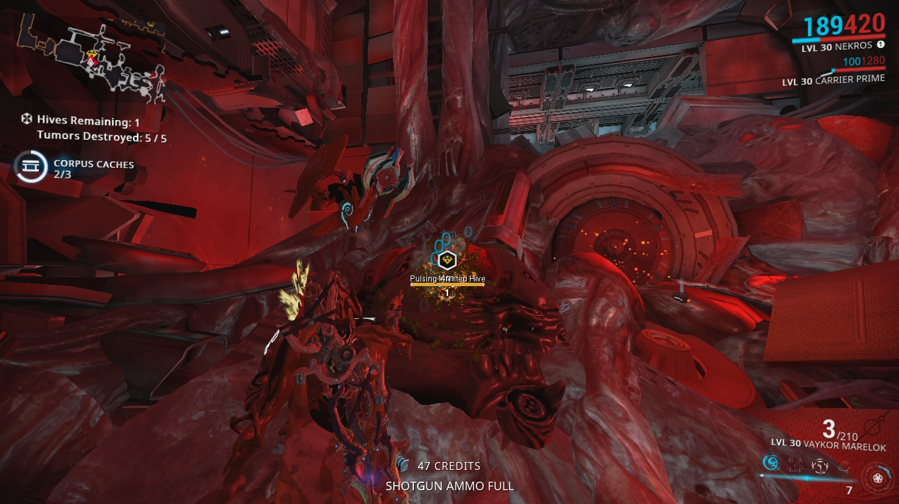

*Image represents an environment overcome with an infectious mass. Used as an inspiration for the infectious spread across the environment.*

With the infection comes a number of changing considerations, such as how mechanically the player will fight back and suppress the spread. This will no doubt feature additions to the art workload that while foreseen, are not necessarily written in stone at this stage.

**Milestone Overview (Hack N’ Plan)**

