**Personal Task Log/Journal:**

* Collected a series of sounds including Music and a handful of sfx (Impact, explosion, electricity, turret activation, menu movement)
* Modelled rigged and fully animated the player character
* Modelled rigged and fully animated a turret variant along with a payload projectile
* Fully Modelled rigged and textured a modular pistol, this consisted of four visual stages complete with textures and models that demonstrated the player’s progress.
* Modelled and rigged rough weapon variations of a shotgun and smg
* Developed vision document with team consultation

**Challenges during development:**

* On two occasions I made the mistake of rigging/animating an artefact *before* UVing it. Luckily this wasn’t too consequential as the basic material look the character has now fits the art style.
* There’s a general lack of knowledge across the group around handling animations. While I have exported all of my animations there is a confusion around how to multitask animations. (Such as running the upper body through animations separately to the lower half of the character within Unity.) As a result a lot of the animations I have worked on and exported won’t end up being implemented.
* The above led to a lot of time spent trying to diagnose and re-export animations to no avail.
* A failure of the team to make a distinctive choice between a modular weapon system (see: the pistol) and a series of different weapons led to a lot of time being invested into developing a complete modular pistol that was not properly utilized, and the additional need for weapon assets to be created to fulfil a role that could have been handled by the modular system. The outcome is one overdeveloped weapon asset, and two underdeveloped weapon assets.

**Artwork Developmental Showcase:**

**Modular Pistol**

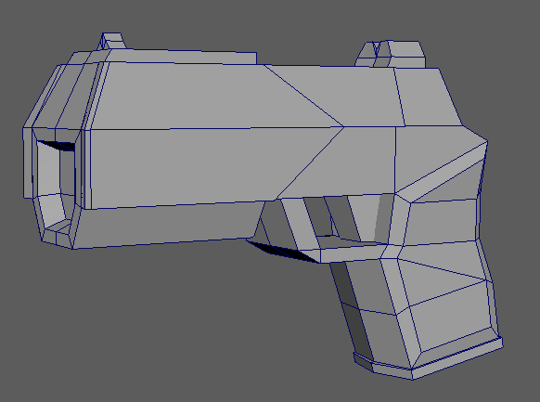

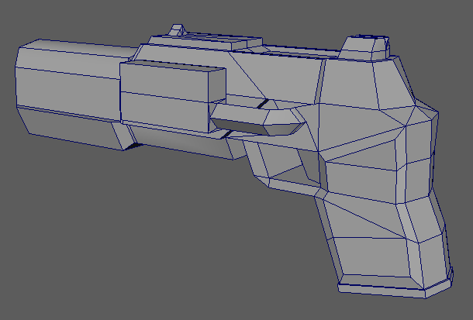

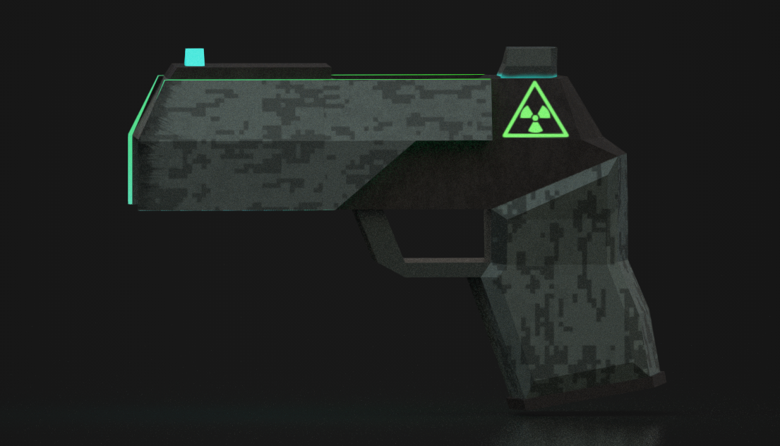

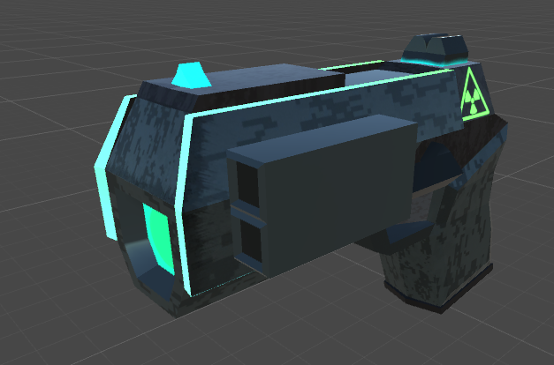

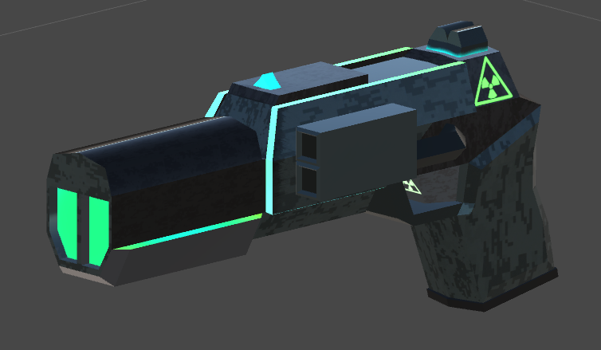

**Player Character**

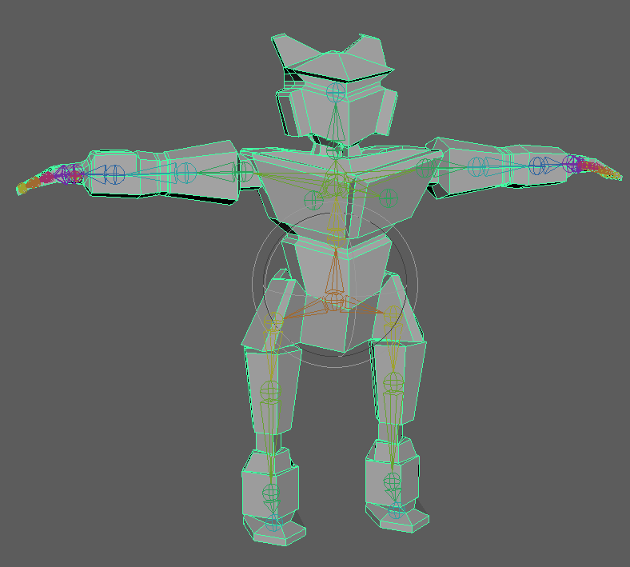

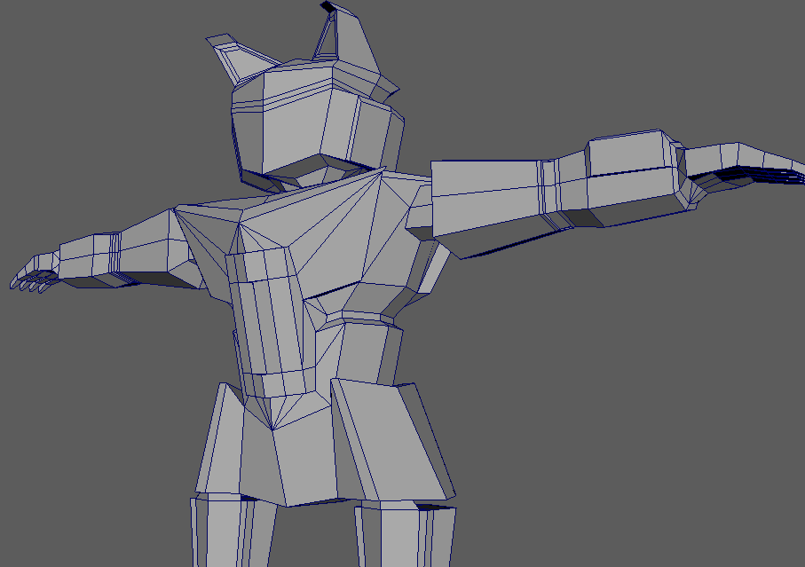

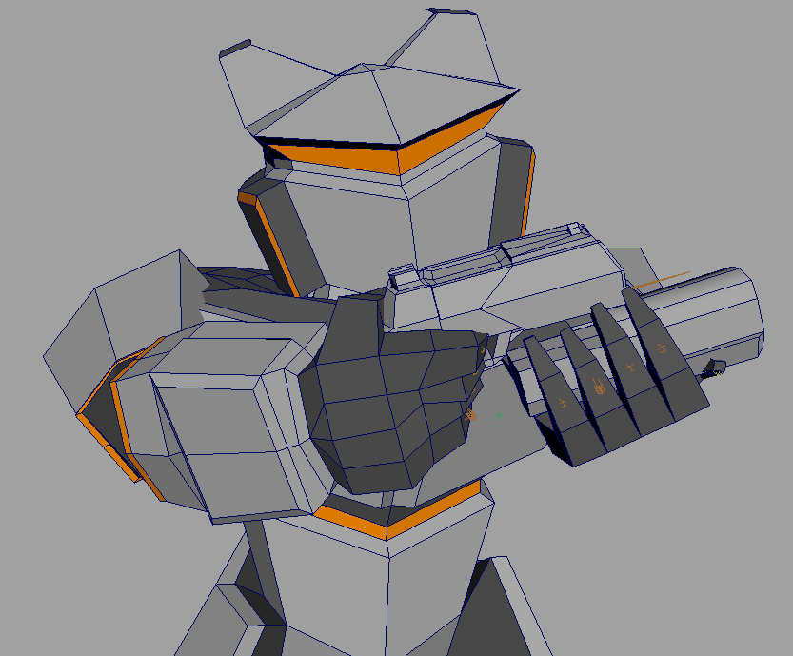

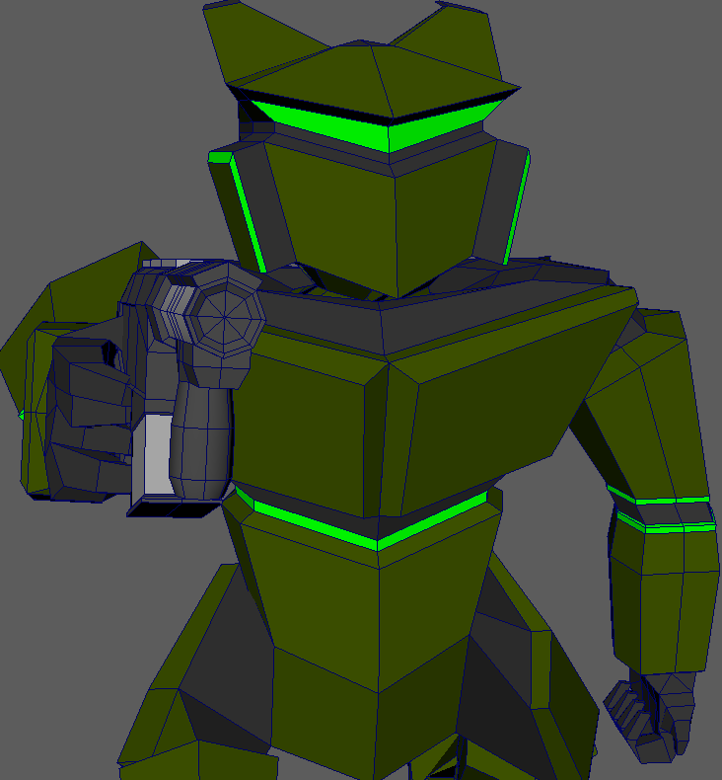

**Payload Turret**

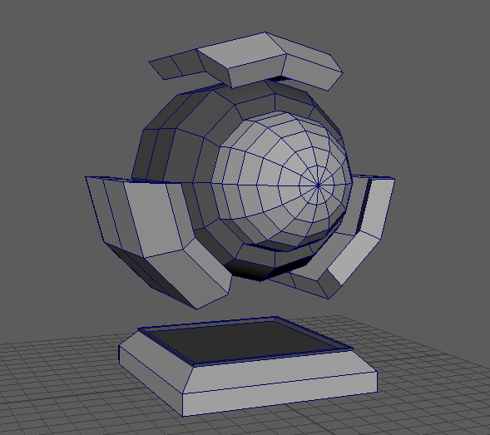

**Shotgun**

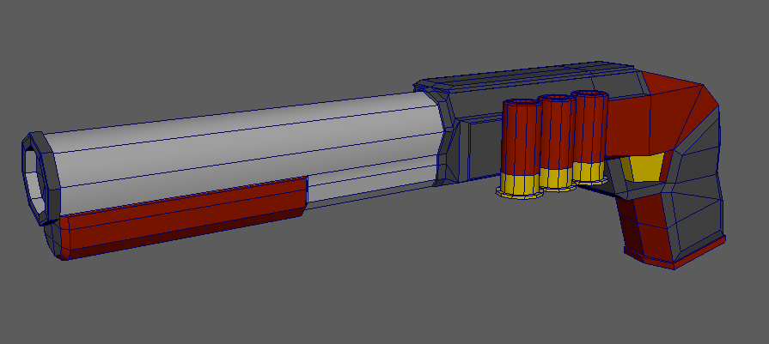

**SMG**

