**Personal Task Log/Journal:**

* Fully modelled and textured all in game currencies for use when upgrading
* Modelled rigged and fully animated all the turrets and interactive towers present in the game with the exception of the core defense objective.
* Fully textured the Dead Man’s Turret (Fireballs)
* Developed Ballista projectile
* Developed vision document with team consultation
* Set up the bulk of the information present on the Trello (<https://trello.com/b/0B3ew691/prototype-2>) to help with task assignment, structuring, and required output

**Challenges during development:**

* An issue caused by adding another bone to a root has caused a structural transformation in which certain elements of a turret do not rotate appropriately, and has also resulted on those elements appearing on a natural undesired offset. This has happened on at least two occasions with two of my turrets and I’m not sure why it’s happening or how to resolve it.

*As a quick fix, the turret bases were exported separately without bone influence, and the turret mechanisms were simply eyeballed on top of the separated bases to prevent the alignment issues. A disadvantage of this is that now the stands of the affected turrets have no animations whatsoever.*

* The Trello hasn’t been used by all group members which has led to lapses in our understanding of individual task progress. Some programming and art tasks and their progress are not well documented as a result.
* Unity has scaled imported assets to random unpredictable sizes, forcing those working directly with the Unity engine to manually scale new assets each time they are imported. This is impractical and happens in spite of scaling assets in Maya to a point of relative size.
* Some communication lapses may lead to certain features of the game not making the cut towards the prototype submission.

**Artwork Developmental Showcase:**

**Currency (Various)**

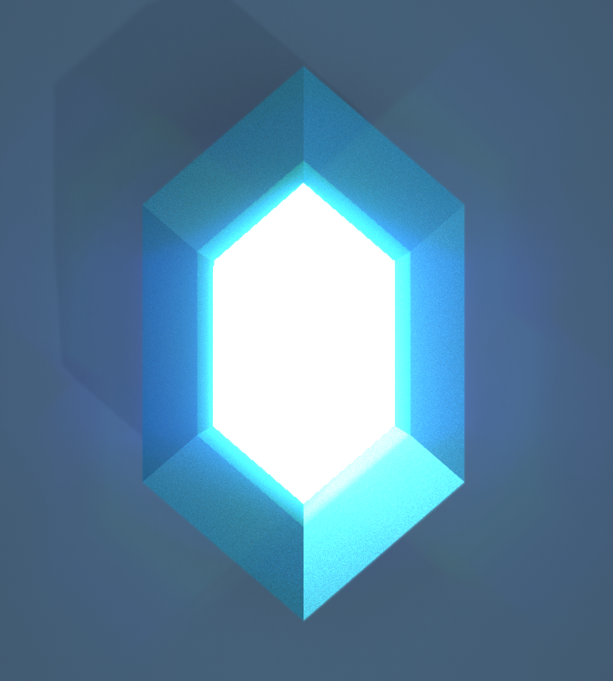

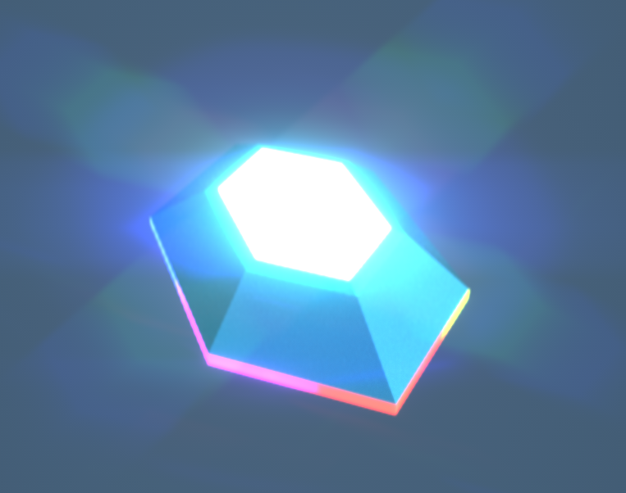

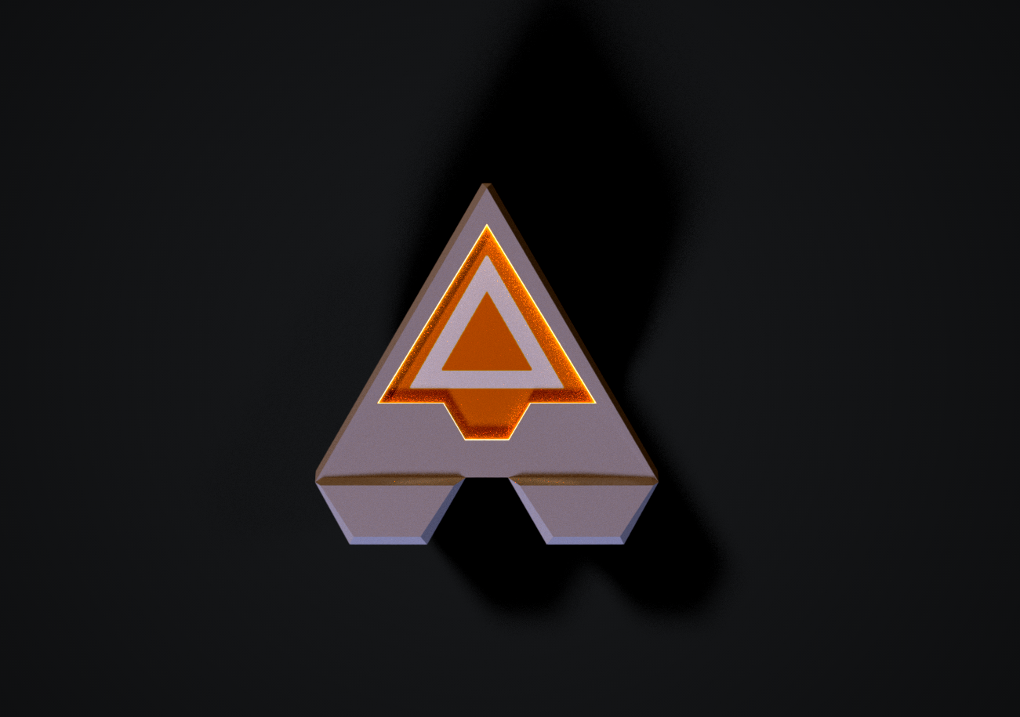

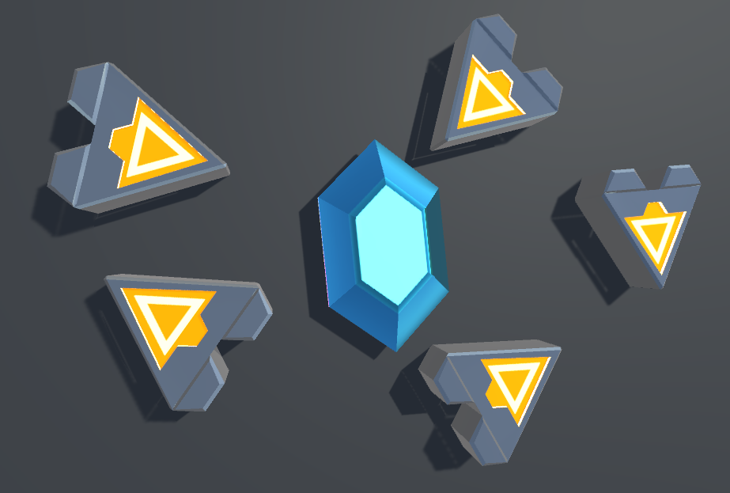

**Towers (Various)**

