FD MATURITY

AND RENEWAL MANAGER

Project Introduction & Problem Statement

Introduction:

Banks give customers Fixed Deposits (FDs) - you put in money for a fixed time and get interest. This project (FD Maturity & Renewal Manager) is a program to keep track of all the FDs a bank has.

Problem Statement:

- Right now bank employees track FDs manually (excel/register)
- Its easy to FORGET when an FD is about to mature
- This means the bank might lose the customer's renewal!!

- Objectives & Domain

Objectives:

- Store all FD details safely in a database
Domain:
Banking / Finance software type:
Python Desktop-Web App (built with flask)
- Automatically CALCULATE maturity value
- Alert staff when an FD is maturing in 30 days
- Handle premature (early) closure with penalty

Existing System & Proposed Solution

Existing System (manual): My Proposed Solution:

- Bank employee writes FD details on
paper/excel
- Have to manually check dates every day
- Very easy to make mistakes or forget!!
- A python program that stores everything in a database
- Calculates maturity value AUTOMATICALLY
- Shows a list of FDs maturing soon, no need
to check manually!

Input / Data & Project Modules

Input Data (what user types in): Project Modules:

customer name, account no, principal amount, interest rate, start date, tenure (years), penalty rate (for early closure)
  - Data Entry Module
  - Calculation Module
  - Renewal Alert Module
  - Database Module

System Architecture & Workflow

Workflow (step by step):

Browser --> app.py -->
fd_logic.py (math)
| v
database.py -->
fd_manager.db

- User adds an FD
- It gets saved to database
- System calculates maturity value
- Checks if it matures in 30 days
- Shows alert if YES!!

- Core Concepts / Algorithms / Processing
Maturity Value = P (1 + r/n)^(nt) <-- quarterly compounding

- Leap Year Algorithm - use real calendar months instead of just x365 days (so Feb 29 doesnt mess things up)
- Premature Closure Algorithm - swap in the penalty rate + only count actual days held
- 30-Day Check - compare maturity date to today, if 0-30 days away then ALERT

Special Features & Challenges

Special Features: Challenges I Expect:

- Automatic renewal call list (30 days)
- Handles early closure + penalty
- Calendar-safe date math (no leap year bugs!)
- Leap years are confusing to code correctly
- Making sure the penalty math doesn't break the normal formula
- I don't fully know Flask yet, so that part
might take time

Class Design & OOP Concepts Used

Planned Classes: OOP Concepts Used:

class FixedDeposit:
  - customer, account_no
  - principal, rate, tenure

class FDDatabase:
  - insert(), get_all()
  - update(), delete()

class FDCalculator:
  - get_maturity_value()
  - get_closure_value()

- Encapsulation - FD data + its own methods
kept together
- Abstraction - user doesn't need to know HOW maturity is calculated, just calls the function

Implementation, Output & Testing

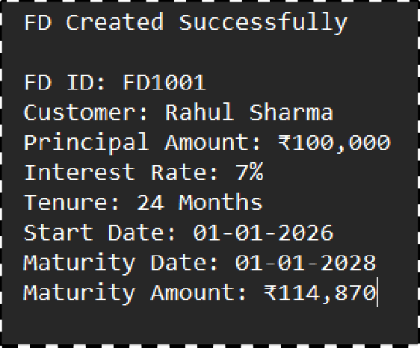Implementation Status: Testing (TO DO):

[ OUTPUT SCREENSHOT GOES HERE ]

☑ Formula written
- Leap year fix
- Database
- Website (flask)
- Leap year test
- Early closure test
- 30 day boundary test

(none of this is fully done yet)

- Current Progress, Future Enhancements & Conclusion

Current Progress:
Future Enhancements:
Conclusion:

about 30% done
(math + planning so far)
- login system
- edit an FD (not just delete)
- search bar
- monthly/yearly compounding
option
This project will help banks stop missing FD renewals.



