Flight Control

Process Oriented Programming (1DT049), project proposal for group 5, version 1, 2012-04-23.

Jonatan Moritz
Niklas Forsmark
Atanasios Karamios

- Brainstorm

The following chapter will contain thoughts, ideas and conclusions from the brainstorm meeting.

  - Preconceptions
After a quick survey in the group, it was clear that there were no preconceptions to take note off.
  - Summary
Ideas | Reasoning
Wolves and Rabbits | Excellent concurrency problem, although lacks ties to reality.
Bank system | Good connection to the real world, much need for concurrency, although not exactly interesting.
Flight control simulation | Real world application, lots of concurrency problems that need to be solved, interesting.
Betting system | Interesting, fair amount of concurrency needed although the effort needed to implement the algorithms would be significantly larger than to solve the concurrency.
Chat and game program | Interesting although the concurrency problem is extremely easy to solve thus most of the time would be spent implementing the game.
Table 0.

Other than these five there appeared ideas that were similar. For example:
An idea that was similar to the Flight Control Simulation was a Traffic Simulation, although after some consideration it was decided that the Flight Control seemed a lot more interesting.
For the chat and game program a number of different games were purposed , but in the end it was obvious that the concurrency problems were too easy to solve, no matter what game that would be implemented.

The idea in bold was the idea that was deemed to have enough concurrency problems, was interesting enough and with enough ties to reality to choose as a subject for this project.

Flight Control Simulation:
Summary → A simulation of an airport with aircraft taking off, landing, queuing to land and all aircraft would be considered to be an independent process. All of this would be handled by the flight control tower, a master process, which would communicate with the aircraft, directing them to land, giving them permission to take off.
Concurrency → The obvious problem that has to be handled concurrently is when the aircraft want to land or take off, needing confirmation from the control tower if they are allowed to or not, as it is possible for a multiple of aircraft to ask for permission at the same time . While this may sound easy the amount of variables that has to be taken into account complicates the problem enormously. But the basic idea is simple and thus it is an excellent project in the sense that it can be expanded, and thus increase the need for concurrency, almost indefinitely due to the amount of variables that are involved.

  - Conclusions
The brainstorming session was a great success and while the final result was easily attained it was a learning experience for the whole group.

2. Project Selection
The reason that this idea was chosen for the project has been lightly discussed in the section above. To elaborate, the Flight Control simulation was chosen mainly because it has a large amount of problems that has to be solved concurrently, it is interesting as it is closely connected to the real world and thus it gives a feeling of purpose in developing it, other than just learning how to solve problems concurrently.
Another part of what makes the idea is the possible complexity involved. While a simple implementation of the simulator would perhaps just be a control tower and a single landing strip, with no other variables to take into account than the order the aircraft are making requests to land or take off, there is huge room for expansion here. There is the option to add more landing strips, increase the number of variables that decide which plane has priority over the other when it comes to landing, and so forth.
What the group hopes to learn from this project is mainly how to solve problems like these concurrently but also to gain experience in the use of Erlang and its powerful tools for concurrency and message passing.
The main challenges that will be faced during the project will when more variables are introduced to the problem, how to correctly weigh which variable holds more importance when calculating priority and then to implement this.

3. System Architecture
The design is rather simple. There is the Flight Control Tower (henceforth know as the FCT) and aircraft, all represented as a process, or as the project is expanded, a multitude of stateful processes. There will also have a process that spawns aircraft. At its simplest the aircraft will have a timer counting down til the time when they ask for permission to land. At this point a message will be sent from the plane to the FCT asking for permission to land. If the request is granted, the plane will land and then terminate successfully after a short while, to simulate the landing and taxing. If the request is denied the process will terminate with an error, allowing the FCT to restart the plane with the timer set to a time meant to simulate the time it takes for an airplane to circle the airport and make another request to land.
This may later be expanded upon, creating processes for the landing strip(s) which has to be communicated with by the FCT, taking into consideration the fuel level of the circling aircraft, if there are any emergencies aboard the aircraft and so forth.
When the simulation is initiated a certain amount of variables will be entered, at its simplest the frequency of spawning aircraft. But this will be improved to include things like chance of critical failures (emergencies), number of landing strips, circling time, among many other.
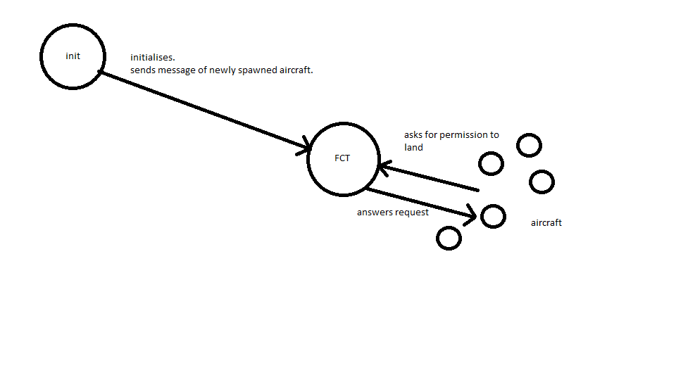

Image 0. A simple flowchart of the program.

4. Concurrency models and programming languages
The concurrency model that is related to this problem is the producers/consumers model, with the resource to be consumed is the landing strip and the aircraft as the consumers, with the FCT controlling the consumption.
The programming language which will be used to complete this project is Erlang, due to its strong concurrency tools and message passing abilities which are extremely well suited for this type of program.

5. Development tools
The project will be completed with the following tools:
Source code editor : Emacs
Reasoning: Due to the great interactivity Emacs has with Erlang it will be used as the main editor while writing this project.

Management: GIT
Reasoning: Due to familiarity GIT was chosen as the version management system for the group.

Built tool: Rebar
Reasoning: Rebar is one of the few , if not the only, commonly used build tools for Erland projects thus the choice was given.

Unit Testing: EUnit
Reasoning: The only logical choice due to the choice of programming language.

Documentation generation: Edoc
Reasoning: Again, the only logical choice.

