PREDICTION OF STUDENT PERFORMANCE BASED ON MACHINE LEARNING

Thi-Thu-Linh Doan
Faculty of Information Technology, Hung Yen University of Technology and Education
linhdoanarmy3009@gmail.com

Abstract
Student success is an important issue in higher education; therefore, early prediction of learning outcomes can help teachers and universities provide timely support for students. In this study, machine learning techniques are applied to predict student performance using their grades from previous semesters as input features. This paper investigates four supervised learning algorithms, including Logistic Regression (LR), K-Nearest Neighbors (KNN), Random Forest (RF), and Support Vector Machine (SVM), which are implemented and comparatively evaluated. Data preprocessing includes detecting and handling missing values, dividing the dataset into training and testing subsets with an 80/20 ratio and applying the SMOTE method and k-fold cross-validation strategy on the training set. Model performance is evaluated using Precision, Recall and F1-score. Experimental results indicate that Logistic Regression, Random Forest and K-Nearest Neighbors achieve strong and stable performance across multiple courses, while the highest F1-score of 95.39%. These findings demonstrate that machine learning-based prediction models can effectively support early academic intervention and help improve student learning outcomes.
Keywords: Machine Learning, Binary Classification, Student Performance Prediction, Educational Data mining
1 Introduction
Student academic performance prediction has become an important research topic in higher education, particularly in the context of data-driven educational management. Universities increasingly seek to identify students at risk of failure before the end of a semester so that timely academic interventions can be implemented. However, accurately predicting student performance at the course level for a specific future semester remains a challenging task.
Early prediction is valuable for multiple stakeholders. For instructors, predictive models enable the early identification of academically at-risk students, allowing adjustments in teaching strategies or the provision of additional academic support. For students, early feedback regarding potential failure risks encourages proactive learning strategies and better academic planning. For universities, such predictive systems support evidence-based decision-making, help reduce failure rates, and improve overall educational quality. Without an early prediction mechanism, academic outcomes are typically known only after final examinations, which may be too late for effective intervention.
Existing studies have applied machine learning techniques to educational data mining, with many focusing on overall GPA prediction, dropout detection, or modeling general academic success using various types of data such as demographic information, family background, and learning behavior data. Although several supervised learning algorithms such as LR, RF, KNN, and SVM have been widely investigated [4], [6], [8], relatively fewer studies focus on course-level pass or fail prediction for a specific semester using only historical academic grade data [5]. In addition, many prior works evaluate models at the student level rather than analyzing each course independently.
To address these limitations, this paper proposes an early prediction framework for fourth-semester course-level pass or fail classification using supervised machine learning algorithms. The study utilizes students’ academic records from the first three semesters as input features and predicts outcomes for common courses in the fourth semester. The dataset is collected from Software Engineering students at Hung Yen University of Technology and Education.
The main contributions of this paper are summarized as follows:
- Design and analyze a real-world dataset based on students’ grades from the first three semesters Software Engineering program.
- Train and evaluate independent prediction models for each course to determine the most suitable algorithm. Conduct a comparative analysis of four supervised learning algorithms using Precision, Recall, and F1-score as evaluation metrics.
The remainder of this paper is organized as follows: Section 2 reviews related work. Section 3 describes the dataset, preprocessing procedures, and machine learning models. Section 4 reports experimental results and discussion. Finally, the conclusion is summarized in Section 5.
2 Related work
Several studies have explored machine learning approaches for predicting student academic performance. Table 1 presents a summary of the models, data types, prediction tasks, and limitations reported in these studies.

Table 1 Summary of methods, limitations and tasks solved in related articles
Articles | Models | Prediction tasks | Limitations
Nayak et al. (2023) [4] | J48, NB, RF, MLP | Academic performance | Focus on overall GPA prediction
Nachouki et al. (2023) [5] | RF | Course grade prediction | Only one model evaluated
Mustapha (2023) [6] | RF, NN, LR, SVM, GB | Learning performance | Limited feature set
Batool et al. (2023) [7] | Multiple ML models | Review of prediction methods | No experimental evaluation
Yağcı (2022) [8] | RF, KNN, SVM, LG, NB | Academic performance | Limited dataset size
Nabil et al. (2021) [9] | DNN | Academic performance | High data requirement
Vivek Raj et al. (2020) [10] | RT, JRip, RF, NB | Student failure prediction | Focus only on failure detection

As shown in Table 1, a wide range of machine learning techniques have been applied to student performance prediction. Nayak et al. (2023) [4] utilized multiple classifiers including J48, Naïve Bayes, Random Forest, and MLP to predict academic performance; however, their study mainly focused on overall GPA rather than course-level outcomes. In contrast, Nachouki et al. (2023) [5] specifically addressed course-level grade prediction, but their study evaluated only a single model (Random Forest), limiting comparative insights. Mustapha (2023) [6] conducted a comparative analysis of multiple algorithms; however, the feature space was restricted, potentially affecting predictive performance.
Batool et al. [7] provided a comprehensive survey of machine learning approaches for educational data mining; however, the study did not include experimental validation. Similarly, Yağcı [8] investigated several machine learning algorithms for academic performance prediction, but the study was conducted on a relatively small dataset, which may affect model generalizability. Nabil et al. (2021) [9] applied deep neural networks and achieved promising results, although the approach requires large-scale data, which may not always be available in real-world academic settings. Vivek Raj et al. (2020) [10] focused on student failure prediction; however, their work primarily addressed failure detection rather than general pass or fail classification.
Overall, existing studies mainly concentrate on general academic performance prediction or rely on limited datasets, single-model evaluation, or restricted feature sets. Furthermore, relatively few studies investigate course-level pass or fail prediction using only historical grade data. Therefore, this study aims to address these gaps by developing a course-level prediction framework and conducting a comparative evaluation of multiple machine learning models using real-world academic data.
3 Methodology
3.1 Data collection and preprocessing
The dataset used in this study was collected from academic records of Software Engineering students at Hung Yen University of Technology and Education. Specifically, data from three student cohorts were utilized, where each cohort contains detailed grade records of students across multiple semesters. From this raw database, the final course grades of common courses in semesters 1-3 and 4 were extracted. The grades from semesters 1-3 were used as input features, while the result of a course in semester 4 was used as the prediction target.

Table 2 Example of extracted historical grade dataset
Student ID | Subject 1 | Subject 2 | ... | Credits
10121739 | 8.7 | 8.4 | ... | 2
10121036 | 7.4 | 6.7 | ... | 3
… | … | … | … | …

Table 2 illustrates an example of the extracted historical academic data. Each record contains the student ID, grades of previously completed courses, and the corresponding number of credits. To build the prediction datasets, a separate dataset was created for each target course in semester 4. The grades from courses in semesters 1-3 were used as predictive features, and the result of the target course was converted into a binary classification label.

Table 3 Example of course-level prediction dataset
Student ID | Subject 1 | Subject 2 | ... | Label | Credits
10121739 | 8.7 | 4.3 | ... | Fail | 2
10121036 | 7.4 | 6.7 | ... | Pass | 3
… | … | … | … | … | …

Table 3 presents an example of the constructed dataset for a target course in semester 4. To construct the prediction datasets, we designed a course-level prediction framework. After preprocessing, the dataset contained 473 valid records and 12 input features used for model training, along with 6 target variables corresponding to the courses in semester 4, which are predicted independently in each experiment. If the final score was greater than or equal to 5, the label was set to 1 (pass); otherwise, it was set to 0 (fail).

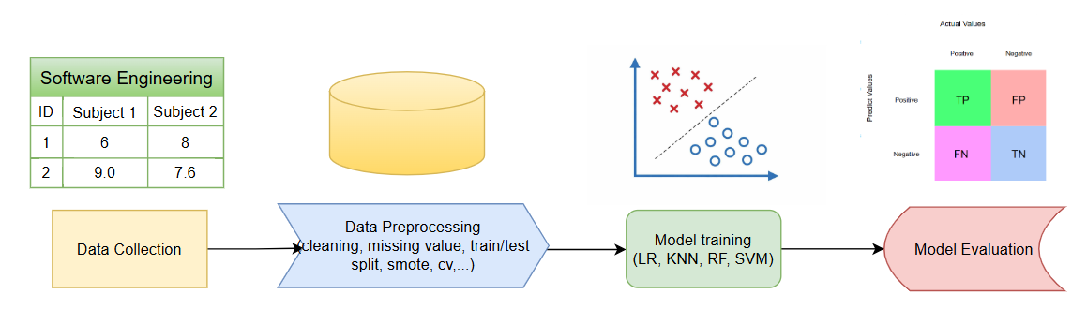
Figure 1 The flowchart of the proposed framework

Figure 1 shows the data preprocessing procedure was conducted as follows. First, the dataset was examined for missing values, and any missing values were handled using a simple imputation strategy. Second, the dataset was divided into training and testing sets using an 80/20 split, preprocessing techniques including missing value imputation and feature scaling were applied to improve data quality. Third, the Borderline-SMOTE technique was applied to generate synthetic samples for the minority class (fail) on the training set, thereby balancing the class distribution. GridSearchCV with 5-fold cross-validation was employed to optimize hyperparameters and feature subset size. the baseline and tuned models were compared to analyze performance improvement and overfitting behavior. Finally, the optimized models were evaluated on the test set and applied for final prediction of student outcomes
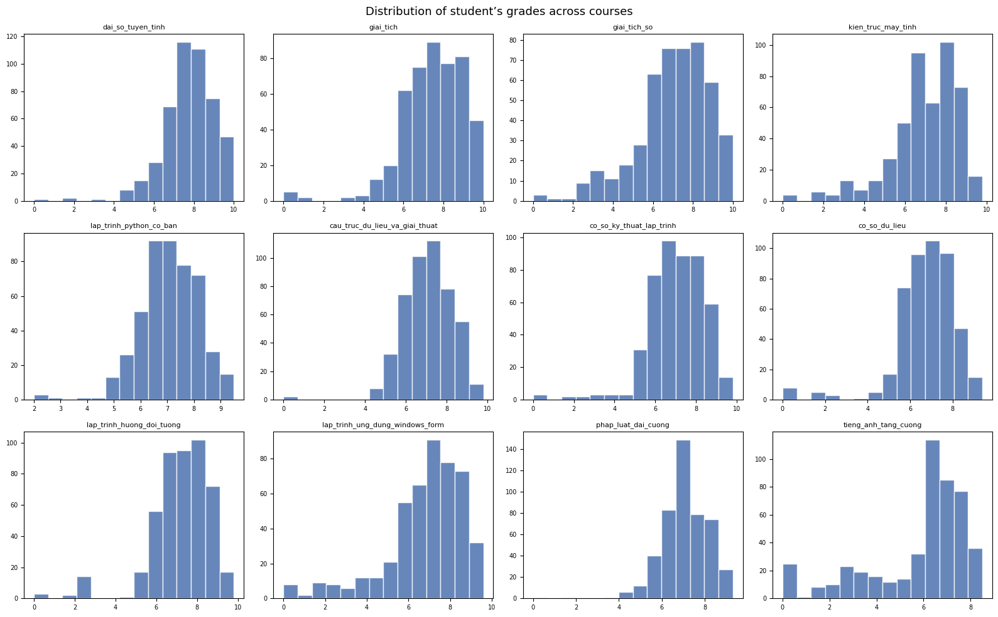
Figure 2 Distribution of student’s grades across courses

Figure 2 presents the distribution of students’ grades across courses from the first three semesters, which are used as input features for the prediction models. As observed, most subjects exhibit a right-skewed distribution, with the majority of students achieving relatively high scores (typically between 6 and 9), while only a small proportion of students receive low scores.
Despite this overall trend, noticeable variations exist among subjects. Some courses, such as General Law and Soft Skills, show highly concentrated distributions with scores clustered in a narrow range, indicating consistent student performance. In contrast, technical subjects such as Data Structures and Algorithms or Numerical Analysis display wider distributions and longer lower tails, suggesting higher variability and potentially greater difficulty.
These differences indicate that the input feature space is heterogeneous, with varying levels of dispersion, skewness, and potential outliers across subjects. Such variability may affect how machine learning models learn feature relationships and decision boundaries. The impact of these characteristics on model performance is further analyzed in Section 4.

3.2 Modeling and prediction
In this study, four supervised machine learning algorithms were implemented and compared, including Logistic Regression (LR), K-Nearest Neighbors (KNN), Random Forest (RF), and Support Vector Machine (SVM).

Logistic Regression
Logistic Regression is a probabilistic classification model in which the probability of a student passing a course is modeled using the sigmoid function:
$$P\left(y=1 | x\right)=\frac{1}{1+e^{-w^{Tx}}}$$ | (1)
where $x$represents the feature vector containing students’ grades from semesters 1–3, and $w$ denotes the model weight vector.

K-Nearest Neighbors
K-Nearest Neighbors (KNN) is a similarity-based classification method in which the label of a student is determined based on the labels of the k nearest neighbors in the feature space. The predicted label is obtained through majority voting among the nearest neighbors.
$$ŷ = argmax_{c∈C}sum_{x_{i}∈N_{k\left(x\right)}}I\left(y_{i}= c\right)$$ | (2)

Random Forest
Random Forest is an ensemble learning model that improves classification performance by combining multiple decision trees. The final prediction is determined by a majority voting mechanism among the trees.
$$ŷ = mode\left(T_{1\left(x\right)}, T_{2\left(x\right)}, … , T_{n\left(x\right)}\right)$$ | (3)

Support Vector Machine
Support Vector Machine (SVM) constructs an optimal separating hyperplane between the pass and fail classes. Using the Radial Basis Function (RBF) kernel, SVM can map the input data into a higher-dimensional feature space to improve classification performance.
$$ŷ = sign\left(w^{Tx}+b\right)$$ | (4)
4 Results and discussion
All experiments were conducted using Python with the Scikit-learn and Imbalanced-learn libraries. In addition, NumPy and Pandas were used for data manipulation and preprocessing, while Matplotlib and Seaborn were utilized for data visualization and analysis. In this study, we implemented four classification models: Logistic Regression (LR), k-Nearest Neighbors (KNN), Random Forest (RF), and Support Vector Machine (SVM). Model performance was evaluated using Precision, Recall, and F1-score reported as weighted averages to account for class imbalance.
Table 4 Comparative Results of Classification Models

Course | Model | Precision | Recall | F1-score
Probability & Statistics | LR | 92.66 | 88.42 | 89.94
 | KNN | 90.35 | 83.16 | 85.88
 | RF | 88.72 | 87.37 | 88.00
 | SVM | 91.19 | 87.37 | 88.87
Basic Web Design | LR | 86.19 | 76.84 | 80.04
 | KNN | 81.62 | 67.37 | 72.47
 | RF | 85.11 | 82.11 | 83.37
 | SVM | 80.07 | 77.89 | 78.92
Software Testing | LR | 93.33 | 84.21 | 87.83
 | KNN | 93.33 | 84.21 | 87.83
 | RF | 93.64 | 87.37 | 89.88
 | SVM | 93.53 | 86.32 | 89.20
Software Engineering | LR | 89.73 | 78.95 | 82.94
 | KNN | 90.98 | 77.89 | 82.39
 | RF | 89.59 | 77.89 | 82.20
 | SVM | 89.34 | 75.79 | 80.71
English 1 | LR | 93.82 | 94.74 | 93.90
 | KNN | 95.33 | 95.79 | 95.39
 | RF | 92.72 | 93.68 | 93.09
 | SVM | 95.97 | 95.79 | 94.78
Project 1 | LR | 89.82 | 85.26 | 86.52
 | KNN | 85.01 | 72.63 | 75.91
 | RF | 86.62 | 78.95 | 81.13
 | SVM | 85.41 | 78.95 | 80.95
Table 4 presents the comparative performance of the four classification models across six target courses in terms of Precision, Recall, and F1-score.
For the Probability & Statistics course, Logistic Regression (LR) achieves the best overall performance with the highest F1-score of 89.94%, supported by Precision of 92.66% and Recall of 88.42%. Although KNN records competitive Precision at 90.35%, its lower Recall (83.16%) results in a lower F1-score of 85.88%. Similarly, SVM and Random Forest (RF) achieve F1-scores of 88.87% and 88.00%, respectively, indicating slightly lower classification effectiveness than LR.
In the Basic Web Design dataset, Random Forest outperforms the other models, achieving the highest F1-score of 83.37%, with balanced Precision (85.11%) and Recall (82.11%). Logistic Regression ranks second with an F1-score of 80.04%, while SVM obtains 78.92%. In contrast, KNN records the lowest F1-score (72.47%) due to its relatively low Recall (67.37%), suggesting weaker predictive performance for this dataset.
For the Software Testing course, all models demonstrate relatively strong classification performance. Among them, Random Forest achieves the best overall result, with the highest F1-score of 89.88%, supported by Precision of 93.64% and Recall of 87.37%. SVM follows closely with an F1-score of 89.20%, while both Logistic Regression and KNN achieve the same F1-score of 87.83%. Overall, the differences among models in this course are relatively small.
In the Software Engineering dataset, Logistic Regression delivers the best performance with the highest F1-score of 82.94%, supported by Precision of 89.73% and Recall of 78.95%. KNN ranks second with an F1-score of 82.39%, followed closely by Random Forest at 82.20%. By comparison, SVM performs slightly worse, achieving the lowest F1-score of 80.71%, mainly due to its lower Recall (75.79%).
For the English 1 course, classification performance is consistently high across all models. KNN achieves the best overall result with the highest F1-score of 95.39%, along with Precision of 95.33% and Recall of 95.79%. SVM records the highest Precision (95.97%) but a slightly lower F1-score of 94.78%. Logistic Regression and Random Forest also perform strongly, achieving F1-scores of 93.90% and 93.09%, respectively, indicating that all models are highly effective for this course.
In the Project 1 dataset, Logistic Regression achieves the best performance with the highest F1-score of 86.52%, supported by Precision of 89.82% and Recall of 85.26%. Random Forest ranks second with an F1-score of 81.13%, followed closely by SVM at 80.95%. By contrast, KNN performs the weakest, achieving the lowest F1-score of 75.91%, mainly due to its substantially lower Recall (72.63%).
Overall, the results indicate that Logistic Regression demonstrates the most stable performance across multiple courses, achieving the best results in three out of six datasets. Meanwhile, Random Forest performs best in Basic Web Design and Software Testing, whereas KNN is the most effective model for English 1. These findings suggest that no single model universally outperforms others across all subjects, and model effectiveness depends on the characteristics of each course dataset.
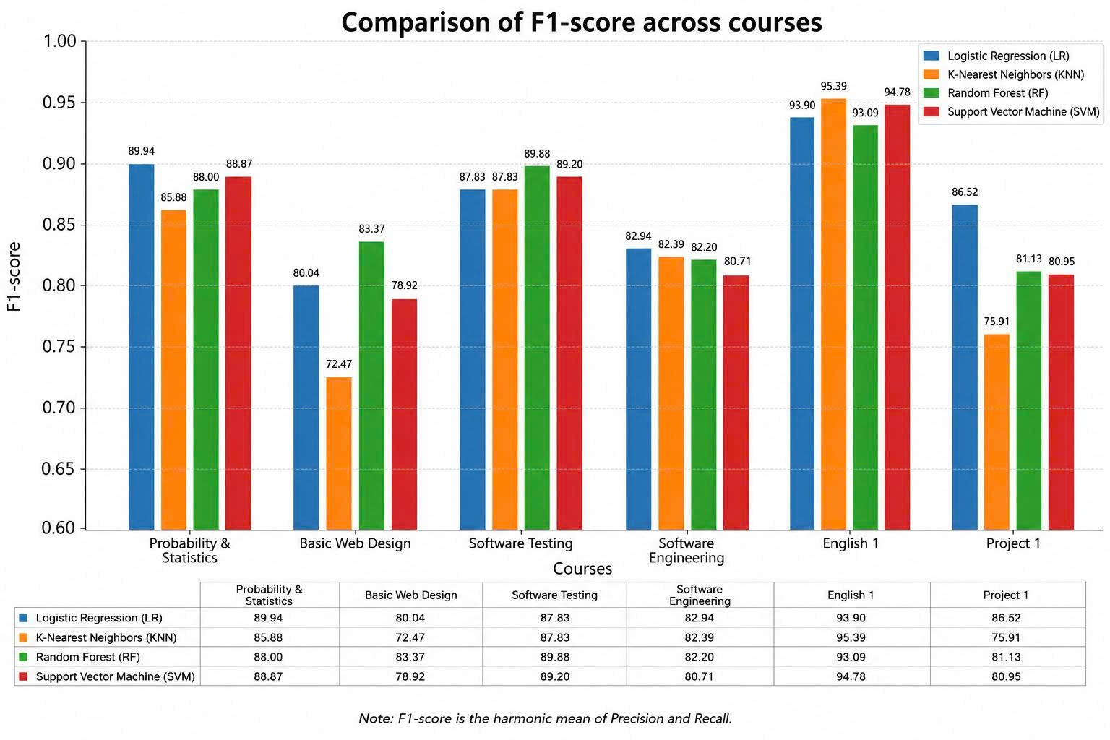
Figure 3 Comparison of F1-score across courses

Figure 3 presents the comparison of weighted F1-scores across six course datasets using four machine learning models, including Logistic Regression (LR), K-Nearest Neighbors (KNN), Random Forest (RF), and Support Vector Machine (SVM). The results demonstrate that model performance varies considerably depending on the characteristics of each course dataset, indicating that no single algorithm consistently achieves the best performance across all tasks. Overall, Random Forest and SVM exhibit relatively stable and competitive performance across most courses, while Logistic Regression performs strongly in several datasets despite its simpler linear structure. In contrast, KNN tends to produce lower F1-scores in multiple courses, suggesting weaker generalization capability under certain data conditions.
Building upon the feature distributions observed in Figure 2, these differences can be explained by both the nature of the datasets and the learning mechanisms of the classification models.
First, each course dataset contains distinct grading behaviors, score distributions, and relationships between previous semester results and final pass/fail outcomes. Courses such as English 1 achieve very high F1-scores across all models, with KNN obtaining the best result (95.39%), indicating that the dataset likely contains clearer class patterns and more separable feature spaces. On the other hand, datasets such as Basic Web Design and Software Engineering produce lower overall scores, suggesting more complex or less predictable relationships among features.
Second, Logistic Regression performs particularly well in Project 1, achieving the highest F1-score of 86.52%. This suggests that the relationship between input features and target labels in this course may be relatively linear and consistent. Since Logistic Regression relies on linear decision boundaries, it can generalize effectively when the dataset structure is stable and less noisy.
By contrast, Random Forest achieves the best performance in courses such as Basic Web Design (83.37%) and Software Testing (89.88%). This can be attributed to its ensemble learning mechanism, which combines multiple decision trees to capture non-linear interactions and complex feature relationships more effectively. The strong performance of Random Forest indicates that these datasets likely contain more diverse and non-linear patterns that simpler linear models cannot fully capture.
Similarly, SVM demonstrates competitive performance across multiple datasets, particularly in English 1 (94.78%) and Software Testing (89.20%). SVM is well known for its ability to construct optimal separating hyperplanes in high-dimensional feature spaces, allowing it to handle structured datasets with clearer class separation effectively.
Third, KNN generally records lower F1-scores in several courses, especially Basic Web Design (72.47%) and Project 1 (75.91%). Because KNN relies heavily on local neighborhood information and distance-based similarity, it is more sensitive to noisy data, overlapping classes, and imbalanced class distributions. As a result, its classification boundaries may become less robust in datasets with high variability or dominant majority classes.
Finally, the variation in results across courses also suggests that the predictive importance of prior academic performance differs depending on the subject. Some courses may depend strongly on cumulative knowledge from previous semesters, while others are influenced by additional hidden factors that are not fully represented in the dataset. Consequently, the optimal classification strategy changes across tasks, further explaining why no single machine learning model consistently outperforms the others in every course dataset.
5 Conclusion
In this paper, we propose a machine learning-based approach for predicting student performance at the course level using historical academic data. By utilizing grades from the first three semesters, early prediction of pass or fail outcomes for six courses in the fourth semester is achieved. The experimental results illustrate that Logistic Regression and Random Forest achieve strong and stable performance across multiple courses, while K-Nearest Neighbors performs effectively in specific cases. It is also observed that model performance varies depending on dataset characteristics, indicating that no single model consistently outperforms others.
These findings highlight the importance of selecting appropriate models based on course-specific data properties. In future work, we plan to explore more advanced models and incorporate additional data sources to further improve prediction performance and model robustness.

References
[1] | Al-Shanableh, N., Alzyoud, M. S., Khalil, A., Benlamine, M., Kraidia, I., Damrah, S., & Tabakhi, A. M. (2026). Forecasting students' academic performance in educational data using machine learning techniques. International Journal of Information and Communication Technology Education (IJICTE), 22(1), 1–23.
[2] | Duch, D., May, M., & George, S. (2026). Enhancing predictive analytics for students’ performance in Moodle: Insight from an empirical study. Journal of Data Science and Intelligent Systems, 4(1), 84–96.
[3] | Misinem, M., et al. (2024). Leveraging data analytics for student grade prediction: A comparative study of data features. Journal of Applied Data Sciences, 5(4), 2025–2038.
[4] | Nayak, P., Vaheed, S., Gupta, S., & Mohan, N. (2023). Predicting students’ academic performance by mining educational data through machine learning-based classification models. Education and Information Technologies, 28(11), 14611–14637. https://doi.org/10.1007/s10639-023-11706-8
[5] | Nachouki, M., Mohamed, E. A., Mehdi, R., & Abou Naaj, M. (2023). Student course grade prediction using the random forest algorithm: Analysis of predictors' importance. Trends in Neuroscience and Education, 33, 100214.
[6] | Syed Mustapha, S.M.F.D. Predictive Analysis of Students’ Learning Performance Using Data Mining Techniques: A Comparative Study of Feature Selection Methods. Appl. Syst. Innov. 2023, 6, 86. https://doi.org/10.3390/asi6050086
[7] | Batool, S., Rashid, J., Nisar, M. W., Kim, J., Kwon, H. Y., & Hussain, A. (2023). Educational data mining to predict students' academic performance: A survey study. Education and Information Technologies, 28(1), 905-971.
[8] | Yağcı, M. Educational data mining: prediction of students' academic performance using machine learning algorithms. Smart Learn. Environ. 9, 11 (2022). https://doi.org/10.1186/s40561-022-00192-z
[9] | Nabil, Aya, Mohammed Seyam, and Ahmed Abou-Elfetouh. "Prediction of students’ academic performance based on courses’ grades using deep neural networks." Ieee Access 9 (2021): 140731-140746.
[10] | Vivek Raj, S. N., and S. K. Manivannan. "Predicting student failure in university examination using machine learning algorithms." forest 84.66.14 (2020): 0-24.

DỰ ĐOÁN KẾT QUẢ HỌC TẬP CỦA SINH VIÊN
DỰA TRÊN MÔ HÌNH HỌC MÁY
Tóm tắt:
Thành công của sinh viên là một vấn đề quan trọng trong giáo dục đại học; do đó, việc dự đoán sớm kết quả học tập có thể giúp giảng viên và nhà trường đưa ra các hỗ trợ kịp thời cho sinh viên. Trong nghiên cứu này, các kỹ thuật học máy được áp dụng để dự đoán kết quả học tập của sinh viên dựa trên điểm số của các học kỳ trước làm đặc trưng đầu vào. Bài báo khảo sát bốn thuật toán học có giám sát, bao gồm: Hồi quy Logistic (LR), K láng giềng gần nhất (KNN), Rừng ngẫu nhiên (RF) và Máy vector hỗ trợ (SVM), được triển khai và đánh giá so sánh. Quy trình tiền xử lý dữ liệu bao gồm: phát hiện và xử lý giá trị thiếu, chia tập dữ liệu thành tập huấn luyện và kiểm tra theo tỷ lệ 80/20, đồng thời áp dụng phương pháp SMOTE và chiến lược kiểm định chéo k-fold trên tập huấn luyện. Hiệu năng của mô hình được đánh giá bằng các chỉ số Precision, Recall và F1-score. Kết quả thực nghiệm cho thấy mô hình Hồi quy Logistic, Rừng ngẫu nhiên và K láng giềng gần nhất đạt hiệu suất cao và ổn định trên nhiều học phần, với F1-score cao nhất là 95,39%. Những phát hiện này chứng minh rằng các mô hình dự đoán dựa trên học máy có thể hỗ trợ hiệu quả việc can thiệp học tập sớm và góp phần cải thiện kết quả học tập của sinh viên.

Từ khóa: Học máy, Phân loại nhị phân, Dự đoán kết quả học tập sinh viên, Khai phá dữ liệu giáo dục.

