# Introduction

* Description

This dataset contains information of Budget, Sales, Product Master from January, 2014 to August, 2020 of a hypothetical company.

* Budget: (11363 rows, 3 columns) expected revenue
* Sales: (34091 rows, 3 columns) actual revenue
* Master: (16 rows, 3 columns) product information (product name and category - 15 products and 4 categories)
* Metric definition
  + Bugdet Variance: It is the difference between the Actual Sales and the Budgeted Sales. It is favourable when greater than 0, it means that the Actual Sales is higher than the Budgeted Sales.
  + YoY Sales Growth: It measures growth rate of sales between the current year and the last year. It is favourable when greater than 0, it means that the revenue is increasing.

# Building dashboard processing

* Step 1: Prepare/Extract data: Collect data related to Sales & Budget of company and Product information
* Step 2: Load and transform data with Power Query: check type of data, change name of tables/columns, split data (if necessary). This dataset doesn’t contain null value so I don’t need replace blank data.
* Step 3: Configure data model: create dimension table (Dim date) and relationship between tables

Create Date Dim Table



Add column in Date Dim Table







Setup Relationship

* Step 4: Calculate: calculate metrics in Sales and Budget table using DAX.

Calculate Measures

* CY Sales

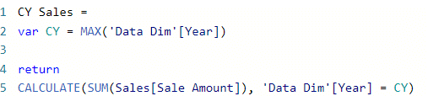

* PY Sales



* YoY Sales Growth (%)



* Budgeted Sales

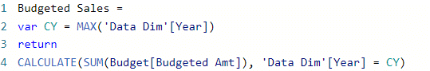

* Budget Variance (%)



Create icon and color growth metrics

* Budget variance icon

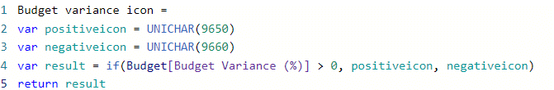

* Budget variance icon color



* YoY sales growth icon

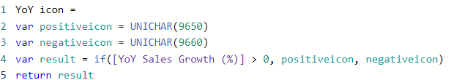

* YoY sales growth icon color



* Step 5: Design dashboard: arrange charts and slicers, add filter and tootltip

# Insight

* **Overall**
  + From 2014 to 2020, Actual Sales had been quite close to Budgeted Sales (Budget Variance = -1.51%).
  + From 2014 to 2019, YoY Sales Growth had remained positive. At the beginning, the growth rate increased extremely fast. In 2015, the revenue doubled between 2014 and 2015. However, the trend is downward. The growth rate of 2016 was around 65% and then dropped to from 30% to 50% between 2017 and 2019. Especially, YoY Growth in 2020 dropped below 0. It could due to lack of sales information in the last 4 months of 2020.
* **By product category**
  + Overall, the Actual sales by product category caught up with the Bugdeted Sales from 2014 to 2019. In 2020, there was a decrease in the Actual Revenue, which made Budget Variance dropped to -12%.
  + Category 1 was the category having highest Budget Variance. However when inspecting why catgory 1 have such impressive Budget Variance from 2018 to 2019. It is because of Revenue Growth from Product 1. Product 1's Revenue increased sharply while its Expected Revenue decreased. That made Budget Variance raised from 77% to 200%.
  + Product's revenue of Category 2, 3, 4 hadn't had big difference from Budgeted Revenue. The Budget Variance fluctuated between -10% and 10%.
  + Sales growth rate between products and categories was quite even, although it reduced noticeably.
* **Sales Distribution**
  + Generally, Category 3's had the biggest revenue. It's because of that have the highest number of products. When dividing into products, there wasn't have much differences betweens them.

# Next steps/Recommendations

* Find out the reason of declinning trend of YoY Sales Growth. It could be result of the law of diminishing marginal utility or not.

Aim: Push sales growth rate

* Analyze business strategy and market demand to make suitable decision

Aim: Ensure the difference between Actual and Predicted Sales not too big

* Finding key products to investing

Aim: create unique products & customer loyalty to reducing the impact of the sudden changes, sustainable revenue growth