File structure
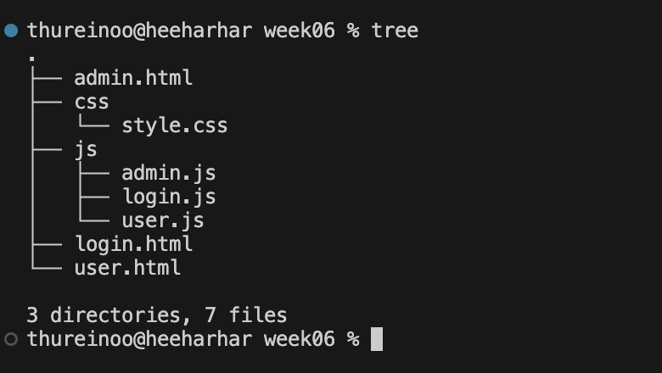
Admin.html
<!DOCTYPE html>
<html>
<head>
<title>User Management</title>
<link rel="stylesheet" href="css/style.css">
</head>
<body>

<div class="admin-container">

<div class="top-bar">
<button class="logout-btn" id="logoutBtn">Logout</button>
</div>

<table>
<thead>
<tr>
<th>ID</th>
<th>Username</th>
<th>Role</th>
<th>Status</th>
</tr>
</thead>
<tbody id="userTable"></tbody>
</table>

</div>

<script src="js/admin.js"></script>
</body>
</html>

Login.html
<!DOCTYPE html>
<html>
<head>
<title>Login to System</title>
<link rel="stylesheet" href="css/style.css">
<script src="https://cdn.jsdelivr.net/npm/sweetalert2@11"></script>
</head>
<body>

<div class="outer-box">
<div class="login-card">
<h2>Login to System</h2>

<input type="text" id="username" placeholder="Email">
<input type="password" id="password" placeholder="Password">

<button id="loginBtn">Login</button>
</div>
</div>

<script src="js/login.js"></script>
</body>
</html>

User.html
<!DOCTYPE html>
<html>
<head>
<title>User Page</title>
<link rel="stylesheet" href="css/style.css">
</head>
<body>

<h2 class="center">User Dashboard</h2>
<p class="center">Welcome, normal user!</p>

<button class="logout" id="logoutBtn">Logout</button>

<script src="js/user.js"></script>
</body>
</html>

Style.css
body {
margin: 0;
font-family: Arial, sans-serif;
background: #d9d9d9;
}

/* ================= LOGIN ================= */

.outer-box {
width: 450px;
margin: 100px auto;
padding: 40px;
border: 2px solid black;
background: #eeeeee;
}

.login-card {
background: #cfd5f6;
padding: 30px;
border-radius: 10px;
text-align: center;
}

.login-card h2 {
color: #3b3bd1;
margin-bottom: 20px;
}

.login-card input {
width: 100%;
padding: 10px;
margin-bottom: 15px;
border: 2px solid #f4c542;
border-radius: 5px;
}

.login-card button {
width: 100%;
padding: 10px;
border: none;
border-radius: 5px;
background: linear-gradient(to right, #4a3cd6, #5f4df0);
color: white;
font-size: 15px;
cursor: pointer;
}

/* ================= ADMIN ================= */

.admin-container {
width: 800px;
margin: 100px auto;
padding: 40px;
border: 2px solid black;
background: #eeeeee;
}

.top-bar {
text-align: right;
margin-bottom: 20px;
}

.logout-btn {
background: #ff5c70;
color: white;
border: none;
padding: 8px 15px;
cursor: pointer;
border-radius: 5px;
}

table {
width: 100%;
border-collapse: collapse;
background: white;
}

th {
background: #18a4d9;
color: white;
padding: 12px;
}

td {
padding: 12px;
text-align: center;
border-top: 1px solid #ccc;
}

/* Toggle switch */

.switch {
position: relative;
display: inline-block;
width: 50px;
height: 24px;
}

.switch input {
display: none;
}

.slider {
position: absolute;
cursor: pointer;
background-color: #ccc;
border-radius: 24px;
top: 0;
left: 0;
right: 0;
bottom: 0;
}

.slider:before {
position: absolute;
content: "";
height: 18px;
width: 18px;
left: 3px;
bottom: 3px;
background: white;
border-radius: 50%;
transition: 0.3s;
}

input:checked + .slider {
background-color: #18a4d9;
}

input:checked + .slider:before {
transform: translateX(26px);
}

Admin.js
let currentUser = JSON.parse(sessionStorage.currentUser || "null");

if (!currentUser || currentUser.role != 1) {
window.location = "login.html";
}

let users = JSON.parse(sessionStorage.users);
let table = document.getElementById("userTable");

function loadUsers() {

table.innerHTML = "";

users.forEach(user => {

let disabled = user.role == 1 ? "disabled" : "";

let row = `
<tr>
<td>${user.id}</td>
<td>${user.username}</td>
<td>${user.role == 1 ? "Admin" : "User"}</td>
<td>
<label class="switch">
<input type="checkbox"
${user.status ? "checked" : ""}
${disabled}
onchange="toggleStatus(${user.id})">
<span class="slider"></span>
</label>
${user.status ? "Enable" : "Disable"}
</td>
</tr>
`;

table.innerHTML += row;
});

sessionStorage.users = JSON.stringify(users);
}

function toggleStatus(id) {

let user = users.find(u => u.id === id);

if (user.role == 1) return;

user.status = !user.status;

loadUsers();
}

document.getElementById("logoutBtn").addEventListener("click", function () {
sessionStorage.removeItem("currentUser");
window.location = "login.html";
});

loadUsers();

login.js
var users = [];

if (sessionStorage.users == null) {

users = [
{ id: 1, username: "admin", password: "1111", role: 1, status: true },
{ id: 2, username: "aaa", password: "2222", role: 2, status: true },
{ id: 3, username: "bbb", password: "3333", role: 2, status: false }
];

sessionStorage.users = JSON.stringify(users);

} else {
users = JSON.parse(sessionStorage.users);
}

document.getElementById("loginBtn").addEventListener("click", function () {

let uname = document.getElementById("username").value;
let pass = document.getElementById("password").value;

let user = users.find(u => u.username === uname && u.password === pass);

if (!user) {
Swal.fire({
icon: 'error',
title: 'Login Failed',
text: 'Username or Password is incorrect'
});
return;
}

if (!user.status) {
Swal.fire({
icon: 'error',
title: 'Login Failed',
text: 'Your account is disabled'
});
return;
}

sessionStorage.currentUser = JSON.stringify(user);

if (user.role == 1) {
window.location = "admin.html";
} else {
Swal.fire({
icon: 'success',
title: 'Login Successful',
text: 'Welcome ' + user.username
});
}
});

User.js
let currentUser = JSON.parse(sessionStorage.currentUser || "null");

if (!currentUser || currentUser.role != 2) {
window.location = "login.html";
}

document.getElementById("logoutBtn").addEventListener("click", function () {
sessionStorage.removeItem("currentUser");
window.location = "login.html";
});

UI design
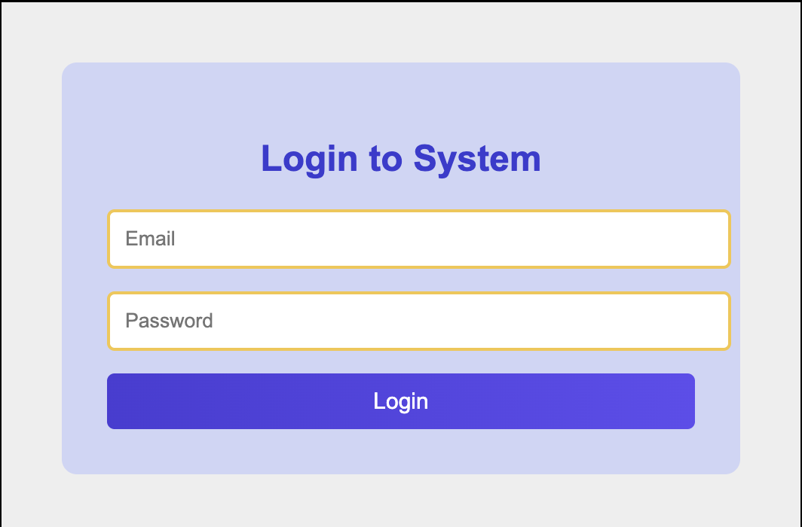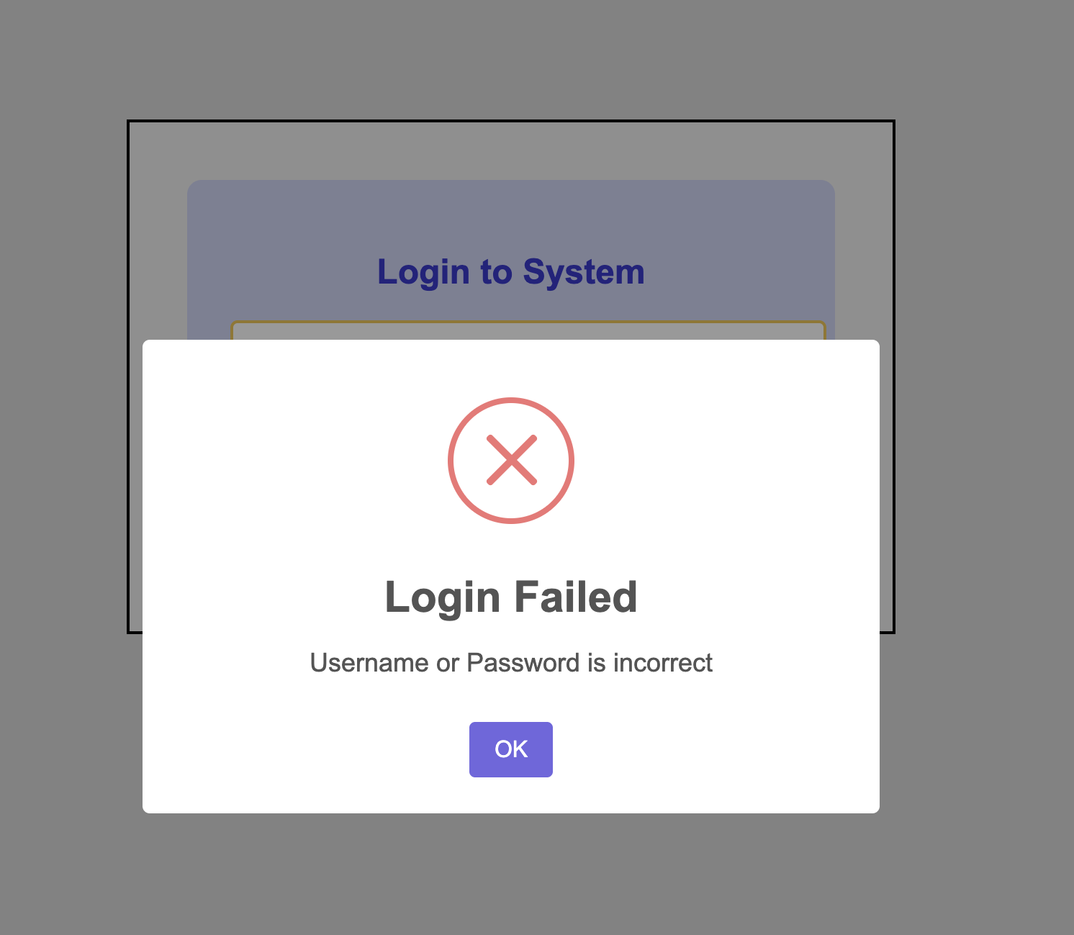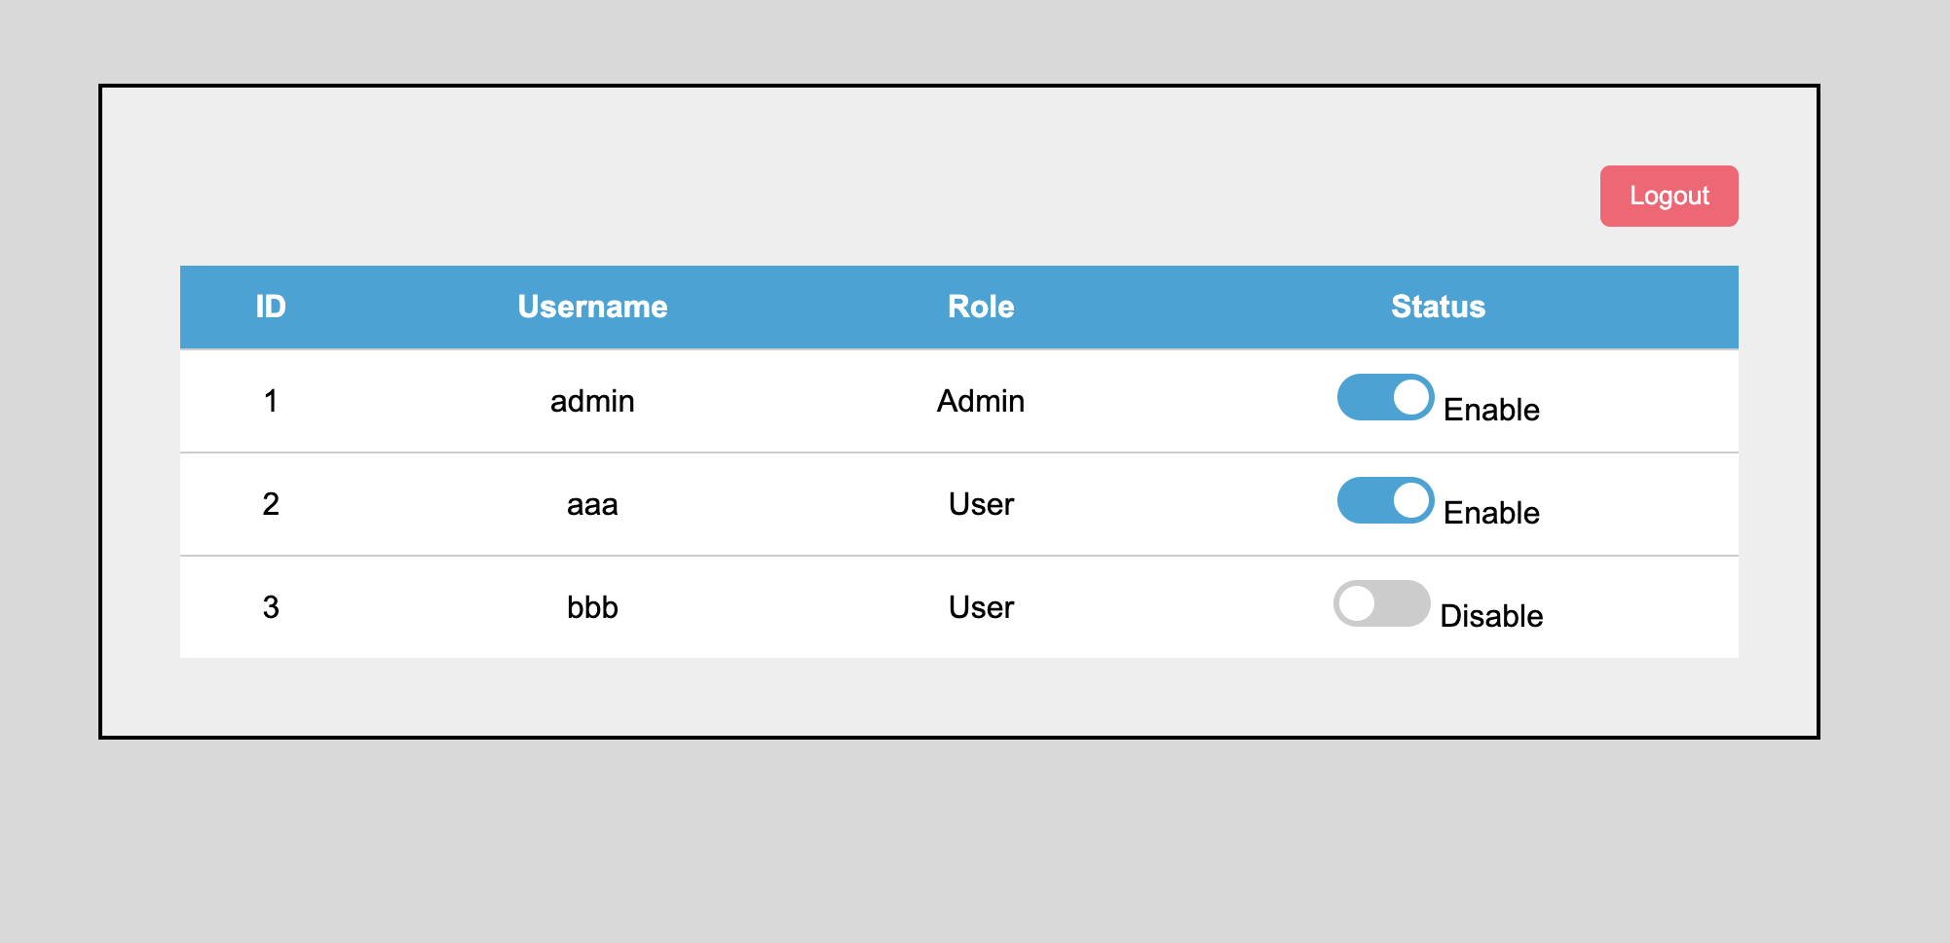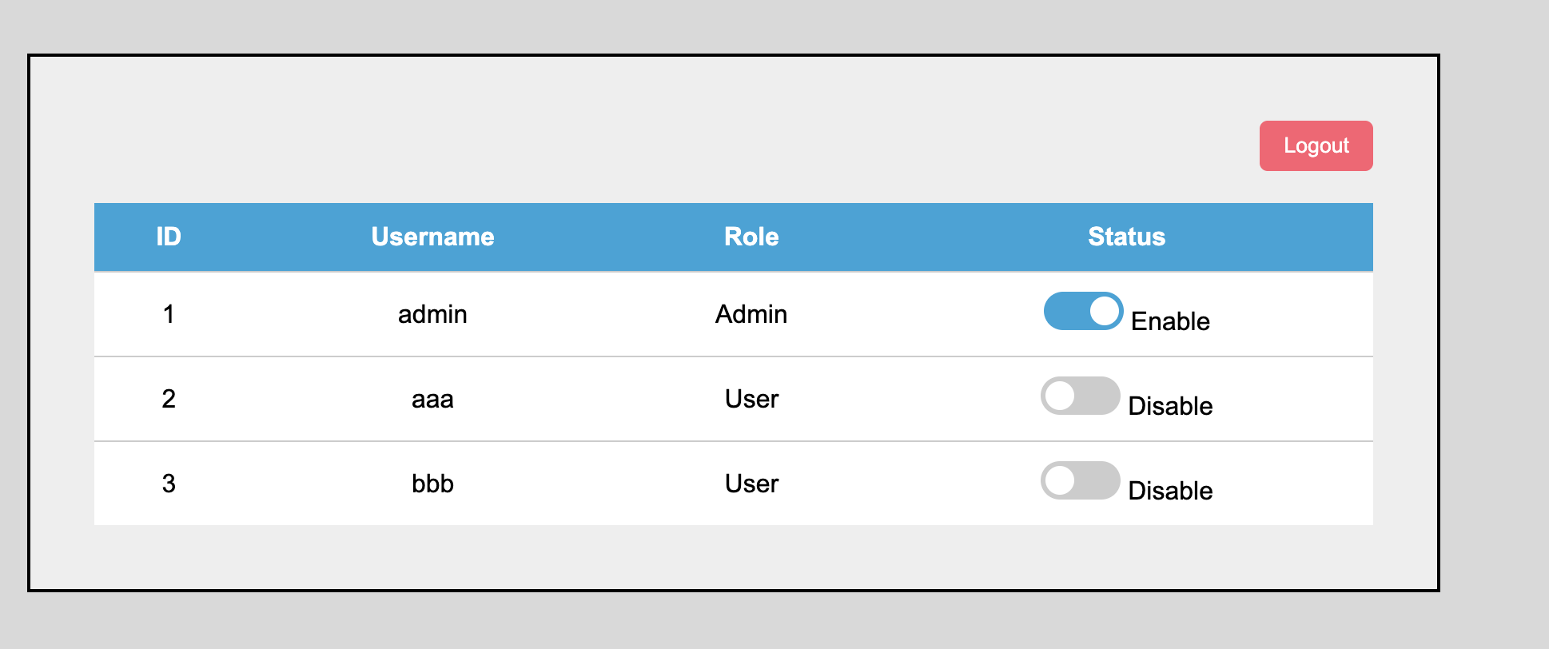
Admin cannot disable
