**THAY ĐỔI KÍCH THƯỚC KERNEL**

|  |
| --- |
| convnet = [imageInputLayer([7400 1])  convolution2dLayer([102 1],3,'stride',1)  maxPooling2dLayer([2 1],'stride',2)  convolution2dLayer([24 1],10,'numChannels',3)  maxPooling2dLayer([2 1],'stride',2)  convolution2dLayer([11 1],10,'stride',1,'numChannels',10)  maxPooling2dLayer([2 1],'stride',2)  convolution2dLayer([9 1],10,'numChannels',10)  maxPooling2dLayer([2 1],'stride',2)  fullyConnectedLayer(30)  fullyConnectedLayer(10)  fullyConnectedLayer(2)  softmaxLayer  classificationLayer]; |

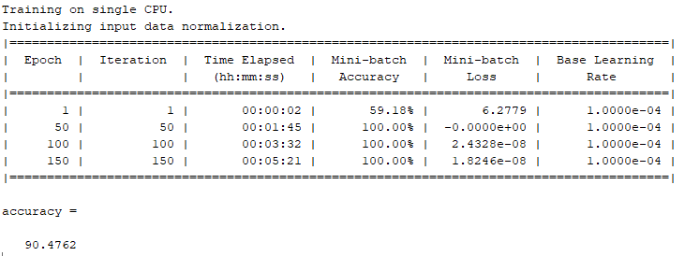

|  |
| --- |
| convnet = [imageInputLayer([7400 1])  convolution2dLayer([**105** 1],3,'stride',1)  maxPooling2dLayer([2 1],'stride',2)  convolution2dLayer([24 1],10,'numChannels',3)  maxPooling2dLayer([2 1],'stride',2)  convolution2dLayer([11 1],10,'stride',1,'numChannels',10)  maxPooling2dLayer([2 1],'stride',2)  convolution2dLayer([9 1],10,'numChannels',10)  maxPooling2dLayer([2 1],'stride',2)  fullyConnectedLayer(30)  fullyConnectedLayer(10)  fullyConnectedLayer(2)  softmaxLayer  classificationLayer]; |

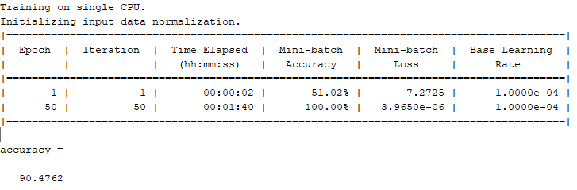

|  |
| --- |
| convnet = [imageInputLayer([7400 1])  convolution2dLayer([**110** 1],3,'stride',1)  maxPooling2dLayer([2 1],'stride',2)  convolution2dLayer([24 1],10,'numChannels',3)  maxPooling2dLayer([2 1],'stride',2)  convolution2dLayer([11 1],10,'stride',1,'numChannels',10)  maxPooling2dLayer([2 1],'stride',2)  convolution2dLayer([9 1],10,'numChannels',10)  maxPooling2dLayer([2 1],'stride',2)  fullyConnectedLayer(30)  fullyConnectedLayer(10)  fullyConnectedLayer(2)  softmaxLayer  classificationLayer]; |

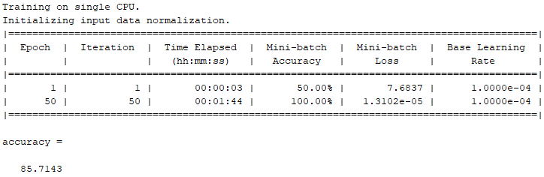

|  |
| --- |
| convnet = [imageInputLayer([7400 1])  convolution2dLayer([**100** 1],3,'stride',1)  maxPooling2dLayer([2 1],'stride',2)  convolution2dLayer([24 1],10,'numChannels',3)  maxPooling2dLayer([2 1],'stride',2)  convolution2dLayer([11 1],10,'stride',1,'numChannels',10)  maxPooling2dLayer([2 1],'stride',2)  convolution2dLayer([9 1],10,'numChannels',10)  maxPooling2dLayer([2 1],'stride',2)  fullyConnectedLayer(30)  fullyConnectedLayer(10)  fullyConnectedLayer(2)  softmaxLayer  classificationLayer]; |

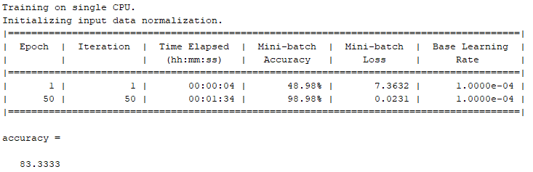

|  |
| --- |
| convnet = [imageInputLayer([7400 1])  convolution2dLayer([**90** 1],3,'stride',1)  maxPooling2dLayer([2 1],'stride',2)  convolution2dLayer([24 1],10,'numChannels',3)  maxPooling2dLayer([2 1],'stride',2)  convolution2dLayer([11 1],10,'stride',1,'numChannels',10)  maxPooling2dLayer([2 1],'stride',2)  convolution2dLayer([9 1],10,'numChannels',10)  maxPooling2dLayer([2 1],'stride',2)  fullyConnectedLayer(30)  fullyConnectedLayer(10)  fullyConnectedLayer(2)  softmaxLayer  classificationLayer]; |

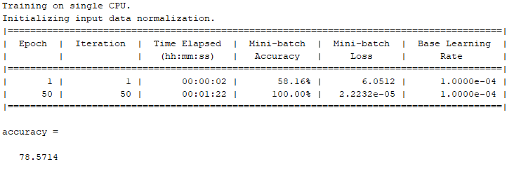

**THAY ĐỔI SỐ LƯỢNG KERNEL**

|  |
| --- |
| convnet = [imageInputLayer([7400 1])  convolution2dLayer([102 1],**2**,'stride',1)  maxPooling2dLayer([2 1],'stride',2)  convolution2dLayer([24 1],10,'numChannels',**2**)  maxPooling2dLayer([2 1],'stride',2)  convolution2dLayer([11 1],10,'stride',1,'numChannels',10)  maxPooling2dLayer([2 1],'stride',2)  convolution2dLayer([9 1],10,'numChannels',10)  maxPooling2dLayer([2 1],'stride',2)  fullyConnectedLayer(30)  fullyConnectedLayer(10)  fullyConnectedLayer(2)  softmaxLayer  classificationLayer]; |

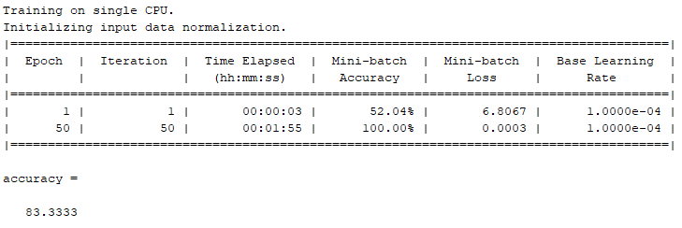

|  |
| --- |
| convnet = [imageInputLayer([7400 1])  convolution2dLayer([102 1],1,'stride',**1**)  maxPooling2dLayer([2 1],'stride',2)  convolution2dLayer([24 1],10,'numChannels',**1**)  maxPooling2dLayer([2 1],'stride',2)  convolution2dLayer([11 1],10,'stride',1,'numChannels',10)  maxPooling2dLayer([2 1],'stride',2)  convolution2dLayer([9 1],10,'numChannels',10)  maxPooling2dLayer([2 1],'stride',2)  fullyConnectedLayer(30)  fullyConnectedLayer(10)  fullyConnectedLayer(2)  softmaxLayer  classificationLayer]; |

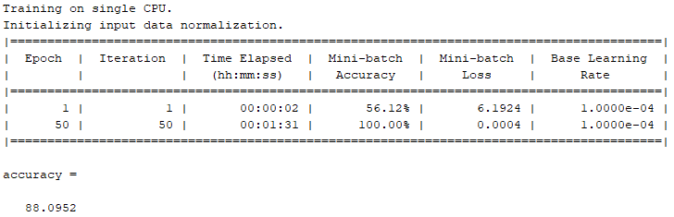

|  |
| --- |
| convnet = [imageInputLayer([7400 1])  convolution2dLayer([102 1],**4**,'stride',1)  maxPooling2dLayer([2 1],'stride',2)  convolution2dLayer([24 1],10,'numChannels',**4**)  maxPooling2dLayer([2 1],'stride',2)  convolution2dLayer([11 1],10,'stride',1,'numChannels',10)  maxPooling2dLayer([2 1],'stride',2)  convolution2dLayer([9 1],10,'numChannels',10)  maxPooling2dLayer([2 1],'stride',2)  fullyConnectedLayer(30)  fullyConnectedLayer(10)  fullyConnectedLayer(2)  softmaxLayer  classificationLayer]; |

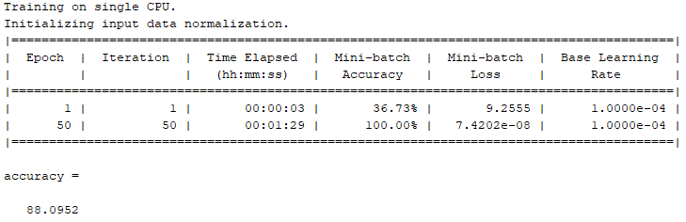

|  |
| --- |
| convnet = [imageInputLayer([7400 1])  convolution2dLayer([200 1],**13**,'stride',1)  maxPooling2dLayer([2 1],'stride',2)  convolution2dLayer([24 1],10,'numChannels',**13**)  maxPooling2dLayer([2 1],'stride',2)  convolution2dLayer([11 1],10,'stride',1,'numChannels',10)  maxPooling2dLayer([2 1],'stride',2)  convolution2dLayer([9 1],10,'numChannels',10)  maxPooling2dLayer([2 1],'stride',2)  fullyConnectedLayer(30)  fullyConnectedLayer(10)  fullyConnectedLayer(2)  softmaxLayer  classificationLayer]; |

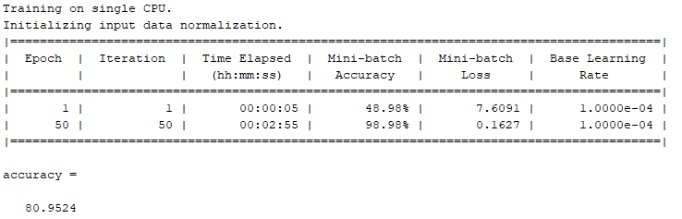

Lần 2  
