**THAY ĐỔI KÍCH THƯỚC KERNEL**

|  |
| --- |
| convnet = [imageInputLayer([7400 1])  convolution2dLayer([102 1],3,'stride',1)  maxPooling2dLayer([2 1],'stride',2)  convolution2dLayer([24 1],10,'numChannels',3)  maxPooling2dLayer([2 1],'stride',2)  convolution2dLayer([11 1],10,'stride',1,'numChannels',10)  maxPooling2dLayer([2 1],'stride',2)  convolution2dLayer([9 1],10,'numChannels',10)  maxPooling2dLayer([2 1],'stride',2)  fullyConnectedLayer(30)  fullyConnectedLayer(10)  fullyConnectedLayer(2)  softmaxLayer  classificationLayer]; |

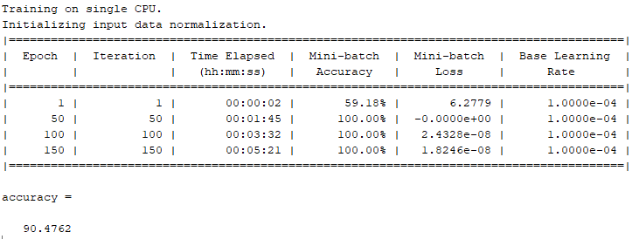

|  |
| --- |
| convnet = [imageInputLayer([7400 1])  convolution2dLayer([**105** 1],3,'stride',1)  maxPooling2dLayer([2 1],'stride',2)  convolution2dLayer([24 1],10,'numChannels',3)  maxPooling2dLayer([2 1],'stride',2)  convolution2dLayer([11 1],10,'stride',1,'numChannels',10)  maxPooling2dLayer([2 1],'stride',2)  convolution2dLayer([9 1],10,'numChannels',10)  maxPooling2dLayer([2 1],'stride',2)  fullyConnectedLayer(30)  fullyConnectedLayer(10)  fullyConnectedLayer(2)  softmaxLayer  classificationLayer]; |

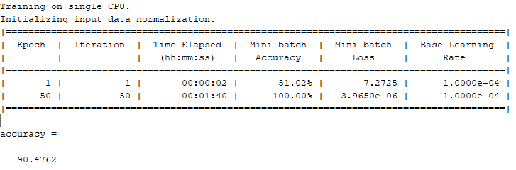

|  |
| --- |
| convnet = [imageInputLayer([7400 1])  convolution2dLayer([**110** 1],3,'stride',1)  maxPooling2dLayer([2 1],'stride',2)  convolution2dLayer([24 1],10,'numChannels',3)  maxPooling2dLayer([2 1],'stride',2)  convolution2dLayer([11 1],10,'stride',1,'numChannels',10)  maxPooling2dLayer([2 1],'stride',2)  convolution2dLayer([9 1],10,'numChannels',10)  maxPooling2dLayer([2 1],'stride',2)  fullyConnectedLayer(30)  fullyConnectedLayer(10)  fullyConnectedLayer(2)  softmaxLayer  classificationLayer]; |

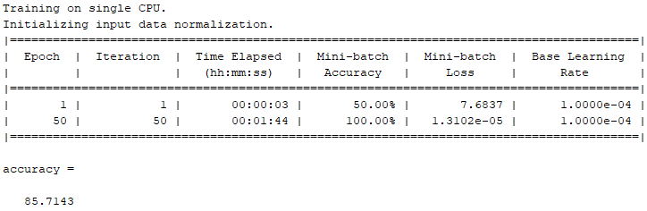

|  |
| --- |
| convnet = [imageInputLayer([7400 1])  convolution2dLayer([**100** 1],3,'stride',1)  maxPooling2dLayer([2 1],'stride',2)  convolution2dLayer([24 1],10,'numChannels',3)  maxPooling2dLayer([2 1],'stride',2)  convolution2dLayer([11 1],10,'stride',1,'numChannels',10)  maxPooling2dLayer([2 1],'stride',2)  convolution2dLayer([9 1],10,'numChannels',10)  maxPooling2dLayer([2 1],'stride',2)  fullyConnectedLayer(30)  fullyConnectedLayer(10)  fullyConnectedLayer(2)  softmaxLayer  classificationLayer]; |

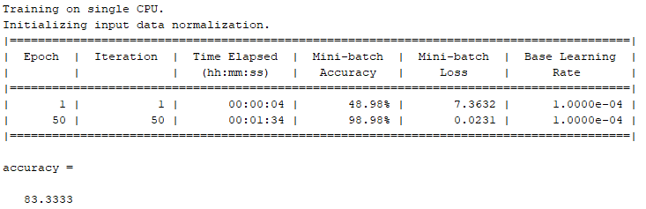

|  |
| --- |
| convnet = [imageInputLayer([7400 1])  convolution2dLayer([**90** 1],3,'stride',1)  maxPooling2dLayer([2 1],'stride',2)  convolution2dLayer([24 1],10,'numChannels',3)  maxPooling2dLayer([2 1],'stride',2)  convolution2dLayer([11 1],10,'stride',1,'numChannels',10)  maxPooling2dLayer([2 1],'stride',2)  convolution2dLayer([9 1],10,'numChannels',10)  maxPooling2dLayer([2 1],'stride',2)  fullyConnectedLayer(30)  fullyConnectedLayer(10)  fullyConnectedLayer(2)  softmaxLayer  classificationLayer]; |

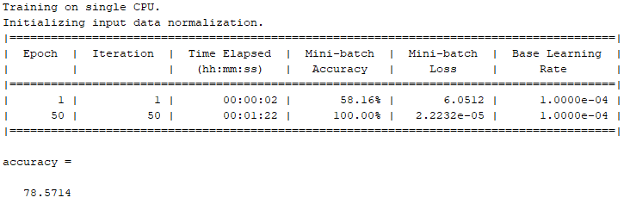

**THAY ĐỔI SỐ LƯỢNG KERNEL**

|  |
| --- |
| convnet = [imageInputLayer([7400 1])  convolution2dLayer([102 1],**2**,'stride',1)  maxPooling2dLayer([2 1],'stride',2)  convolution2dLayer([24 1],10,'numChannels',**2**)  maxPooling2dLayer([2 1],'stride',2)  convolution2dLayer([11 1],10,'stride',1,'numChannels',10)  maxPooling2dLayer([2 1],'stride',2)  convolution2dLayer([9 1],10,'numChannels',10)  maxPooling2dLayer([2 1],'stride',2)  fullyConnectedLayer(30)  fullyConnectedLayer(10)  fullyConnectedLayer(2)  softmaxLayer  classificationLayer]; |

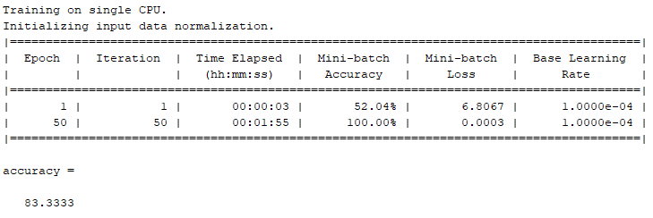

|  |
| --- |
| convnet = [imageInputLayer([7400 1])  convolution2dLayer([102 1],1,'stride',**1**)  maxPooling2dLayer([2 1],'stride',2)  convolution2dLayer([24 1],10,'numChannels',**1**)  maxPooling2dLayer([2 1],'stride',2)  convolution2dLayer([11 1],10,'stride',1,'numChannels',10)  maxPooling2dLayer([2 1],'stride',2)  convolution2dLayer([9 1],10,'numChannels',10)  maxPooling2dLayer([2 1],'stride',2)  fullyConnectedLayer(30)  fullyConnectedLayer(10)  fullyConnectedLayer(2)  softmaxLayer  classificationLayer]; |

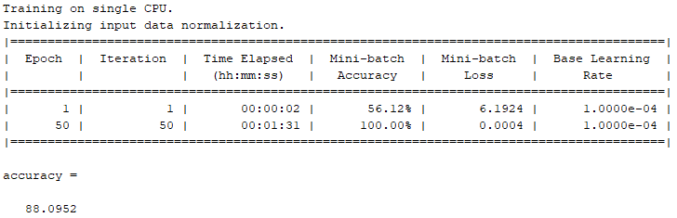

|  |
| --- |
| convnet = [imageInputLayer([7400 1])  convolution2dLayer([102 1],**4**,'stride',1)  maxPooling2dLayer([2 1],'stride',2)  convolution2dLayer([24 1],10,'numChannels',**4**)  maxPooling2dLayer([2 1],'stride',2)  convolution2dLayer([11 1],10,'stride',1,'numChannels',10)  maxPooling2dLayer([2 1],'stride',2)  convolution2dLayer([9 1],10,'numChannels',10)  maxPooling2dLayer([2 1],'stride',2)  fullyConnectedLayer(30)  fullyConnectedLayer(10)  fullyConnectedLayer(2)  softmaxLayer  classificationLayer]; |

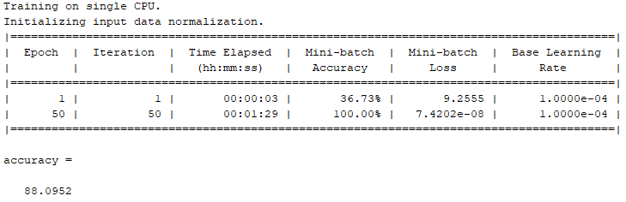

|  |
| --- |
| convnet = [imageInputLayer([7400 1])  convolution2dLayer([200 1],**13**,'stride',1)  maxPooling2dLayer([2 1],'stride',2)  convolution2dLayer([24 1],10,'numChannels',**13**)  maxPooling2dLayer([2 1],'stride',2)  convolution2dLayer([11 1],10,'stride',1,'numChannels',10)  maxPooling2dLayer([2 1],'stride',2)  convolution2dLayer([9 1],10,'numChannels',10)  maxPooling2dLayer([2 1],'stride',2)  fullyConnectedLayer(30)  fullyConnectedLayer(10)  fullyConnectedLayer(2)  softmaxLayer  classificationLayer]; |

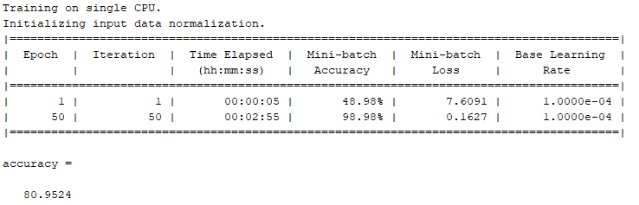

Lần 2  
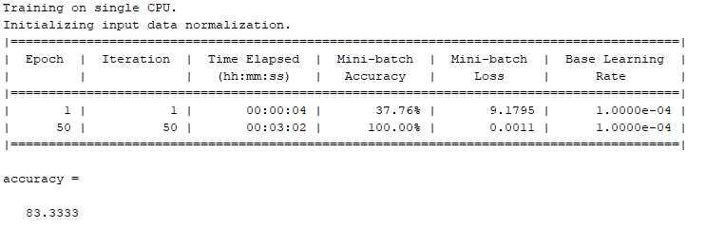

**THAY ĐỔI KÍCH THƯỚC KERNEL CỦA NHIỀU LỚP**

|  |
| --- |
| convnet = [imageInputLayer([7400 1])  convolution2dLayer([**102** 1],3,'stride',1)  maxPooling2dLayer([2 1],'stride',2)  convolution2dLayer([**26** 1],10,'numChannels',3)  maxPooling2dLayer([2 1],'stride',2)  convolution2dLayer([**13** 1],10,'stride',1,'numChannels',10)  maxPooling2dLayer([2 1],'stride',2)  convolution2dLayer([**11** 1],10,'numChannels',10)  maxPooling2dLayer([2 1],'stride',2)  fullyConnectedLayer(30)  fullyConnectedLayer(10)  fullyConnectedLayer(2)  softmaxLayer  classificationLayer]; |

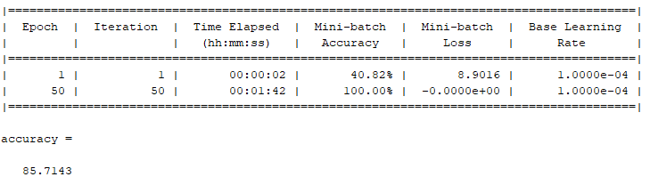

Nhận xét: Accuracy thấp hơn so với cấu hình gốc

|  |
| --- |
| convnet = [imageInputLayer([7400 1])  convolution2dLayer([**102** 1],3,'stride',1)  maxPooling2dLayer([2 1],'stride',2)  convolution2dLayer([**28** 1],10,'numChannels',3)  maxPooling2dLayer([2 1],'stride',2)  convolution2dLayer([**15** 1],10,'stride',1,'numChannels',10)  maxPooling2dLayer([2 1],'stride',2)  convolution2dLayer([**13** 1],10,'numChannels',10)  maxPooling2dLayer([2 1],'stride',2)  fullyConnectedLayer(30)  fullyConnectedLayer(10)  fullyConnectedLayer(2)  softmaxLayer  classificationLayer]; |

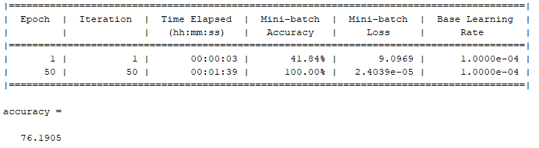

Nhận xét: Accuracy thấp hơn so với cấu hình gốc

|  |
| --- |
| convnet = [imageInputLayer([7400 1])  convolution2dLayer([105 1],3,'stride',1)  maxPooling2dLayer([2 1],'stride',2)  convolution2dLayer([30 1],10,'numChannels',3)  maxPooling2dLayer([2 1],'stride',2)  convolution2dLayer([17 1],10,'stride',1,'numChannels',10)  maxPooling2dLayer([2 1],'stride',2)  convolution2dLayer([15 1],10,'numChannels',10)  maxPooling2dLayer([2 1],'stride',2)  fullyConnectedLayer(30)  fullyConnectedLayer(10)  fullyConnectedLayer(2)  softmaxLayer  classificationLayer]; |

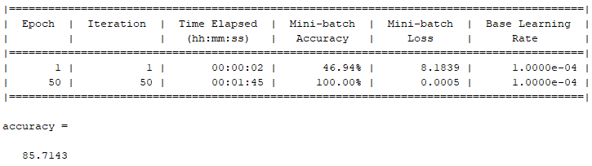

Nhận xét: Accuracy thấp hơn so với cấu hình gốc

|  |
| --- |
| convnet = [imageInputLayer([7400 1])  convolution2dLayer([**98** 1],3,'stride',1)  maxPooling2dLayer([2 1],'stride',2)  convolution2dLayer([**20** 1],10,'numChannels',3)  maxPooling2dLayer([2 1],'stride',2)  convolution2dLayer([**7** 1],10,'stride',1,'numChannels',10)  maxPooling2dLayer([2 1],'stride',2)  convolution2dLayer([**5** 1],10,'numChannels',10)  maxPooling2dLayer([2 1],'stride',2)  fullyConnectedLayer(30)  fullyConnectedLayer(10)  fullyConnectedLayer(2)  softmaxLayer  classificationLayer]; |

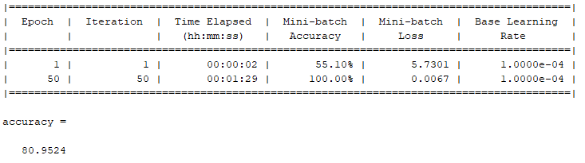

|  |
| --- |
| convnet = [imageInputLayer([7400 1])  convolution2dLayer([98 1],3,'stride',1)  maxPooling2dLayer([2 1],'stride',2)  convolution2dLayer([20 1],10,'numChannels',3)  maxPooling2dLayer([2 1],'stride',2)  convolution2dLayer([7 1],10,'stride',1,'numChannels',10)  maxPooling2dLayer([2 1],'stride',2)  convolution2dLayer([5 1],10,'numChannels',10)  maxPooling2dLayer([2 1],'stride',2)  fullyConnectedLayer(30)  fullyConnectedLayer(10)  fullyConnectedLayer(2)  softmaxLayer  classificationLayer]; |

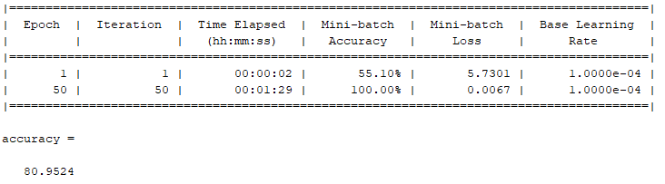

Nhận xét: Accuracy thấp hơn so với cấu hình gốc

**KIỂM TRA ACCURACY SAU KHI QUA BỘ LỌC STRAVITZKY GOLAY**

|  |
| --- |
| %% Load data  clear ; clc;  load('Dx.mat');  Dx=Dx';  for i = 1:98  Dy_Sgolay(:,i) = sgolayfilt(Dy(:,i),1,101);  end  Dx=Dx'; |

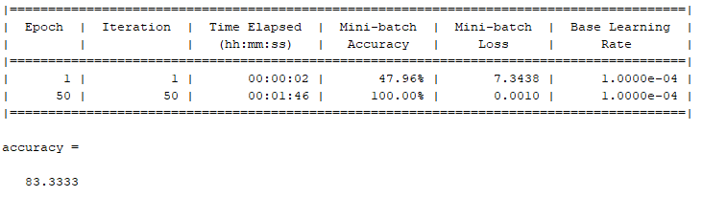

Nhận xét: Accuracy thấp hơn so với tín hiệu gốc