

Capstone Project Report
Report 4 – Software Design Document
OptiPack AI – AI-Assisted Omnichannel Order Fulfillment and Packaging Optimization (FA26SE036)

– Ho Chi Minh City, October 2026 –

Table of Contents
I. Record of Changes 3
II. Software Design Document 4
1. System Design 4
1.1 System Architecture 4
1.2 Package Diagram 5
1.3 Technology Declaration 5
2. Database Design 8
3. Main Business Workflows 10
3.1 End-to-End Overview 11
3.2 WF-01 Order Intake & Consolidation 11
3.3 WF-02 Picking 12
3.4 WF-03 Packing 13
3.5 WF-04 Shipping via GHN 15
3.6 WF-05 Return / Exchange via AURELLE 16
3.7 WF-06 Stock Receiving by Lot 16
3.8 State Machine Diagrams 17
4. Detailed Design 18
4.1 Authentication and Account Management 18
4.2 Marketplace Integration and Order Intake 18
4.3 Warehouse and Inventory 19
4.4 Picking 19
4.5 Packing 19
4.6 Shipping 19
4.7 Returns and Exchanges 20
4.8 Marketplace Write-back 20
4.9 AURELLE Website 20
4.10 History and Notifications 20

I. Record of Changes
Date | A*  M, D | In charge | Change Description
24/10/2026 | A | ThuanNPM | Initial SDD for Review 2: system architecture, technology declaration, package descriptions, database design, main business workflows with activity diagrams, detailed design per feature.
25/10/2026 | M | ThuanNPM | Aligned with the code: two web front ends plus the AURELLE Open API simulator; mobile app listed as planned (Iteration 3); Tiki / TikTok adapters not registered; CI jobs, release trigger, branches and Git hooks as configured in the repository; staging environment marked as not available; packing-plan states include approved; collection names corrected (customers, packaging_bags).
*A - Added M - Modified D - Deleted

II. Software Design Document

1. System Design

1.1 System Architecture
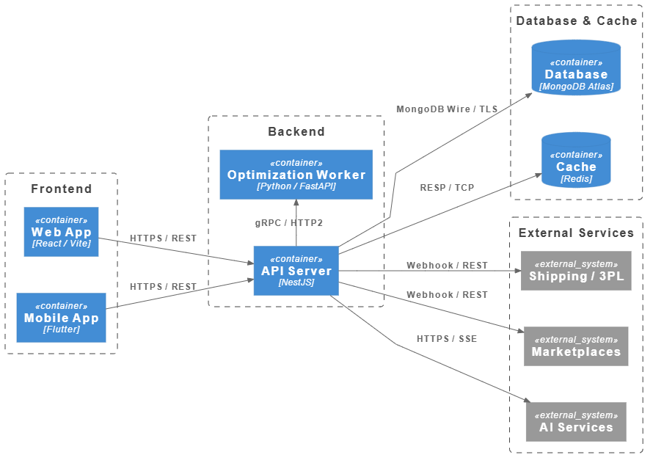
Figure 1. OptiPack AI system architecture
OptiPack AI follows a client–server architecture with a modular monolithic back end. Two web front ends (the OptiPack staff portal and the AURELLE website with its admin and developer pages) call one REST API; the AURELLE Open API used as the second marketplace runs as a separate simulator process (be/scripts/aurelle-mock-server.ts, port 4000) that reads the AURELLE data. Time-based work (order sync, packing-plan computation, status write-back) runs as scheduled jobs inside the back end. The 3D packing proof service runs as a separate internal service and is optional.
Component | Technology | Responsibility
OptiPack staff portal (fe) | React 19, Vite, Tailwind CSS, three.js | Web UI for the five staff roles; role-based menus and routes; 3D packing viewer.
AURELLE website (storefront) | Next.js 15, React 19 | Customer shop (catalog, cart, checkout, order tracking, returns), web admin, developer portal.
Back end API (be) | NestJS 11 (Node.js, TypeScript) | REST API, authentication / RBAC, business logic of all modules, scheduled jobs, webhooks, AURELLE website back end and Open API mapper.
Packer service (packer) | Python 3.12, FastAPI, OR-Tools CP-SAT | Internal HTTP service that proves / improves 3D packing plans; if it is down the back end uses its built-in BRKGA solver.
Database | MongoDB Atlas (Mongoose ODM) | All business data (57 collections); multi-document transactions for stock and status changes.
Cache | Redis | Authentication state cache.
Mobile app | Flutter (planned) | Planned for Iteration 3; not implemented in this release (scanning is done on the staff portal).
External services | Lazada, GHN, Google OAuth, SMTP, AI text API | See section 1.3 Technology Declaration.

1.2 Package Diagram
[Insert Figure 2 – Package Diagram]
Figure 2. Package diagram
Package descriptions
No | Package | Description
01 | be/src/modules/auth | Login, Google OAuth, JWT access / refresh tokens, two-factor authentication, password reset, guards and role decorators.
02 | be/src/modules/users | Staff accounts, roles, leave status, account lock / reactivation.
03 | be/src/modules/marketplace-integration | Marketplace adapters registered for Lazada and AURELLE (shared Lazada-style protocol client), OAuth connect / disconnect, encrypted shop tokens. Tiki and TikTok adapter files exist but are not registered.
04 | be/src/modules/marketplace-webhooks | Receives and verifies AURELLE webhooks, de-duplicates events.
05 | be/src/modules/marketplace-writeback | Status outbox and write-back scheduler, stock push to AURELLE.
06 | be/src/modules/orders | Order import, Lazada sync scheduler, order sync settings and consolidation policy.
07 | be/src/modules/order-groups | Order groups, stock reservation, staff assignment, picking, split / merge / link, express SLA and backfill schedulers.
08 | be/src/modules/warehouse | Warehouses, zones, bins, SKU bin assignment, stock receipts, FIFO stock-lot ledger, inventory movements.
09 | be/src/modules/categories, master-skus | Product categories, colours, internal SKUs, marketplace SKU mappings.
10 | be/src/modules/product-master | Marketplace catalog sync and packaging profile of SKUs.
11 | be/src/modules/packaging | Boxes, bags, filling materials, packing engine helpers, AI packing guide.
12 | be/src/modules/packaging-materials | Packaging material stock, movements and rules.
13 | be/src/modules/packing | Packing plans (BRKGA and CP-SAT solvers), packing job, packer assignment, packing session, settings, reports and feedback.
14 | be/src/modules/shipping | Carrier quotes, live carrier service, shipping settings.
15 | be/src/modules/carriers | Carrier adapters (GHN) and carrier types.
16 | be/src/modules/shipments | Shipments, carrier webhook, shipment SLA scheduler, returns and marketplace returns sync.
17 | be/src/modules/storefront | AURELLE back end: catalog, cart, customer auth, orders, returns, web admin, Open API mapper and webhook publisher.
18 | be/src/modules/notifications | In-app notifications by role / user.
19 | be/src/modules/history, activity-log | Business action log, history queries and CSV export.
20 | be/src/modules/documents, mail | PDF documents (labels, picking list, receipts, manifests) and e-mail sending.
21 | be/src/common | Shared constants, enums, exceptions, filters, Redis client, schema helpers and utilities.
22 | fe/src (pages, components, api, lib) | Staff portal pages, UI components, typed API clients, RBAC route rules.
23 | storefront/app, components, lib | Next.js pages of AURELLE, UI components, API client and developer portal helpers.
24 | packer/packer | FastAPI service: models, feasibility checks, CP-SAT solving.
25 | be/scripts | Seed, migration, benchmark and AURELLE mock / conformance scripts.

1.3 Technology Declaration

a. Third-party services
Service | Purpose in OptiPack AI | Data sent
Lazada Open Platform | Shop connection (OAuth) and order / catalog import. | App key and HMAC-SHA256 signature, OAuth authorization code and shop access / refresh tokens; read requests with time window, page and order IDs (orders, order items, products). Nothing is written back to Lazada.
AURELLE Open API (team-built) | Second marketplace: orders, webhooks, returns, status and stock write-back. | Signed requests with app key and shop access token: order acknowledgement; order status with tracking code, trip code, carrier and failure reason; return approve / reject decisions and exchange shipment; sellable stock per seller SKU.
GHN (Giao Hàng Nhanh) API | Shipping fee quotes, shipping orders, tracking, status webhooks, labels. | Shop ID and API token; recipient name, phone and address (province, district, ward); parcel weight and dimensions; item names, codes, quantities and prices; COD amount, insurance value, note and client order code.
Google OAuth 2.0 | Staff login with Google for existing accounts. | OAuth client ID / secret, authorization code and PKCE verifier; Google returns the account e-mail and its verified flag.
Gmail SMTP | Account and password e-mails. | Recipient e-mail and name with the e-mail content: temporary password (new account), password reset link, account-locked notice.
Groq API (OpenAI-compatible, model openai/gpt-oss-120b) | Wording of packing guides; template text when unavailable (timeout 20 s). | Box code, name and inner dimensions, fill ratio, packing materials and the computed placement steps; no customer, recipient or order data.
MongoDB Atlas | Managed database. | All application data over a TLS connection: staff accounts (hashed passwords), orders with recipient name, phone and address, stock, shipments, returns and the activity log.
Redis | Cache for authentication state. | Per staff account (key user:auth:<user id>, with expiry): active flag, role and must-change-password state.

b. Development technologies
Layer | Technology and version
Back end | Node.js, TypeScript 5.7, NestJS 11, Mongoose 9, @nestjs/schedule 6, @nestjs/throttler 6, Swagger 11, bcrypt 6, otplib, pdfkit, nodemailer 7, ioredis, helmet
Staff portal | React 19.2, TypeScript 6, Vite 8, React Router 7, Tailwind CSS 4, three.js 0.185, @react-three/fiber 9
AURELLE website | Next.js 15.5, React 19.1, TypeScript
Packer service | Python 3.12, FastAPI 0.142, Google OR-Tools 9.15 (CP-SAT)
Testing | Jest 30 (back end, ≥ 1,251 tests), pytest (packer)
Diagrams | PlantUML (activity diagrams in docs/diagrams/activity), Mermaid (ERD in docs/ERD.md)

c. Source code management and DevOps
– Source code on GitHub, npm workspaces monorepo (be, fe, storefront) plus packer.
– Branches: main plus one working branch per member (thi_dev, feature/thuan_be, feature/viet_ui, feature/phuong_admin, feature/phuong_ui) and short-lived topic / merge branches; changes reach main through pull requests.
– Commit messages follow Conventional Commits with the Jira ticket as scope, checked by commitlint in a Husky commit-msg hook (header ≤ 100 characters, e.g. feat(AOFP-123): …); a Husky pre-commit hook runs the back-end test suite.
– GitHub Actions ci.yml on every push and on pull requests to main: back end type check, lint and tests; staff portal type check, build and lint; AURELLE type check and build; packer ruff, mypy and pytest; Docker image builds (no push); Kubernetes manifest validation (kustomize + kubeconform).
– GitHub Actions release.yml builds and pushes the Docker images to GitHub Container Registry on push to main, on v* tags or manually; it does not deploy to a cluster.

d. Environments
Environment | Description
Local development | Each service run with npm / Python on the developer machine; database on MongoDB Atlas.
Docker Compose | docker-compose.yml with be, fe, storefront, packer, redis (and optional local mongodb, mongo-express).
Kubernetes | k8s/base with overlays local and ghcr (images from GitHub Container Registry); MongoDB stays on Atlas. Details in docs/DEPLOYMENT.md.
Staging | Not available yet: no hosted staging environment is declared. Planned: deploy the Docker Compose / Kubernetes setup to a hosted server and seed demo data with the repository scripts (see Design Brief risk R1). Production is not in scope.
Deployment and rollback | Deployment is manual: release.yml only builds and pushes the images to GitHub Container Registry, tagged with the branch name, the short commit SHA (sha-<commit>), the v* version and latest; the cluster is deployed with kubectl apply -k k8s/overlays/ghcr (or k8s/overlays/local). Rollback: kubectl -n optipackai rollout undo deployment/<be | fe | storefront | packer> returns to the previous ReplicaSet, or set newTag in k8s/overlays/ghcr/kustomization.yaml to an earlier sha-<commit> tag and apply again; with Docker Compose, check out the previous Git tag or commit and run docker compose up -d --build. Data on MongoDB Atlas is not rolled back automatically; data migration scripts in be/scripts are run manually.

e. AI tools used in development
Tool | Usage
Claude (Anthropic) | Code review, implementation support, test writing, create model 3D, documentation and diagram drafting; every output is reviewed and verified against the code by the team.
Cursor | Frontend implementation support, documentation and diagram drafting, CI lock file fix, and merge-conflict resolution; every output is reviewed and verified against the code by the team.

2. Database Design
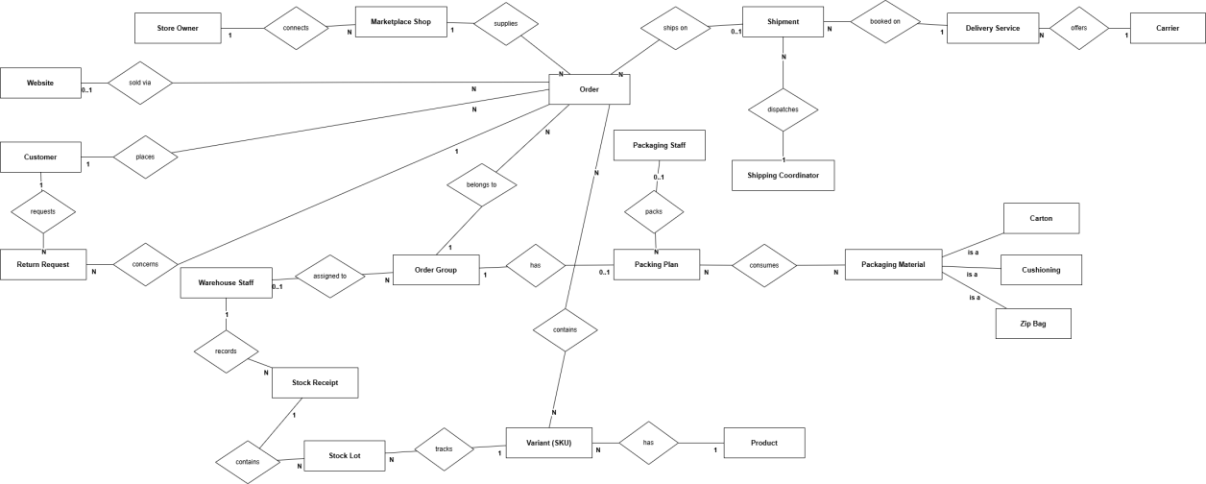
Figure 3. Logical ERD
OptiPack AI uses MongoDB. Every collection has primary key _id (ObjectId). Foreign keys are ObjectId fields that reference another collection; references inside arrays are written as array[].field. The table below lists the main collections; other collections are support data (OAuth states, counters, processed event ids, settings).
No | Collection | Description | Foreign keys (PK is _id)
01 | users | Staff accounts, role, lockout, two-factor, leave. | created_by → users
02 | refresh_tokens / trusted_devices / login_audit_logs | Sessions, trusted devices and login audit. | user_id → users
03 | marketplace_shops | Connected marketplace shops with encrypted tokens. | connected_by, disconnected_by → users
04 | orders | Marketplace orders and items. | marketplace_shop → marketplace_shops; consolidated_group_id → order_groups; source_return_id → return_requests
05 | order_groups | Unit of fulfilment (status, priority, flags). | assigned_staff_id → users; warehouse_id → warehouses; source_return_id → return_requests; split_from_group_id, merged_into_group_id → order_groups
06 | stock_reservations | Reserved quantity per group and SKU. | order_group_id → order_groups; warehouse_id → warehouses
07 | pick_events | Pick scans. | order_group_id → order_groups; warehouse_id → warehouses; bin_location_id → bin_locations; lot_allocations.lot_id → stock_lots
08 | warehouses / warehouse_zones / bin_locations | Warehouse structure. | warehouse_zones.warehouse_id → warehouses; bin_locations.warehouse_id, zone_id
09 | sku_bin_assignments | Stock of a SKU in a bin. | warehouse_id → warehouses; bin_location_id → bin_locations
10 | stock_receipts / stock_lots | Stock receipts and FIFO lots. | stock_lots.receipt_id → stock_receipts; assignment_id → sku_bin_assignments; lines[].lot_id → stock_lots
11 | inventory_movements | Stock ledger. | warehouse_id, assignment_id, bin_location_id; lot_allocations.lot_id → stock_lots
12 | categories / colors / master_skus / marketplace_sku_mappings | Internal product classification, internal SKUs and seller-SKU mappings. | By code (category code, internal SKU code)
13 | product_master | Marketplace catalog with packaging profile. | By platform and seller SKU
14 | packing_plans | 3D packing plan per group: orders, parcels, placements, scans, weighings. | order_group_id → order_groups; approved_by, rejected_by, packed_by, assigned_packer_id → users; orders[].order_id, parcels[].order_id → orders
15 | packaging_materials / packaging_bags / packaging_movements / packaging_material_rules | Boxes and filling materials, their stock movements and material rules; packaging_bags holds zip bags. | packaging_movements.packing_plan_id → packing_plans; rules.updated_by → users
16 | shipments / shipment_events | Shipments with carrier parcels and status history. | order_group_id → order_groups; carrier_parcels[].order_id → orders; shipment_events.shipment_id → shipments
17 | return_requests | Return / exchange / failed-delivery tickets with inspection. | order_group_id, replacement_group_id → order_groups; shipment_id → shipments; source_order_id, replacement_order_id → orders; inspection[].bin_location_id
18 | marketplace_status_outbox | Queued status write-backs. | order_group_id, shipment_id, return_request_id, order_id
19 | notifications | In-app notifications. | recipient_user_id → users; related_entity_id
20 | activity_logs | Business action history. | order_group_id → order_groups; entity_id
21 | customers, customer_addresses and storefront_* (products, product_variants, carts, cart_items, orders, order_items, order_events, payments, shipments, return_requests, categories, images, inventory_stocks, counters) | AURELLE website data. | Internal references of the AURELLE website

3. Main Business Workflows
The system has six main business workflows. Each workflow involves at least two actors and changes the state of a main entity. Each workflow is described by one activity diagram (swimlane per actor). Diagram sources are kept in the repository at docs/diagrams/activity (PlantUML) and rendered images in docs/diagrams/activity/export.
ID | Workflow | Actors | Trigger | Outcome / main entity state | Owner
WF-01 | Order Intake & Consolidation | Customer, Marketplace, OptiPack System, Store Owner / Coordinator, Warehouse Staff | Customer places an order | Order Group: awaiting_packaging → picking
WF-02 | Picking | Warehouse Staff, OptiPack System, Packaging Staff | Group in picking with an assigned picker | Order Group: picking → picked, or → partial_needs_review → picked / picking
WF-03 | Packing | OptiPack System, Packaging Staff, Reviewer | Group reaches picked | Packing Plan: computing → ready → approved → packing → packed; Order Group: picked → pending_approval → approved_for_packing → packed
WF-04 | Shipping via GHN | Shipping Coordinator, OptiPack System, GHN, Customer, Warehouse Staff | Coordinator creates a shipment | Shipment: awaiting_pickup → in_transit → out_for_delivery → delivered / delivery_failed → returning_to_warehouse → returned_to_warehouse
WF-05 | Return / Exchange via AURELLE | Customer, AURELLE Website, OptiPack System, Store Owner, Warehouse Staff | Customer submits a return / exchange request | Return Request: requested → awaiting_receipt → received → closed (rejected, canceled)
WF-06 | Stock Receiving by Lot | Warehouse Staff, OptiPack System, AURELLE Website | Goods arrive from supplier | Stock Lot created; stock-shortage flag of groups cleared

3.1 End-to-End Overview
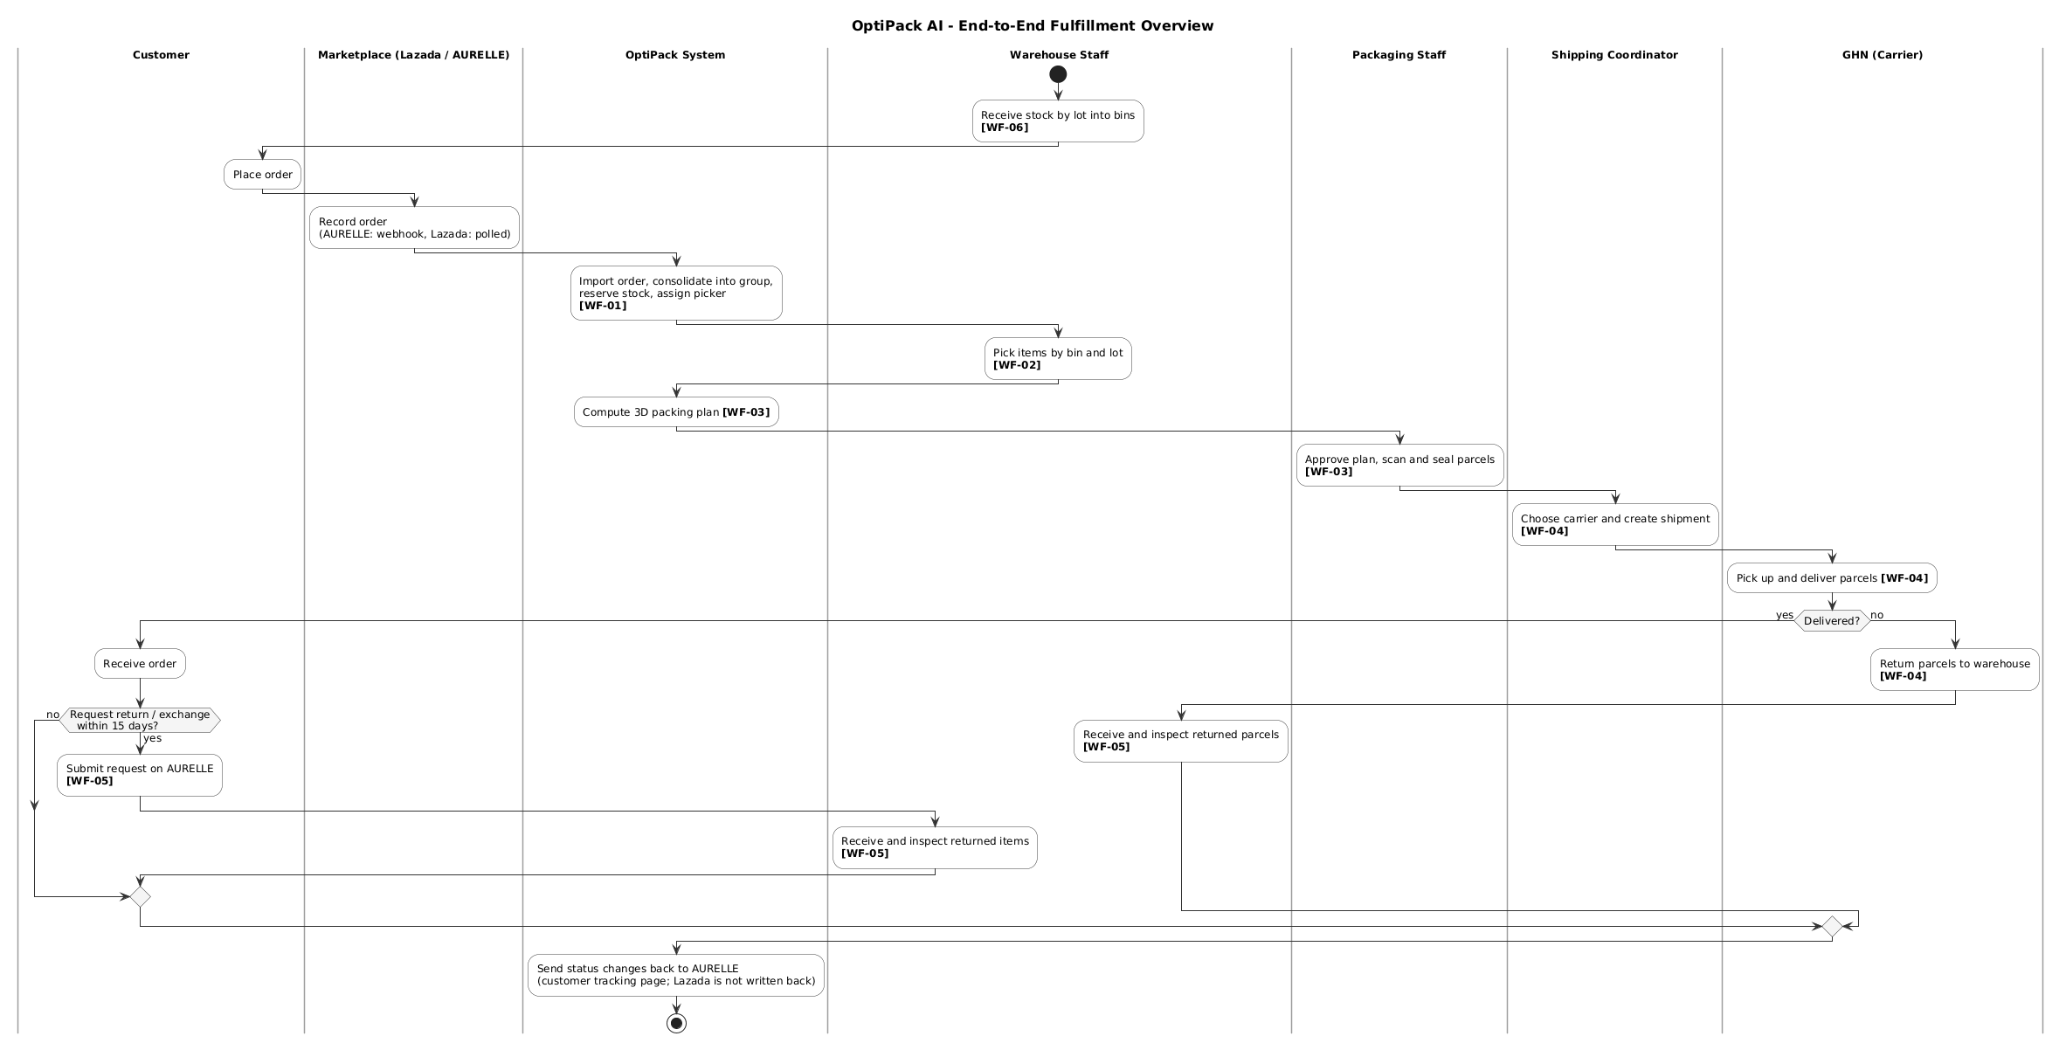Figure 4. End-to-end fulfillment overview (context of WF-01 to WF-06)

3.2 WF-01 Order Intake & Consolidation
An order placed on Lazada or AURELLE is imported (scheduled polling per shop interval, default 5 minutes, for Lazada and AURELLE, plus signed webhooks for AURELLE), joined to an open order group of the same recipient or put into a new group, stock is reserved and a Warehouse Staff is assigned. Shortage and recipient-name mismatch are notified to the responsible roles.
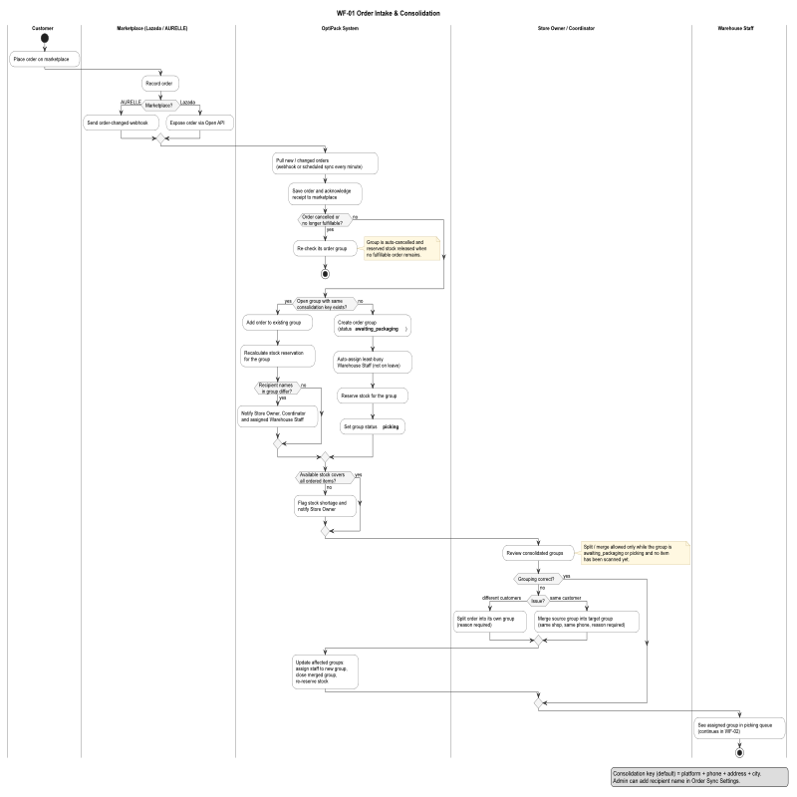
Figure 5. Activity diagram – WF-01 Order Intake & Consolidation

3.3 WF-02 Picking
The assigned Warehouse Staff scans items bin by bin (oldest lot first). When all items are picked the group becomes picked; when an item is missing the group waits for the Packaging Staff to ship the available items or restart picking.
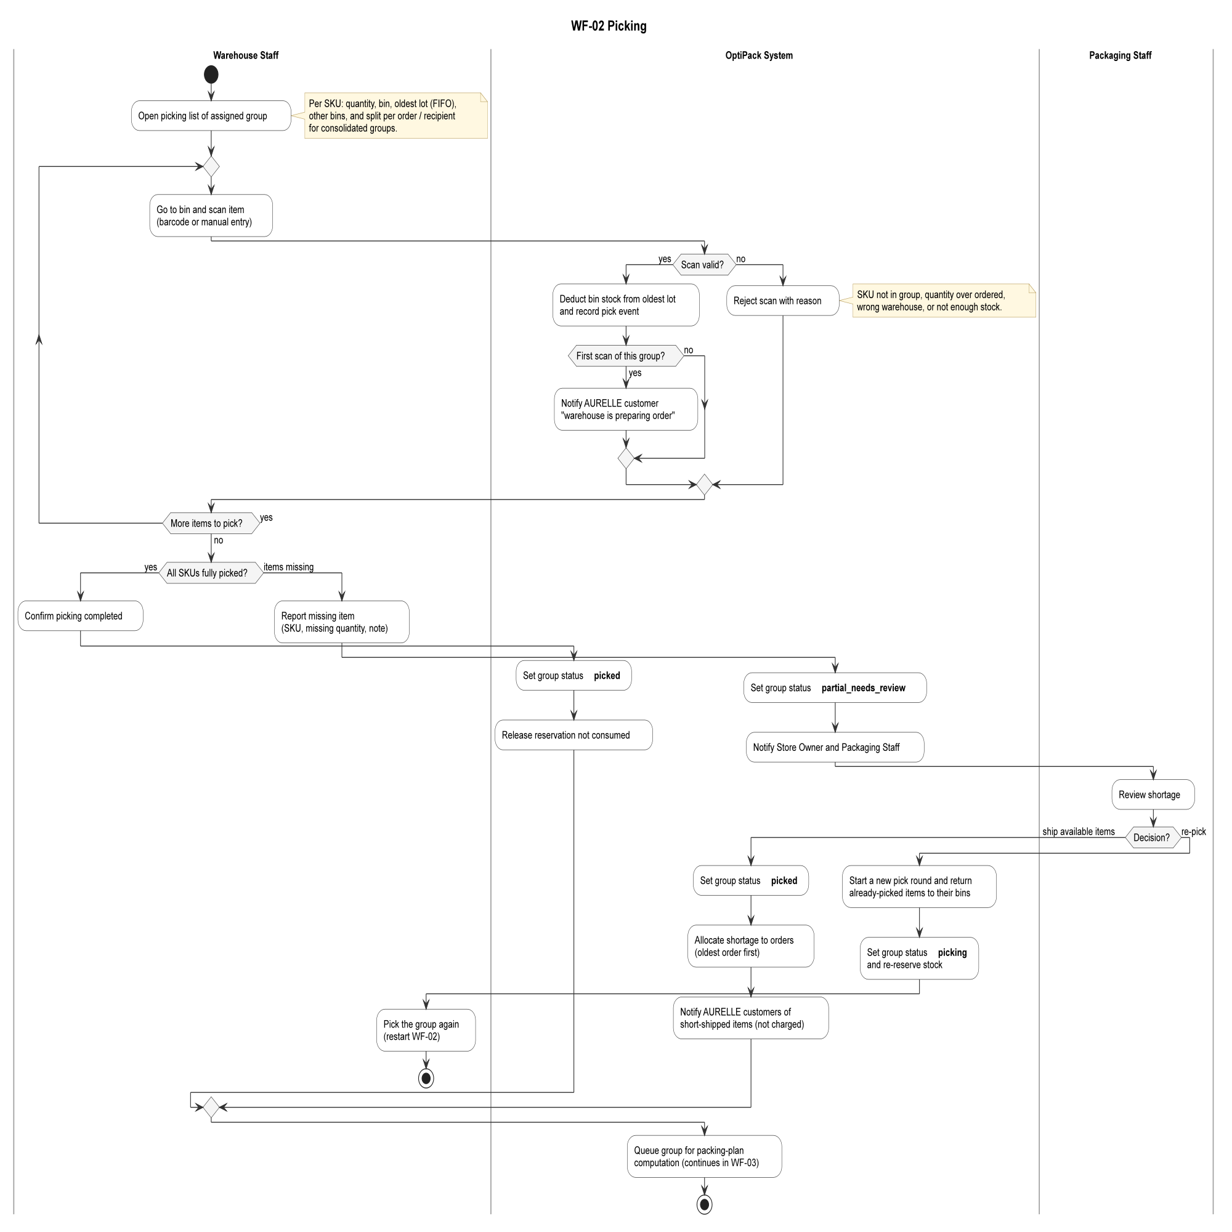
Figure 6. Activity diagram – WF-02 Picking

3.4 WF-03 Packing
The system computes a 3D packing plan and assigns a packer. The Packaging Staff approves or rejects the plan, scans items into each parcel, seals and weighs it; parcels outside the weight tolerance are reviewed by another person. The last sealed parcel moves the group to packed.
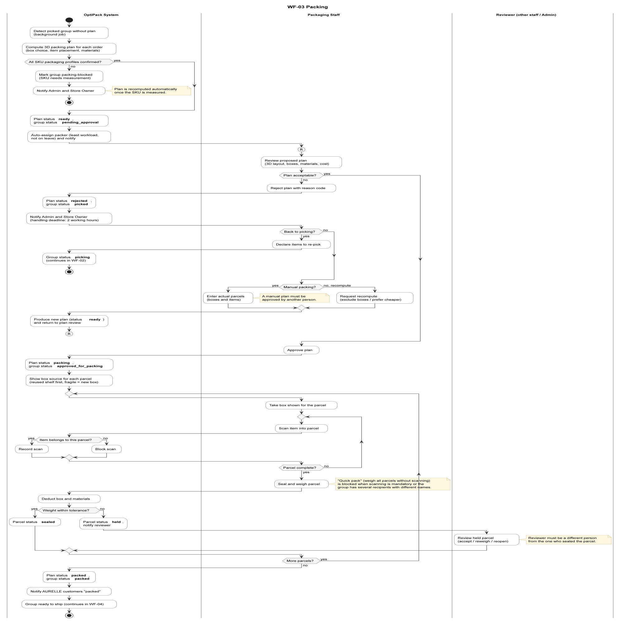
Figure 7. Activity diagram – WF-03 Packing

3.5 WF-04 Shipping via GHN
The Shipping Coordinator compares quotes and creates a shipment; one GHN order is created per parcel. GHN status updates move the shipment to delivered, or to failed delivery and return to the warehouse, where Warehouse Staff receives the returned parcel.
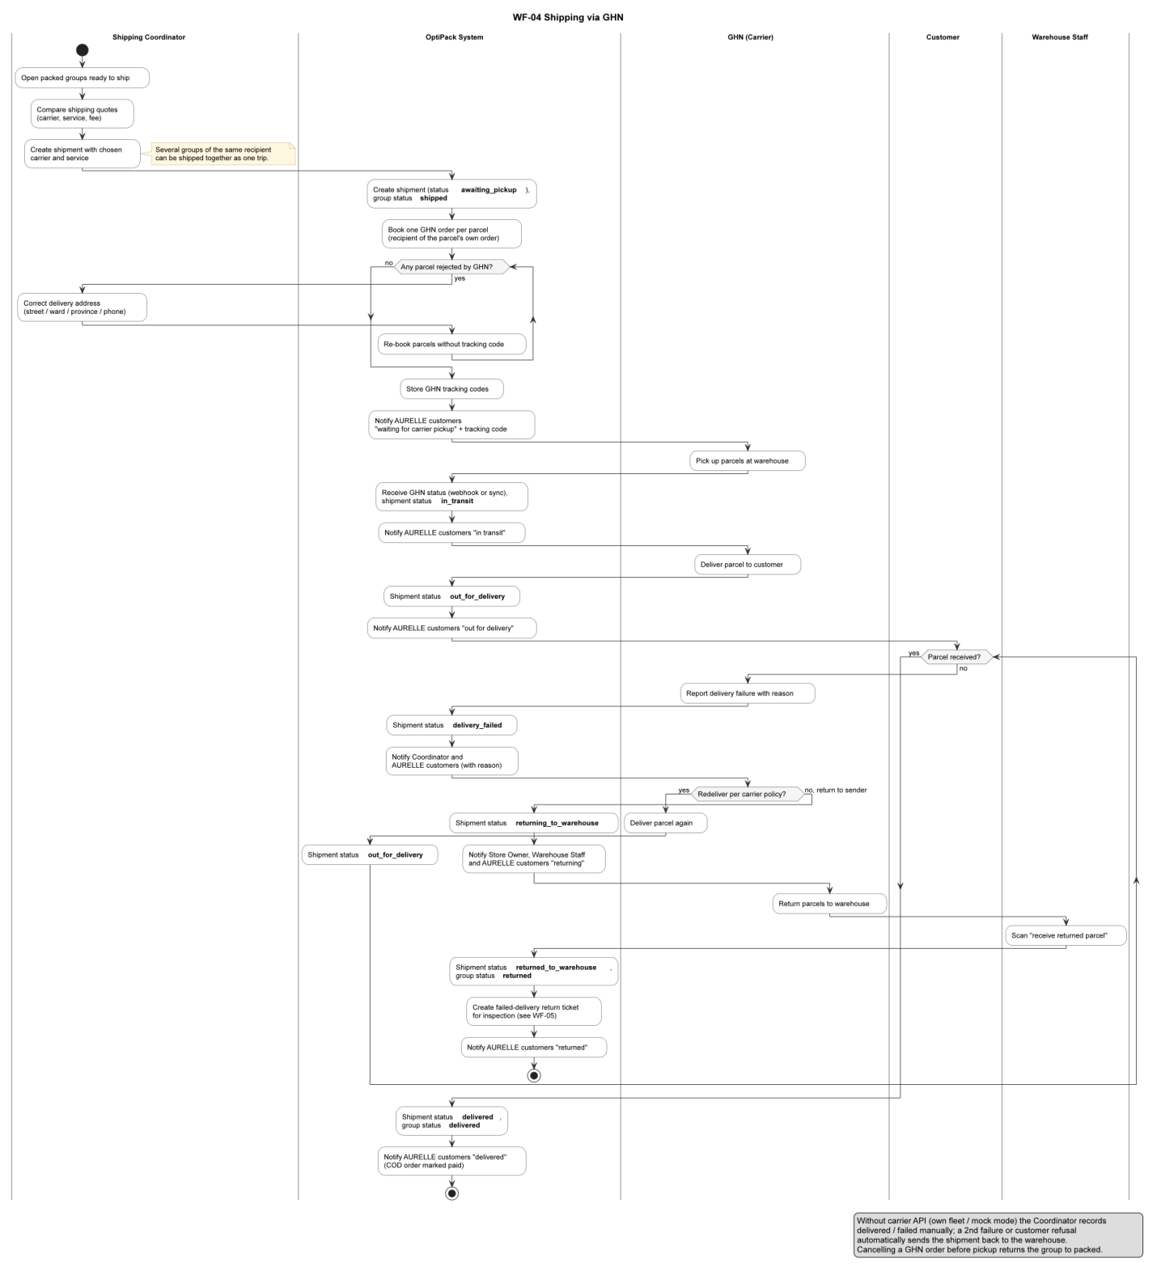
Figure 8. Activity diagram – WF-04 Shipping via GHN

3.6 WF-05 Return / Exchange via AURELLE
A customer requests a return or exchange on AURELLE within 15 days. The Store Owner approves or rejects; the Warehouse Staff receives and inspects the goods (restock / quarantine / discard). Refund is recorded or a replacement order is created and fulfilled.
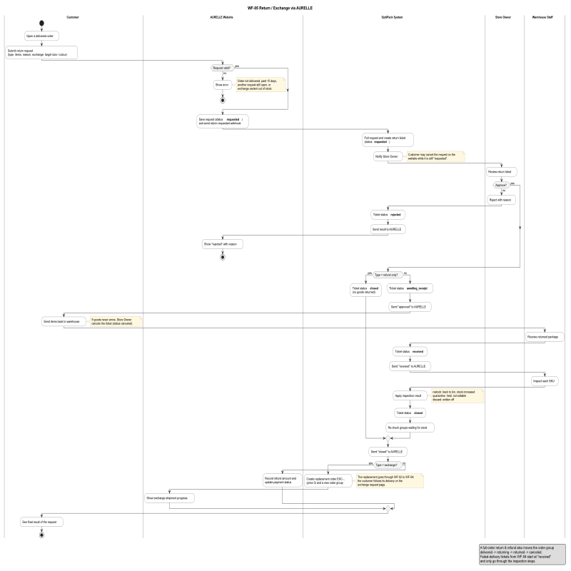
Figure 9. Activity diagram – WF-05 Return / Exchange via AURELLE

3.7 WF-06 Stock Receiving by Lot
Warehouse Staff assigns SKUs to bins and creates a stock receipt; each line becomes a FIFO lot. Groups with stock shortage are re-checked and available stock is pushed to AURELLE.
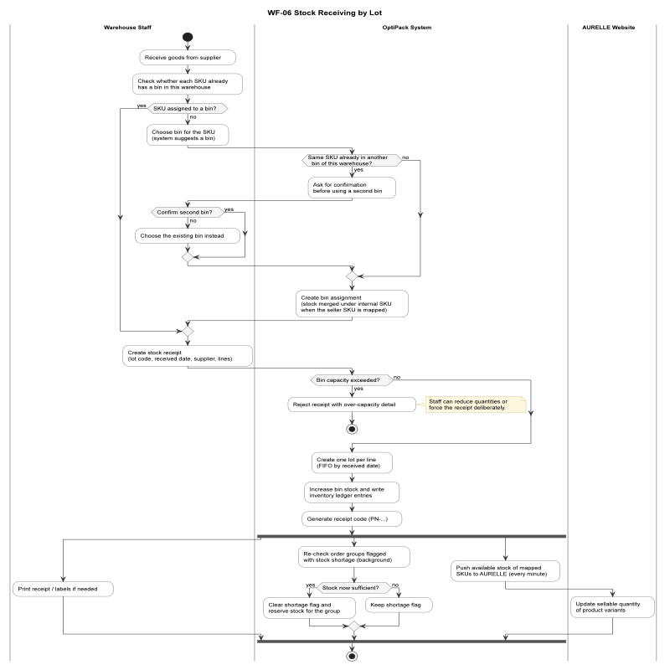
Figure 10. Activity diagram – WF-06 Stock Receiving by Lot

3.8 State Machine Diagrams
State machine diagrams of the main entities whose states are changed by the workflows above.
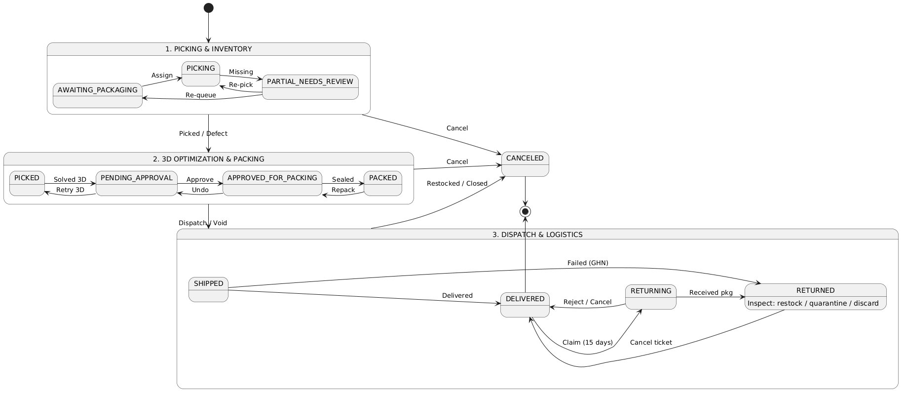
Figure 11. State machine diagram – Order Group

4. Detailed Design
For each feature, the class diagram shows the controller, services, schemas and external adapters involved, and the sequence diagrams show the main interactions of the functions listed in Report 3.

4.1 Authentication and Account Management

4.1.1 Class Diagram
Main classes: AuthController, AuthService, TokenService, MfaService, JwtStrategy, RolesGuard, UsersController, UsersService, MailService.
[Insert figure – Class Diagram: Authentication and Account Management]

4.1.2 Sequence Diagram(s)
[Insert figure – Sequence Diagram: Log in (with two-factor)]
[Insert figure – Sequence Diagram: Reset password]
[Insert figure – Sequence Diagram: Create user account]

4.2 Marketplace Integration and Order Intake

4.2.1 Class Diagram
Main classes: MarketplaceIntegrationController / Service, LazadaAdapter, AurelleAdapter, LazadaOrderSyncScheduler, MarketplaceWebhooksService, OrdersService, OrderGroupsService, StockReservationService, StaffAssignmentService.
[Insert figure – Class Diagram: Marketplace Integration and Order Intake]

4.2.2 Sequence Diagram(s)
[Insert figure – Sequence Diagram: Connect marketplace shop]
[Insert figure – Sequence Diagram: Synchronize and consolidate orders]
[Insert figure – Sequence Diagram: Receive AURELLE webhook]

4.3 Warehouse and Inventory

4.3.1 Class Diagram
Main classes: WarehouseController, WarehouseService, StockLotLedger, MasterSkusService, CategoriesService, ProductMasterService, DocumentsService.
[Insert figure – Class Diagram: Warehouse and Inventory]

4.3.2 Sequence Diagram(s)
[Insert figure – Sequence Diagram: Assign SKU to bin]
[Insert figure – Sequence Diagram: Create stock receipt]

4.4 Picking

4.4.1 Class Diagram
Main classes: OrderGroupsController, OrderGroupsService, StockReservationService, NotificationsService.
[Insert figure – Class Diagram: Picking]

4.4.2 Sequence Diagram(s)
[Insert figure – Sequence Diagram: Pick item]
[Insert figure – Sequence Diagram: Report missing items and decide partial]

4.5 Packing

4.5.1 Class Diagram
Main classes: PackingPlanController, PackingPlanService, PackingJobService, PackerAssignmentService, PackingSessionService, PackingSettingsService, BRKGA / CP-SAT solver, PackingGuideAiService.
[Insert figure – Class Diagram: Packing]

4.5.2 Sequence Diagram(s)
[Insert figure – Sequence Diagram: Compute packing plan]
[Insert figure – Sequence Diagram: Approve / reject plan]
[Insert figure – Sequence Diagram: Seal and weigh parcel]

4.6 Shipping

4.6.1 Class Diagram
Main classes: ShippingController, ShippingService, LiveCarrierService, GhnAdapter, ShipmentsController, ShipmentsService, CarrierWebhookController.
[Insert figure – Class Diagram: Shipping]

4.6.2 Sequence Diagram(s)
[Insert figure – Sequence Diagram: Create shipment]
[Insert figure – Sequence Diagram: Process carrier status update]

4.7 Returns and Exchanges

4.7.1 Class Diagram
Main classes: ReturnsController, ReturnsService, ReturnsMarketplaceSyncService, StorefrontReturnsService.
[Insert figure – Class Diagram: Returns and Exchanges]

4.7.2 Sequence Diagram(s)
[Insert figure – Sequence Diagram: Approve / reject return]
[Insert figure – Sequence Diagram: Receive and inspect returned items]

4.8 Marketplace Write-back

4.8.1 Class Diagram
Main classes: MarketplaceWritebackService, MarketplaceWritebackScheduler, MarketplaceStockPushService.
[Insert figure – Class Diagram: Marketplace Write-back]

4.8.2 Sequence Diagram(s)
[Insert figure – Sequence Diagram: Write status back to AURELLE]
[Insert figure – Sequence Diagram: Push stock to AURELLE]

4.9 AURELLE Website

4.9.1 Class Diagram
Main classes: StorefrontController, CustomerAuthService, StorefrontCartService, StorefrontOrdersService, StorefrontAdminService, AurelleWebhookPublisher.
[Insert figure – Class Diagram: AURELLE Website]

4.9.2 Sequence Diagram(s)
[Insert figure – Sequence Diagram: Place order]
[Insert figure – Sequence Diagram: Cancel order]
[Insert figure – Sequence Diagram: Request return / exchange]

4.10 History and Notifications

4.10.1 Class Diagram
Main classes: HistoryService, NotificationsService.
[Insert figure – Class Diagram: History and Notifications]

4.10.2 Sequence Diagram(s)
[Insert figure – Sequence Diagram: View history / export CSV]

