

Capstone Project Report
Report 3 – Software Requirement Specification
OptiPack AI – AI-Assisted Omnichannel Order Fulfillment and Packaging Optimization (FA26SE036)

– Ho Chi Minh City, October 2026 –

Table of Contents
I. Record of Changes 3
II. Software Requirement Specification 4
1. Product Overview 4
2. User Requirements 5
2.1 Actors 5
2.2 Use Cases 6
3. Functional Requirements 12
3.1 System Functional Overview 12
3.2 Authentication and Account Management 18
3.3 Marketplace Integration and Order Intake 21
3.4 Warehouse and Inventory 24
3.5 Picking 26
3.6 Packing 28
3.7 Shipping 30
3.8 Returns and Exchanges 32
3.9 Packaging Materials 33
3.10 Notifications 34
3.11 AURELLE Customer Website 34
3.12 AURELLE Web Administration 38
4. Non-Functional Requirements 38
4.1 External Interfaces 38
4.2 Quality Attributes 39
5. Requirement Appendix 39
5.1 Business Rules 39
5.2 Common Requirements 40
5.3 Application Messages List 40
5.4 Other Requirements 41

I. Record of Changes
Date | A*  M, D | In charge | Change Description
24/10/2026 | A | ThuanNPM | Initial SRS for Review 2: product overview, actors, use cases, system functional overview, functional requirements of 12 features, non-functional requirements, business rules and message list.
25/10/2026 | M | ThuanNPM | Aligned with the code: two-factor authentication is optional for every role (not mandatory for Admin); order sync runs per shop interval (default 5 minutes), not every minute; manual sync is Admin only; Tiki / TikTok adapters are not registered; Dashboard Overview partly uses sample data; AI text service is Groq; packing-plan performance measured by benchmark script; mobile app noted as planned for Iteration 3.
*A - Added M - Modified D - Deleted

II. Software Requirement Specification

1. Product Overview
Small and medium online sellers in Vietnam sell the same products on several channels at once. Orders arrive separately from each marketplace, staff pick items from memory, pack them in whatever box is at hand and book carriers by hand. The result is mis-picked items, oversized boxes, wasted packaging material, unnecessary shipping cost and no single place to follow an order from purchase to delivery or return.
OptiPack AI is a web-based fulfillment system for one seller (one Store Owner and its warehouse team). It pulls orders from connected marketplaces into one queue, groups orders that go to the same recipient, reserves stock, guides warehouse staff to pick by bin and by oldest lot (FIFO), computes a 3D packing plan for every order (box choice, item placement, filling materials) with a step-by-step packing guide, books one carrier shipment per parcel with GHN, follows delivery, failed delivery and return to the warehouse, and handles customer return and exchange requests. Every important status change is written back to the marketplace so that end customers can track their orders.
The release covered by this SRS integrates two sales channels:
- Lazada – real marketplace connected through the Lazada Open Platform (OAuth; a scheduler runs every minute and synchronizes each shop when its configured interval has passed, default 5 minutes). OptiPack AI does not write order status back to Lazada (read-only by design).
- AURELLE – a fashion web store built by the team (customer website + Open API that follows the Lazada API style, HMAC-signed requests and webhooks). AURELLE plays the role of a second marketplace and lets the team demonstrate the full loop: order → fulfillment → customer tracking → return / exchange.
- Tiki, TikTok Shop, Shopee and Facebook Marketplace – out of scope of this release because of partner API access constraints (see Form BM03). Adapter source files for Tiki and TikTok Shop remain in the repository but are not registered, so these shops cannot be connected.
The context diagram below shows the boundary of OptiPack AI and the external entities it exchanges data with.
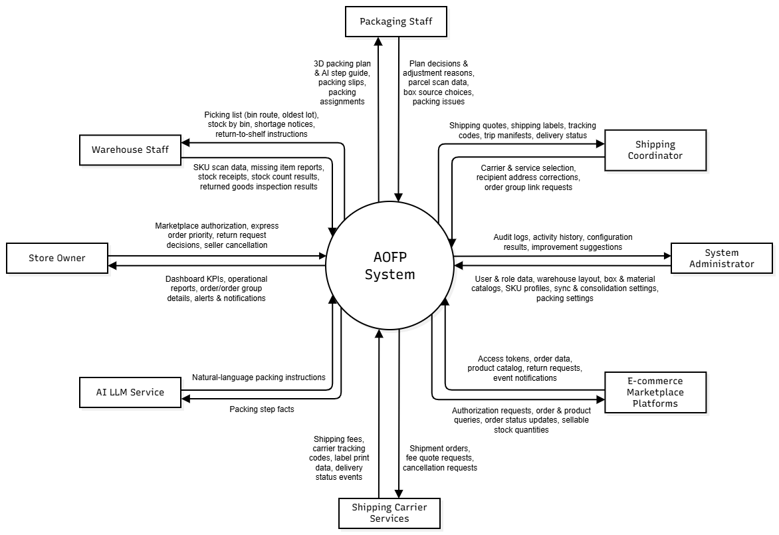
Figure 1. Context diagram of OptiPack AI
External entity | Type | Data exchanged with OptiPack AI
Lazada Open Platform | External system | OAuth tokens, orders and order items, product catalog (seller SKUs)
AURELLE Website / Open API | External system (team-built marketplace) | Orders, order-changed / product-updated / return-requested webhooks, return requests, order status and return status written back, available stock pushed every minute
GHN (Giao Hàng Nhanh) | External system (carrier) | Shipping fee quotes, shipping orders per parcel, tracking codes, status webhooks, A5 labels
Google Identity | External system | OAuth 2.0 login for staff whose e-mail already exists in the system
Gmail SMTP | External system | Account, temporary password, password reset and lock notification e-mails
AI text service (Groq API, OpenAI-compatible) | External system | Packing-guide wording for a parcel (no personal data)
Staff (5 roles) | People | Operate the web portal: configuration, picking, packing, shipping, returns
Customer (AURELLE) | People | Places orders, tracks delivery, requests return / exchange on the AURELLE website

2. User Requirements

2.1 Actors
# | Actor | Description
1 | Admin | Full access. Manages user accounts and roles, connects / disconnects marketplace shops, configures warehouses, internal SKUs, packaging catalog, carriers and system settings. Can enable optional two-factor authentication (TOTP), like every staff account.
2 | Store Owner | Business owner. Monitors orders and order groups, sets express priority, cancels AURELLE orders as seller, approves or rejects return requests, configures packing and shipping settings, manages staff leave, views reports and action history.
3 | Warehouse Staff | Picks items for assigned order groups, reports missing items, receives stock by lot, assigns SKUs to bins, adjusts / transfers / counts stock, receives returned parcels and inspects returned items.
4 | Packaging Staff | Reviews, approves or rejects packing plans, packs parcels (scan, seal, weigh), reviews parcels with abnormal weight, decides partial shipment when items are missing.
5 | Shipping Coordinator | Compares carrier quotes, creates shipments (single group or same-recipient trip), corrects delivery addresses, follows delivery and failed delivery, links or splits / merges order groups.
6 | Customer | End buyer on the AURELLE website. Registers, browses products, places and cancels orders, tracks delivery and requests return or exchange.
7 | AURELLE Web Admin | Administrator of the AURELLE website. Manages storefront categories, products, variants and images, and Open Platform developer apps (app key / secret).
8 | Lazada Open Platform | External system providing orders and catalog of the connected Lazada shop.
9 | AURELLE Open Platform | External system providing AURELLE orders, return requests and webhooks, and receiving status and stock written back by OptiPack AI.
10 | GHN Carrier | External carrier system that quotes fees, creates shipping orders and reports delivery status.
11 | System Scheduler | Time-based jobs inside OptiPack AI (order sync, packing-plan computation, status write-back, stock push, SLA checks).

2.2 Use Cases

2.2.1 Diagram(s)
Use cases are grouped into packages so that each diagram stays readable. One diagram is drawn per package below.
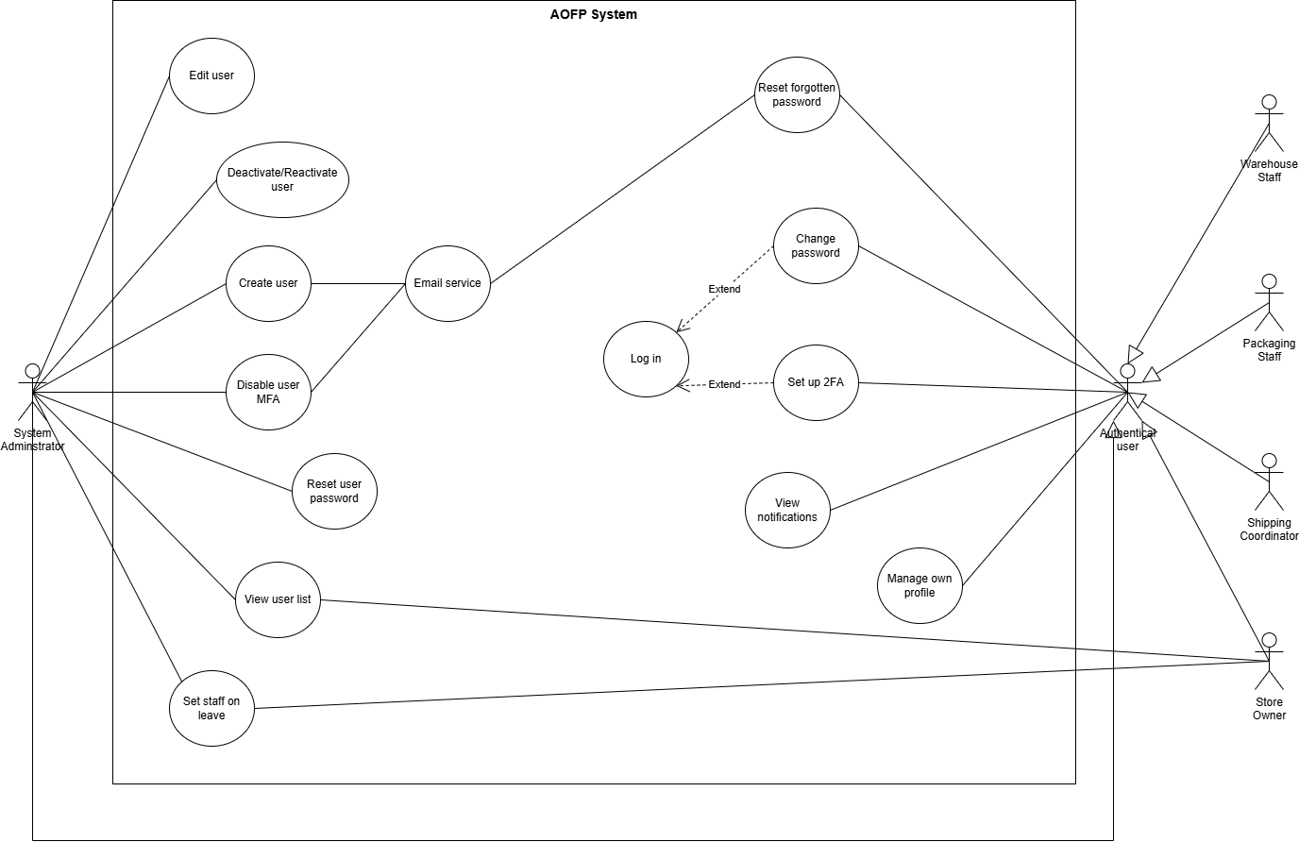
Figure 2. Use case diagram – Account & Security (UC-01 to UC-08)
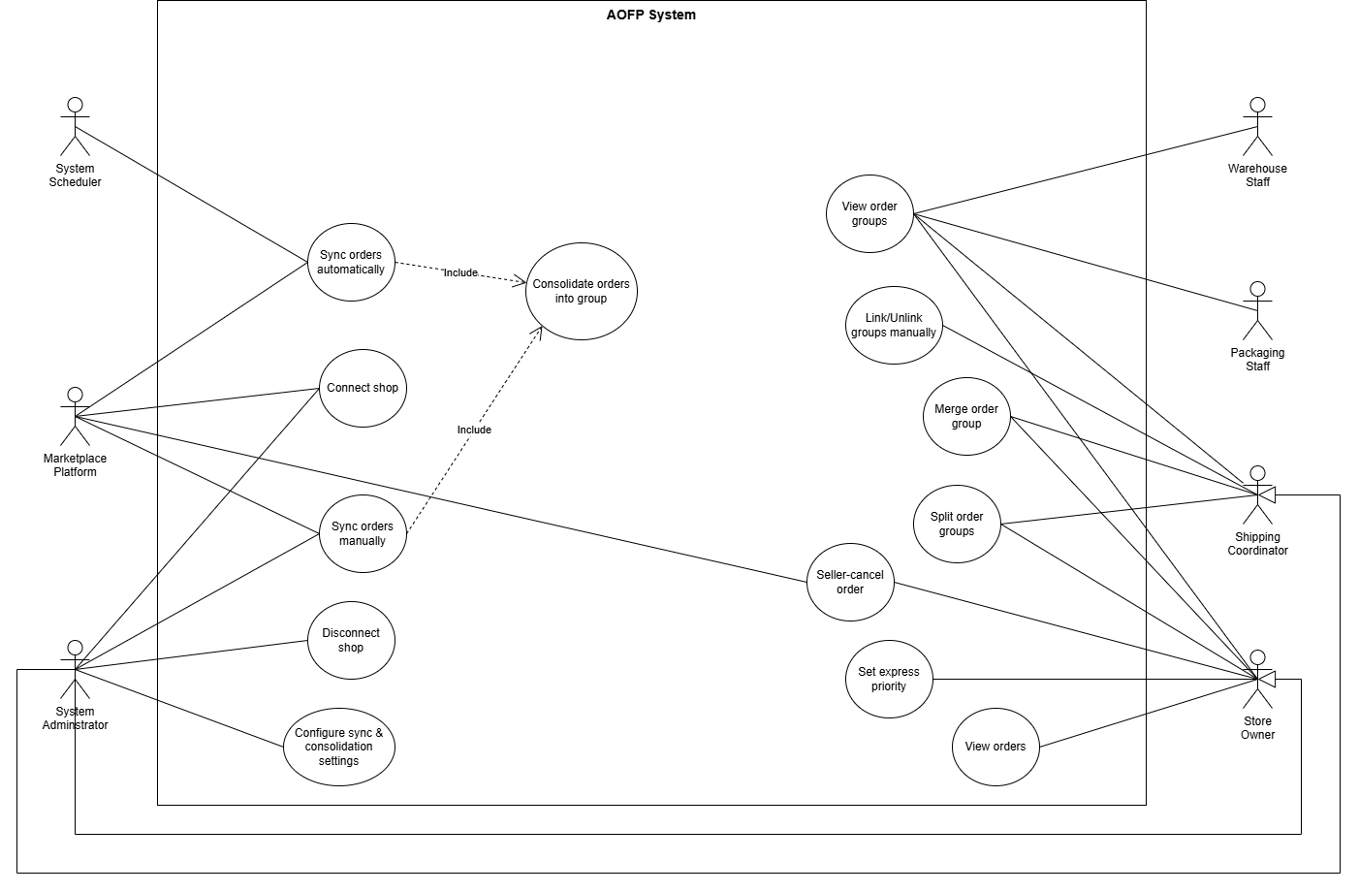
Figure 3. Use case diagram – Marketplace & Orders (UC-09 to UC-19)
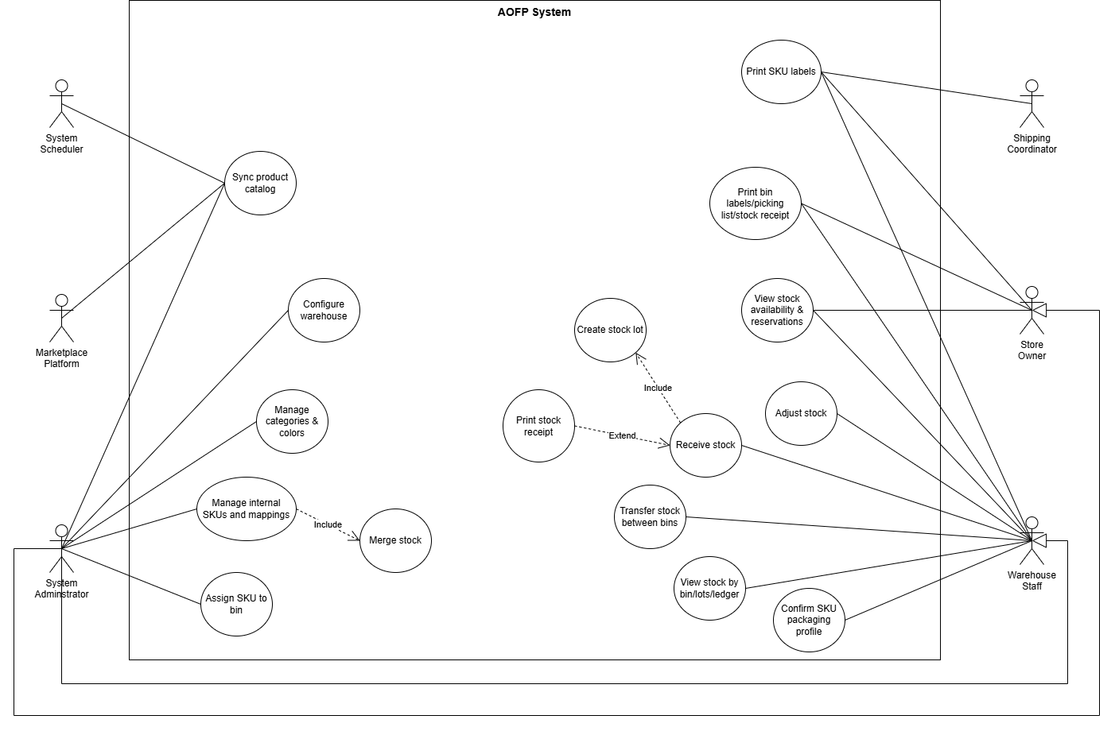
Figure 4. Use case diagram – Warehouse & Inventory (UC-20 to UC-25)
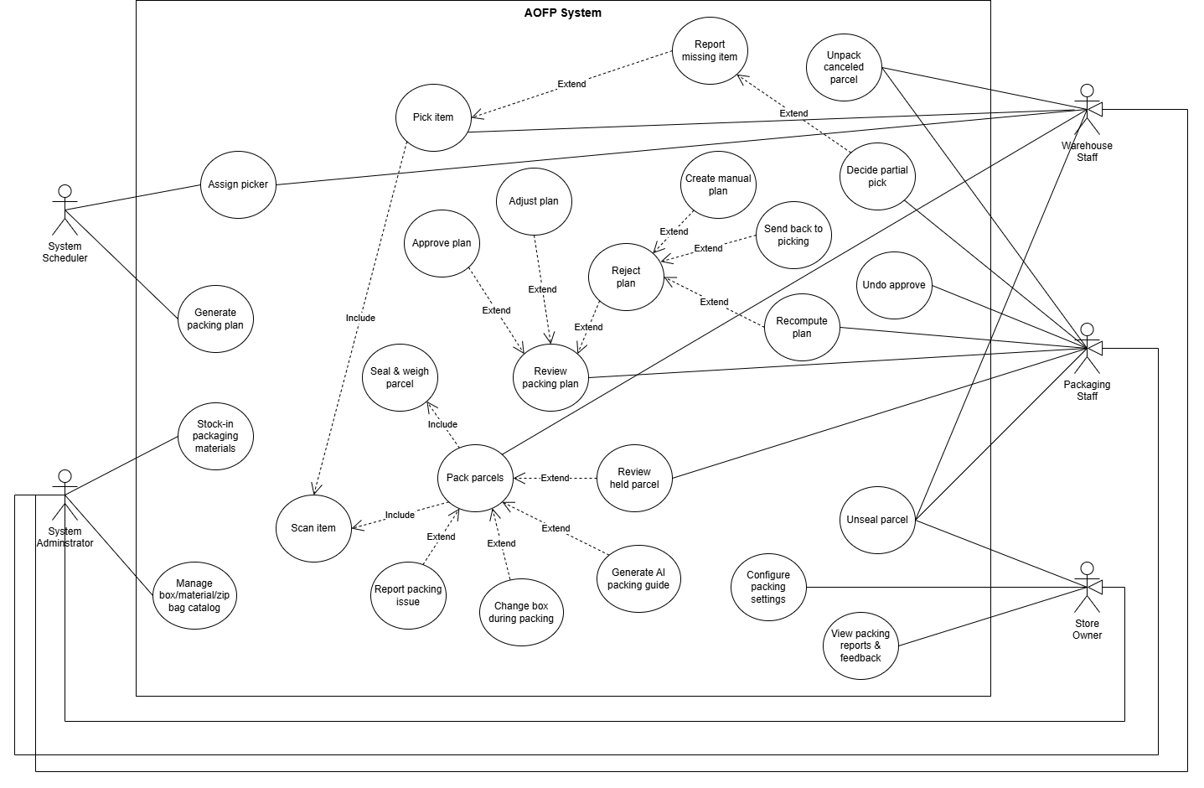
Figure 5. Use case diagram – Picking & Packing (UC-26 to UC-36)
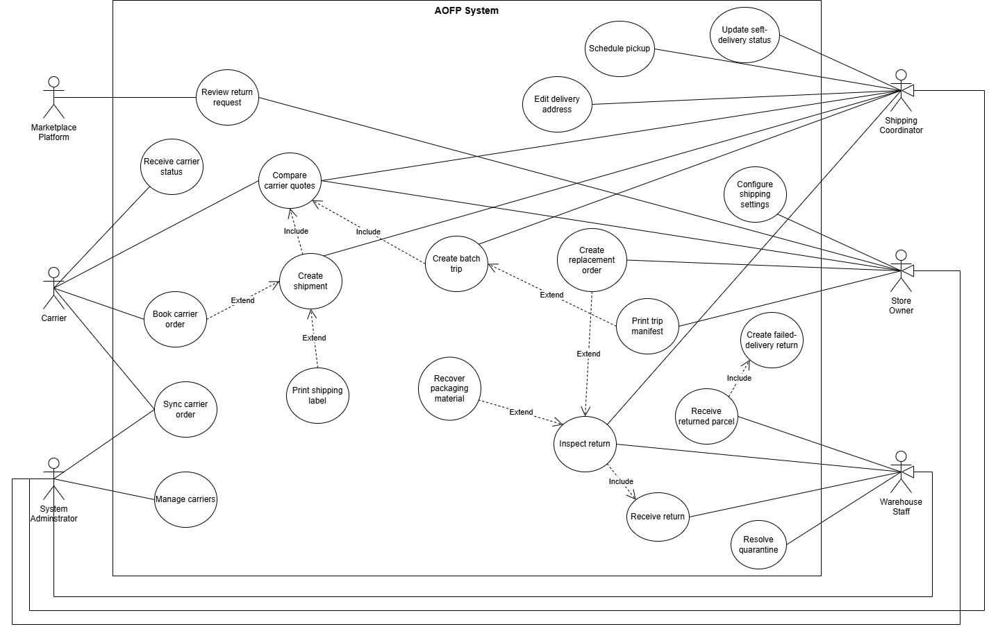
Figure 6. Use case diagram – Shipping & Returns (UC-37 to UC-44)
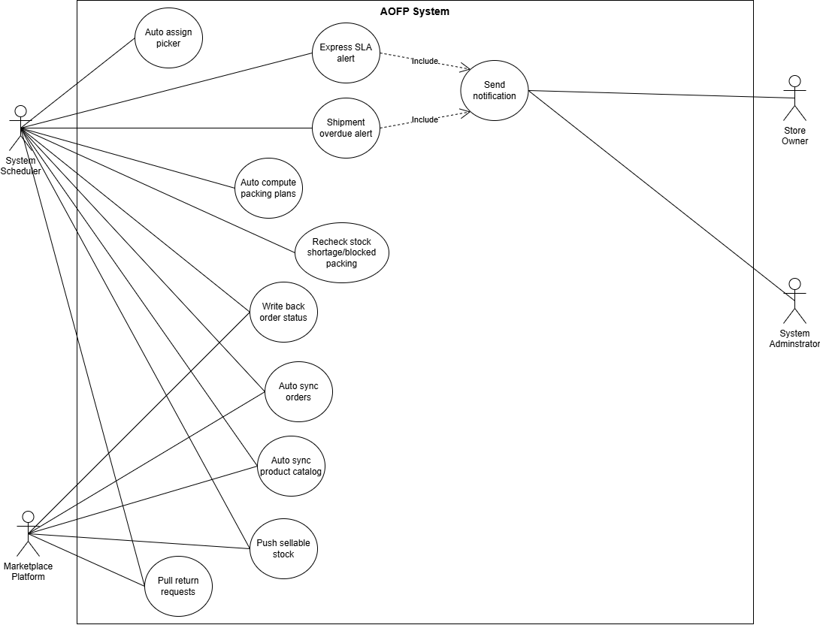
Figure 7. Use case diagram – System Scheduler: background jobs and alerts (UC-52)

2.2.2 Descriptions
ID | Use Case | Actors | Use Case Description
UC-01 | Log in | All staff roles | Log in with e-mail and password or with Google (e-mail must already exist). Failed attempts are counted; a new account must change its temporary password before using the portal.
UC-02 | Verify two-factor authentication | All staff roles (opt-in) | For an account that has enabled two-factor authentication: enter a TOTP code or a one-time backup code; a device can be trusted for 30 days.
UC-03 | Reset forgotten password | All staff roles | Request a reset link by e-mail and set a new password before the link expires.
UC-04 | Change password | All staff roles | Change password (forced on first login); all sessions of the account are signed out.
UC-05 | Manage user accounts | Admin (Store Owner: view) | Create staff accounts with a role, edit, deactivate / reactivate, reset password, disable two-factor authentication, delete.
UC-06 | Set staff leave | Admin, Store Owner | Mark a staff member on leave (until a date); staff on leave are not auto-assigned work.
UC-07 | View notifications | All staff roles | View, read and mark all notifications as read (missing items, shortages, plans to approve, failed delivery…).
UC-08 | View action history | All staff roles | View history filtered by the categories allowed for the role, view the timeline of one order group; Admin and Store Owner export CSV.
UC-09 | Connect marketplace shop | Admin, Lazada / AURELLE | Authorize a shop through OAuth; tokens are stored encrypted.
UC-10 | Disconnect marketplace shop | Admin | Deactivate a connected shop; it is no longer synchronized.
UC-11 | Configure order sync and consolidation | Admin (Store Owner: view) | Choose order statuses to import, consolidation key fields, time window and statuses of groups that still accept late orders; every change is versioned.
UC-12 | Synchronize orders | Admin, System Scheduler | Import new and changed orders on demand or automatically.
UC-13 | View omnichannel orders | Admin, Store Owner | List and view orders of all connected channels with items and recipient.
UC-14 | View and search order groups | Admin, Store Owner, operational staff | Filter groups by status, priority, platform; search by group id or marketplace order number.
UC-15 | Set express priority | Store Owner, Admin | Mark a group as express with a packaging deadline; the system warns before the deadline.
UC-16 | Link order groups | Shipping Coordinator, Admin | Link groups of the same recipient (e.g. masked Lazada data) so they are picked and shipped together.
UC-17 | Split or merge order groups | Store Owner, Shipping Coordinator, Admin | Split an order out of a consolidated group or merge two groups of the same customer, before any item is picked.
UC-18 | Cancel AURELLE order as seller | Store Owner, Admin | Cancel an AURELLE order that cannot be fulfilled; the customer is informed with the reason.
UC-19 | Assign warehouse staff | Admin, System Scheduler | Assign a picker to a group manually or automatically (least workload, not on leave).
UC-20 | Manage warehouse structure | Admin | Create and edit warehouses, zones, racks and bins with capacity; deactivate or delete when empty.
UC-21 | Manage internal SKUs and mappings | Admin | Manage categories, colours and internal SKUs (code rule CATEGORY-MODEL-COLOUR-SIZE), map marketplace seller SKUs to internal SKUs so their stock is pooled.
UC-22 | Confirm packaging profile | Warehouse Staff, Admin | Sync the marketplace catalog and confirm package dimensions, weight, fragility, item category and folding of each SKU.
UC-23 | Manage bin stock | Warehouse Staff, Admin | Assign a SKU to a bin, add stock, adjust with reason, transfer between bins, stocktake, view movements and lots.
UC-24 | Receive stock by lot | Warehouse Staff, Admin | Create a stock receipt (lot code, received date, supplier, lines); stock is consumed oldest lot first.
UC-25 | Print labels and documents | Warehouse Staff, Packaging Staff, Shipping Coordinator, Store Owner, Admin | Print bin labels, SKU labels, picking list, stock receipt, packing slip, shipping label and trip manifest (PDF).
UC-26 | Pick items | Warehouse Staff | Scan items of an assigned group bin by bin and confirm picking completed.
UC-27 | Report missing items | Warehouse Staff | Report a SKU that cannot be found; the group waits for a decision.
UC-28 | Decide partial shipment | Packaging Staff, Admin | Ship the available items (customers are informed of short-shipped items) or restart picking.
UC-29 | Review and approve packing plan | Packaging Staff, Admin | View the 3D plan per order and approve it to start packing.
UC-30 | Reject packing plan | Packaging Staff, Admin | Reject with a reason code, then recompute, pack manually or send the group back to picking.
UC-31 | Pack parcels | Packaging Staff, Warehouse Staff | Scan items into each parcel, change box if needed, seal and weigh; view the packing guide.
UC-32 | Review held parcel | Packaging Staff, Admin | Accept, reweigh or reopen a parcel whose weight is outside tolerance (different person from the sealer).
UC-33 | Handle packing issue | Packaging Staff, Warehouse Staff, Admin | Report damaged / missing / wrong items, replace from shelf, unseal, unpack parcels of cancelled orders.
UC-34 | Configure packing and view reports | Store Owner, Admin | Set weight tolerance, fragile cushion, preferred plan, parcel limit, scan requirement; view packing reports.
UC-35 | Manage packaging catalog | Admin | Manage boxes, bags and filling materials, stock-in, material rules.
UC-36 | Record packaging material movements | Admin, Warehouse Staff (Store Owner: savings) | Record purchases and internal use, view movement history and savings from reused boxes.
UC-37 | Create shipment | Shipping Coordinator, Admin | Compare quotes, choose carrier and service and create a shipment (or a same-recipient trip).
UC-38 | Fix carrier booking | Shipping Coordinator, Admin | Correct delivery address, re-book parcels without tracking code, cancel a carrier order before pickup.
UC-39 | Track delivery | Shipping Coordinator, GHN | Receive carrier status (webhook / sync), record delivered, failed delivery and redelivery.
UC-40 | Receive returned parcel | Warehouse Staff | Scan a parcel returned by the carrier; a failed-delivery return ticket is created.
UC-41 | Manage carriers and shipping settings | Admin, Store Owner | Manage carriers / services and sender information printed on labels.
UC-42 | Review return request | Store Owner, Admin | Approve, reject (reason required) or cancel a return ticket that never arrived.
UC-43 | Inspect returned items | Warehouse Staff, Admin | Receive returned goods and decide restock / quarantine / discard per SKU; resolve quarantine later.
UC-44 | Create replacement order | System, Store Owner, Admin | Create the EXC replacement order of an exchange after inspection (retry if it failed).
UC-45 | Register and log in (customer) | Customer | Create an AURELLE account and log in.
UC-46 | Browse products and manage cart | Customer | Browse categories and products, add variants to cart, update quantities.
UC-47 | Place order | Customer | Check out with a shipping address (province + ward) and payment method (COD or bank transfer).
UC-48 | Track and cancel order | Customer | Follow the 7-step order progress and delivery events; cancel while the order is not yet packed.
UC-49 | Request return or exchange | Customer | Request return & refund, refund only or exchange within 15 days of delivery; cancel a pending request.
UC-50 | Manage storefront catalog | AURELLE Web Admin | Manage categories, products, variants (SKU by OptiPack rule) and images.
UC-51 | Manage developer apps | AURELLE Web Admin | Create Open Platform apps, rotate secret, revoke / reactivate keys.
UC-52 | Run scheduled jobs | System Scheduler | Order sync, packing-plan computation, status write-back, stock push, return sync, SLA and backfill checks.

3. Functional Requirements

3.1 System Functional Overview
OptiPack AI has two web front ends served by one back end: the OptiPack staff portal (React) and the AURELLE website with its customer, web admin and developer pages (Next.js). The AURELLE Open API used as the second marketplace runs as a separate simulator process. Staff roles see only the screens allowed for them (section 3.1.3). Main business workflows WF-01 to WF-06 are described with activity diagrams in Report 4 (SDD), section "Main Business Workflows".

3.1.1 Screens Flow
Notation (as in the template sample): yellow box = public screen (before login); white box = screen after login; rounded box = pop-up dialog; thick border = screen with several tabs (tab names in italics); arrow = navigation. Diagram sources are kept in the repository at docs/diagrams/screens-flow (Mermaid).

3.1.2 Screen Descriptions
# | Feature | Screen | Description
1 | Common | Login | E-mail / password and Google login, two-factor step when enabled for the account, link to forgot password.
2 | Common | Forgot / Reset Password | Request a reset link and set a new password from the e-mailed link.
3 | Common | Change Password | Forced change of the temporary password on first login.
4 | Common | Profile & Settings | Personal information, password change, optional two-factor setup.
5 | Common | Notifications (top bar) | Unread counter and list; clicking a notification opens the related screen.
6 | Dashboard | Dashboard Overview | Home screen of Store Owner / Admin: packing report figures and packaging-material savings come from the back end; revenue-by-channel, finance and staff widgets still show sample data (no back-end aggregate API in this release).
7 | Orders | Omnichannel Orders / Order Detail | Orders of all channels with filters; detail shows items, recipient and status history.
8 | Orders | Groups & Express | Order groups with status, priority, packer, shortage and blocked flags; detail with orders, link, priority.
9 | Orders | Order Sync Settings | Consolidation key fields, imported statuses, time window, change history.
10 | Warehouse | Warehouse Picking | Assigned groups, picking list per SKU (bin, oldest lot, other bins), scan, report missing, confirm picked.
11 | Warehouse | Warehouse Inventory | Bin stock, assign SKU to bin, add / adjust / transfer stock, stocktake, stock receipts and lots.
12 | Warehouse | Admin Warehouse | Warehouses, zones, racks, bins, internal SKUs, categories, colours, SKU mappings, product master.
13 | Packing | Packing Station | Plans waiting for approval, 3D viewer, approve / reject, packing session (scan, seal, weigh), held parcels, issues.
14 | Packing | Admin Packing Plans | All packing plans with status, proof label and recompute.
15 | Packing | Packaging Rules / Packaging Materials | Boxes, bags, filling materials, rules, purchases, internal use and savings.
16 | Shipping | Shipping & Fulfillment | Packed groups, quotes, create shipment / trip, carrier parcels and tracking, failed delivery, labels.
17 | Returns | Returns | Return tickets (customer requests and failed deliveries): approve / reject, receive, inspect, quarantine, replacement.
18 | People | Staff Directory | Staff list, roles, leave status.
19 | Admin | Admin Home / Roles | User accounts, roles, two-factor reset, reactivation.
20 | Admin | Marketplace Connections | Connect / disconnect Lazada and AURELLE shops, shop status.
21 | Admin | AI & Packing Settings / Analytics | Packing settings, packing reports and feedback.
22 | AURELLE | Home / Shop / Product Detail | Customer catalog, product with variants and sellable stock.
23 | AURELLE | Cart / Checkout | Cart and checkout with new two-level address (province, ward) and payment method.
24 | AURELLE | My Orders / Order Detail | Order list and detail with 7-step progress bar, events, cancel and return actions.
25 | AURELLE | My Returns / Return Detail | Return and exchange requests with status and exchange shipment progress.
26 | AURELLE | Customer Login / Register | Customer account access; Admin web accounts are redirected to the admin page.
27 | AURELLE | Web Admin (Products, Categories) | Storefront catalog management with SKU built from OptiPack categories, colours and sizes.
28 | AURELLE | Developer Portal | Open Platform apps: app key / secret, rotate, revoke.

3.1.3 Screen Authorization
X = screen available. Back-end endpoints enforce the same roles (role-based guard on every request).
Screen | Admin | Store Owner | Warehouse Staff | Packaging Staff | Shipping Coord.
Dashboard Overview | X | X
Omnichannel Orders / Order Detail | X | X
Groups & Express | X | X
Order Sync Settings (edit) | X | view
Returns | X | X
Warehouse Picking | X |  | X
Warehouse Inventory | X |  | X
Admin Warehouse (structure, SKUs) | X
Packing Station | X |  |  | X
Packaging Materials | X | X | X | X
Packaging Rules | X | X
Shipping & Fulfillment | X |  |  |  | X
Staff Directory | X | X
Analytics | X | X
Admin Home / Roles / Marketplace / Packing Plans / AI | X
Profile & Settings, Notifications | X | X | X | X | X
Action History (own categories) | X | X | X | X | X
Export history CSV | X | X

3.1.4 Non-Screen Functions
# | Feature | System Function | Description
1 | Orders | Marketplace order auto-sync | Every minute: for each connected Lazada / AURELLE shop whose sync interval has passed (default 5 minutes, configurable 5–1,440), import new / changed orders page by page, consolidate and create groups.
2 | Orders | Marketplace webhooks | Receive AURELLE webhooks (order changed, product updated, return requested / cancelled), verify HMAC signature, ignore duplicates.
3 | Orders | Order-group backfill | Every 5 minutes: create missing groups and resume groups stuck in awaiting_packaging.
4 | Orders | Express SLA check | Every 10 minutes: warn when an express group is less than 1 hour from its deadline and flag overdue groups.
5 | Catalog | Product master sync | Hourly catalog sync and daily full sync at 03:00 (Asia/Ho_Chi_Minh); auto-map and auto-create internal SKUs that follow the code rule.
6 | Packing | Packing-plan auto compute | Every 10 seconds: compute plans for picked groups (BRKGA solver, optional CP-SAT proof service).
7 | Packing | Packing-blocked recheck | Every minute: retry groups blocked by unmeasured SKUs after the SKU is confirmed.
8 | Packing | Rejected plan reminder | Every 15 minutes: remind once when a rejected plan passes its 2-working-hour deadline.
9 | Shipping | Carrier webhook | Receive GHN status callbacks, map to shipment status, ignore duplicates.
10 | Shipping | Shipment SLA scan | Every 15 minutes: mark overdue deliveries.
11 | Write-back | Order / return status write-back | Every 15 seconds: send queued status changes to AURELLE, retry with back-off (up to 8 attempts).
12 | Write-back | Stock push | Every minute: push available stock of mapped SKUs to AURELLE.
13 | Returns | Marketplace returns sync | Every 2 minutes: pull AURELLE return requests and cancellations not received by webhook.
14 | Common | Notification and e-mail | Create in-app notifications by role / user; send account e-mails through SMTP.

3.1.5 Entity Relationship Diagram
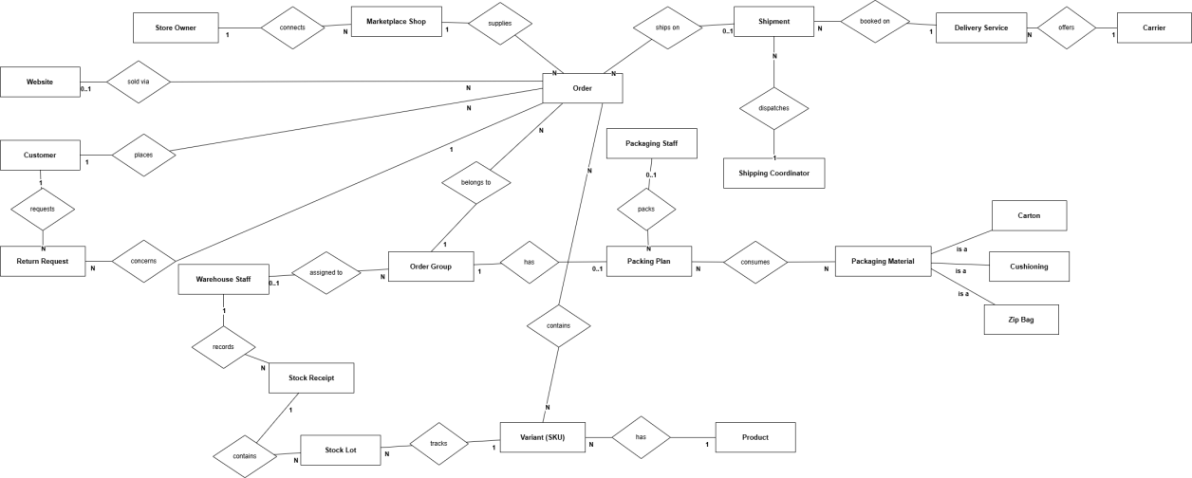
Figure 10. Logical entity relationship diagram
Entities Description
# | Entity | Description
1 | User | Staff account with one role (Admin, Store Owner, Warehouse Staff, Packaging Staff, Shipping Coordinator), lockout, two-factor and leave data.
2 | Marketplace Shop | A connected shop of Lazada / AURELLE (encrypted tokens, connection status).
3 | Order | Marketplace order with recipient, items, statuses and consolidation key.
4 | Order Group | Unit of fulfilment: one or more orders of the same recipient that are picked, packed and shipped together.
5 | Stock Reservation | Quantity of a SKU reserved for an order group in a warehouse.
6 | Pick Event | One scan of a SKU while picking (quantity, bin, lots, pick round).
7 | Warehouse / Zone / Bin Location | Physical structure of the warehouse with bin capacity.
8 | SKU Bin Assignment | Stock of one SKU in one bin.
9 | Stock Lot / Stock Receipt | Lot received on a date (FIFO) and the receipt that created it.
10 | Inventory Movement | Ledger entry of every stock change (pick, adjust, transfer, restock…).
11 | Category / Colour / Master SKU | Internal product classification and internal SKU code.
12 | Marketplace SKU Mapping | Link from a marketplace seller SKU to an internal SKU (pooled stock).
13 | Product Master | Marketplace catalog item with confirmed packaging profile (dimensions, weight, fragility, category).
14 | Packing Plan | Active 3D packing plan of a group: orders, parcels, boxes, placements, scans, session.
15 | Packaging Material / Movement | Boxes, bags and filling materials with new / reused stock and their movements.
16 | Shipment / Shipment Event | Outbound shipment of a group with carrier parcels and its status history.
17 | Return Request | Return, refund-only, exchange or failed-delivery ticket with inspection results.
18 | Notification / Activity Log | In-app notification and business action log used by history screens.
19 | Status Outbox | Queue of status changes to be written back to AURELLE.
20 | Storefront Customer / Product / Variant / Order / Return | Entities of the AURELLE website.

3.2 Authentication and Account Management

3.2.1 Log in
Function trigger: Login screen; Google button; /login.
Function description: All staff roles. Authenticates the user and opens the home screen of the role.
Screen layout:
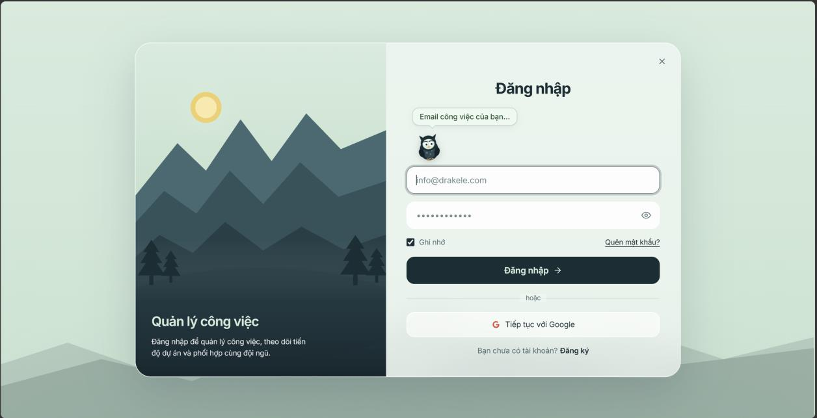
Function details:
- E-mail and password are required; a wrong password increases the failed-attempt counter. After 5 consecutive failures the account is locked for 15 minutes.
- Google login succeeds only when the verified Google e-mail already belongs to an active account.
- A user who has enabled two-factor authentication must enter a TOTP code or a backup code unless the device is trusted (30 days); two-factor authentication is optional for every role.
- An account created by Admin has a temporary password that must be changed within 72 hours; otherwise the account is locked until Admin reactivates it.
- Access token lifetime 24 hours, refresh token 30 days with rotation; reuse of an old refresh token revokes the session.

3.2.2 Reset and change password
Function trigger: Forgot Password link; Change Password screen.
Function description: All staff roles. Recovers access or replaces the password.
Screen layout:
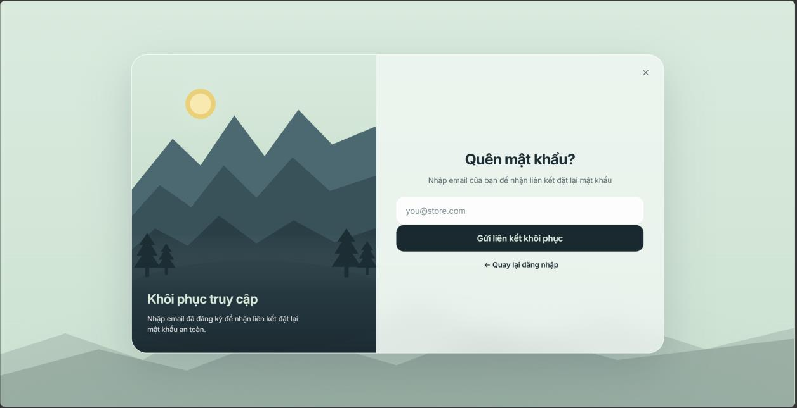
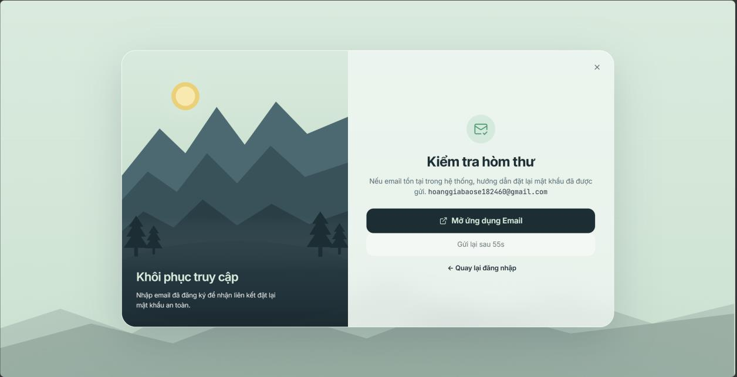
Function details:
- The reset e-mail always shows the same generic message whether the e-mail exists or not.
- The reset link expires after 30 minutes and can be used once.
- New password: at least 8 characters with upper case, lower case, digit and special character.
- Changing or resetting the password signs out all sessions of the account.

3.2.3 Manage user accounts and leave
Function trigger: Admin Home / Roles; Staff Directory.
Function description: Admin manages accounts; Store Owner views staff and sets leave.
Screen layout:
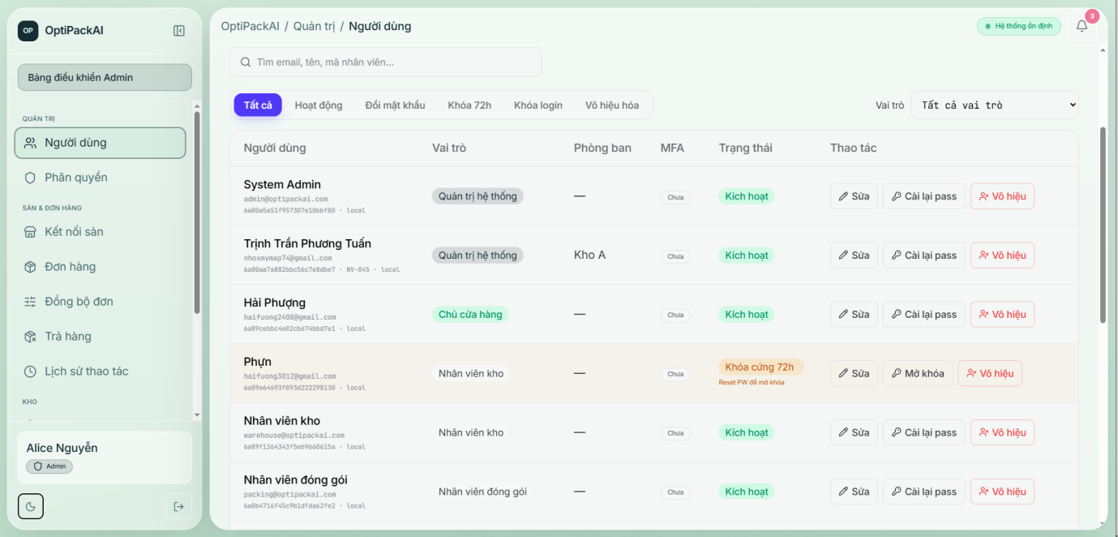
Function details:
- Admin creates the account and the system e-mails a temporary password.
- Deactivating an account revokes its sessions; reactivation clears lock state.
- Staff on leave (until a date) are skipped by auto-assignment and cannot be assigned manually.

3.2.4 Action history
Function trigger: History screen; Timeline tab of an order group.
Function description: All roles; each role sees only its categories. Admin and Store Owner export CSV (max 5,000 rows).
Screen layout:
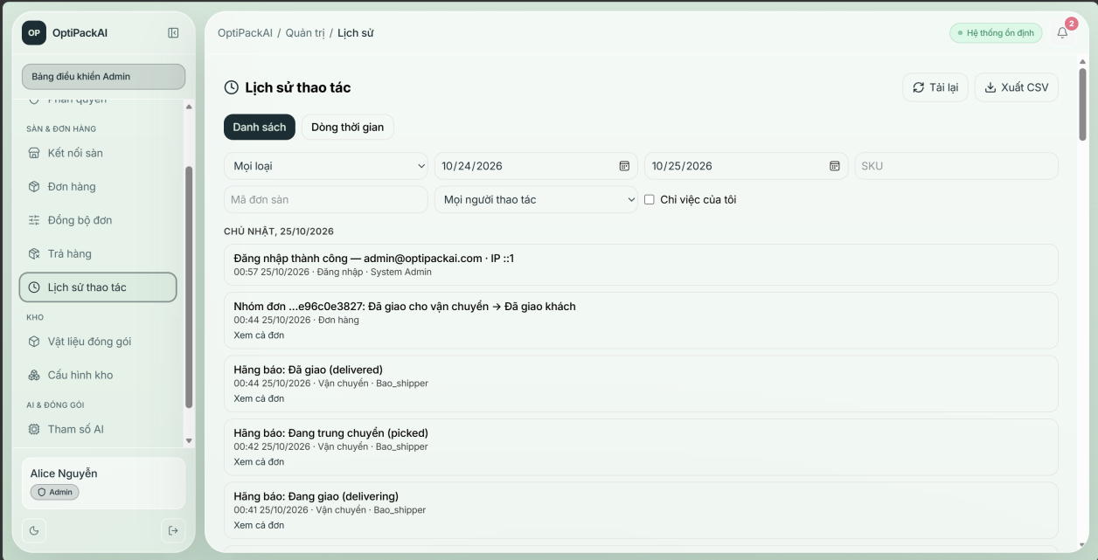
Function details:
- Categories: orders, picking, packing, shipping, returns, warehouse, packaging materials, login (Admin only).
- Default period 30 days; filter by date, SKU, order code, actor, "my actions".

3.3 Marketplace Integration and Order Intake

3.3.1 Connect / disconnect shop
Function trigger: Admin → Marketplace Connections.
Function description: Admin authorizes a Lazada or AURELLE shop through OAuth.
Screen layout:
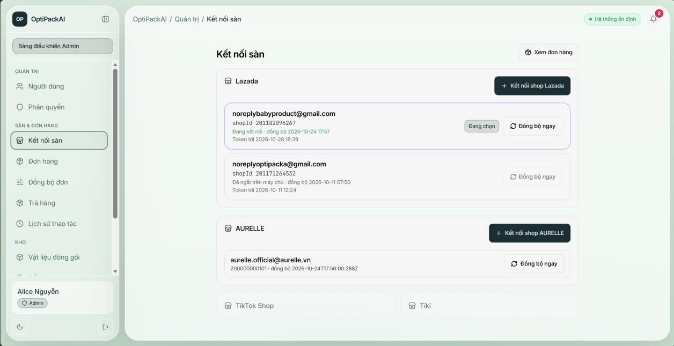
Function details:
- Tokens are encrypted (AES-256-GCM) before storage and refreshed automatically.
- A disconnected shop is no longer synchronized; reconnecting reactivates it.

3.3.2 Synchronize and consolidate orders
Function trigger: Automatic (scheduler every minute, each shop at its interval, default 5 minutes), webhook (AURELLE), or "Sync" button (Admin).
Function description: System imports orders and builds order groups.
Screen layout:
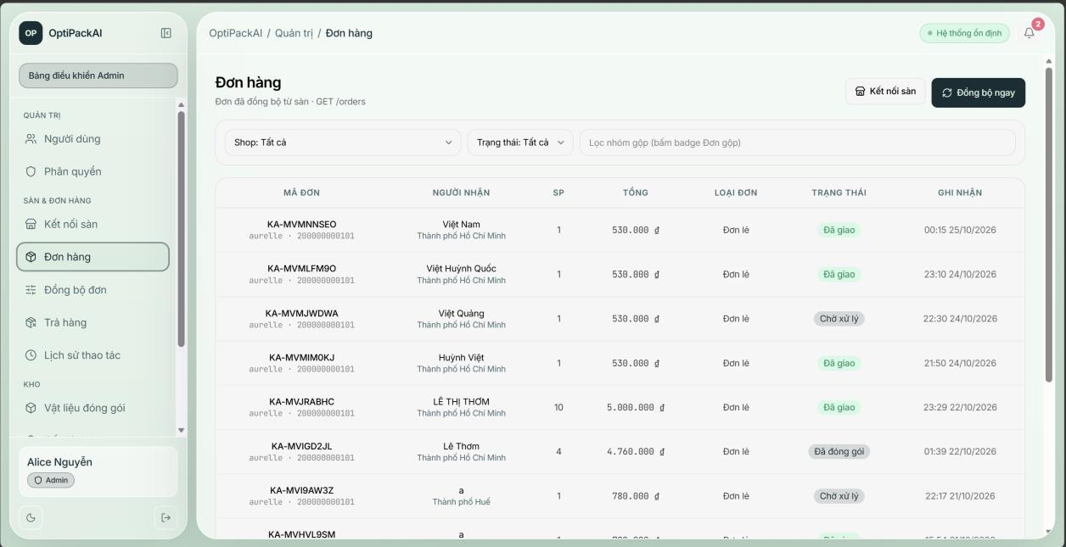
Function details:
- Orders with the same consolidation key (default: platform + phone + address + city), same shop and an open group join that group; otherwise a new group is created.
- A new group is reserved stock, assigned the least-busy Warehouse Staff and moved to picking.
- If available stock does not cover the group, it is flagged stock shortage and the Store Owner is notified.
- If recipient names in a group differ, Store Owner, Coordinator and the picker are notified.
- A cancelled order re-checks its group; a group without fulfillable orders is cancelled automatically.

3.3.3 Order sync settings
Function trigger: Order Sync Settings screen.
Function description: Admin edits, Store Owner views.
Screen layout:
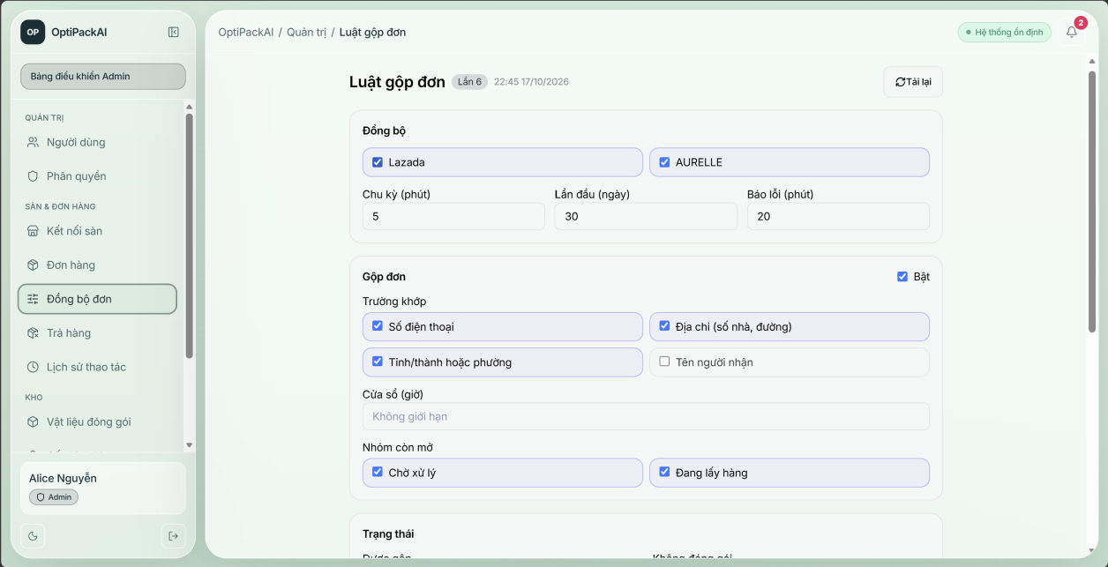
Function details:
- Every save creates a new version with author and time; history can be viewed.

3.3.4 Manage order groups
Function trigger: Groups & Express screen.
Function description: Store Owner, Shipping Coordinator, Admin.
Screen layout:
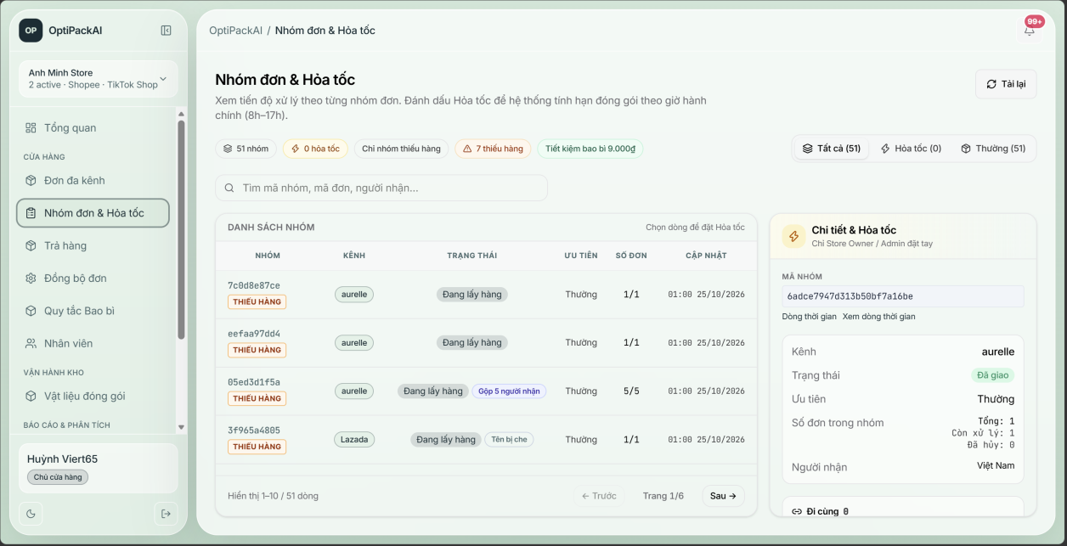
Function details:
- Express priority sets a packaging deadline in business hours; warning when less than 1 hour remains.
- Split / merge only while the group is awaiting_packaging or picking with no item scanned; merge requires same shop and same real phone number; a reason is mandatory.
- Seller cancel is allowed only for AURELLE orders not yet handed to the carrier; the customer is refunded if paid.

3.4 Warehouse and Inventory

3.4.1 Warehouse structure
Function trigger: Admin Warehouse screen.
Function description: Admin creates warehouses, zones, racks and bins.
Screen layout:
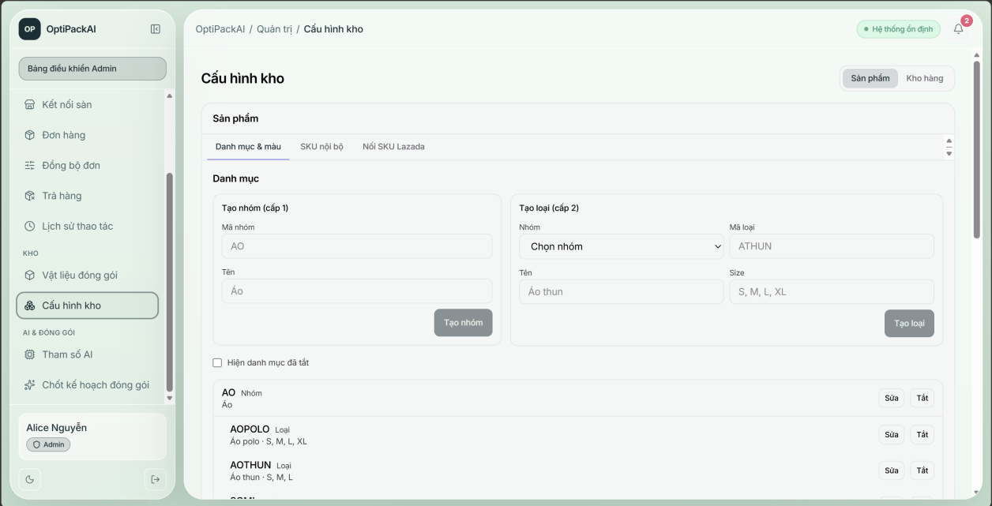
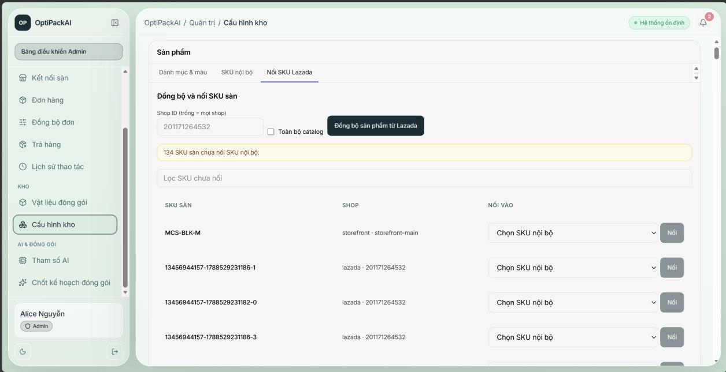
Function details:
- Bin codes are generated by rack; a bin can have a capacity in units.
- A warehouse, zone or bin can be deleted permanently only when it holds no stock.

3.4.2 Internal SKU and mapping
Function trigger: Admin Warehouse → SKU tab.
Function description: Admin manages internal SKUs and seller-SKU mappings.
Screen layout:
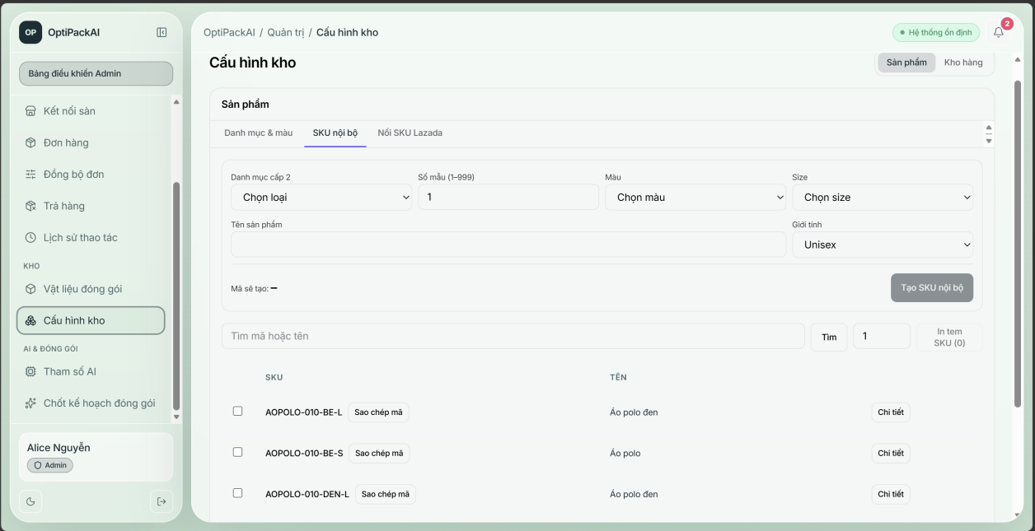
Function details:
- Internal SKU code follows CATEGORY-MODEL-COLOUR-SIZE; category and colour must exist.
- Mapping a seller SKU to an internal SKU pools the stock and moves existing reservations.
- Seller SKUs with the same code as an internal SKU are mapped automatically.

3.4.3 Packaging profile
Function trigger: Product master list → profile form.
Function description: Warehouse Staff confirms dimensions, weight, fragility, item category and folding.
Screen layout:
[Insert screenshot of the "Packaging profile" screen]
Function details:
- Only the six clothing categories can be folded in half.
- A group whose SKU has no confirmed profile cannot get a packing plan (packing-blocked).

3.4.4 Bin stock and stock receipt
Function trigger: Warehouse Inventory screen.
Function description: Warehouse Staff assigns SKUs to bins and receives stock by lot.
Screen layout:
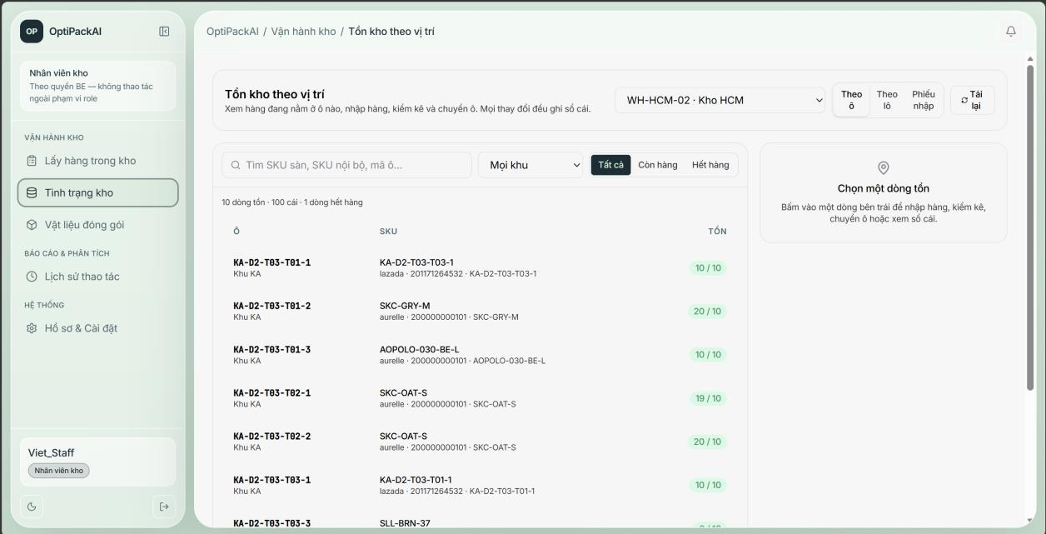
Function details:
- Putting a SKU into a second bin of the same warehouse requires explicit confirmation.
- A receipt that exceeds bin capacity is rejected unless forced.
- Each receipt line creates a lot; picking consumes the oldest lot first (FIFO).
- Every change writes an inventory movement; stock-in re-checks groups with shortage.

3.5 Picking

3.5.1 Pick items
Function trigger: Warehouse Picking screen → group.
Function description: Warehouse Staff assigned to the group.
Screen layout:
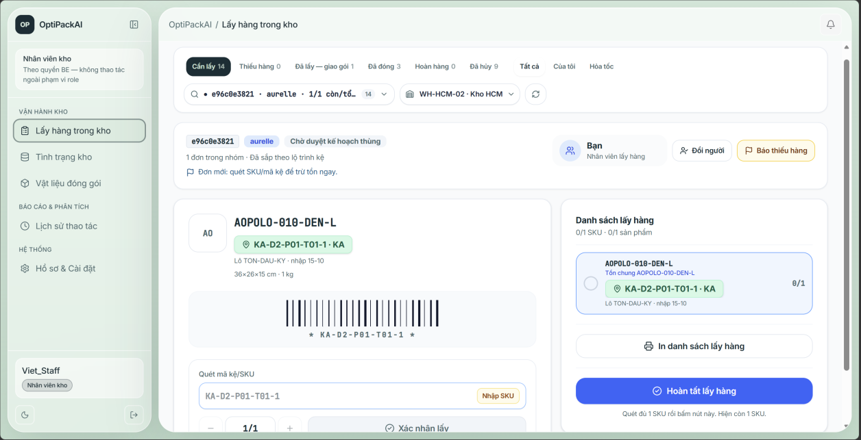
Function details:
- The picking list shows per SKU: quantity, bin, oldest lot, other bins and split per order for consolidated groups.
- A scan is rejected when the SKU is not in the group, the quantity exceeds the ordered quantity, the warehouse differs or bin stock is insufficient.
- A repeated scan with the same client event id is not counted twice.
- The first scan notifies AURELLE customers "warehouse is preparing your order".
- "Picking completed" is allowed only when every SKU is fully picked.

3.5.2 Report missing and decide partial
Function trigger: Picking screen → Report missing; Packing Station → shortage.
Function description: Warehouse Staff reports; Packaging Staff / Admin decides.
Screen layout:
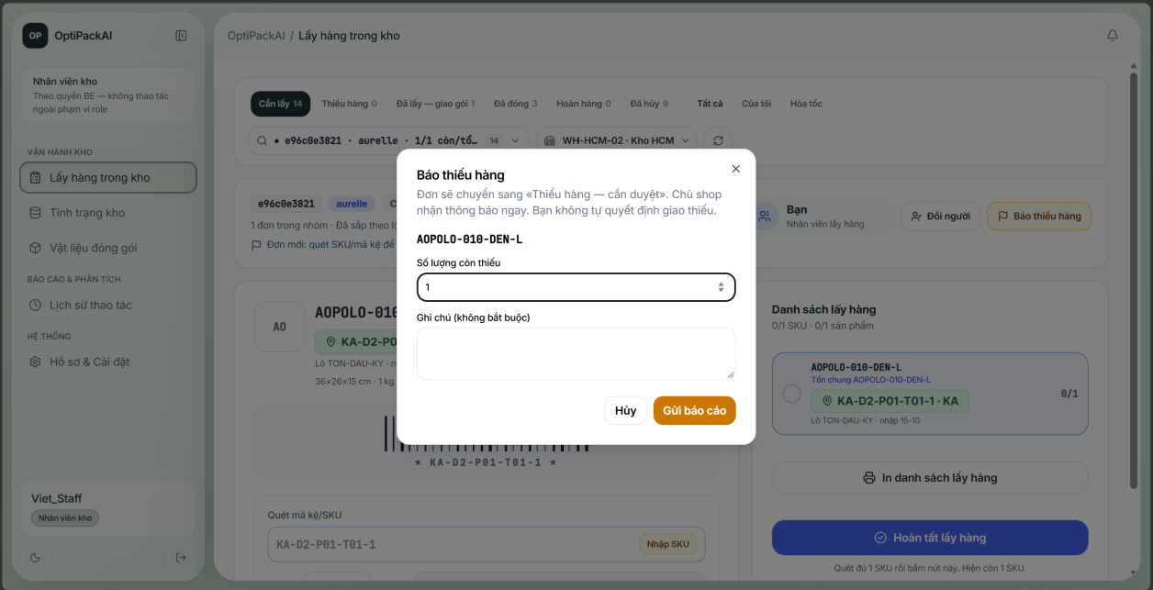
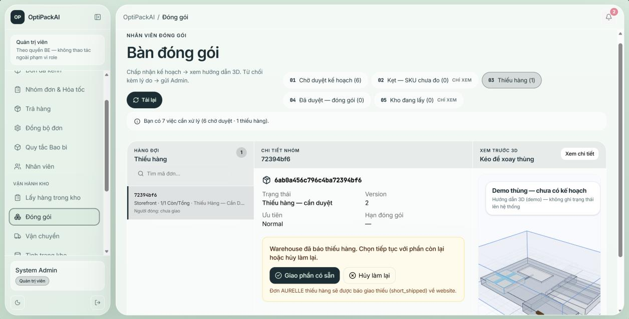
Function details:
- Reporting moves the group to partial_needs_review and notifies Store Owner and Packaging Staff.
- Ship available: group becomes picked, shortage is allocated to oldest orders first and AURELLE customers are informed (not charged).
- Re-pick: a new pick round starts, picked items are returned to their bins and stock is re-reserved.

3.6 Packing

3.6.1 Compute and approve packing plan
Function trigger: Automatic; Packing Station.
Function description: System computes; Packaging Staff / Admin approves.
Screen layout:
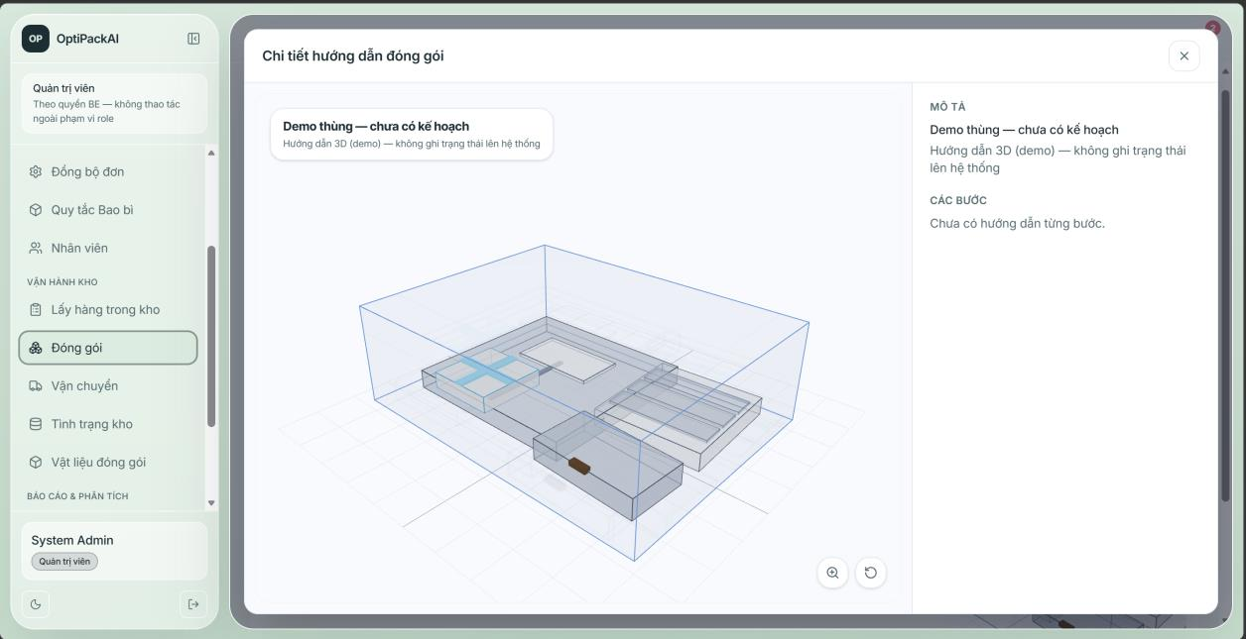
Function details:
- One plan per order group; each parcel belongs to exactly one order.
- The plan is assigned automatically to the least-busy packer not on leave.
- Approval is possible only when every item of every order is placed.

3.6.2 Reject and recover
Function trigger: Packing Station → Reject.
Function description: Packaging Staff / Admin.
Screen layout:
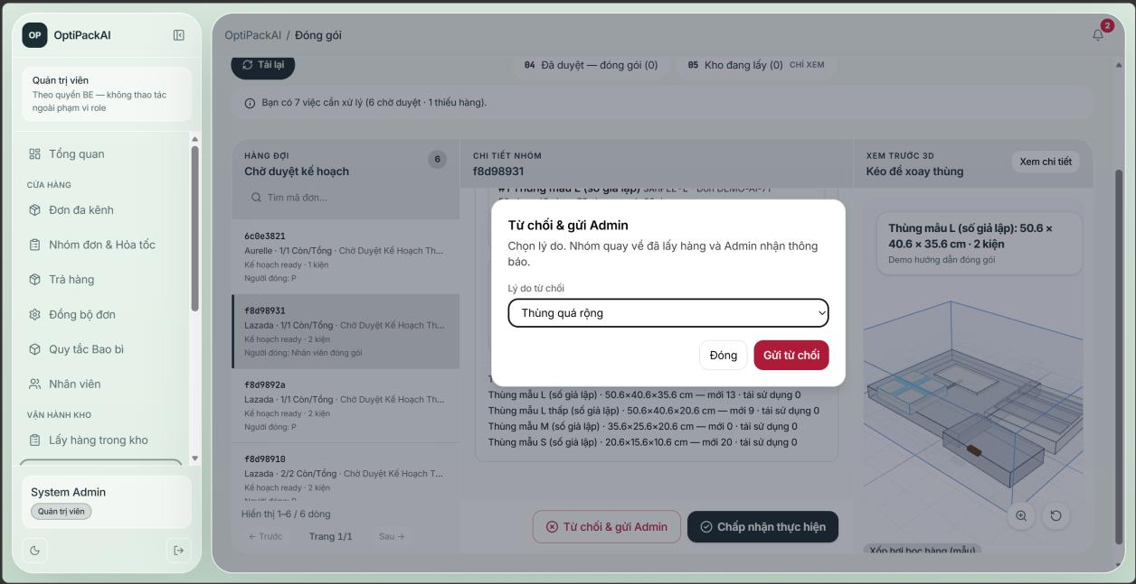
Function details:
- Reason is chosen from a code list; "Other" needs a note; Admin and Store Owner are notified with a 2-working-hour deadline.
- Recovery: recompute (exclude boxes / prefer cheaper), manual packing approved by another person, or back to picking.

3.6.3 Pack parcels
Function trigger: Packing Station → session.
Function description: Packaging Staff / Warehouse Staff.
Screen layout:
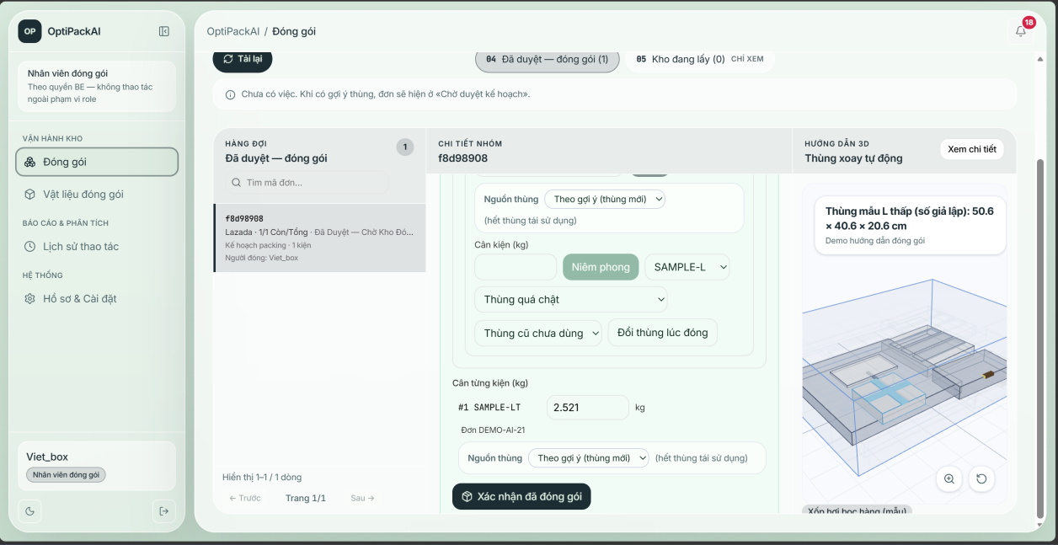
Function details:
- Items must be scanned into the correct parcel; wrong parcel or extra item is blocked.
- Sealing deducts the box (reused shelf first, new box for fragile items) and materials.
- Weight outside tolerance (default 20%) puts the parcel on hold for review by another person.
- "Quick pack" without scanning is blocked when scanning is mandatory or the group has several recipient names.
- The last sealed parcel moves the group to packed and notifies AURELLE customers.

3.7 Shipping

3.7.1 Create shipment
Function trigger: Shipping & Fulfillment screen.
Function description: Shipping Coordinator / Admin.
Screen layout:
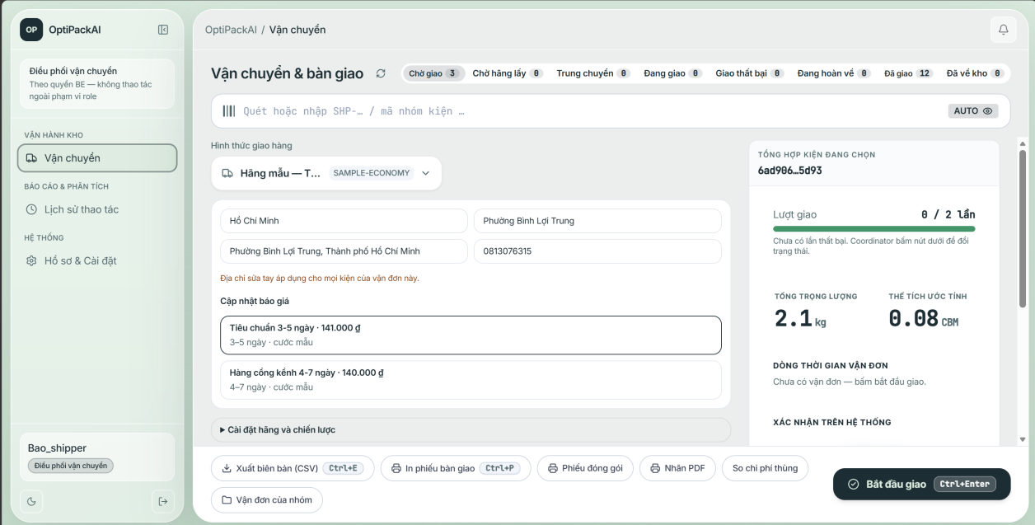
Function details:
- Only packed groups can be shipped; several groups of the same recipient can be shipped as one trip.
- One GHN order is created per parcel with the recipient of that parcel's order.
- Rejected bookings (e.g. address) are corrected and re-booked without creating duplicates.

3.7.2 Track delivery
Function trigger: Automatic (GHN webhook / sync); Shipping screen.
Function description: GHN, Shipping Coordinator.
Screen layout:
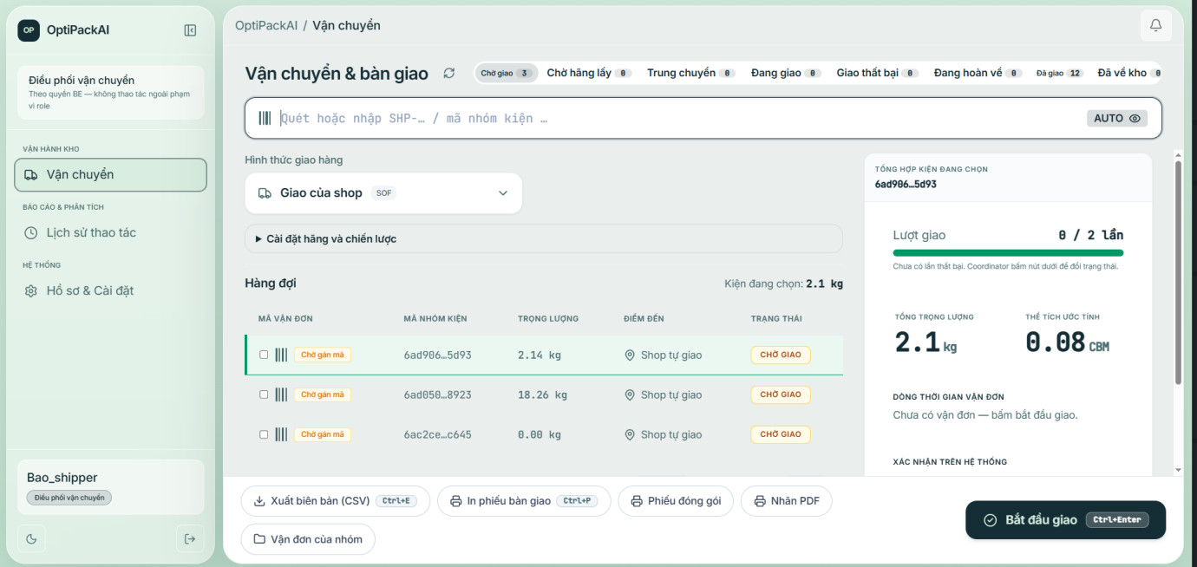
Function details:
- GHN statuses are mapped to awaiting_pickup, in_transit, out_for_delivery, delivered, delivery_failed, returning_to_warehouse.
- Without carrier API, a second failed attempt or customer refusal automatically returns the shipment.
- Every change is sent to AURELLE so customers see the progress.

3.7.3 Receive returned parcel
Function trigger: Shipping / Warehouse screen → Receive return.
Function description: Warehouse Staff.
Screen layout:
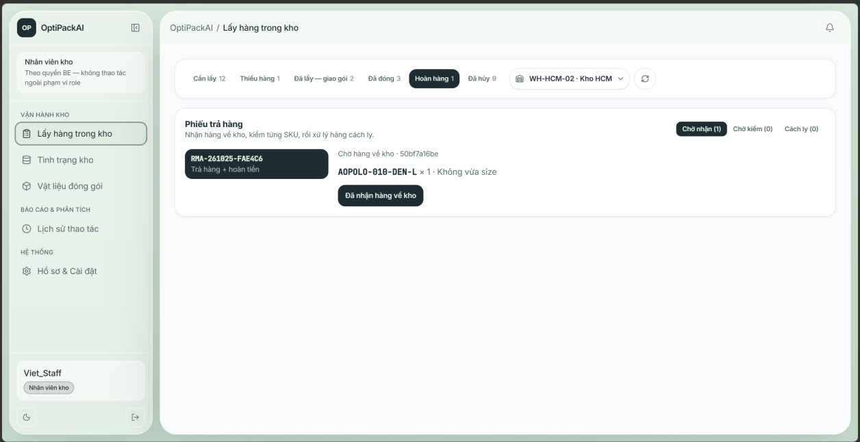
Function details:
- Shipment becomes returned_to_warehouse, group becomes returned and a failed-delivery return ticket is created for inspection.

3.8 Returns and Exchanges

3.8.1 Review return ticket
Function trigger: Returns screen.
Function description: Store Owner / Admin.
Screen layout:
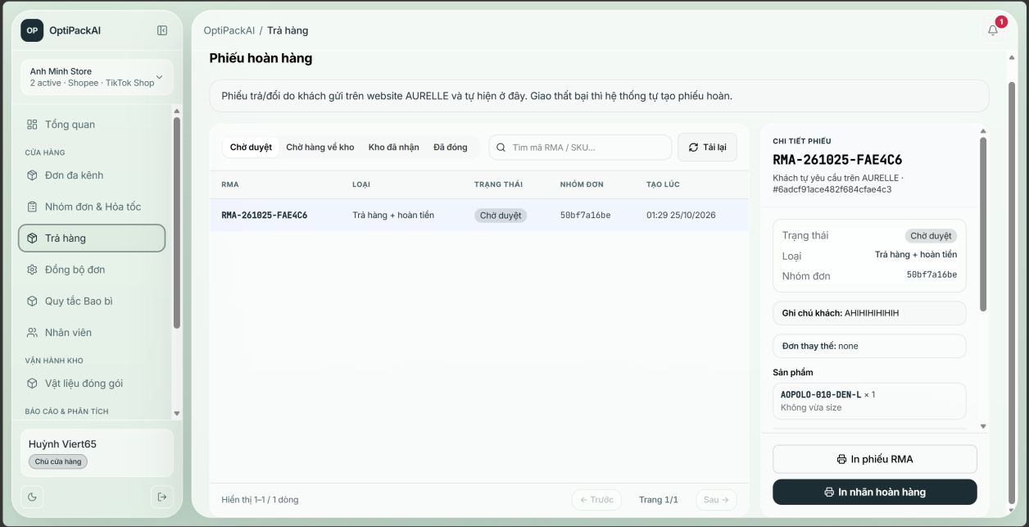
Function details:
- The creator of a ticket cannot approve it.
- Reject and cancel require a reason.
- Refund-only is closed at approval without goods returned.

3.8.2 Receive and inspect
Function trigger: Returns screen → Receive / Inspect.
Function description: Warehouse Staff / Admin.
Screen layout:
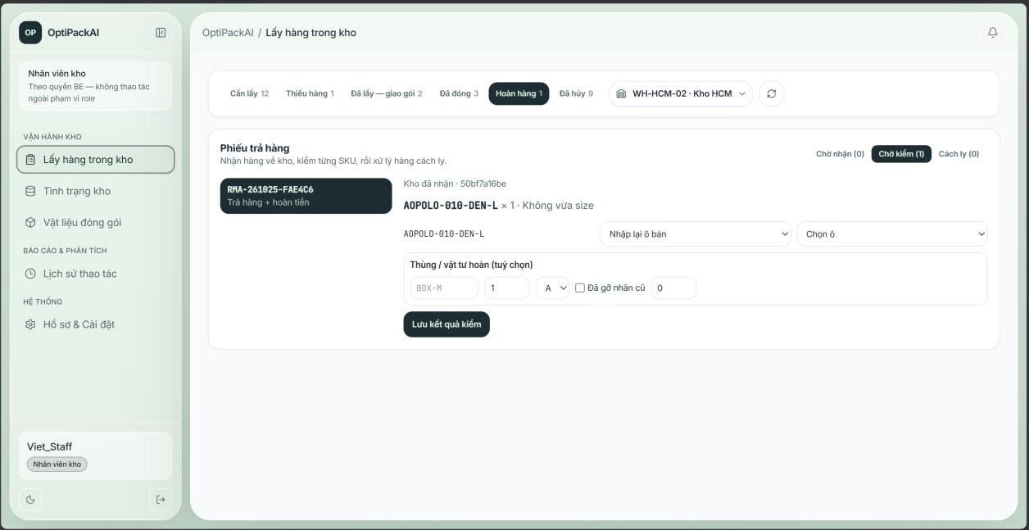
Function details:
- Each SKU is restocked, quarantined or discarded; restocked items return to a bin and write the ledger.
- Exchange tickets create a replacement order EXC-… (price 0) that goes through picking, packing and shipping.

3.9 Packaging Materials

3.9.1 Manage packaging catalog and movements
Function trigger: Packaging Materials / Rules screens.
Function description: Admin manages; Warehouse Staff records stock-in and use; Store Owner views savings.
Screen layout:
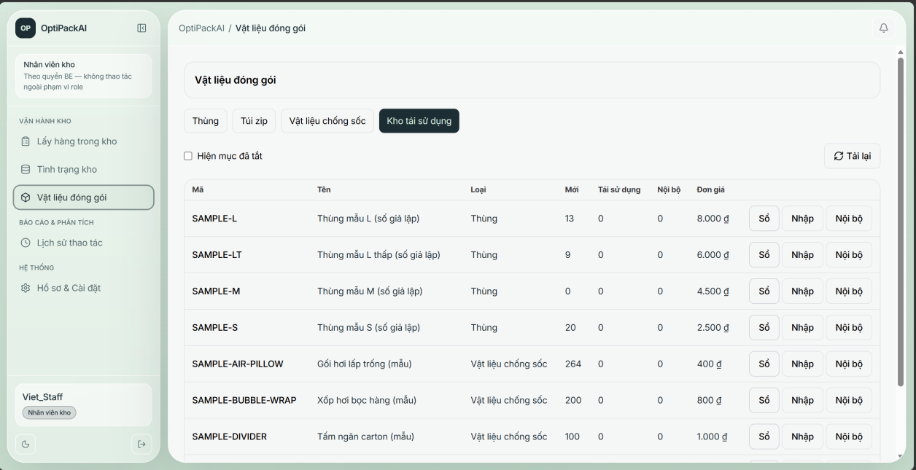
Function details:
- Boxes have new and reused stock; fragile items use new boxes unless allowed in settings.
- Every purchase, internal use, consumption and recovery is recorded as a movement.

3.10 Notifications

3.10.1 Notifications
Function trigger: Top bar bell.
Function description: All staff roles.
Screen layout:
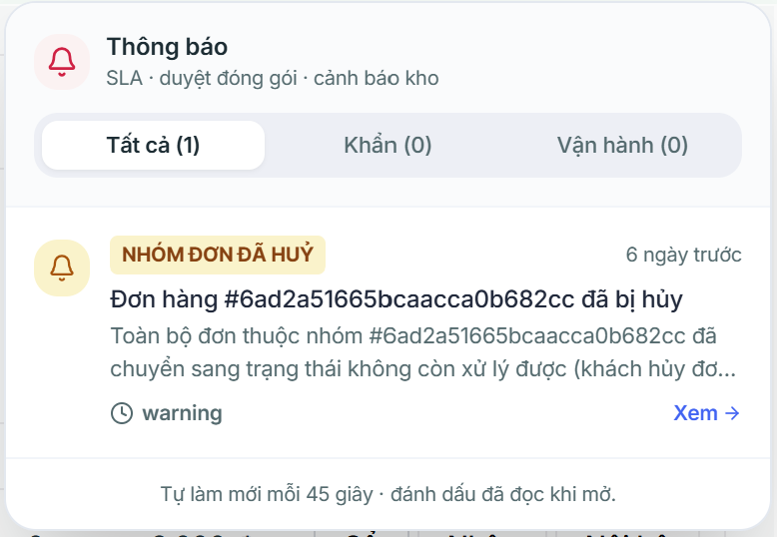
Function details:
- Notifications are addressed to a role or to a user and link to the related entity.

3.11 AURELLE Customer Website

3.11.1 Browse, cart and checkout
Function trigger: Home → Shop → Product → Cart → Checkout.
Function description: Customer.
Screen layout:
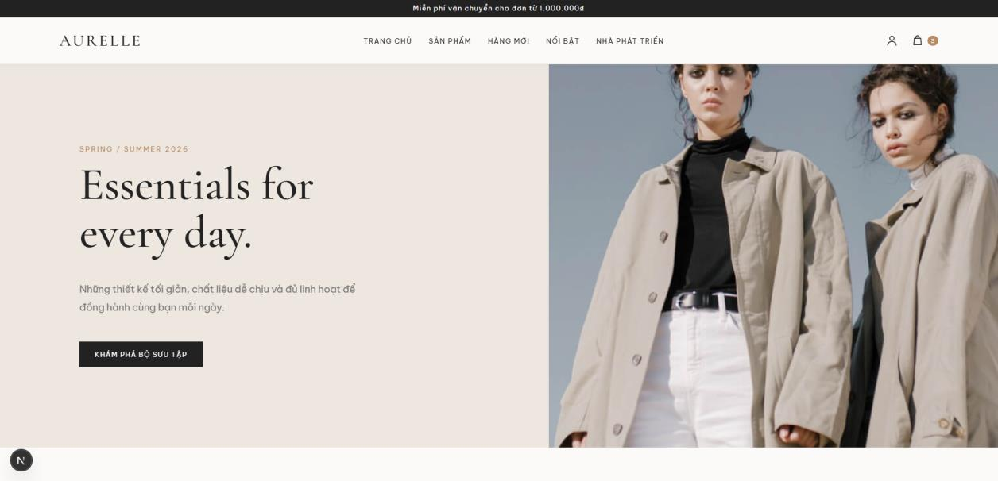
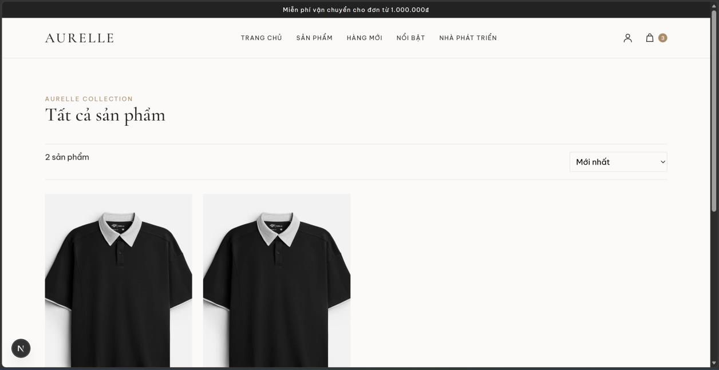
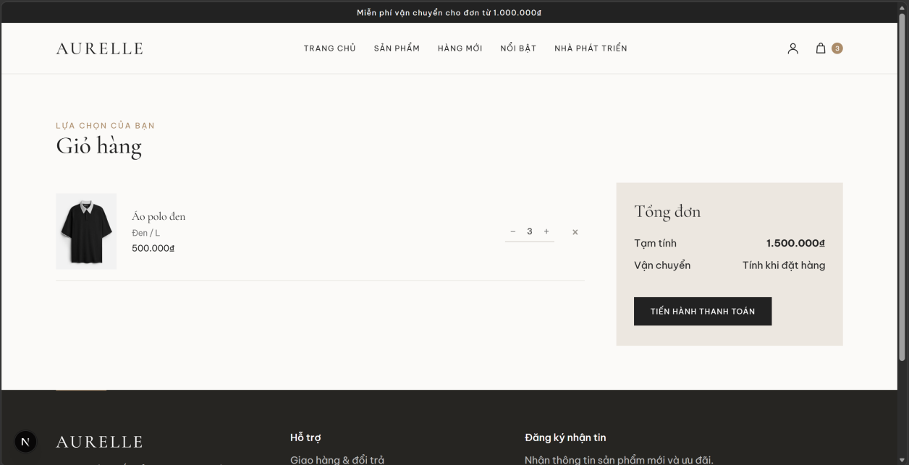
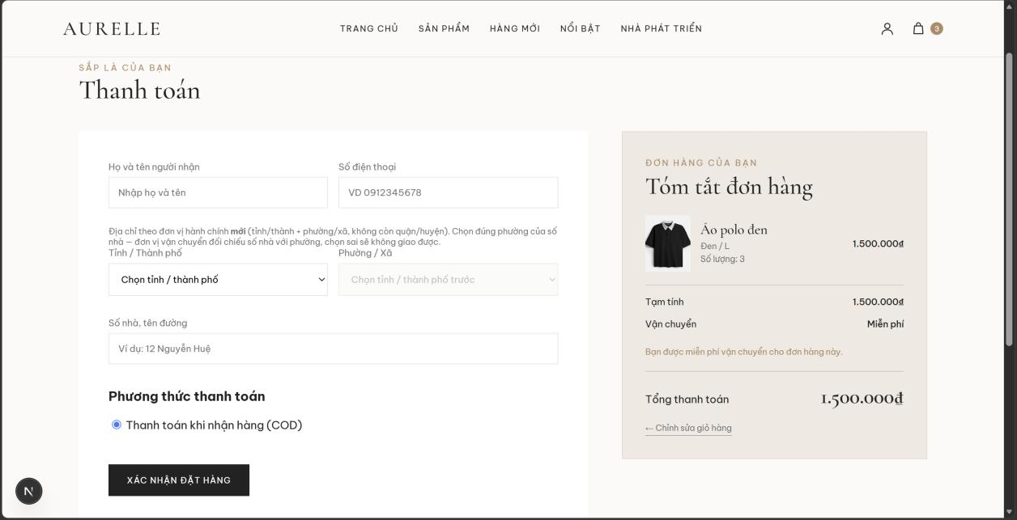
Function details:
- Only variants whose stock is managed by the OptiPack warehouse are sellable.
- Address uses the new two-level administrative units (province, ward); phone must be 10 digits starting with 0.
- Payment method: COD or bank transfer.

3.11.2 Track and cancel order
Function trigger: My Orders → Order Detail.
Function description: Customer.
Screen layout:
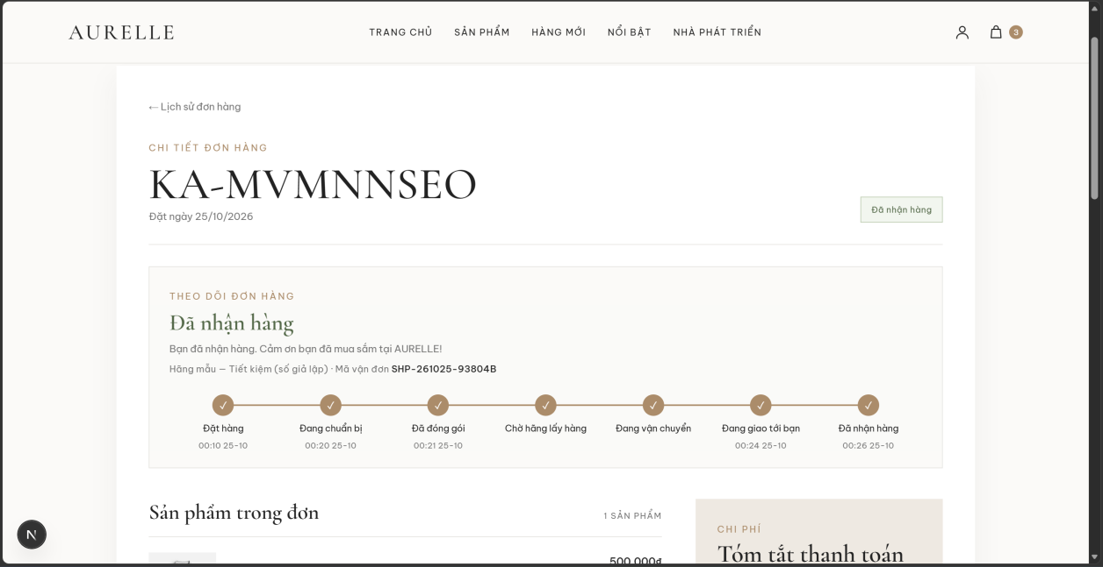
Function details:
- A 7-step progress bar (Placed, Preparing, Packed, Waiting for pickup, In transit, Out for delivery, Delivered) is shown from the moment the order is placed, with branches for cancellation, failed delivery and return.
- The page refreshes every 30 seconds while the order is not finished.
- The customer can cancel only while the order is pending and not packed.

3.11.3 Return and exchange request
Function trigger: Order Detail → Request return.
Function description: Customer.
Screen layout:
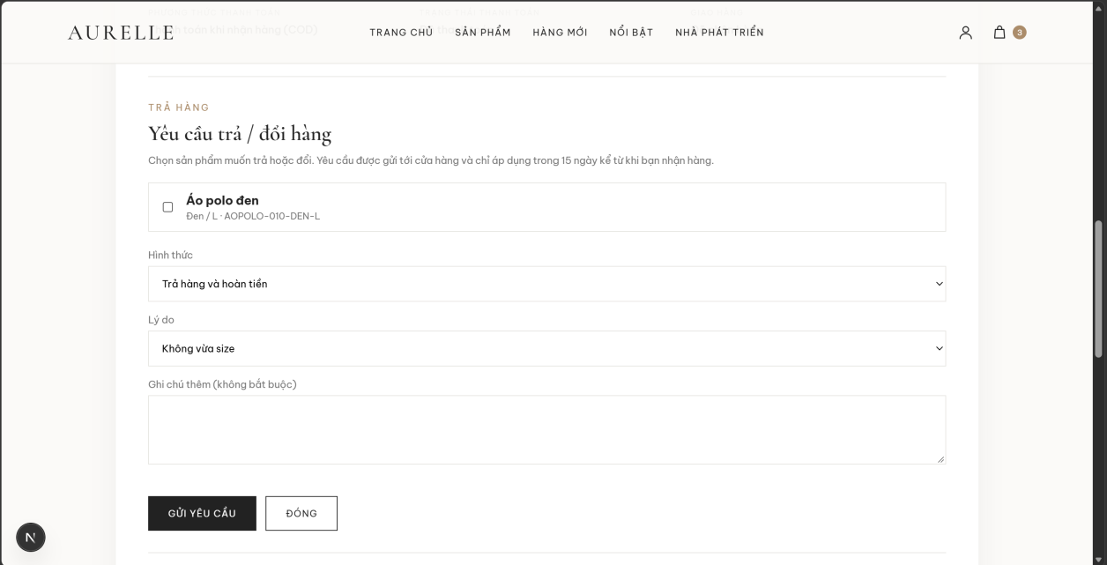
Function details:
- Allowed within 15 days after delivery, one open request per order; exchange target must be in stock.
- A pending request can be cancelled by the customer.

3.12 AURELLE Web Administration

3.12.1 Manage storefront catalog
Function trigger: AURELLE Web Admin page.
Function description: AURELLE Web Admin.
Screen layout:
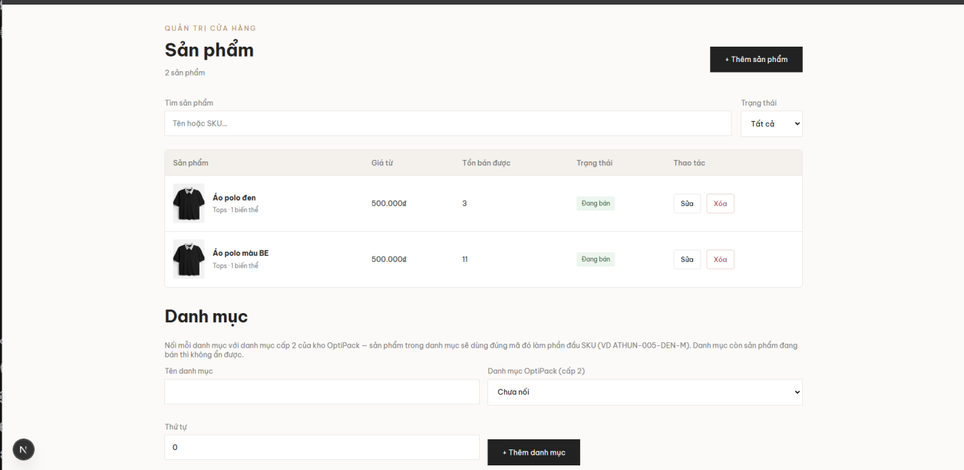
Function details:
- New variants must use OptiPack category, model number, colour and size so the SKU matches an internal SKU.
- Saving a product notifies OptiPack (product-updated webhook) so the catalog is synchronized.

4. Non-Functional Requirements

4.1 External Interfaces
Interface | Description
User interfaces | Web portal for staff (web browser; a mobile scanning app is planned for Iteration 3 and is not part of this release), AURELLE customer website and admin page (desktop and mobile browser).
Lazada Open Platform | HTTPS REST with OAuth 2.0 access / refresh tokens and request signing.
AURELLE Open API | HTTPS REST in Lazada style with HMAC-SHA256 signed requests; webhooks signed with the app secret. In the demo the Open API runs as a simulator (be/scripts/aurelle-mock-server.ts, port 4000) that reads the AURELLE website data.
GHN API | HTTPS REST with token and shop id; webhooks for status changes; A5 shipping labels.
Google OAuth 2.0 | Login for existing staff accounts.
SMTP (Gmail) | Transactional e-mails.
CP-SAT packer service | Internal HTTP service (Python, OR-Tools) used to prove packing plans; optional.
AI text service | Groq API (OpenAI-compatible chat completions, model openai/gpt-oss-120b, timeout 20 s) used to word packing guides; the template text is used when it is unavailable. No customer data is sent.

4.2 Quality Attributes

4.2.1 Usability
- Each role lands on its own home screen and sees only its menu items.
- Every error returned to the user has a stable error code and a readable Vietnamese message.
- Picking and packing screens on the web portal accept barcode scanner input and manual entry.

4.2.2 Reliability
Requirement | Metric / threshold | How it is achieved / measured
Stock never goes negative or double-counted | 0 negative bin stock | Atomic conditional decrement in a MongoDB transaction; idempotent scans by client event id; unit tests.
No duplicated external events | 0 duplicates | Processed webhook / carrier event collections and idempotency keys on write-back.
Status write-back to AURELLE | Retried up to 8 times with back-off 30 s → 30 min | Outbox written in the same transaction as the business change.
Degraded mode when packer service is down | Plans still produced | Fallback to the built-in BRKGA solver (label "heuristic").
Automated regression | ≥ 1,251 automated back-end tests pass on every push | GitHub Actions CI: type check, lint, tests, builds.

4.2.3 Performance
Requirement | Metric / threshold | How it is achieved / measured
New Lazada orders appear in OptiPack | ≤ configured sync interval + 1 minute (default ≤ 6 minutes) | Scheduler every minute; each shop is synchronized when its interval (default 5 minutes) has passed.
Picked group gets a packing plan | Job runs every 10 s; BRKGA p95 ≤ 1 s per order; CP-SAT limit 6 s per order | Benchmark scripts/solver-benchmark.ts on 300 orders (last run p95 560 ms).
Customer sees status change on AURELLE | ≤ 15 s write-back + ≤ 30 s page refresh | Write-back job every 15 s; page auto-refresh.
AURELLE stock follows warehouse stock | ≤ 1 minute | Stock push every minute.
API protection | 600 requests / minute / client | Global rate limiter.

4.2.4 Security
- Passwords hashed with bcrypt; account lockout after 5 failed logins for 15 minutes.
- JWT access token 24 hours, refresh token 30 days with rotation and reuse detection; logout revokes the refresh token.
- Optional two-factor authentication (TOTP + 10 one-time backup codes) for every staff account; trusted device 30 days.
- Marketplace tokens encrypted with AES-256-GCM; AURELLE and GHN callbacks verified by signature / secret.
- Role-based access control on every endpoint; HTTP security headers (Helmet); login audit log.

5. Requirement Appendix

5.1 Business Rules
ID | Rule Definition
BR-01 | Orders of the same shop with the same consolidation key are grouped while the group is still awaiting_packaging or picking (configurable).
BR-02 | Each parcel contains items of exactly one order; each parcel has its own carrier tracking code with the recipient of that order.
BR-03 | Split or merge of order groups is allowed only before the first item is scanned; merge requires same shop and same real phone number.
BR-04 | Stock is reserved per order group; picking consumes the oldest lot first (FIFO).
BR-05 | A group can be marked picked only when all ordered quantities are scanned; otherwise missing items must be reported.
BR-06 | A packing plan cannot be approved while any item is unplaced; a manual plan must be approved by another person.
BR-07 | A parcel whose weight differs from the estimate by more than the tolerance (default 20%) is held and reviewed by a different person.
BR-08 | Fragile items are packed in new boxes unless reused boxes are allowed in packing settings.
BR-09 | A rejected packing plan must be handled within 2 working hours (08:00–17:00).
BR-10 | Without carrier API, a shipment returns to the warehouse after 2 failed delivery attempts or customer refusal.
BR-11 | Return requests are accepted within 15 days after delivery; one open request per order.
BR-12 | The creator of a return ticket cannot approve it; reject and cancel require a reason.
BR-13 | A customer can cancel an AURELLE order only while it is pending and not packed; the seller can cancel until it is handed to the carrier.
BR-14 | Short-shipped items are allocated to the oldest orders first and are not charged.
BR-15 | Only the six clothing categories can be folded in half in a packing plan.
BR-16 | Staff on leave are not assigned work automatically or manually.
BR-17 | A new account must change its temporary password within 72 hours.

5.2 Common Requirements
- Every state-changing request that can be performed by two people at the same time carries the version of the record (expected_version); an outdated version is rejected with a conflict error.
- Errors are returned as { error_code, message, details } with HTTP status 400 / 401 / 403 / 404 / 409 / 422.
- All dates are stored in UTC and displayed in Asia/Ho_Chi_Minh time.
- Every business action that changes the state of an order group, return ticket or stock is recorded in the history.

5.3 Application Messages List
Code | Type | Context | Content
AUTH_INVALID_CREDENTIALS | Error | Login | Email hoặc mật khẩu không chính xác. (Wrong e-mail or password.)
AUTH_ACCOUNT_LOCKED | Error | Login | Account locked for 15 minutes after too many failed attempts.
AUTH_PASSWORD_DEADLINE_LOCKED | Error | Login | Account locked: temporary password not changed within 72 hours.
ORD_GROUP_STATE_CONFLICT | Error | Any group action | The group was changed by someone else — reload and try again.
ORD_GROUP_PICK_EXCEEDS_ORDERED | Error | Picking | Scanned quantity exceeds the ordered quantity.
ORD_GROUP_INSUFFICIENT_STOCK | Error | Picking | Not enough stock in the bin — report missing items.
ORD_GROUP_PICK_INCOMPLETE | Error | Picking | Some SKUs are not fully picked.
ORD_GROUP_WRONG_WAREHOUSE | Error | Picking | This round is being picked in another warehouse.
ORD_GROUP_REGROUP_HAS_PICKS | Error | Split / merge | Items already scanned — the group cannot be split or merged.
ORD_GROUP_MERGE_RECIPIENT_MISMATCH | Error | Merge | Different phone numbers — use "Link" instead of merging.
PACKING_SCAN_REQUIRED | Error | Quick pack | Scanning each item is required (setting or several recipients).
PACKING_PACK_WEIGHTS_MISMATCH | Error | Packing | Weights must be entered once for every unsealed parcel.
PKG_BOX_OUT_OF_STOCK | Error | Packing | The selected box is out of stock.
WH_SKU_IN_OTHER_BIN | Confirmation | Bin assignment | The SKU is already in another bin — confirm to use a second bin.
RMA_WINDOW_EXPIRED | Error | Returns | More than 15 days since delivery — return period expired.
RMA_SIMULATION_DISABLED | Error | Returns | Simulated returns are disabled; customers request returns on AURELLE.
PM_FOLD_NOT_ALLOWED | Error | Packaging profile | Only clothing categories can be folded in half.
consolidation_name_mismatch | Notification | Order groups | Consolidated group has several recipients with different names.
stock_shortage | Notification | Order groups | Available stock does not cover the group.
missing_item | Notification | Picking | Warehouse Staff reported a missing item.
packing_blocked | Notification | Packing | Packing plan blocked — SKU needs measurement.
delivery_failed | Notification | Shipping | Carrier reported a failed delivery.
return_requested | Notification | Returns | A customer requested a return / exchange.

5.4 Other Requirements
The main business workflows WF-01 to WF-06 that combine the features above (actors, triggers, outcomes and state changes) are specified with activity diagrams in Report 4 – Software Design Document.

