20053391_NgoMinhThuan_LTLaptrinhhuongdoituong_tuan3

Class HinhHoc

Class HinhChuNhat

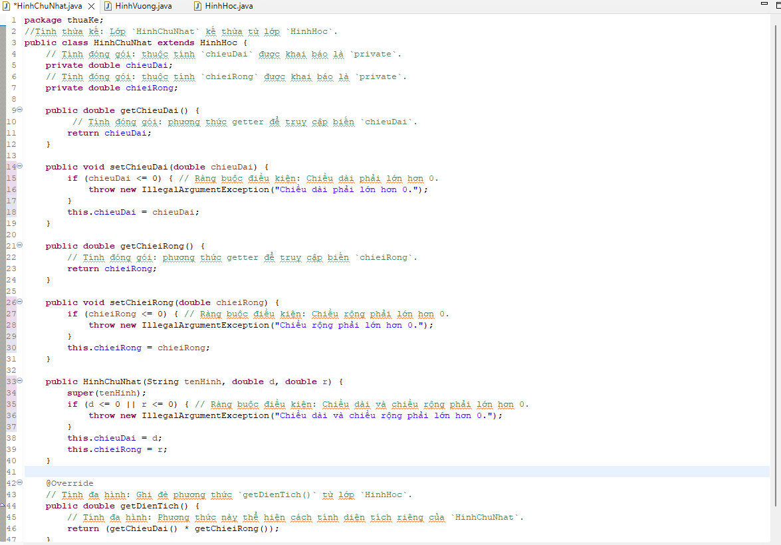

Class HinhVuong

ClassTest

