

PROJECT: Online_SMS
GROUP NO:04 BATCH:T1.2302E1

A. SYSTEM REQUIREMENTS:
Sr. | Item | Description
1. | Operating system | Windows 7, 8, or higher
2. | Hardware | CPU Cores or better with 2 Gigabytes of RAM or better
3. | Web Browser | Version in later of: Edge, Firefox, Chrome, etc…
4. | Fonts | Standard font Unicode: Arial, Tahoma, Lucida Console, Times New Roman, etc…
5. | Other requirement | Visual Studio, Visual Studio Code, Git, Sql server management studio | A working internet connection.

B. Program Instrallation
Step 1: Download GIT onto your device
After enter “Download Git” website, please choose your device operation, for
example if you’re using window laptop choose windows. After that click on “Click
here to download”.
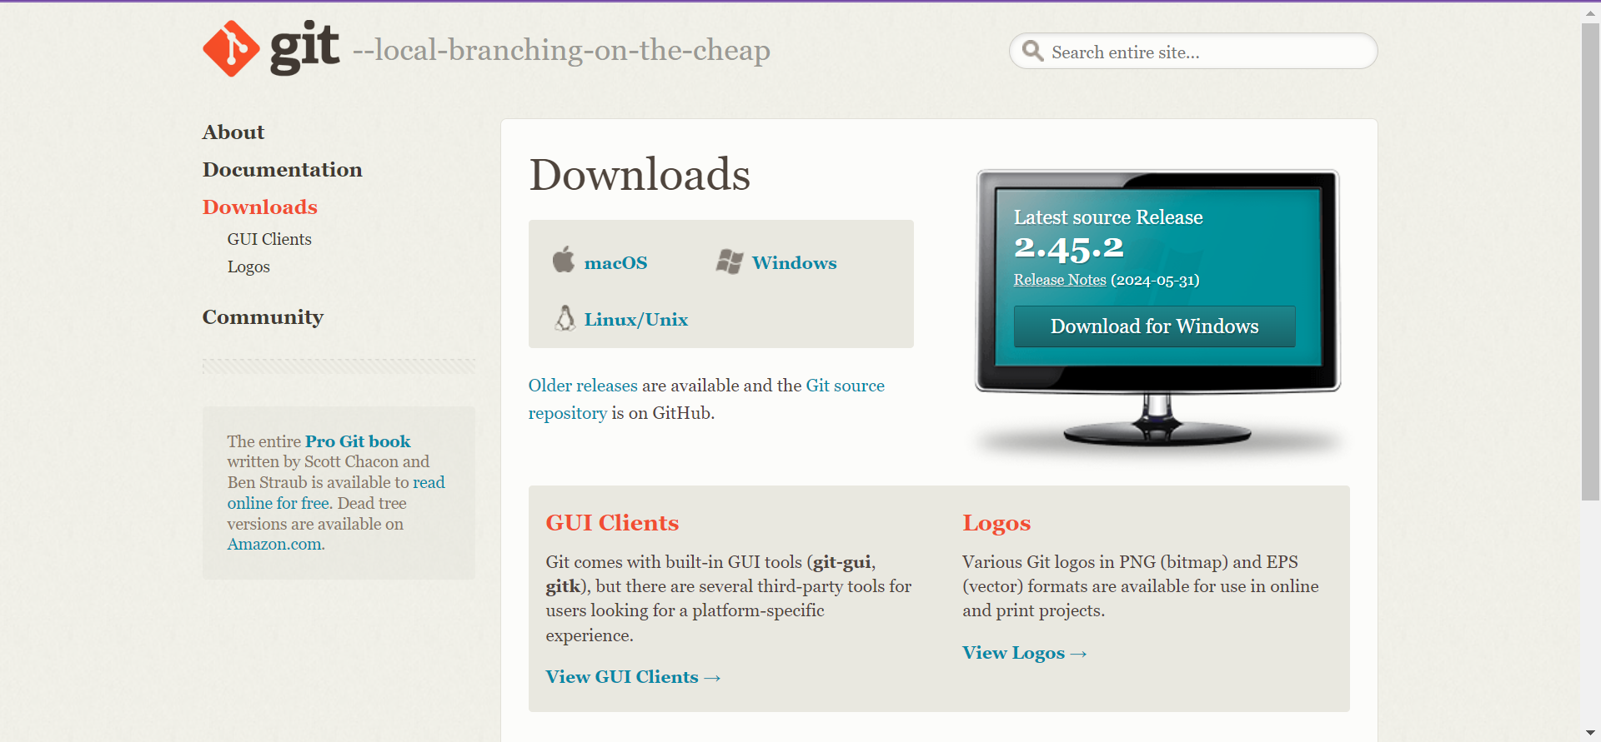

Step 2: Clone Github project to your folder
After Git is download and setup, you can go ahead and clone Github project into
your folder.
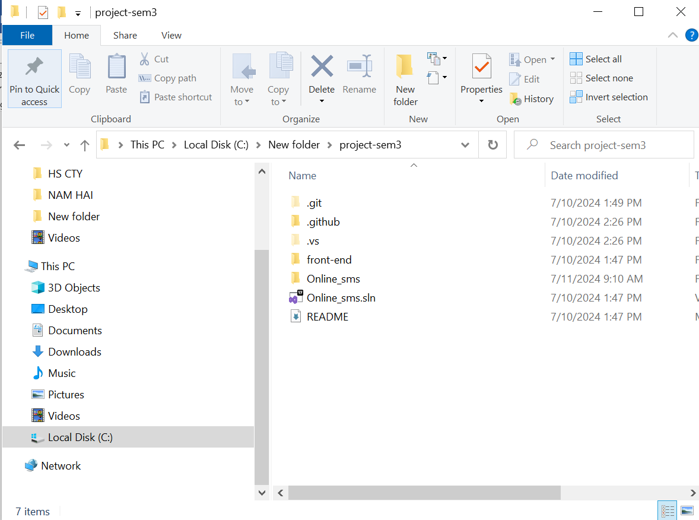

Step 3: Open Visual Studio
Now click on “Open a project or solution” and locate your folder.
After that click on Online_sms.sln to open the project
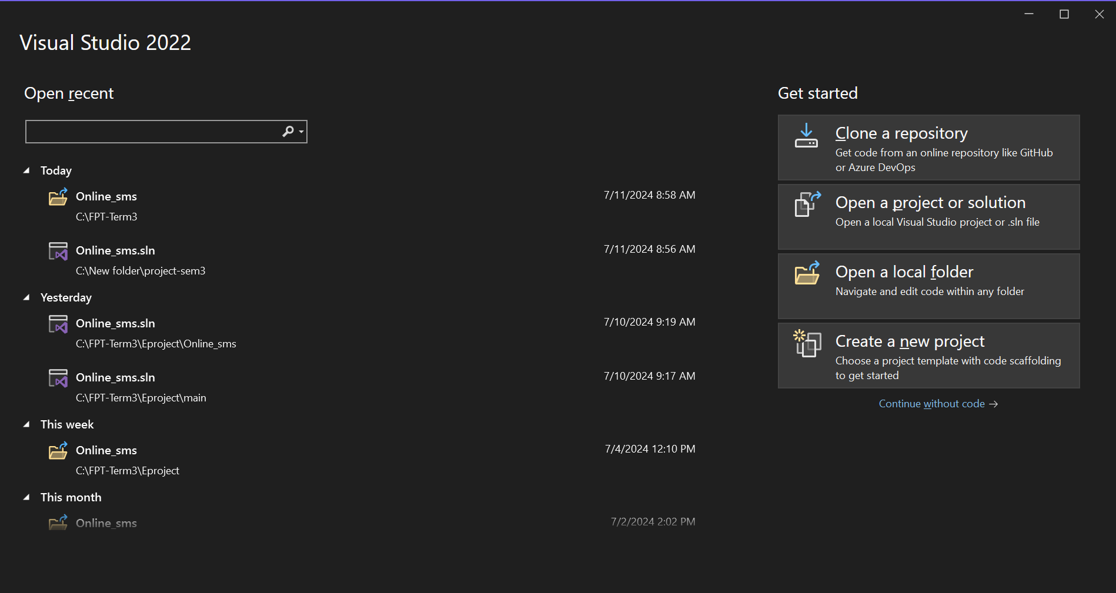
Step 4: Connect your Sql server management studio to Visual Code
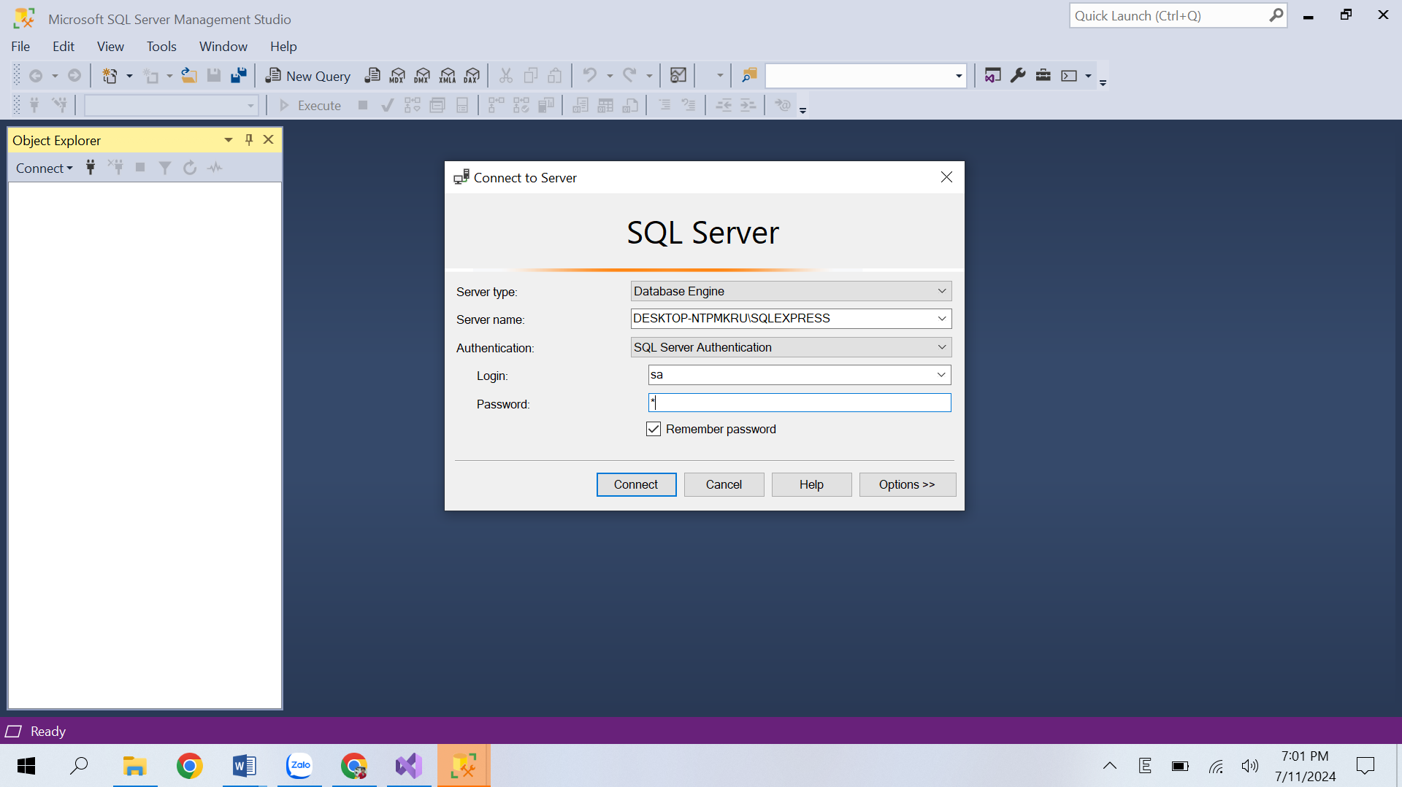
Locate “appsetting” in your Visual Studio project, and change the Connection string to connect to your Sql server
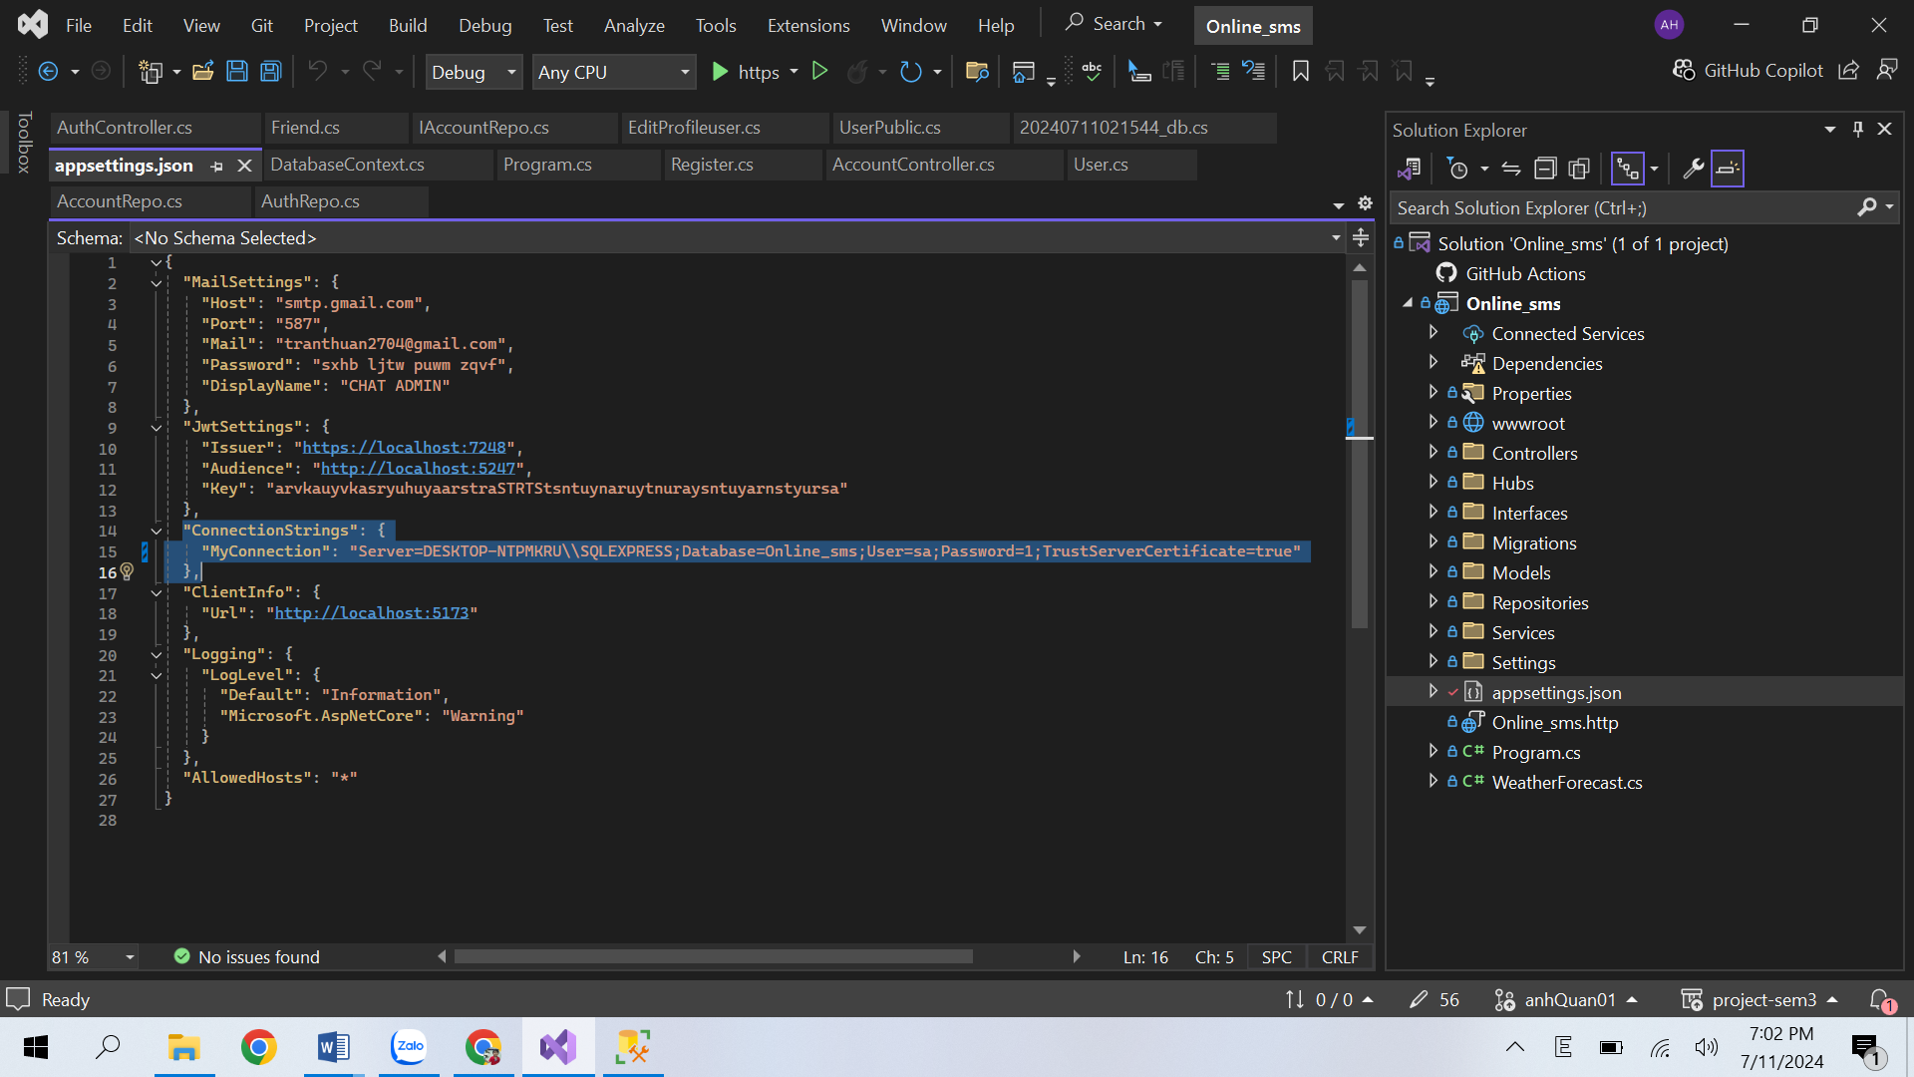
Step 5: Create database
Locate Package Manager Console
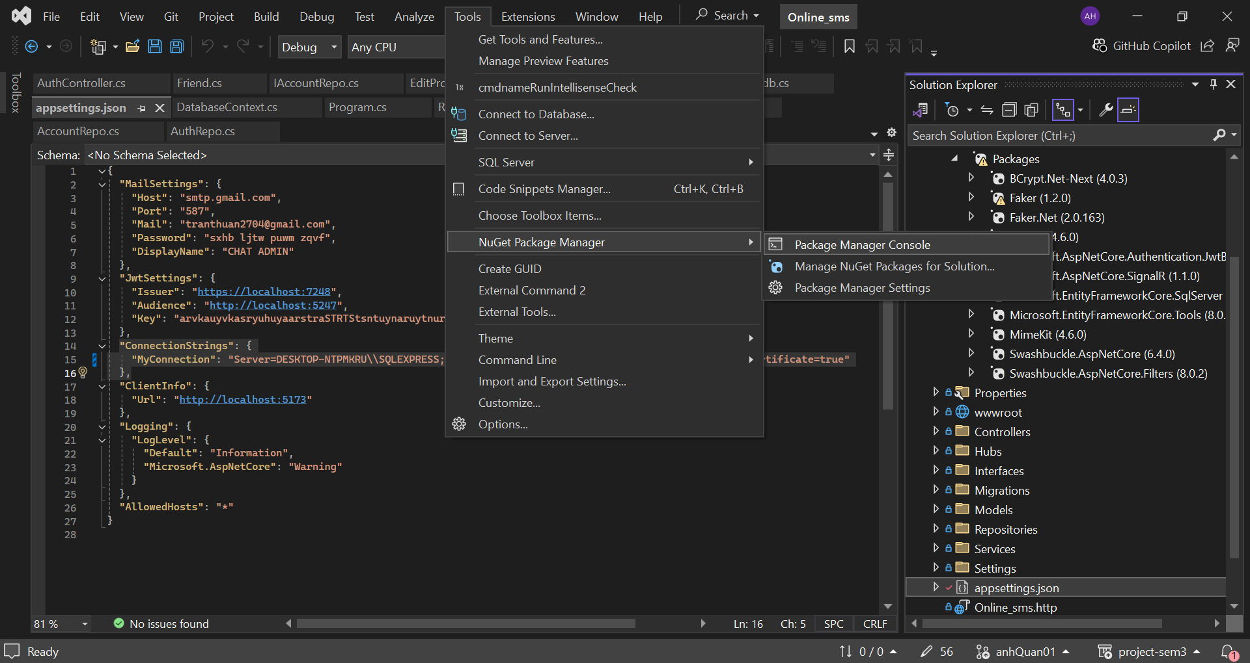
And run the following command: “Add-Migration” after that “Update-Database”
When finished running those command it should shows “done”
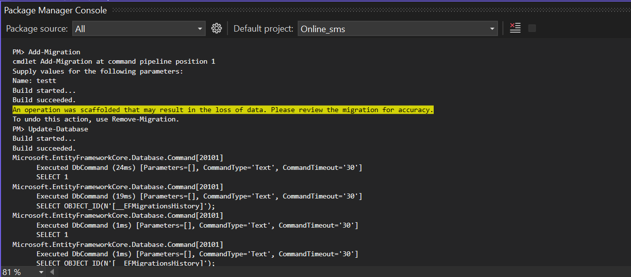

C. Successful test
- The website is loaded successfully.
- Homepage should be displayed as described in the documentation.

Your Homepage Screen Shot

