|  |  |  |
| --- | --- | --- |
| **Supervisor:** | Le Thi Mong Thuy | |
| **Semester:** | 1 | |
| **Batch No:** | T1.1910.M1 | |
| **Group No:** | 3 | |
| **Order:** | **Full Name** | **Roll No.** |
| 1. | Huynh Qui Thuan | Student1235023 |
| 2. | Hoang Phi Hai | Student1233863 |
| 3. | Nguyen Thanh Nhat Quang | Student1233871 |



This is to certify that

Mr. **Huynh Qui Thuan**

Mr. **Hoang Phi Hai**

Mr. **Nguyen Thanh Nhat Quang**

Has successfully Designed & Developed

**eProject: Kid-zone**

Submitted by:

**Huynh Qui Thuan**

Date of issue:

Authorized Signature:

Table of content

Definition of the problem ……………………………………………………………………………. 4

Customer requirements specifications ……………………………………………………………….. 5

Architecture and design of the system ……………………………………………………………….. 8

Site Map ……………………………………………………………………………………………... 10

Mocking of the website ……………………………………………………………………………… 11

1. DEFINITION OF THE PROBLEM

* The [www.kids-Zone](http://www.kids-Zone) website is designed for the Kids (Toddlers) for Learning ABC’s in more creative way. The website includes the ABC with A for …., B for….
* Also it includes some nursery rhymes with images so that child can grasp more easily. One two three till 100 with and without spellings, some basic calculation of addition and subtraction. Prayers, Galleries of basic animals, plants, fruits, games colors, Sunday-Mondays and so on.
* The website is to be developed for the Windows Platform using HTML5, JavaScript and Geolocation. The site should work well in all leading browsers including Chrome, IE, Firefox etc.

1. CUSTOMER REQUIREMENTS SPECIFICATIONS

* Home page must be designed by including various interactive images like of a child say prayer, brushing teeth, drinking milk and so on.
* Navigation links must be included and must be designed in an interactive way so as to become more user friendly for the kids.
* Font sizes must be selected appropriately thinking about the end users.
* Navigation must be made user friendly.
* Menus can be included such as :
  + ABC.s
  + abc.s
  + 123….
  + Table of 2, 3, 4, 5
  + Some nursery rhymes with relevant images.
  + Basic colors
  + Some animals
  + Some Vegetables
  + Sunday, Monday…
  + January, February
  + Addition (here allow the end user to enter the value and message must be prompted whether correct ans or incorrect)
  + Subtraction (here allow the end user to enter the value and message must be prompted whether correct ans or incorrect)
* Look and feel must be made user friendly.
* Uniformity and Navigation must be made smooth throughout the website.
* The “Contact Us” page should have the Address of the Company and the mail address which when clicked will invoke the local mail client from where they can send an email. Address of the Company should be displayed using GeoLocation API (eg. GoogleMaps).

Hardware/ Software Requirements

**Hardware**

* A minimum computer system that will help you access all the tools in the courses is a Pentium 166 or better
* 64 Megabytes of RAM or better

**Software**

* Notepad/HTML editor
* Dreamweaver
* IE 5.0/ Netscape 6.0

1. ARCHITECTURE AND DESIGN OF THE SYSTEM

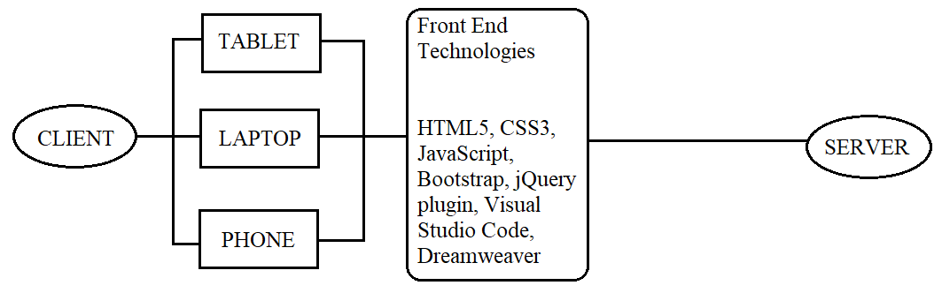

TASK SHEET PREVIEW 1

|  |  |  |  |  |  |  |  |
| --- | --- | --- | --- | --- | --- | --- | --- |
| **Project Ref. No.:**  **eProject / Kid-zone / 01** | | **Project Title:** | **Activity Plan Prepared By:** | **Date of Preparation of Activity Plan:** | | | |
| **No.** | **Task** | **Actual Start Date** | **Actual Days** | **Team Mate Names** | **Status** |
| 1 | Problem Definition | Kid-zone | Thuan | 12/10/2019 | 1 | All | Completed |
| 2 | Customer Requirement Specification | 12/10/2019 | 1 | All | Completed |
| 3 | Architechture and Design | 12/10/2019 | 1 | All | Completed |

1. Site map

|  |
| --- |
| Navigation bar |
| HOME |
| LESSON |
| CONTACT US |

|  |
| --- |
| ABC |
| Numbers |
| Animals |
| Vegetables |
| Colors |
| Days of week |
| Months |
| Math |

1. MOCKING OF THE WEBSITE
2. **HOMEPAGE**

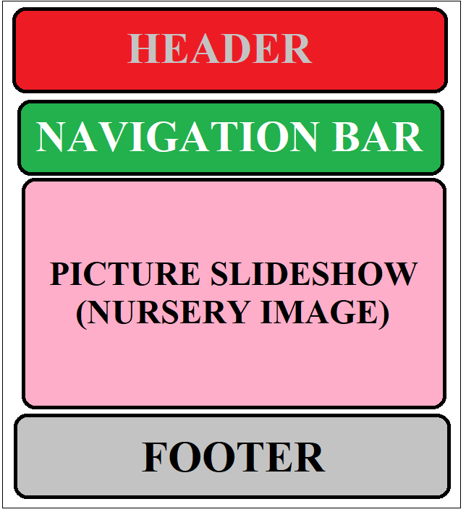

1. LESSON

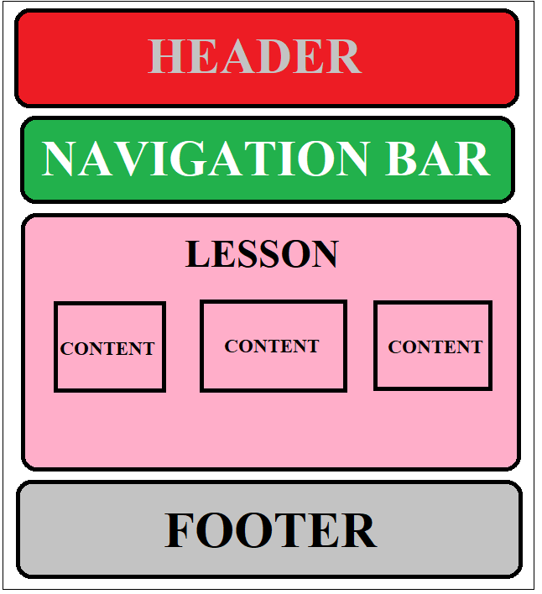

1. 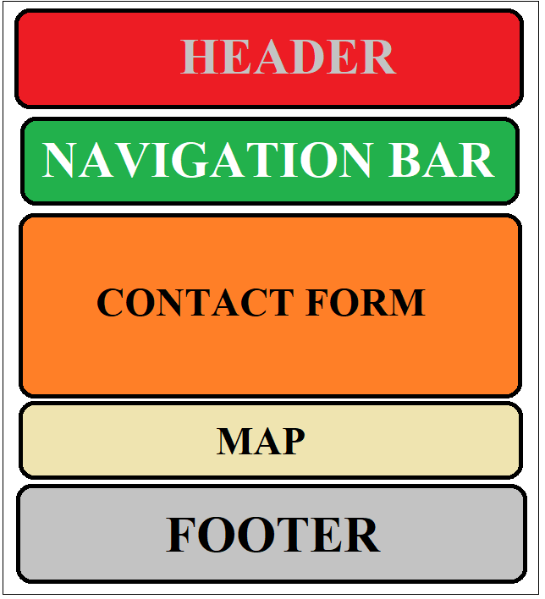CONTACT US

TASK SHEET PREVIEW 2:

|  |  |  |  |  |  |  |  |
| --- | --- | --- | --- | --- | --- | --- | --- |
| **Project Ref. No.:**  **eProject / Kid-zone / 01** | | **Project Title:** | **Activity Plan Prepared By:** | **Date of Preparation of Activity Plan:** | | | |
| **No.** | **Task** | **Actual Start Date** | **Actual Days** | **Team Mate Names** | **Status** |
| 1 | SITE MAP | Kid-zone | Thuan | 12/10/2019 | 1 | Thuan | Completed |
| 2 | MOCKING OF THE WEBSITE | 12/10/2019 | 1 | Thuan | Completed |
| 3 | TASK SHEET | 12/10/2019 | 1 | Thuan | Completed |