# Introduction

Momo stands as a prominent figure in the dynamic landscape of mobile payments, particularly within the Vietnamese fintech sector. Focused on providing users with a seamless and secure platform, Momo has swiftly grown to become a key player in facilitating various financial transactions, including bill payments, online shopping, and peer-to-peer transfers. This analysis aims to explore Momo's journey, organizational structure, leadership styles, mission, vision, products and services, target market, competitors, and subsequently provide recommendations for leadership approaches and organizational improvements.

# Body

## Overview of the company

### History of company.

Established in 2007 by Nguyen Manh Tuong, Momo has witnessed remarkable growth and success, boasting a user base surpassing 31 million and fostering partnerships with over 50,000 domestic collaborators [1]. The company has established a staggering 140,000 payment acceptance points nationwide, in collaboration with 70 banks and international card providers. This extensive ecosystem positions Momo as a super app, empowering users to seamlessly integrate it into their daily activities, offering convenience anytime and anywhere [1].

### Management team, organizational structure

At the helm is Mr. Nguyen Manh Tuong, serving as the Chief Executive Officer. Other key figures in the Momo management team include Mr. Athony Thomas (chairman), Mr. Pham Thanh Duc (vice chairman), NguyenBa Diep (vice chairman), Ms. Manisha Shah (Senior Vice President in charge of finance – CFO, HR), Mr. Dang Huu Dat (Vice President – in charge of Growth & Marketing), Mr. Vu Thanh Cong (Vice President, in charge of Product & Customer Experience) [1][3].

Organizational structure is not explicitly outlined in the provided search results, Momo is known to have a significant workforce, with the experience management teams and effort employees and a corporate vision focused on providing equal financial opportunities to all Vietnamese people. Departments such as technology, finance, marketing, and customer service are likely integral to Momo's operations, aligning with the standard functional areas in the fintech industry. Further details about specific roles and the organizational chart may require access to Momo's official publications or statements.

### Size and Geographic

Momo boasts a workforce exceeding 2000 employees and maintains its operational headquarters in Ho Chi Minh City, with additional offices strategically located in Hanoi and Da Nang [1]. This distribution signifies Momo's significant presence across key cities in Vietnam, showcasing the company's commitment to accessibility and service coverage throughout the nation.

### Leaders and their styles

While a detailed breakdown of specific leadership styles is not extensively elucidated in the available search results, it is noteworthy that Ms. Manisha Shah, serving as Momo's Chief Financial Officer (CFO), has provided insights into her managerial approach [3][4]. Described as direct and dynamically evolving, her leadership philosophy underscores strength and transparent communication. In her capacity overseeing finance, human resources, capital-raising, and investor relations, Shah's leadership style is poised to exert a significant impact on the company's strategic decisions and operational dynamics [3][4]. The collective influence of this distinguished leadership team has contributed to Momo's recognition as one of the Top 10 Global Financial Service Platforms by TABInsights [6].

## Mission Statement, Vision, Objectives, and Goals

* **Mission Statement**: To empower individuals and businesses through seamless, secure, and innovative digital financial solutions.
* **Vision**: To be a regional super app, offering a one-stop digital platform for various lifestyle needs.
* **Objectives and Goals**: Continuously enhance user experience, expand market presence, and drive financial inclusion through cutting-edge technology.

### Descriptions of their products and/or services

Momo belonging to M_Serviece company, offers a diverse range of digital financial services, making it a comprehensive platform for users in Vietnam. The key products and services provided by Momo include:

#### Mobile Payments:

Momo facilitates mobile payments, allowing users to make transactions, pay for goods and services, and transfer money using their mobile devices.

#### E-Wallet Functionality:

The platform serves as an electronic wallet, enabling users to store funds digitally, make quick and secure payments, and manage their financial transactions seamlessly.

#### Utility Bill Payments:

Momo supports the payment of utility bills, providing users with a convenient way to settle their bills for services such as electricity, water, and other utilities.

#### Financial Management Tools:

Momo offers financial management tools to assist users in managing their funds, tracking expenses, and gaining insights into their financial activities. These services cater to the evolving needs of consumers, emphasizing convenience, speed, and security in digital financial transactions [6][7].

### Target Market, Competitors, and Competitive Advantages

#### Target Market:

Primarily Vietnamese consumers and businesses seeking convenient and secure digital financial solutions.

#### Competitors:

Recently, the digital payment industry in Vietnam has experienced phenomenal expansion. The number of fintech companies functioning in Vietnam increased from forty to nearly one hundred between 2016 and 2018, with twenty-six intermediary payment service providers among them. The total transaction value within the Digital Payments sector is anticipated to reach $10,073 million in 2020, per [Statista](https://www.statista.com/outlook/dmo/fintech/digital-payments/vietnam)[8][9]. Obviously, Digital payment is one of the most attractive sectors for the big financial companies and banks to invest in. As a result, Momo faces a multitude of rivals who possess various competitive advantages. For instance:

*Zalo Pay:*

* Zalo Pay gains a competitive edge through its association with the popular Zalo messaging app in Vietnam, so leveraging the trust built with its extensive user base[10]. This brand recognition fosters user trust in its payment services.
* Zalo Pay provides a seamless experience by integrating with the Zalo messaging app. This integration makes it convenient for users already using Zalo to adopt Zalo Pay for their financial transactions.

*Shopee Pay:*

* Shopee Pay is closely tied to the Shopee e-commerce platform, allowing seamless integration for users. This ecosystem approach provides convenience for online shoppers who can easily manage their payments within the Shopee ecosystem.
* Shopee Pay forms strategic partnerships with a wide range of merchants, expanding its acceptance network. This extensive network enhances the accessibility of Shopee Pay, allowing users to make transactions at various establishments.

*Viettel Pay:*

* Viettel Pay, being part of the Viettel Group, can leverage its association with one of Vietnam's major telecommunications providers. This integration potentially enhances accessibility and user adoption due to the widespread presence of Viettel in the country.
* Viettel, as a telecommunications giant, already has a vast user base. Viettel Pay can capitalize on this existing customer base, potentially converting a significant portion into users of its financial services.
* Viettel Pay aims for wide acceptance in various establishments, making it a versatile payment solution. This widespread acceptance enhances its competitiveness by offering users the flexibility to use Viettel Pay across different services.

#### Competitive Advantages:

With a significant user base, Momo enjoys a broad market reach, providing a solid foundation for its services. Apart from using a vast user database, investors are also eagerly anticipating the realization of Momo's "super-app" idea. This electronic wallet is designed to cater to various daily activities through its payment functionalities, including savings, fuel stations, educational institutions, hospitals, and more. This infrastructure plays a crucial role in enabling Momo to expand into a comprehensive everyday super app. Moreover, Momo emphasizes security, positioning itself as a highly secure e-wallet option in the competitive landscape.

# Analysis and Recommendations

## Current Functioning:

### Market Position:

Momo holds a significant share of the Fintech market in Vietnam, with a reported 58% market share in May 2023, positioning it as a major player in the industry [13]. This underscores its dominance, reflecting user trust and adoption. However, the competitive landscape necessitates ongoing innovation for sustained success.

### Organizational Structure:

Insufficient information is available regarding Momo's current organizational structure. A thorough analysis of its structure is essential to ensure alignment with strategic goals, promoting efficiency and agility.

## Leadership Approaches:

### Transformational Leadership:

This approach emphasizes inspiring and motivating employees to achieve higher performance levels. Given Momo's dynamic industry, a transformational leadership style can drive innovation and adaptability, crucial for staying ahead in Fintech.

### Situational Leadership:

Given the competitive market, situational leadership prioritizes the well-being and growth of employees. This approach fosters a positive workplace culture, aligning with Momo's recognition as one of the best companies to work for. It contributes to employee satisfaction and engagement.

## Justification For Chosen Leadership Approach:

### Transformational Leadership:

#### Overview

Transformational leadership focuses on inspiring and motivating employees for higher performance. Leaders employing this approach often stimulate creativity and innovation within their teams.

#### Applicability to Momo

*Innovation and Adaptability:*

* Momo operates in the dynamic Fintech sector, where continuous innovation is key to staying competitive.
* Transformational leadership encourages a culture of innovation and adaptability, aligning with Momo's need for ongoing technological advancements.

*Employee Engagement:*

* Momo's recognition as one of the best companies to work for indicates a positive workplace culture.
* Transformational leaders prioritize employee well-being and growth, contributing to a positive work environment and fostering engagement.

### Situational Leadership:

#### Overview

Situational leadership emphasizes adapting leadership styles based on the situation and the readiness of followers. Leaders assess the needs of their team and adjust their approach accordingly.

#### Applicability to Momo

*Agile Response to Challenges:*

* In the dynamic Fintech landscape, challenges can be diverse and require varying leadership responses.
* Situational leadership enables leaders to adapt their styles based on the specific challenges faced, promoting an agile organizational response.

*Employee Development:*

* As Momo continues to grow, the readiness and developmental needs of employees may vary.
* Situational leadership allows leaders to tailor their approach to individual and team developmental levels, enhancing employee growth.

## Challenge

### Customer-Related Challenges:

#### Regulatory Compliance:

In a heavily regulated operational landscape, Fintech entities like Momo encounter challenges stemming from stringent regulatory frameworks. The dynamic nature of evolving compliance requirements introduces complexities, demanding meticulous resource allocation and operational adjustments.

#### Cybersecurity Threats:

Amidst the increasing sophistication of cyber threats, Momo's digital payment platform faces risks that necessitate vigilant security measures. Safeguarding customer data and transactions becomes an ongoing challenge, demanding robust cybersecurity protocols. In the realm of customer relations, building and sustaining trust in digital financial services requires persistent efforts. Additionally, addressing the challenge of financial literacy is crucial, emphasizing the need for continuous customer education regarding the benefits and security aspects of digital payments.

### Competitor-Related Challenges:

#### Market Saturation:

Momo has a hard time standing out in a market that is very competitive with e-wallet services like ZaloPay, ViettelPay, ShopeePay, VNPay, and Moca [11]. To stay ahead of the competition in a market that is already full, the company needs to keep coming up with new ideas and offering something that no one else does.

#### Technological Advancements:

Within the fintech landscape, Momo encounters the imperative of achieving interoperability in technological integration with diverse partners. This demands seamless compatibility to facilitate collaborative endeavors. Furthermore, the company faces the critical task of upholding data security in these partnerships, a pivotal aspect for preserving and enhancing customer trust.

### Partner-Related Challenges:

#### Strategic Partnerships:

In navigating its partnerships, Momo places emphasis on strategic alignment, ensuring coherence with the objectives of diverse collaborators, spanning banks and merchants. This strategic congruence serves as a foundation for successful and mutually beneficial alliances. Simultaneously, the company engages in robust risk management practices, addressing potential challenges linked to changes in partner strategies or fluctuations in market dynamics. This proactive approach helps mitigate risks and fortify the resilience of Momo's collaborative ventures.

#### Collaborative Innovation:

Momo prioritizes Innovation Alignment in its collaborations, ensuring that joint innovative efforts with partners align seamlessly with the company's overarching strategic goals. This strategic coherence enhances the effectiveness and relevance of collaborative innovations. Additionally, Momo embraces Agile Collaboration, adeptly adapting to the dynamic needs of partners and fostering an environment characterized by agility. This approach enables the company to respond swiftly to changes, promoting effective and responsive collaboration.

# Conclusions

Finally, Momo transforms digital payments and financial services in Vietnam's fintech sector. Since 2007, Momo has grown into a great app with several functions. The management team, led by CEO Nguyen Manh Tuong, drives Momo's growth. The startup wants to become a regional super app by empowering customers with seamless digital banking solutions. Momo must address fintech issues like cybersecurity, regulatory compliance, and client education. It competes with ZaloPay, ShopeePay, and ViettelPay. Market saturation requires ongoing innovation and differentiation to stay competitive. Momo utilizes transformational and situational leadership techniques to adapt to the finance industry. Transformational leadership encourages creativity, while situational leadership meets different employee demands. Momo's consumer, competition, and partner issues demonstrate fintech's complexity. Momo prioritizes strategic alliances, aligning with partners' goals, and risk management to address these issues. Collaborative innovation and agile collaboration demonstrate the company's adaptability and responsiveness. Momo's journey comprises overcoming obstacles and creating innovative financial solutions. Market dominance and strategic initiatives position Momo to shape digital finance in Vietnam. Momo's capacity to innovate, collaborate, and adapt will help them lead mobile payments as the fintech industry changes.

# [Reference](https://www.google.com/search?sca_esv=582945116&rlz=1C5CHFA_enVN1059VN1059&sxsrf=AM9HkKk6kIMx_JFtjSQjXqSfi6cCnkWkbg:1700150488859&q=Reference&spell=1&sa=X&ved=2ahUKEwiG0c-P8siCAxUgrVYBHQ0qB1AQkeECKAB6BAgJEAI)

[1]“About us - MOMO,” *MOMO*. [Online]. Available: https://momo.careers/about/

[2]V. MoMo, “Lãnh đạo của ví điện tử nhiều người dùng nhất Việt Nam từng phải vác loa thùng đi rao: Dịch vụ chuyển tiền MoMo đây,” *Siêu Ứng Dụng MoMo*. [Online]. Available: https://momo.vn/tin-tuc/tin-tuc-su-kien/lanh-dao-cua-vi-dien-tu-nhieu-nguoi-dung-nhat-viet-nam-tung-phai-vac-loa-thung-di-rao-dich-vu-chuyen-tien-momo-day-1383

[3]“Manisha Shah, CFO, MoMo,” *Vietcetera*, Jul. 12, 2020. [Online]. Available: https://vietcetera.com/en/how-i-manage-manisha-shah-cfo-momo

[4]“‘I would like MoMo to be the homepage for all consumers in Vietnam’: Q&A with MoMo’s CFO Manisha Shah | KrASIA,” *KrASIA*, Sep. 14, 2020. [Online]. Available: https://kr-asia.com/i-would-like-Momo-to-be-the-homepage-for-all-consumers-in-vietnam-qa-with-Momos-cfo-manisha-shah

[5]T. A. Banker, “Innovation Leadership Achievement in Vietnam goes to Nguyen Manh Tuong, Executive Vice Chairman and CEO of MoMo,” *Innovation Leadership Achievement in Vietnam goes to Nguyen Manh Tuong, Executive Vice Chairman and CEO of MoMo- The Asian Banker*. [Online]. Available: https://www.theasianbanker.com/updates-and-articles/innovation-leadership-achievement-in-vietnam-goes-to-nguyen-manh-tuong-executive-vice-chairman-and-ceo-of-momo-2023

[6]“MoMo named among Top 10 global financial service platforms,” *vietnamnews.vn*. [Online]. Available: https://vietnamnews.vn/bizhub/1502912/momo-named-among-top-10-global-financial-service-platforms.html

[7]T. A. Banker, “MoMo was awarded Best Digital Wallet Product at The Asian Banker Vietnam Awards 2020,” *MoMo was awarded Best Digital Wallet Product at The Asian Banker Vietnam Awards 2020- The Asian Banker*. [Online]. Available: https://www.theasianbanker.com/updates-and-articles/momo-was-awarded-best-digital-wallet-product-at-the-asian-banker-vietnam-awards-2020

[8]My and M. Vu, “Momo E-Wallet | The Rise of Super App Platform in Viet Nam,” *AgileTech Vietnam*, Feb. 11, 2020. [Online]. Available: https://agiletech.vn/momo-e-wallet-super-app-platform/

[9]“Digital Payments - Vietnam | Statista Market Forecast,” *Statista*. [Online]. Available: https://www.statista.com/outlook/dmo/fintech/digital-payments/vietnam

[10]Kate and K. Ta, “MoMo Wallet Vietnam: The Super App Reaches 20 Million Users,” *AgileTech Vietnam*, Sep. 17, 2020. [Online]. Available: https://agiletech.vn/momo-wallet-vietnam-super-app/

[11]A. Vietnam, “ZaloPay and the Battle of Super App Platforms in Vietnam - Top Digital Agency,” *Top Digital Agency*, Jul. 06, 2020. [Online]. Available: https://topdigital.agency/zalopay-and-the-battle-of-super-app-platforms-in-vietnam/

[12]F. N. Vietnam, “This Messaging App With 73 Mil Users is Emerging as Vietnam’s 2nd Most Used E-Wallet,” *Fintech Singapore*, Apr. 04, 2023. [Online]. Available: https://fintechnews.sg/71131/vietnam/this-messaging-app-with-73-million-users-is-emerging-as-vietnams-2nd-most-used-e-wallet/

[13]“MoMo is the most popular Fintech application in Vietnam in early 2023 - Vietnam.vn,” *Vietnam.vn - Nền tảng quảng bá về Việt Nam*, May 22, 2023. [Online]. Available: https://www.vietnam.vn/en/momo-la-ung-dung-fintech-duoc-ua-chuong-nhat-viet-nam-dau-nam-2023/

[14]“What is Transformational Leadership and Why is it Effective? | UMass Global,” *www.umassglobal.edu*. [Online]. Available: https://www.umassglobal.edu/news-and-events/blog/what-is-transformational-leadership

[15]V.- tin tức và phân tích chuyên sâu kinh tế, quốc tế, y tế, “MoMo nắm giữ 68% thị phần Fintech Việt Nam, theo sau là ZaloPay, ViettelPay, ShopeePay, VNPay, Moca,” *Viettimes - tin tức và phân tích chuyên sâu kinh tế, quốc tế, y tế*, May 22, 2023. [Online]. Available: <https://viettimes.vn/post-166914.html>

[16]Admin, “Difference Between Transformational and Situational Leadership | Compare the Difference Between Similar Terms,” *Compare the Difference Between Similar Terms*, Aug. 21, 2014. [Online]. Available: https://www.differencebetween.com/difference-between-transformational-and-vs-situational-leadership/

# **Appendices**

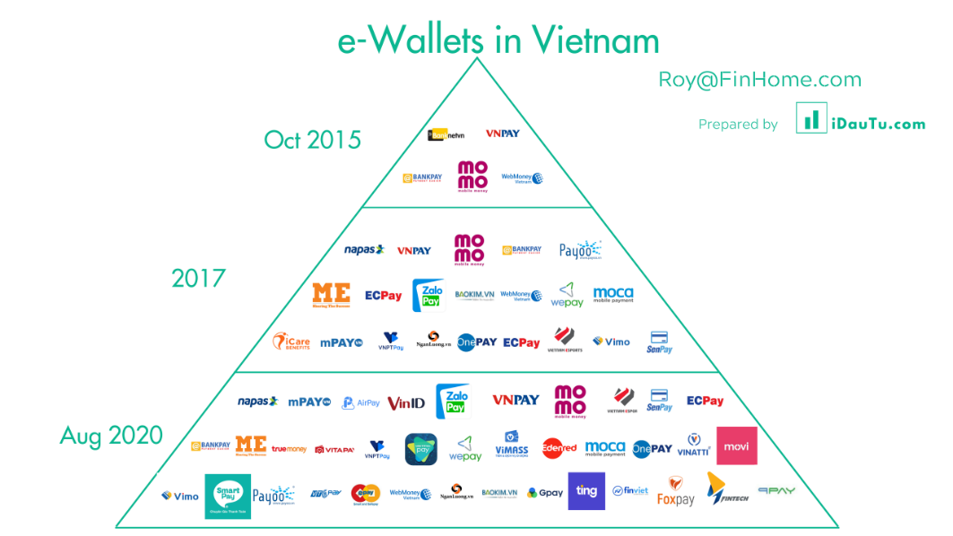

Figure 1 The rapid development of E-wallet in Vietnam from 2016-2018 [10]

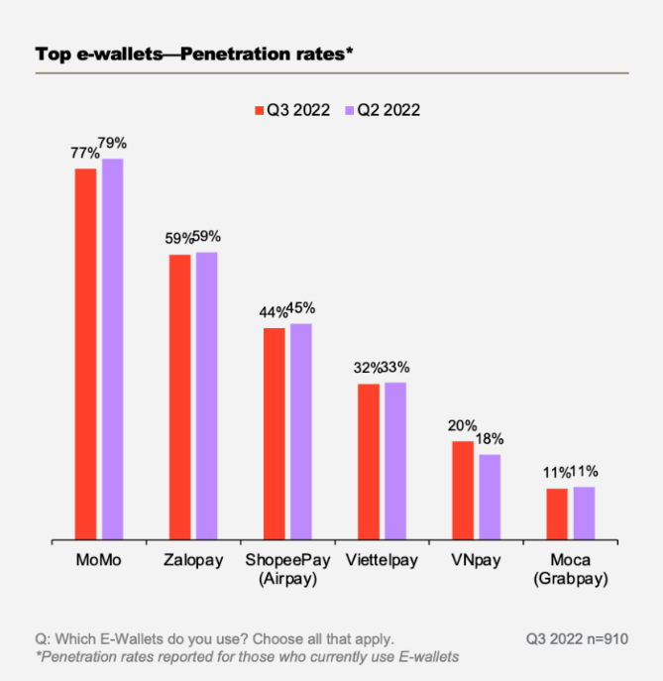

Figure 2 Top e-wallets in Vietnam in Q2 and Q3 2022 [12]

|  |  |  |
| --- | --- | --- |
|  | **Transformational Leadership** | **Situational Leadership** |
| Focus | Inspires and motivates employees to achieve higher performance levels. | Adapts leadership style based on the situation and followers' readiness. |
| Traits | Visionary, emphasizes creativity and innovation | Relies on intuition and analysis of a given situation. |
| Application | Encourages a culture of continuous improvement and adaptability. | Enables leaders to tailor their approach to diverse challenges and employee developmental levels. |

Table 1. The Difference Between Transformational Leadership vs Situational Leadership [16]