Tên:Nguyễn Song Anh Thuần lớp 11_TMDT

Lab 6 MSSV:1150070043

Bước 1: Tạo Project Android Studio

1. Mở Android Studio → chọn New Project → Empty Activity.
2. Đặt tên project: Lab06
3. Chọn ngôn ngữ Java
4. Finish.

Ảnh có chứa văn bản, ảnh chụp màn hình, phần mềm, Phần mềm đa phương tiện

Nội dung do AI tạo ra có thể không chính xác.

Thiết kế giao diện (activity_main.xml)

Ảnh có chứa văn bản, ảnh chụp màn hình, thiết kế

Nội dung do AI tạo ra có thể không chính xác.

Code:

<?xml version="1.0" encoding="utf-8"?>

<androidx.constraintlayout.widget.ConstraintLayout xmlns:android="http://schemas.android.com/apk/res/android"

xmlns:app="http://schemas.android.com/apk/res-auto"

xmlns:tools="http://schemas.android.com/tools"

android:layout_width="match_parent"

android:layout_height="match_parent"

tools:context=".MainActivity">

<!-- Toolbar -->

<com.google.android.material.appbar.MaterialToolbar

android:id="@+id/topBar"

style="@style/Widget.Material3.Toolbar"

android:layout_width="0dp"

android:layout_height="wrap_content"

android:background="?attr/colorPrimary"

android:title="Lab05_1"

android:titleTextColor="@android:color/white"

app:layout_constraintTop_toTopOf="parent"

app:layout_constraintStart_toStartOf="parent"

app:layout_constraintEnd_toEndOf="parent" />

<!-- ImageView -->

<ImageView

android:id="@+id/imgLogo"

android:layout_width="120dp"

android:layout_height="120dp"

android:src="@drawable/ic_launcher_foreground"

android:layout_marginTop="40dp"

app:layout_constraintTop_toBottomOf="@id/topBar"

app:layout_constraintStart_toStartOf="parent"

app:layout_constraintEnd_toEndOf="parent" />

<!-- Bảng button -->

<GridLayout

android:id="@+id/gridButtons"

android:layout_width="wrap_content"

android:layout_height="wrap_content"

android:layout_marginTop="40dp"

android:columnCount="2"

android:rowCount="4"

android:alignmentMode="alignMargins"

android:rowOrderPreserved="false"

android:columnOrderPreserved="false"

app:layout_constraintTop_toBottomOf="@id/imgLogo"

app:layout_constraintStart_toStartOf="parent"

app:layout_constraintEnd_toEndOf="parent">

<!-- From XML column -->

<Button

android:id="@+id/btnFadeInXml"

android:layout_width="150dp"

android:layout_height="wrap_content"

android:text="FADE IN" />

<Button

android:id="@+id/btnFadeInCode"

android:layout_width="150dp"

android:layout_height="wrap_content"

android:text="FADE IN" />

<Button

android:id="@+id/btnFadeOutXml"

android:layout_width="150dp"

android:layout_height="wrap_content"

android:text="FADE OUT" />

<Button

android:id="@+id/btnFadeOutCode"

android:layout_width="150dp"

android:layout_height="wrap_content"

android:text="FADE OUT" />

<Button

android:id="@+id/btnBlinkXml"

android:layout_width="150dp"

android:layout_height="wrap_content"

android:text="BLINK" />

<Button

android:id="@+id/btnBlinkCode"

android:layout_width="150dp"

android:layout_height="wrap_content"

android:text="BLINK" />

<Button

android:id="@+id/btnZoomInXml"

android:layout_width="150dp"

android:layout_height="wrap_content"

android:text="ZOOM IN" />

<Button

android:id="@+id/btnZoomInCode"

android:layout_width="150dp"

android:layout_height="wrap_content"

android:text="ZOOM IN" />

</GridLayout>

</androidx.constraintlayout.widget.ConstraintLayout>

Trong res/layout/activity_main.xml

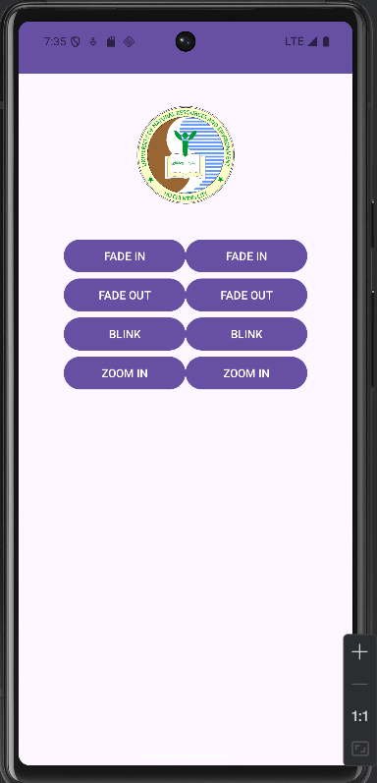

Tiếp tục tạo animation

**Bước 1: Tạo thư mục res/anim**

1. Trong Android Studio → click phải **res** → New → Android Resource Directory.
2. Resource type: chọn **anim**.
3. Đặt tên: anim.

Bước 2: Tạo file animation XML

-anim_fade_in.xml

Code thực hiện:

package com.example.lab06_animation;

import android.os.Bundle;

import android.view.animation.AlphaAnimation;

import android.view.animation.Animation;

import android.view.animation.AnimationUtils;

import android.view.animation.RotateAnimation;

import android.view.animation.ScaleAnimation;

import android.view.animation.TranslateAnimation;

import android.widget.Button;

import android.widget.ImageView;

import androidx.appcompat.app.AppCompatActivity;

public class MainActivity extends AppCompatActivity {

// ImageView

private ImageView ivUitLogo;

// Các button

private Button btnFadeInXml, btnFadeInCode;

private Button btnFadeOutXml, btnFadeOutCode;

private Button btnBlinkXml, btnBlinkCode;

private Button btnZoomInXml, btnZoomInCode;

private Button btnZoomOutXml, btnZoomOutCode;

private Button btnRotateXml, btnRotateCode;

private Button btnMoveXml, btnMoveCode;

private Button btnSlideUpXml, btnSlideUpCode;

private Button btnBounceXml, btnBounceCode;

private Button btnCombineXml, btnCombineCode;

@Override

protected void onCreate(Bundle savedInstanceState) {

super.onCreate(savedInstanceState);

setContentView(R.layout.activity_main);

// Ánh xạ view

ivUitLogo = findViewById(R.id.iv_uit_logo);

btnFadeInXml = findViewById(R.id.btn_fade_in_xml);

btnFadeInCode = findViewById(R.id.btn_fade_in_code);

btnFadeOutXml = findViewById(R.id.btn_fade_out_xml);

btnFadeOutCode = findViewById(R.id.btn_fade_out_code);

btnBlinkXml = findViewById(R.id.btn_blink_xml);

btnBlinkCode = findViewById(R.id.btn_blink_code);

btnZoomInXml = findViewById(R.id.btn_zoom_in_xml);

btnZoomInCode = findViewById(R.id.btn_zoom_in_code);

btnZoomOutXml = findViewById(R.id.btn_zoom_out_xml);

btnZoomOutCode = findViewById(R.id.btn_zoom_out_code);

btnRotateXml = findViewById(R.id.btn_rotate_xml);

btnRotateCode = findViewById(R.id.btn_rotate_code);

btnMoveXml = findViewById(R.id.btn_move_xml);

btnMoveCode = findViewById(R.id.btn_move_code);

btnSlideUpXml = findViewById(R.id.btn_slide_up_xml);

btnSlideUpCode = findViewById(R.id.btn_slide_up_code);

btnBounceXml = findViewById(R.id.btn_bounce_xml);

btnBounceCode = findViewById(R.id.btn_bounce_code);

btnCombineXml = findViewById(R.id.btn_combine_xml);

btnCombineCode = findViewById(R.id.btn_combine_code);

// ---------------- BÀI 1: XML ----------------

handleClickAnimationXml(btnFadeInXml, R.anim.anim_fade_in);

handleClickAnimationXml(btnFadeOutXml, R.anim.anim_fade_out);

handleClickAnimationXml(btnBlinkXml, R.anim.anim_blink);

handleClickAnimationXml(btnZoomInXml, R.anim.anim_zoom_in);

handleClickAnimationXml(btnZoomOutXml, R.anim.anim_zoom_out);

handleClickAnimationXml(btnRotateXml, R.anim.anim_rotate);

handleClickAnimationXml(btnMoveXml, R.anim.anim_move);

handleClickAnimationXml(btnSlideUpXml, R.anim.anim_slide_up);

handleClickAnimationXml(btnBounceXml, R.anim.anim_bounce);

handleClickAnimationXml(btnCombineXml, R.anim.anim_combine);

// ---------------- BÀI 2: CODE ----------------

handleClickAnimationCode(btnFadeInCode, createFadeIn());

handleClickAnimationCode(btnFadeOutCode, createFadeOut());

handleClickAnimationCode(btnBlinkCode, createBlink());

handleClickAnimationCode(btnZoomInCode, createZoomIn());

handleClickAnimationCode(btnZoomOutCode, createZoomOut());

handleClickAnimationCode(btnRotateCode, createRotate());

handleClickAnimationCode(btnMoveCode, createMove());

handleClickAnimationCode(btnSlideUpCode, createSlideUp());

handleClickAnimationCode(btnBounceCode, createBounce());

handleClickAnimationCode(btnCombineCode, createCombine());

}

// ----------------- HÀM DÙNG CHUNG -----------------

private void handleClickAnimationXml(Button btn, int animId) {

btn.setOnClickListener(v -> {

Animation anim = AnimationUtils.loadAnimation(this, animId);

ivUitLogo.startAnimation(anim);

});

}

private void handleClickAnimationCode(Button btn, final Animation animation) {

btn.setOnClickListener(v -> ivUitLogo.startAnimation(animation));

}

// ----------------- BÀI 2: CODE ANIMATION -----------------

private Animation createFadeIn() {

AlphaAnimation anim = new AlphaAnimation(0.0f, 1.0f);

anim.setDuration(1000);

return anim;

}

private Animation createFadeOut() {

AlphaAnimation anim = new AlphaAnimation(1.0f, 0.0f);

anim.setDuration(1000);

return anim;

}

private Animation createBlink() {

AlphaAnimation anim = new AlphaAnimation(0.0f, 1.0f);

anim.setDuration(300);

anim.setRepeatMode(Animation.REVERSE);

anim.setRepeatCount(3);

return anim;

}

private Animation createZoomIn() {

ScaleAnimation anim = new ScaleAnimation(

1.0f, 2.0f,

1.0f, 2.0f,

Animation.RELATIVE_TO_SELF, 0.5f,

Animation.RELATIVE_TO_SELF, 0.5f

);

anim.setDuration(1000);

return anim;

}

private Animation createZoomOut() {

ScaleAnimation anim = new ScaleAnimation(

1.0f, 0.5f,

1.0f, 0.5f,

Animation.RELATIVE_TO_SELF, 0.5f,

Animation.RELATIVE_TO_SELF, 0.5f

);

anim.setDuration(1000);

return anim;

}

private Animation createRotate() {

RotateAnimation anim = new RotateAnimation(

0, 360,

Animation.RELATIVE_TO_SELF, 0.5f,

Animation.RELATIVE_TO_SELF, 0.5f

);

anim.setDuration(600);

anim.setRepeatCount(2);

return anim;

}

private Animation createMove() {

TranslateAnimation anim = new TranslateAnimation(

Animation.RELATIVE_TO_PARENT, 0.0f,

Animation.RELATIVE_TO_PARENT, 0.75f,

Animation.RELATIVE_TO_PARENT, 0.0f,

Animation.RELATIVE_TO_PARENT, 0.0f

);

anim.setDuration(800);

return anim;

}

private Animation createSlideUp() {

ScaleAnimation anim = new ScaleAnimation(

1.0f, 1.0f,

1.0f, 0.0f,

Animation.RELATIVE_TO_SELF, 0.5f,

Animation.RELATIVE_TO_SELF, 0.5f

);

anim.setDuration(500);

return anim;

}

private Animation createBounce() {

ScaleAnimation anim = new ScaleAnimation(

1.0f, 1.0f,

0.0f, 1.0f,

Animation.RELATIVE_TO_SELF, 0.5f,

Animation.RELATIVE_TO_SELF, 0.5f

);

anim.setDuration(500);

anim.setInterpolator(this, android.R.anim.bounce_interpolator);

return anim;

}

private Animation createCombine() {

android.view.animation.AnimationSet set = new android.view.animation.AnimationSet(true);

ScaleAnimation scale = new ScaleAnimation(

1.0f, 3.0f,

1.0f, 3.0f,

Animation.RELATIVE_TO_SELF, 0.5f,

Animation.RELATIVE_TO_SELF, 0.5f

);

scale.setDuration(4000);

RotateAnimation rotate = new RotateAnimation(

0, 360,

Animation.RELATIVE_TO_SELF, 0.5f,

Animation.RELATIVE_TO_SELF, 0.5f

);

rotate.setDuration(500);

rotate.setRepeatCount(2);

set.addAnimation(scale);

set.addAnimation(rotate);

return set;

}

}

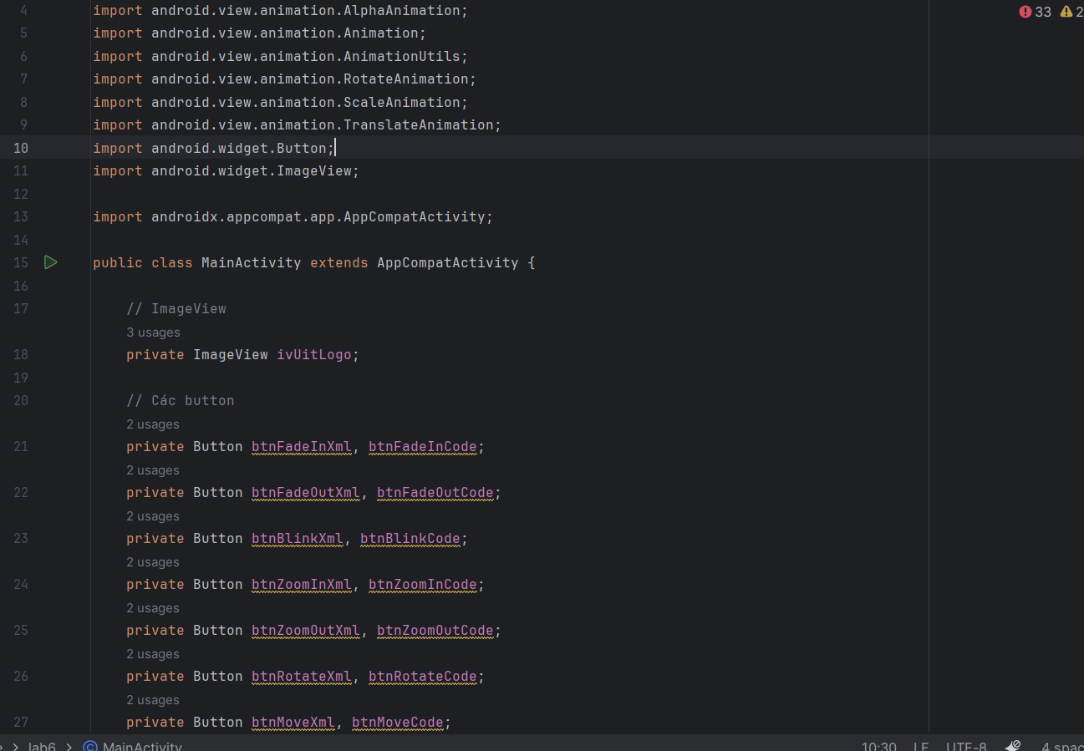

3)

Ảnh có chứa văn bản, ảnh chụp màn hình, phần mềm, Phần mềm đa phương tiện

Nội dung do AI tạo ra có thể không chính xác.

Code thực hiện:

<?xml version="1.0" encoding="utf-8"?>

<RelativeLayout xmlns:android="http://schemas.android.com/apk/res/android"

android:layout_width="match_parent"

android:layout_height="match_parent"

android:background="#FF4081">

<!-- Nút BACK ở góc trên bên trái -->

<Button

android:id="@+id/btnBack"

android:layout_width="wrap_content"

android:layout_height="wrap_content"

android:text="BACK"

android:layout_margin="16dp"

android:layout_alignParentStart="true"

android:layout_alignParentTop="true" />

<!-- Text "New Activity" canh ngang với nút BACK -->

<TextView

android:id="@+id/tvNewActivity"

android:layout_width="wrap_content"

android:layout_height="wrap_content"

android:text="New Activity"

android:textSize="18sp"

android:textColor="@android:color/black"

android:layout_toEndOf="@id/btnBack"

android:layout_alignTop="@id/btnBack"

android:layout_marginStart="32dp"/>

</RelativeLayout>