9/8/2025
Logic league
Week 2
Elonathemba Phosa Thobeka Zitha Thubelihle Titi Mthobisi Ntshakala Treasure Khumalo

Table of Contents
Introduction 2
Project Overview 2
3 Existing AI Applications in Manufacturing 2
Problem Statement 3
AI Processing Logic 4
User Interaction Touchpoints 4
Data Flow Diagram 5
Error Handling 5
Ethical Considerations 5
Deliverables 5
Conclusion 6

Documentation

Introduction
The rise of Artificial Intelligence (AI) in manufacturing has transformed how factories operate, offering solutions that improve efficiency, reduce costs, and ensure safety. This documentation presents the Figma Predictive AI, a prototype dashboard designed to tackle one of the biggest challenges in the industry, unplanned machine breakdowns. By leveraging predictive analytics, the system analyzes sensor data from machines (such as temperature, vibration, and runtime) to classify them as healthy, at risk, or critical. Users interact with the system by uploading a CSV file, after which the AI processes and visualizes results in an intuitive, color-coded dashboard within Figma. The solution aims to demonstrate how predictive maintenance can reduce downtime, cut maintenance costs, and enhance equipment effectiveness while maintaining ethical and practical considerations.

Project Overview
The Figma Predictive AI is a prototype dashboard designed for the manufacturing sector. It helps detect machines that are healthy, at risk, or critical, based on uploaded sensor data.
Users provide a CSV file with machine details, and the AI processes the data using predictive analytics (classification). The results are then shown visually inside Figma as a color-coded dashboard with charts and tables.

3 Existing AI Applications in Manufacturing
1: Predicting Machine Failures (Predictive Maintenance)
Unplanned machine breakdowns cause production delays, financial loss, and safety risks in factories. AI can analyze machine sensor data (temperature, vibration, noise levels) to predict failures before they happen.

2: Defect Detection in Product Quality Control
Factories often rely on human inspection, which is error-prone and slow. AI-based image recognition can detect surface defects (scratches, dents, cracks) in products during assembly or packaging.

3: Optimizing Energy Consumption in Manufacturing Plants
Manufacturing plants consume massive energy, often inefficiently (running idle machines, peak-hour usage, or unoptimized heating/cooling). AI can analyze energy usage patterns and recommend optimizations.

Problem Statement
Predicting Machine Failures (Predictive Maintenance)
Unplanned machine breakdowns cause production delays, financial loss, and safety risks in factories. AI can analyze machine sensor data (temperature, vibration, noise levels) to predict failures before they happen.
Unplanned machine breakdowns lead to:
- Production delays
- Costly emergency repairs
- Worker safety risks

Factories often rely on manual inspections or reactive maintenance, which is inefficient.

Impact Metrics:
Reduce downtime by 20–30%
Save on maintenance costs by 15–25%
Increase overall equipment effectiveness by 10–15%

Solution: An AI-powered predictive maintenance system that helps teams detect risks early.

Input Data (CSV Requirements)
 | Data Type | Units | Example
MachineID | Text/Number | Varchar | M101, M102
Temperature | Numeric | °C | 82, 65
Vibration | Numeric | mm/s | 0.08, 0.04
Runtime | Numeric | Hours | 500, 320

This is mandatory for CSV File upload.
All four columns must exist.
Data types must be correct
If data is missing or invalid, AI shows error:
Invalid file. Please include Machine ID, Temperature (°C), Vibration (mm/s), and Runtime (hours).

AI Processing Logic
Once the CSV is uploaded:
1. Data Validation: AI checks if all required columns and numeric values exist.
2. Data Cleansing: Removes errors or empty cells.
3. Pattern Recognition: AI applies thresholds and machine learning models.
4. Dashboard Output

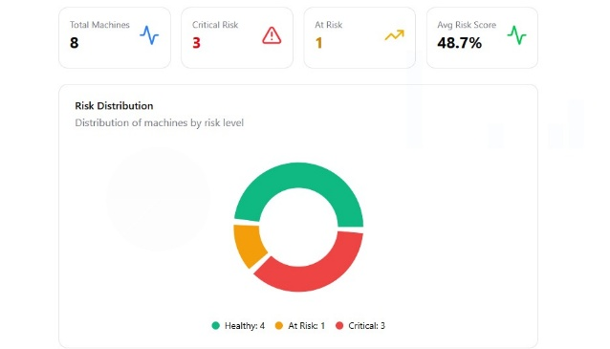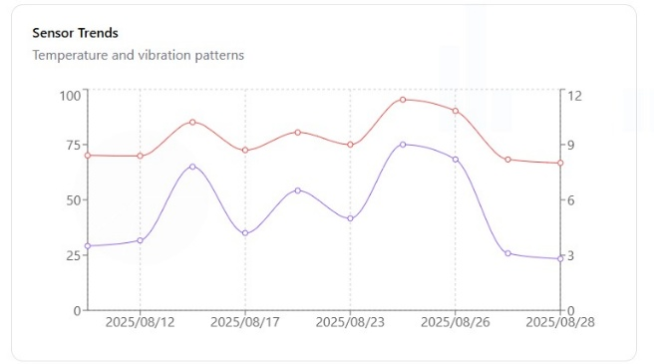

User Interaction Touchpoints
1. Upload Screen: User drags and drops CSV file.
2. Processing Screen: Loader animation with text - “Analyzing your data”
3. Dashboard Screen: Results displayed with table + charts.

Data Flow Diagram

Error Handling
Missing column, display Error message.
Wrong data type, display Error message.
Empty CSV Prompt: “Please upload a valid CSV file with machine data.”

Ethical Considerations
Bias: Predictions depend on the quality of training data.
Privacy: Uploaded files remain local or anonymized.
Accessibility: Clear text, icons, and colorblind-friendly colors.
Environmental Impact: Lightweight models reduce energy use.
Unintended Consequences: Overly strict thresholds may cause false alarms balance required.

Deliverables
Figma Prototype Link
2-minute Demo Video
Presentation slides

Conclusion
The Figma Predictive AI prototype highlights the potential of AI-driven predictive maintenance in revolutionizing the manufacturing sector. By analyzing real-time machine sensor data, the system enables early detection of risks that would otherwise result in costly repairs, production delays, and safety hazards. The prototype demonstrates a seamless workflow from CSV input to AI processing and dashboard visualization while ensuring accessibility, error handling, and ethical use of data. Ultimately, this project underscores how AI can be applied in practical, user-friendly ways to solve real industrial challenges, paving the way for smarter, safer, and more efficient manufacturing operations.

