**Design and Development of an Automatic Automobile Headlight Switching System**

**PROJECT REPORT**

|  |  |  |
| --- | --- | --- |
| SR NO | REGISTRATION NO | NAME |
| 1 | 18BIS0147 | MRINMAY DATE |
| 2 | 18BIS0096 | K YESWANTH |
| 3 | 18BIS0128 | NAKUL SINGH |

**SLOT F1**

**FACULTY**

**Prof Bagubali A**

**6 NOVEMBER 2019**

**CERTIFICATE**

This is to certify that the project work entitled “**Design and Development of an Automatic Automobile Headlight Switching System**” that is being Submitted by Mrinmay, Nakul and Yeswanth is a record of bonafide work done under my supervision. The contents of this Project work, in full or in parts, have neither been taken from any other source nor have been submitted for any other CAL course.

Place: Vellore

Date: 06-11-2019.

*MRINMAY DATE*

*NAKUL SINGH*

*YESWANTH K*

ACKNOWLEDGEMENTS

This is to acknowledge the immense support I got from the faculty and the institution while pursuing this project on “**Design and Development of an Automatic Automobile Headlight Switching System**”. I would like to take this moment to thank VIT for giving me the opportunity to work on this project. I would additionally thank the dean of school SENSE (School of Electronics Engineering) for their unconditional support. I would also like to thank my faculty Prof Bagubali A for his guidance and keen involvement in helping us to do this project.

**ABSTRACT/INTRODUCTION**

This project/paper presents the requirement of headlight is a necessity during night travel. The same headlight which assists the driver for better vision during night travel is also responsible for many accidents. The driver has the control of the headlight which can be switched from high beam (bright) to low beam (dim). During pitch black conditions where there are no other sources of light, high beam is used while on all other cases, low beam is preferred. In a two-way traffic, vehicles ply on both sides of the road, so when the bright light from the headlight of a vehicle coming from the opposite direction falls on a person, it glares him for a certain amount of time, causing disorientation to that driver. This discomfort will result in momentary involuntary closing of the driver’s eyes. This fraction of distraction is the prime cause of many road accidents at night. This prototype reduces this problem by actually switching the bright headlight of the vehicle to low beam automatically when it senses a vehicle at close proximity approaching from the other direction and switching it back after the vehicle passes.

**MATERIALS AND METHODOLOGY**

The circuit consists of a dc power supply, resistors, a transistor, diodes, a relay, switches, a light dependent resistor and LEDs. The circuit was designed from the relationships of these components to obtain the desired behavior.

i. The effects of high illumination on the human eye and response delay

ii. Luminous intensity of headlamps

iii. The selection of components to be used for the effective switching of beams

iv. The sensitivity of components to reduce the switching time

v. The power supply unit vi. Protection of the module against electrical and environmental hazards vii. Backup plan in case of module failure

**DESIGN AND ANALYSIS:**

i. Power Supply: This block provides the voltage needed for the comparison, processing, switching and the output.

ii. Sensor: The sensor is a component that responds to light, in this case a light dependent resistor. It senses both the presence and absence of light at different intensities which changes the values of its resistance.

iii. Comparator: The comparator is the resistor arrangement which serves as a potential divider that control the gate current to the transistor.

iv. Switching Unit: This is the block that performs the switching function. It consists of the transistor and relay. The current that the transistor receives from the comparator switches the relay on and off.

v. Output: The output is two Light emitting diodes connected to the relay. The lights alternate based on the behavior of the entire system. The output shows the performance of the intended purpose of the circuit, which is switching the high beam to low beam.

*\*some parameters such as size and light intensities are considered at a reduced scale\**

A. The Light Dependent Resistor the LDR acts as a variable resistor. So, the LDR and the two resistors form a potential divider network which will decide the current in the circuit. In pitch black situations, its resistance is very high. The circuit is balanced and a very negligible current flows to the transistor. This current is not sufficient to activate the transistor.

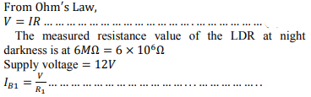

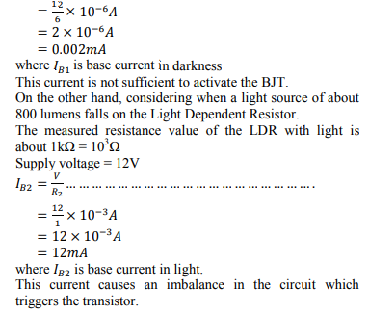

B. Resistors R1 and RV1: The resistors combined with the light dependent resistor form the potential divider network. They are used as a potential divider in order to control the base current to the transistor. The RV1 is a variable resistor of 2kΩ. Varying this potentiometer increases or decreases the current going into the base of the transistor, which varies the sensitivity of the switching circuit. We can say that the two resistors depend on the LDR since no current flows into the loop in the dark.

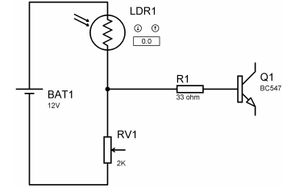

C. The transistor (BC547): The transistor is an NPN silicon transistor. It is used as an operated in the saturated region which sets the circuit on. The transistor terminals require a fixed DC voltage to operate in the desired region of its characteristic curves. This is known as the biasing. For amplification applications, the transistor is biased such that it is partly on for all input conditions. The input signal at base is amplified and taken at the emitter. BC547 is used in common emitter configuration for amplifiers. The voltage divider is the commonly used biasing mode. For switching applications, transistor is biased so that it remains fully on if there is a signal

at its base. In the absence of base signal, it gets completely off

The transistor in the circuit is used as a switching sensor. The current at the base from when light is applied to the LDR turns it on and it stays on till the LDR loses illumination

D. The Relay: After the transistor is triggered, the current that flows through the collector goes into the coil of the 12V Single Pole Double Throw Relay. The relay in its default position is in the normally closed (NC) state. This current that flows through the coil causes an electromagnetic induction which disconnects the relay from the normally closed terminal to the normally open (NO) terminal. The relay contacts stay in that position till the transistor current is cut off, which will be due to the absence of light to the Light Dependent Resistor. When the trigger current from the transistor is cut off, the relay mechanically switches back to its initial (normal)

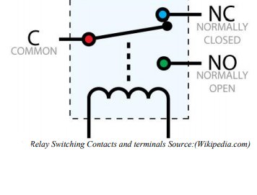

As the relay deactivates, energy is generated from the collapsing magnetic field which will tend to move in the reverse direction towards the transistor. This current will cause damage to the transistor; hence a diode is connected across the relay to dissipate the collapsing magnetic field energy

E. The Diode: The most common function of a diode is to allow an electric current to pass in one direction (called the diode's forward direction), while blocking current in the opposite direction (the reverse direction). Thus, the diode can be viewed as an electronic version of a check valve. As the relay coil is energized with DC, a diode is installed across the coil to dissipate the energy from the collapsing magnetic field at deactivation, which would otherwise generate a spike of voltage and might cause damage to circuit components. This diode can be seen as a freewheel diode. The diode chosen for this function is the 1N4001 as it can handle up to 1A efficiently

F. LED's: The LED's used in the prototype represent the actual high and low beams. LED 1 (The white LED) represents the high beam light and is connected to Normally Closed (NC) terminal of the relay. When the switch is closed in the dark, the high resistance of the Light Dependent Resistor prevents current from going through the transistor so the high beam LED displays and stays on. On the other hand, LED 2 (Red LED) is the low beam light. It is connected to the Normally Open terminal of the relay which depends on the resistance of the Light Dependent Resistor and the potential divider network. It is switched on when light is incident on the LDR and current flows to the BJT.

G. The Switches The switch employed is a Four Position Switch. It serves to open and close the entire circuit. Its action is same as that of the control switch around the steering wheel of the vehicle. The four states are the OFF, LOW BEAM, HIGH BEAM and AUTO. When it is in OFF state, no light is seen at the headlamp. When the switch is turned to LOW BEAM, the headlamp's output is the low beam which does not change no matter the lighting condition. Also, the headlamp stays at high beam when the switch is turned to HIGH BEAM. Finally, when tuned to AUTO, the switching circuit comes into play

**SCHEMATICS AND CIRCUIT CONSTRUCTION**

SCHEMATIC

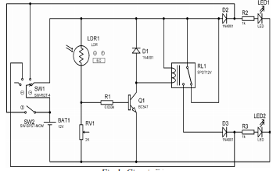

TEMPORAL

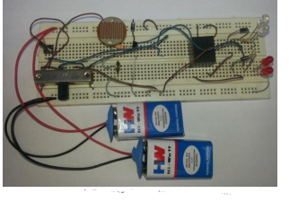

Permanent Construction This stage involved the transfer of the components from the bread board onto the Vero board. As the functionality and workability of the entire system was confirmed on the bread board, the components were soldered to the Vero board permanently and placed in a suitable case. The circuit components were compacted to a small part of the Vero board so that the entire unit will be as small as possible to minimize space consumption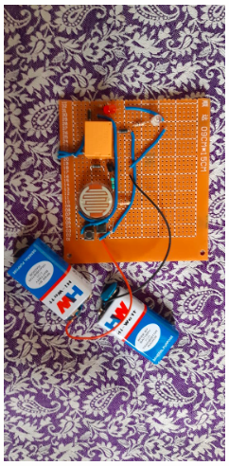

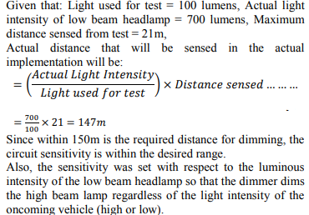

**CONCLUSION**

Glare during driving is a serious problem for drivers. This is caused due to the sudden exposure of our eyes to a very bright light; the bright headlights of vehicles in this case. This causes a temporary blindness called the Troxler effect, a major reason for night accidents. The driver should actually turn down the bright lights immediately to avoid glare to the other person which is hardly done. Hence, came the idea for the design and construction of an automatic headlight dimming prototype circuit.

It allows the driver to use high beam light when required and automatically switches the headlight to low beam when it senses a vehicle approaching from the opposite side, and switches it back to high beam when the approaching vehicle passes. The circuit consists of simple and economical components which can be easily implemented. The working and implementation of the prototype were discussed in detail. The effects of bright light on the human eye are also studied. Thus, the implementation of this device in every vehicle in future will not only avoid accidents but also provide a safe and a comfortable driving.

**LIMITATIONS**

The major limitation of this prototype comes when one of the two vehicles coming from opposite directions has its high beam on and the other has its low beam on. This will reduce the distance at which the switching occurs and may still cause a glare to the driver using low beam lights. Also, this prototype does not solve the problem of the glare from the rear, which is caused by the vehicles that use high beam lights moving closely behind another vehicle.

**REFERENCES**

[1] Woody's Automotive Group (2013), Auto Dimming Mirrors, Dodge Durango Citadel. Retrieved 26/06/2014 Available: http://www.megawoody’s.com

[2] Fairchild Semiconductor Corporation, “Datasheet: BC546/547/548/549/550 NPN Epitaxial Silicon Transistor,” Fairchild Semiconductor Corporation, November 2014. Available: <http://www.fairchildsemi.com/datasheets>

[3] Ontario Ministry of transportation, “Drivers Handbook: Driving at Night and in Bad Weather,” 2013

[4] Crydom Inc., “Coil Suppression & DC Output Solid State Relays,” Crydom Inc. 2010 pp. 2-3. Available: <http://www.crydom.com>

[5] <https://www.researchgate.net/publication/271843873_Automatic_High_Beam_Controller_for_Vehicles>

[6] Images from Wikipedia