PHP MVC Migration - Complete Student Submission
Topic: Converting a Plain PHP CRUD Application to MVC Architecture
Concrete Implementation Domain: Library Book Borrowing System

1. Assignment Overview
This submission applies the PHP MVC migration guide to a concrete CRUD project: a Library Book Borrowing System. The goal is to refactor a plain PHP CRUD application into a clean Model-View-Controller architecture without using any framework.
The solution includes a written migration analysis, MVC folder structure, component responsibility tables, route/action mapping, security checklist, diagrams, XAMPP running steps, and a complete PHP MVC code skeleton.

2. Part 1 - Understand the Existing Plain PHP CRUD Application
Before migration, a typical plain PHP CRUD application usually mixes database connection, SQL queries, form handling, and HTML output in one or several loosely organized files. The migration process begins by identifying these mixed responsibilities.
Component in old code | Typical content | MVC destination
Database connection | new PDO(...) block at the top of a PHP file | config/database.php
Business logic / SQL | SELECT, INSERT, UPDATE, DELETE queries | models/BookModel.php
Form handling | $_POST and $_GET processing | controllers/BookController.php
HTML output | tables, forms, echo statements, mixed PHP/HTML | views/books/*.php

3. Part 2 - Planned MVC Folder Structure
The final project uses a single public entry point. The browser accesses public/index.php, while models, controllers, views, and config files are loaded internally by PHP.
php_mvc_library_crud/
│
├── config/
│ └── database.php
│
├── models/
│ └── BookModel.php
│
├── controllers/
│ └── BookController.php
│
├── views/
│ ├── partials/
│ │ ├── header.php
│ │ └── footer.php
│ └── books/
│ ├── index.php
│ ├── show.php
│ ├── create.php
│ └── edit.php
│
├── public/
│ ├── index.php
│ └── assets/
│ └── style.css
│
├── database.sql
└── README.md

4. Part 3 - Step-by-Step Migration Plan

Step 1 - Extract the Database Connection
Move the PDO connection into config/database.php and create one reusable getConnection(): PDO function. This prevents duplicated database connection code.

Step 2 - Create the Model
Create models/BookModel.php. This file contains only database operations such as getAll(), getById(), create(), update(), and delete(). It must not echo HTML or read $_POST directly.

Step 3 - Create the Controller
Create controllers/BookController.php. This file reads HTTP requests, validates input, calls BookModel methods, and loads the correct view.

Step 4 - Create the Views
Create views/books/index.php, show.php, create.php, and edit.php. Views contain only HTML and small PHP display logic. SQL queries must not be placed in views.

Step 5 - Create the Front Controller
Create public/index.php. This file reads the action parameter and calls the corresponding controller method.

Step 6 - Add Security Practices
Use prepared statements for SQL, cast IDs to integers, use htmlspecialchars() in views, validate required fields, and redirect after POST actions.

5. MVC Responsibility Table
Layer | File / Class | Responsibility
Model | models/BookModel.php | Handles database queries and returns book data as arrays.
View | views/books/index.php | Displays all books in an HTML table.
View | views/books/create.php | Displays the add book form.
View | views/books/edit.php | Displays the edit book form.
View | views/books/show.php | Displays one book detail page.
Controller | controllers/BookController.php | Handles requests, validates input, calls the Model, and loads Views.
Config | config/database.php | Creates a reusable PDO connection.
Front Controller | public/index.php | Reads action from URL and routes to controller methods.

6. Route / Action Table
HTTP | URL | Controller@Action | Purpose
GET | /public/index.php?action=index | BookController@index | List all books.
GET | /public/index.php?action=show&id=1 | BookController@show | View details of one book.
GET | /public/index.php?action=create | BookController@create | Show add book form.
POST | /public/index.php?action=store | BookController@store | Save a new book.
GET | /public/index.php?action=edit&id=1 | BookController@edit | Show edit form.
POST | /public/index.php?action=update | BookController@update | Update an existing book.
GET | /public/index.php?action=delete&id=1 | BookController@delete | Delete a book and redirect.

7. UML and Data Flow Diagrams
The UML diagram below shows how the main MVC classes and files relate to one another.
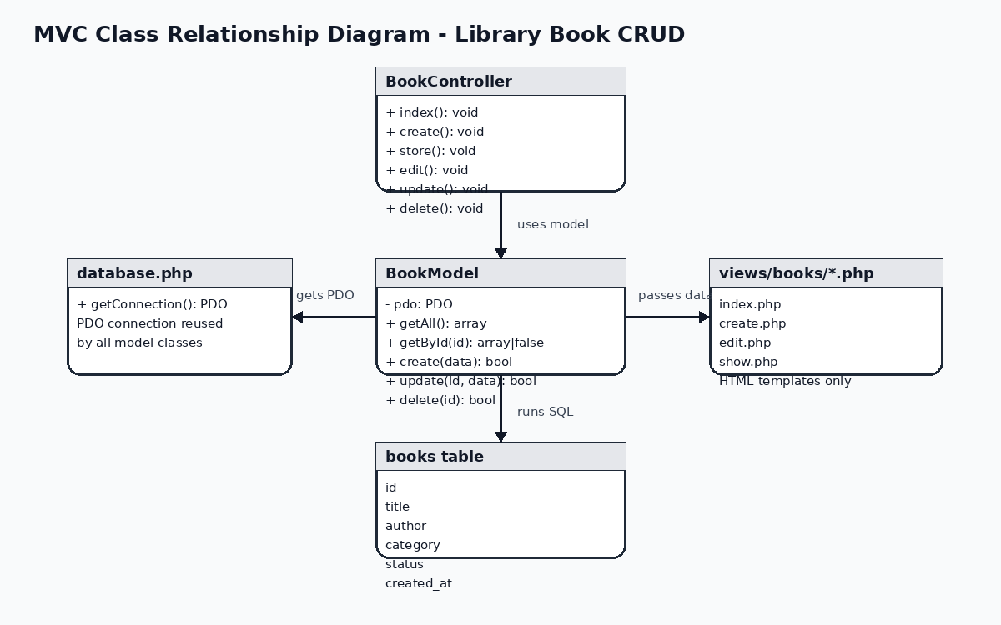
The data flow diagram below shows how a browser request moves through public/index.php, the Controller, the Model, the View, and finally back to the browser as an HTML response.
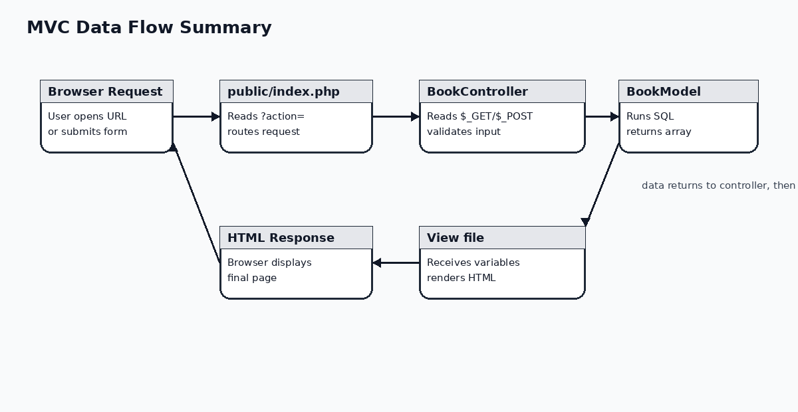

8. Migration Mapping from Plain PHP to MVC
Old plain PHP part | Problem | New MVC location
PDO connection copied in many files | Hard to maintain and risky when credentials change | config/database.php
SELECT query inside list page | View is mixed with database logic | BookModel::getAll()
INSERT query inside form page | Form page handles too many responsibilities | BookController::store() + BookModel::create()
UPDATE query inside edit page | HTML and SQL are mixed | BookController::update() + BookModel::update()
DELETE logic in link target file | No central routing | BookController::delete()
HTML table generated inside SQL file | Model outputs presentation | views/books/index.php

9. Security and Quality Checklist
- All SQL statements that receive user input use prepared statements with placeholders.
- All values printed in Views use htmlspecialchars() to reduce XSS risk.
- All IDs from URL or form input are cast to integers before being used.
- After create, update, and delete actions, the controller redirects to avoid duplicate form submissions.
- Database credentials are kept only in config/database.php.
- Views do not contain SQL queries.
- Models do not echo HTML.
- Controllers do not contain raw SQL queries.

10. Running Steps in VS Code and XAMPP
- 1. Copy folder: Copy php_mvc_library_crud to C:\xampp\htdocs\php_mvc_library_crud.
- 2. Start services: Open XAMPP Control Panel and start Apache and MySQL.
- 3. Create database: Open phpMyAdmin and import database.sql. This creates mvc_library_db and the books table.
- 4. Open project in VS Code: Use File > Open Folder and select C:\xampp\htdocs\php_mvc_library_crud.
- 5. Run in browser: Visit http://localhost/php_mvc_library_crud/public/index.php.
- 6. Test CRUD: Add a book, view book details, edit a book, and delete a book.

11. Reflection Questions

1. Which files are Model, View, and Controller?
The Model is BookModel.php because it communicates with the database and returns data. The Views are the files inside views/books because they display HTML only. The Controller is BookController.php because it receives user actions, calls the Model, validates input, and loads the correct View.

2. Why should SQL not be placed inside Views?
SQL should not be placed inside Views because Views are responsible only for presentation. If SQL is mixed with HTML, the application becomes difficult to maintain and the MVC boundary is broken.

3. Why should prepared statements be used?
Prepared statements reduce SQL injection risk because user input is passed as parameters instead of being directly concatenated into SQL strings.

4. Why redirect after POST actions?
Redirecting after create, update, and delete actions prevents duplicate form submissions when the user refreshes the page. It also returns the user to a stable GET page.

5. What can be improved next?
The next improvement is adding authentication for librarian/admin users, adding a BorrowModel for borrowing history, and using autoloading to load classes automatically.

12. Submission Package
Recommended submission folder:
PHP_MVC_Migration_Library_Submission/
│
├── 01_Report/
│ ├── PHP_MVC_Migration_Library_Complete_Submission.docx
│ └── PHP_MVC_Migration_Library_Complete_Submission.pdf
│
├── 02_Source_Code/
│ └── php_mvc_library_crud.zip
│
└── README_Submission.txt
If the submission system allows only one file, submit the PDF report. If it allows multiple files, submit both the PDF report and the source code ZIP.

13. Key Code Summary
This section summarizes the main code files included in the ZIP package.
File | Main responsibility
config/database.php | Defines getConnection(): PDO.
models/BookModel.php | Contains getAll(), getById(), create(), update(), delete().
controllers/BookController.php | Handles index, show, create, store, edit, update, and delete actions.
views/books/*.php | Displays book list, detail, create form, and edit form.
public/index.php | Routes ?action= to the correct controller method.
database.sql | Creates the database, table, and sample data.

