Sri Lanka Institute of Information Technology



IT2130 – Operating Systems and System Administration
Year 2, Semester 2- 2026

Practical Answer Submission
Practical Sheet No: 04

 | Student ID |  |  |  |  |  | IT24100213
 | Student Name |  |  |  |  |  | Thujeev K
 | Campus/ Center name |  |  |  |  |  | Malabe
 | Specialization |  |  |  |  |  | IT
 | Batch No |  |  |  |  |  | Y2.S2.WE.IT.01.02

ACTIVITY 1
- What is the output you can see in the terminal?
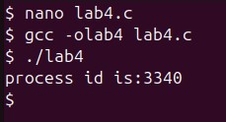
3340

- What is the system call used in the above program?
  - Getpid()
C. .Briefly describe the purpose of the system call you mentioned in a)?
  - returns the process id of the currently running process

  - Helps identify a process uniquely in system

D. Remove the include statement, ”#include¡unistd.h¿” from the program and check the output. What can you see in the output? Describe the reason for your observation

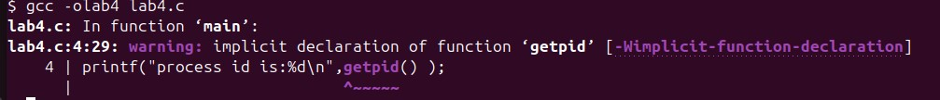
  - Got an Error

ACTIVITY 2

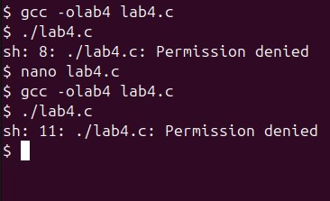

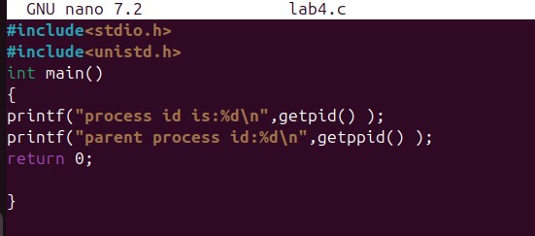
PERMISSION DENIED

ACTIVITY 3

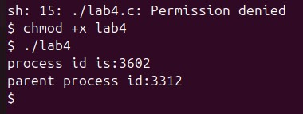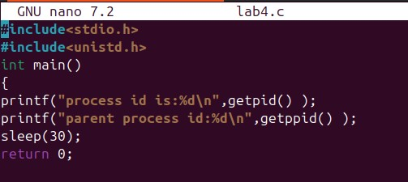

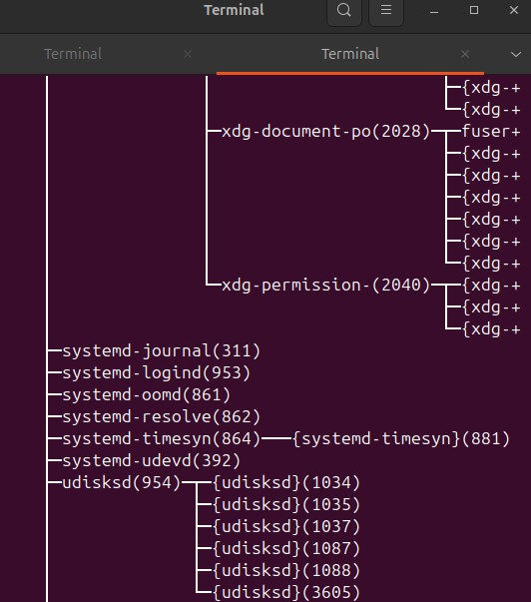

ACTIVITY 4

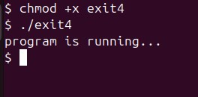

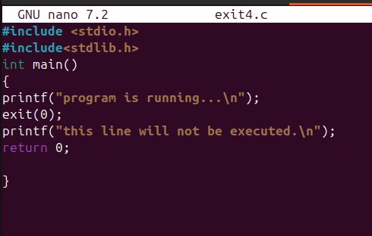

ACTIVITY 5

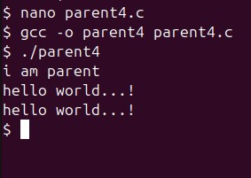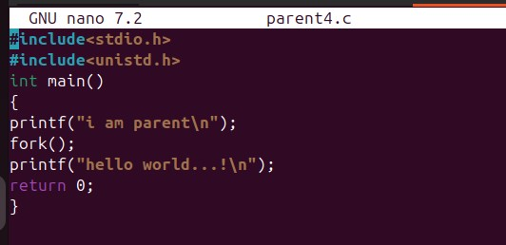

AFTER FORK() BOTH PARENT AND CHILD EXECUTE THE SAME CODE SO
BOTH PRINT “HELLO WORLD”

ACTIVITY 6

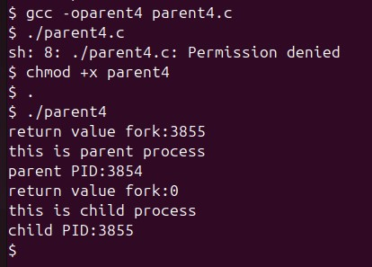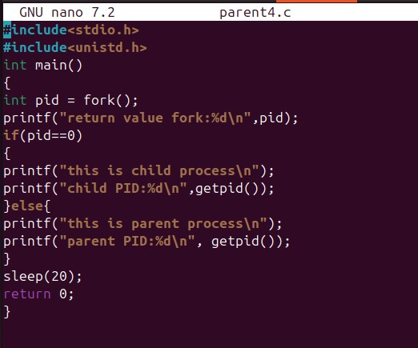

ACTIVITY 7

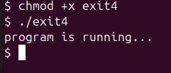

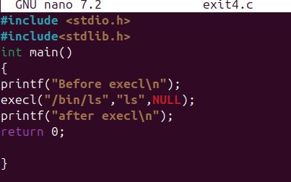

ACTIVITY 8

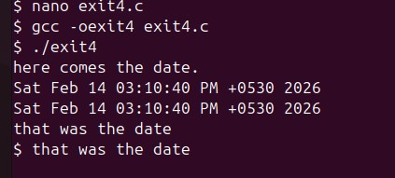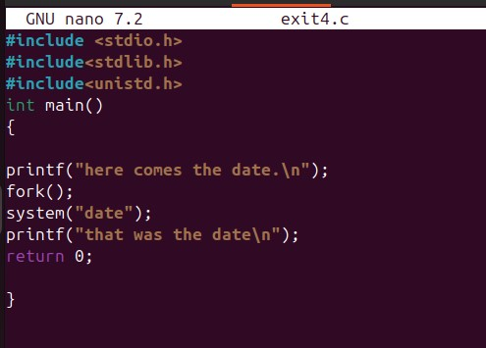

BOTH PARENT AND CHILD PROCESS EXECUTE SYSTEM DATE

