# HR Analyst Dashboard Project Report

## Dashboard Overview

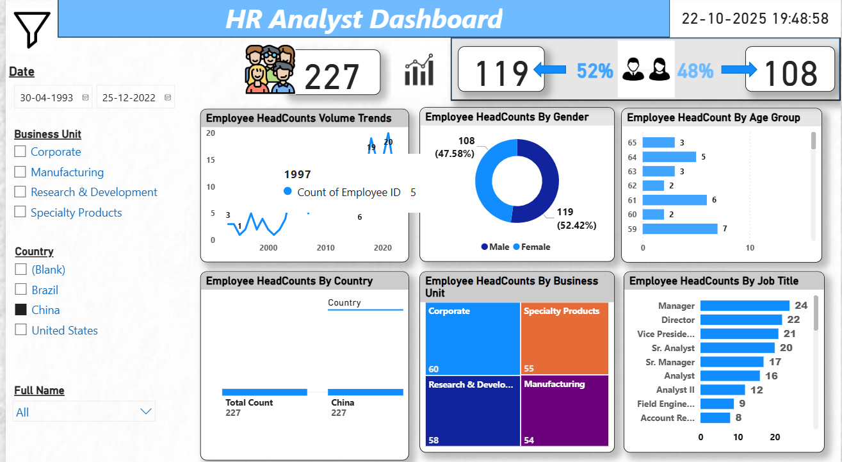

## 1. Project Overview

The HR Analyst Dashboard was developed to analyze workforce demographics, business unit structures, and job role distributions across the organization. It leverages Power BI to transform raw employee data into actionable insights that assist HR departments in decision-making, workforce planning, and diversity management.

## 2. Dataset Information

Dataset: Employee Sample Data (1).xlsx  
Records: 227 Employees  
Key Fields: Employee ID, Gender, Age, Country, Business Unit, Job Title, Hire Date

## 3. Key Performance Indicators (KPIs)

|  |  |  |
| --- | --- | --- |
| KPI | Description | Result |
| Total Employees | Total number of active employees | 227 |
| Male Employees | Count and percentage | 119 (52%) |
| Female Employees | Count and percentage | 108 (48%) |
| Countries | Regions included | China, Brazil, United States |
| Business Units | Divisions analyzed | Corporate, Manufacturing, R&D, Specialty Products |

## 4. Analytical Results & Insights

• Gender Diversity: Workforce is balanced with 52% male and 48% female employees.  
• Country Distribution: Majority of employees are based in China (227 employees in current filter).  
• Business Units: Corporate (60), R&D (58), Specialty Products (55), Manufacturing (54).  
• Job Roles: Top positions are Manager (24), Director (22), and Vice President (21).  
• Age Group: Most employees are aged 59–65, indicating an experienced workforce.  
• Hiring Trends: Steady growth since 1997, showing company stability and expansion.

## 5. Summary and Conclusions

The HR Analyst Dashboard provides a clear, data-driven view of the organization’s workforce. It highlights a balanced gender ratio, experienced employee base, and consistent headcount growth. Recommendations include hiring more junior employees, planning for generational transition, and broadening regional recruitment efforts.