NAME:THULASI.S EXPERIMENT:11

ROLL:NO:241901118 DATE:14/10/25

**EXAMINING NETWORK ADDRESS TRANSLATION(NAT) USING CISCO PACKET TRACER**

**AIM:**

To examing network address translation using cisco packet tracer.

**INTRODUCTION:**

In modern networking, Network Address Translation (NAT) plays a vital role in enabling private networks to access the internet using a limited number of public IP addresses. NAT allows multiple devices on a local network to share a single public IP address, providing both IP address conservation and network security.

**ALGORITHM:**

1.select two PCs ,two routers , two switches and one server.

2.Use the appropriate cables to connect the devices.

3.assign IP address(10.10.10.0/20) to PC1 and router 1 internal interface .

4.assign a public IP address(50.50.50/30) to router 1 external interface.

5.assignan IP address to server (10.10.10.2).

6.assign IP address (20.20.20.0/20) to PC2 and router2 internal interface.

7.assign public IP address(60.60.60/30)to router2 external interface.

**CONFIGURING NAT ON ROUTER:**

1.click on the router and go to CLI tab.



2.set up the internal and external interfaces.

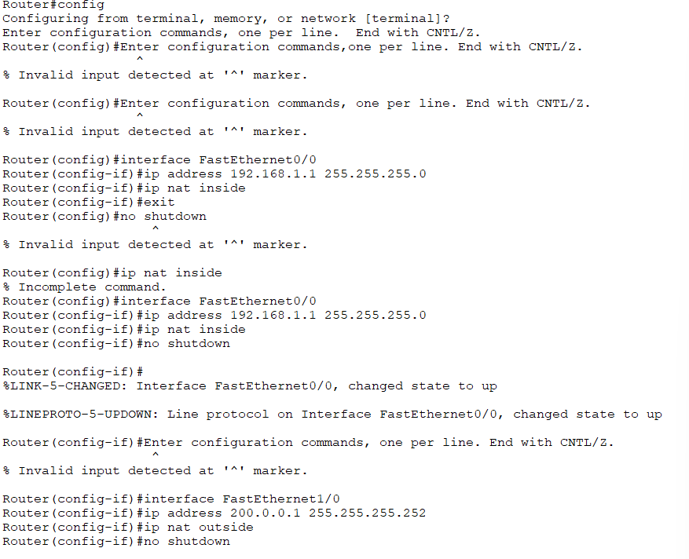

3.configure NAT overload(PAT)

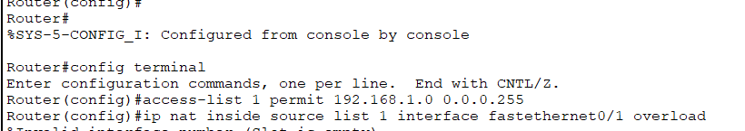

4.testing NAT

5.observing the traffic.

6.saving the configuration

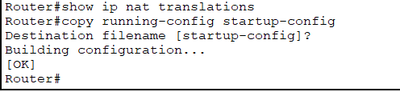

**CONNECTION OF DEVICES:**

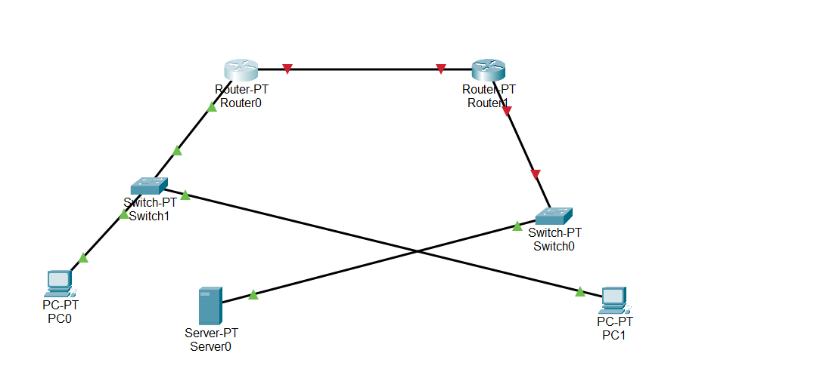

**RESULT:**

Thus,successfully we examined Network Address Translation using Cisco Packet Tracer.