Name : Soma Sri Thulasi RamE-mail : somasrithulasiram@gmail.comPhone no : 6300592254Roll no : 208X1A0597College name : Kallam Harnadhareddy Institue Of Technology

source code :

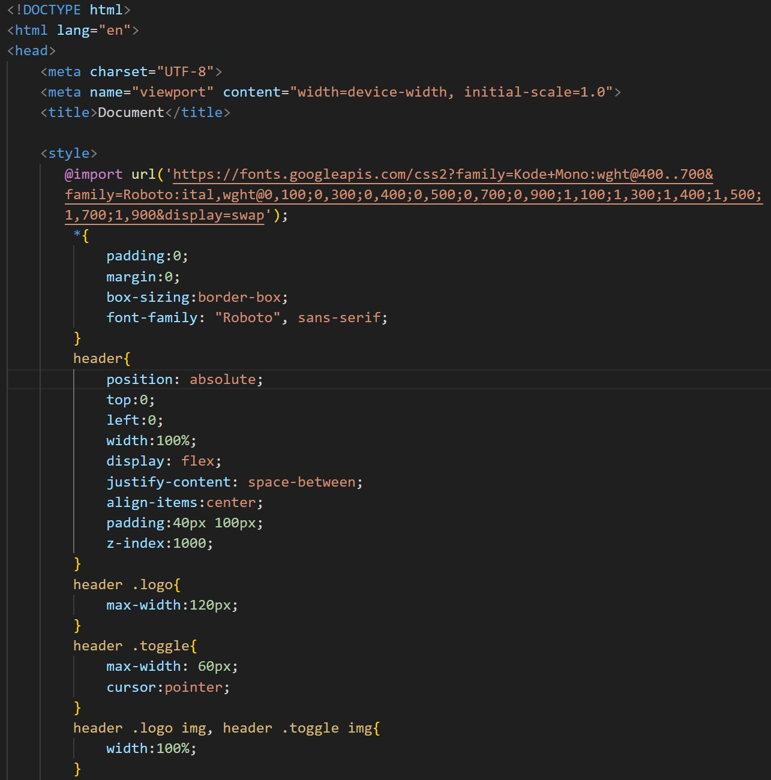

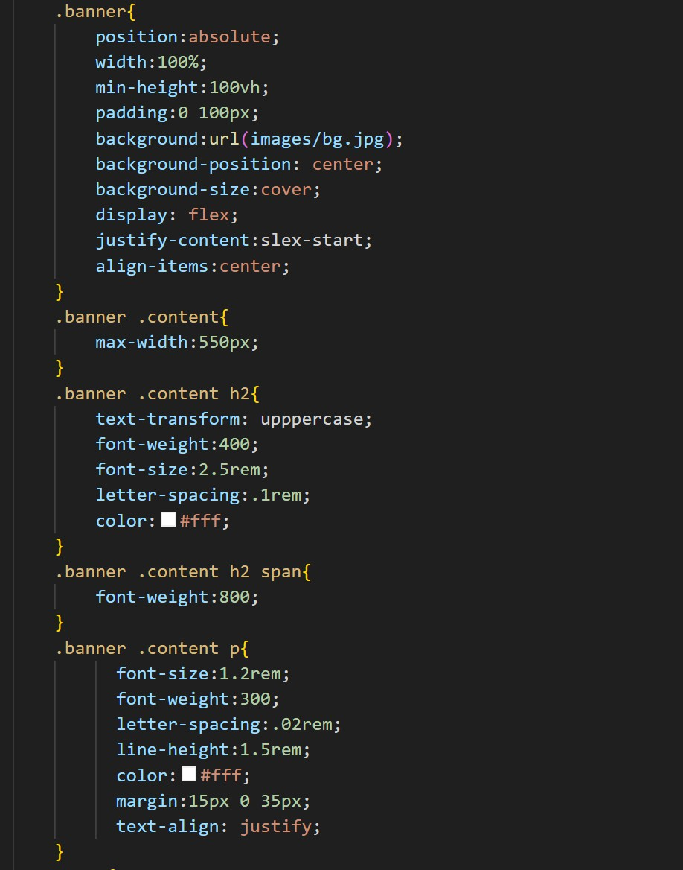

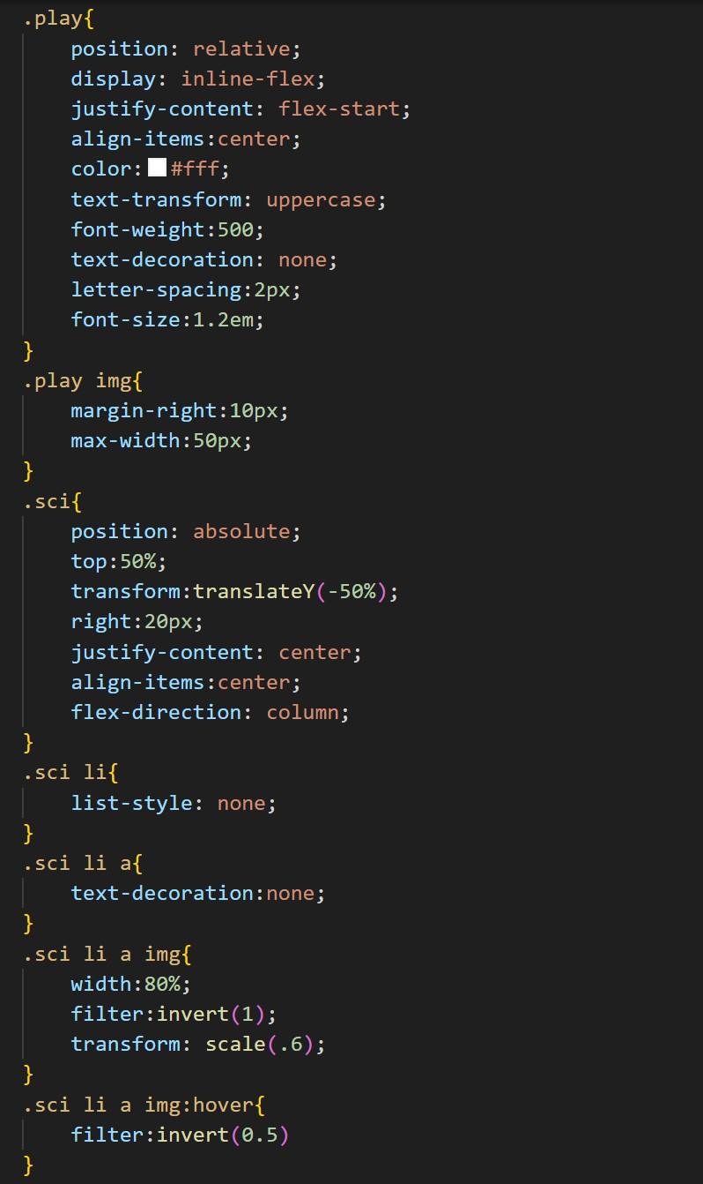

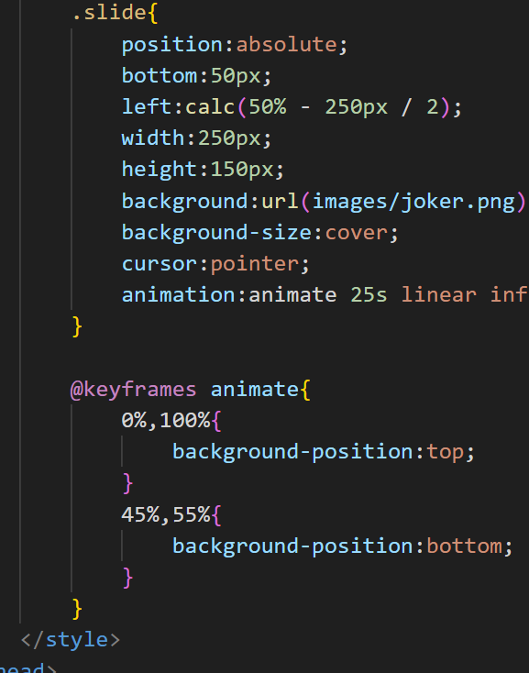

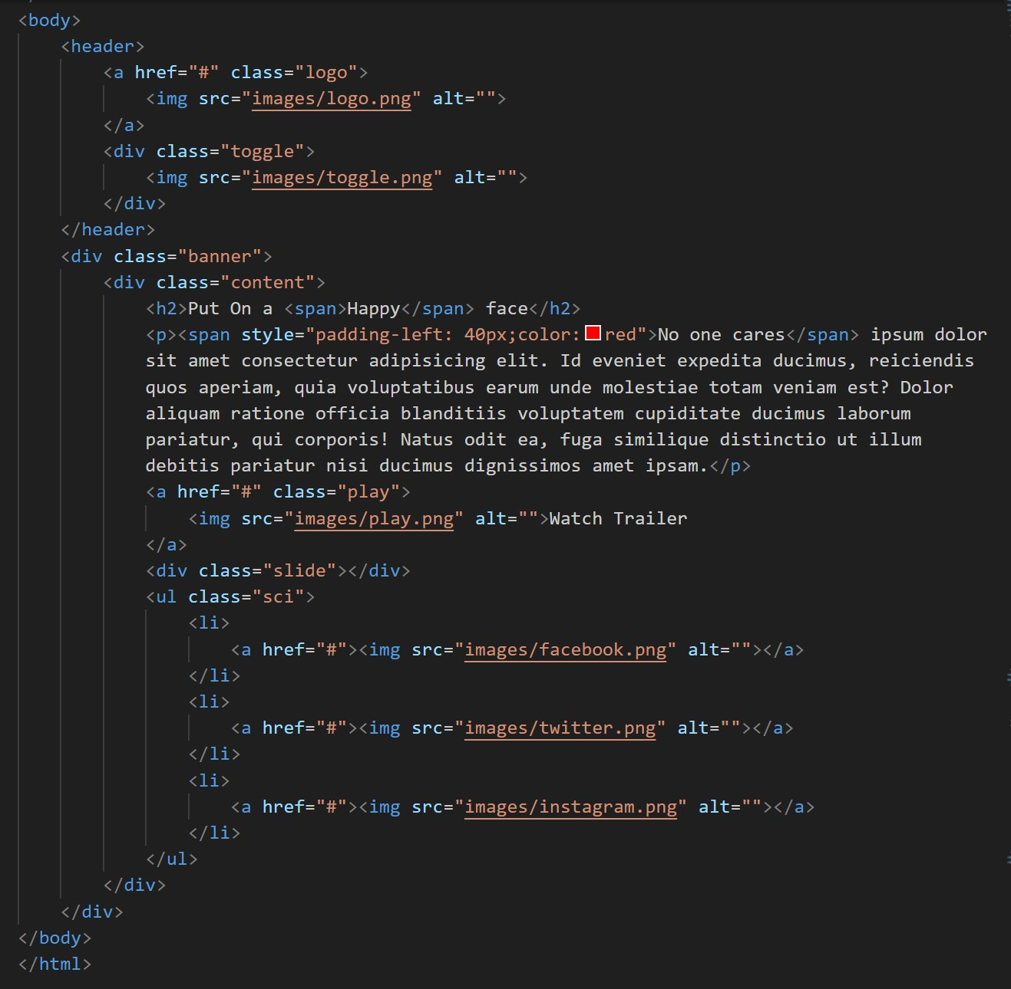

flnal output :

