NAME : SOMA SRI THULASI RAM

EMAIL : [somasrithulasiram@gmail.com](mailto:somasrithulasiram@gmail.com)

PHONE NO : 6300592254

ROLL NO : 208X1A0597

COLLEGE NAME : KALLAM HARNADHAREDDY INSTITUE OF TECHNOLOGY

source code :

CARD COMPONENT :

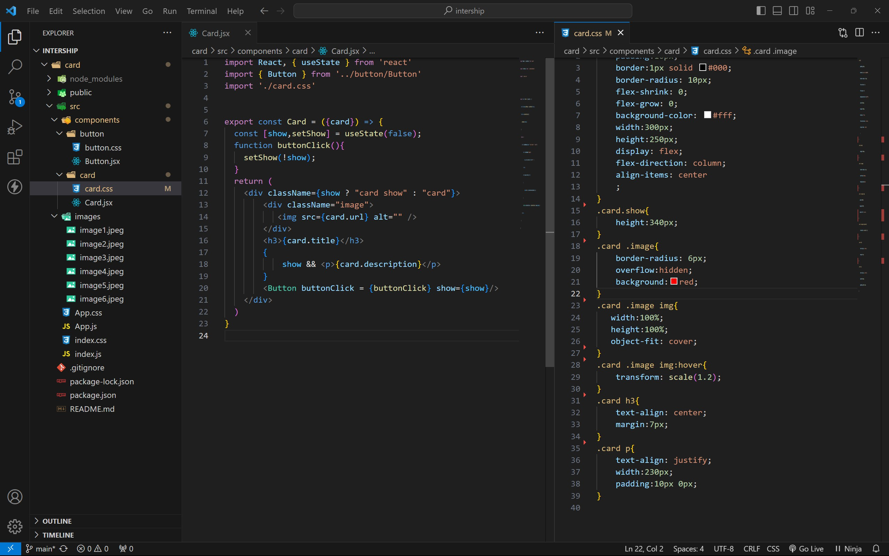

BUTTON COMPONENT :

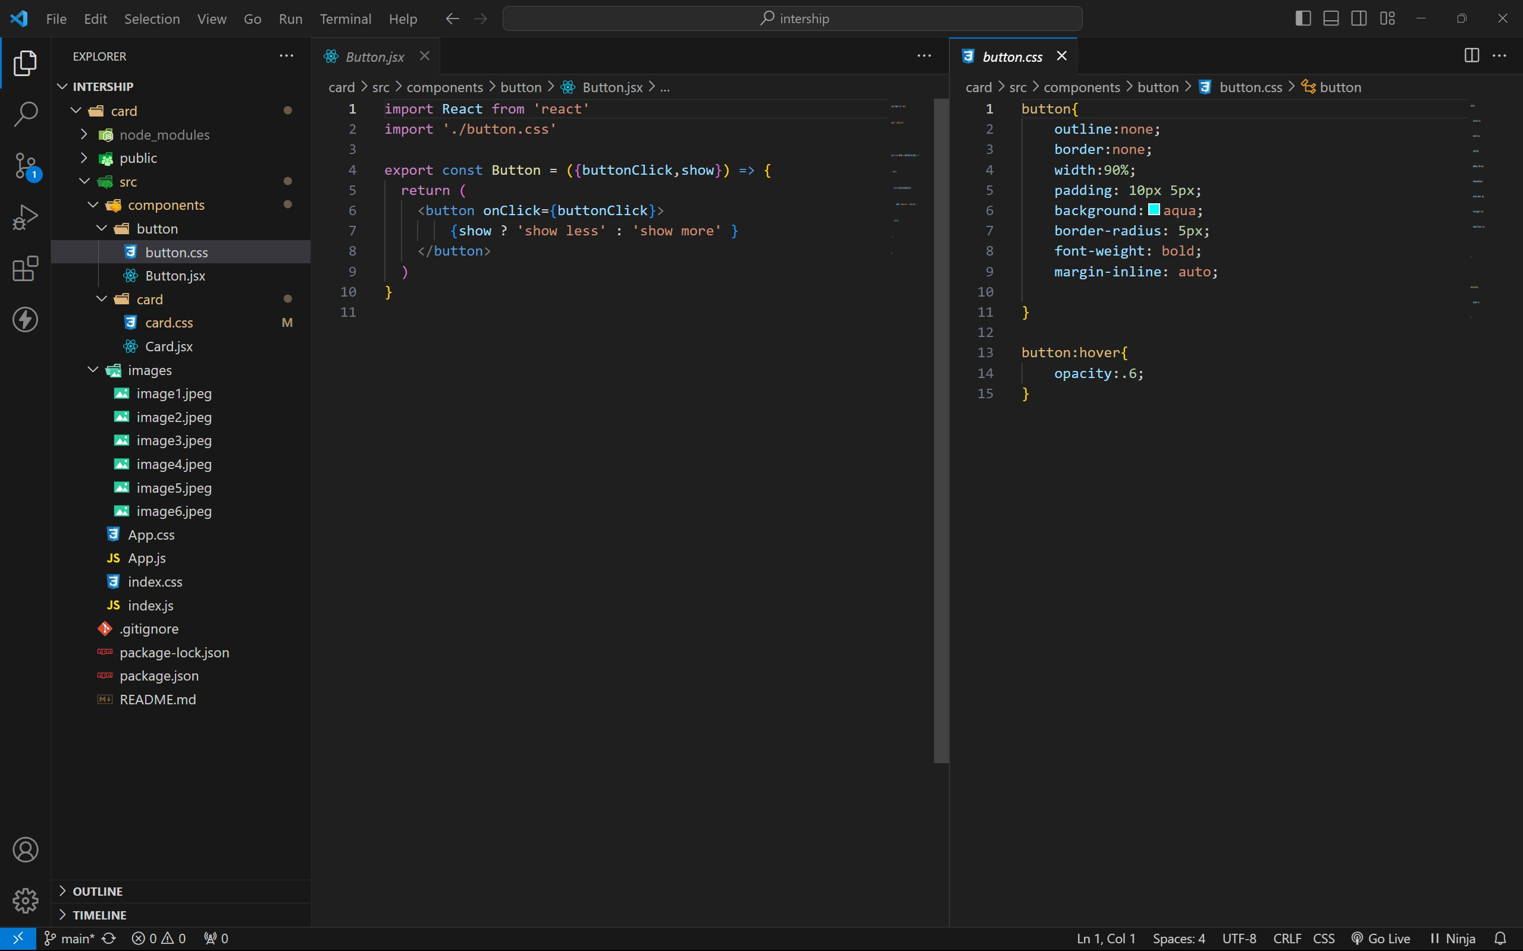

APP COMPONENT :

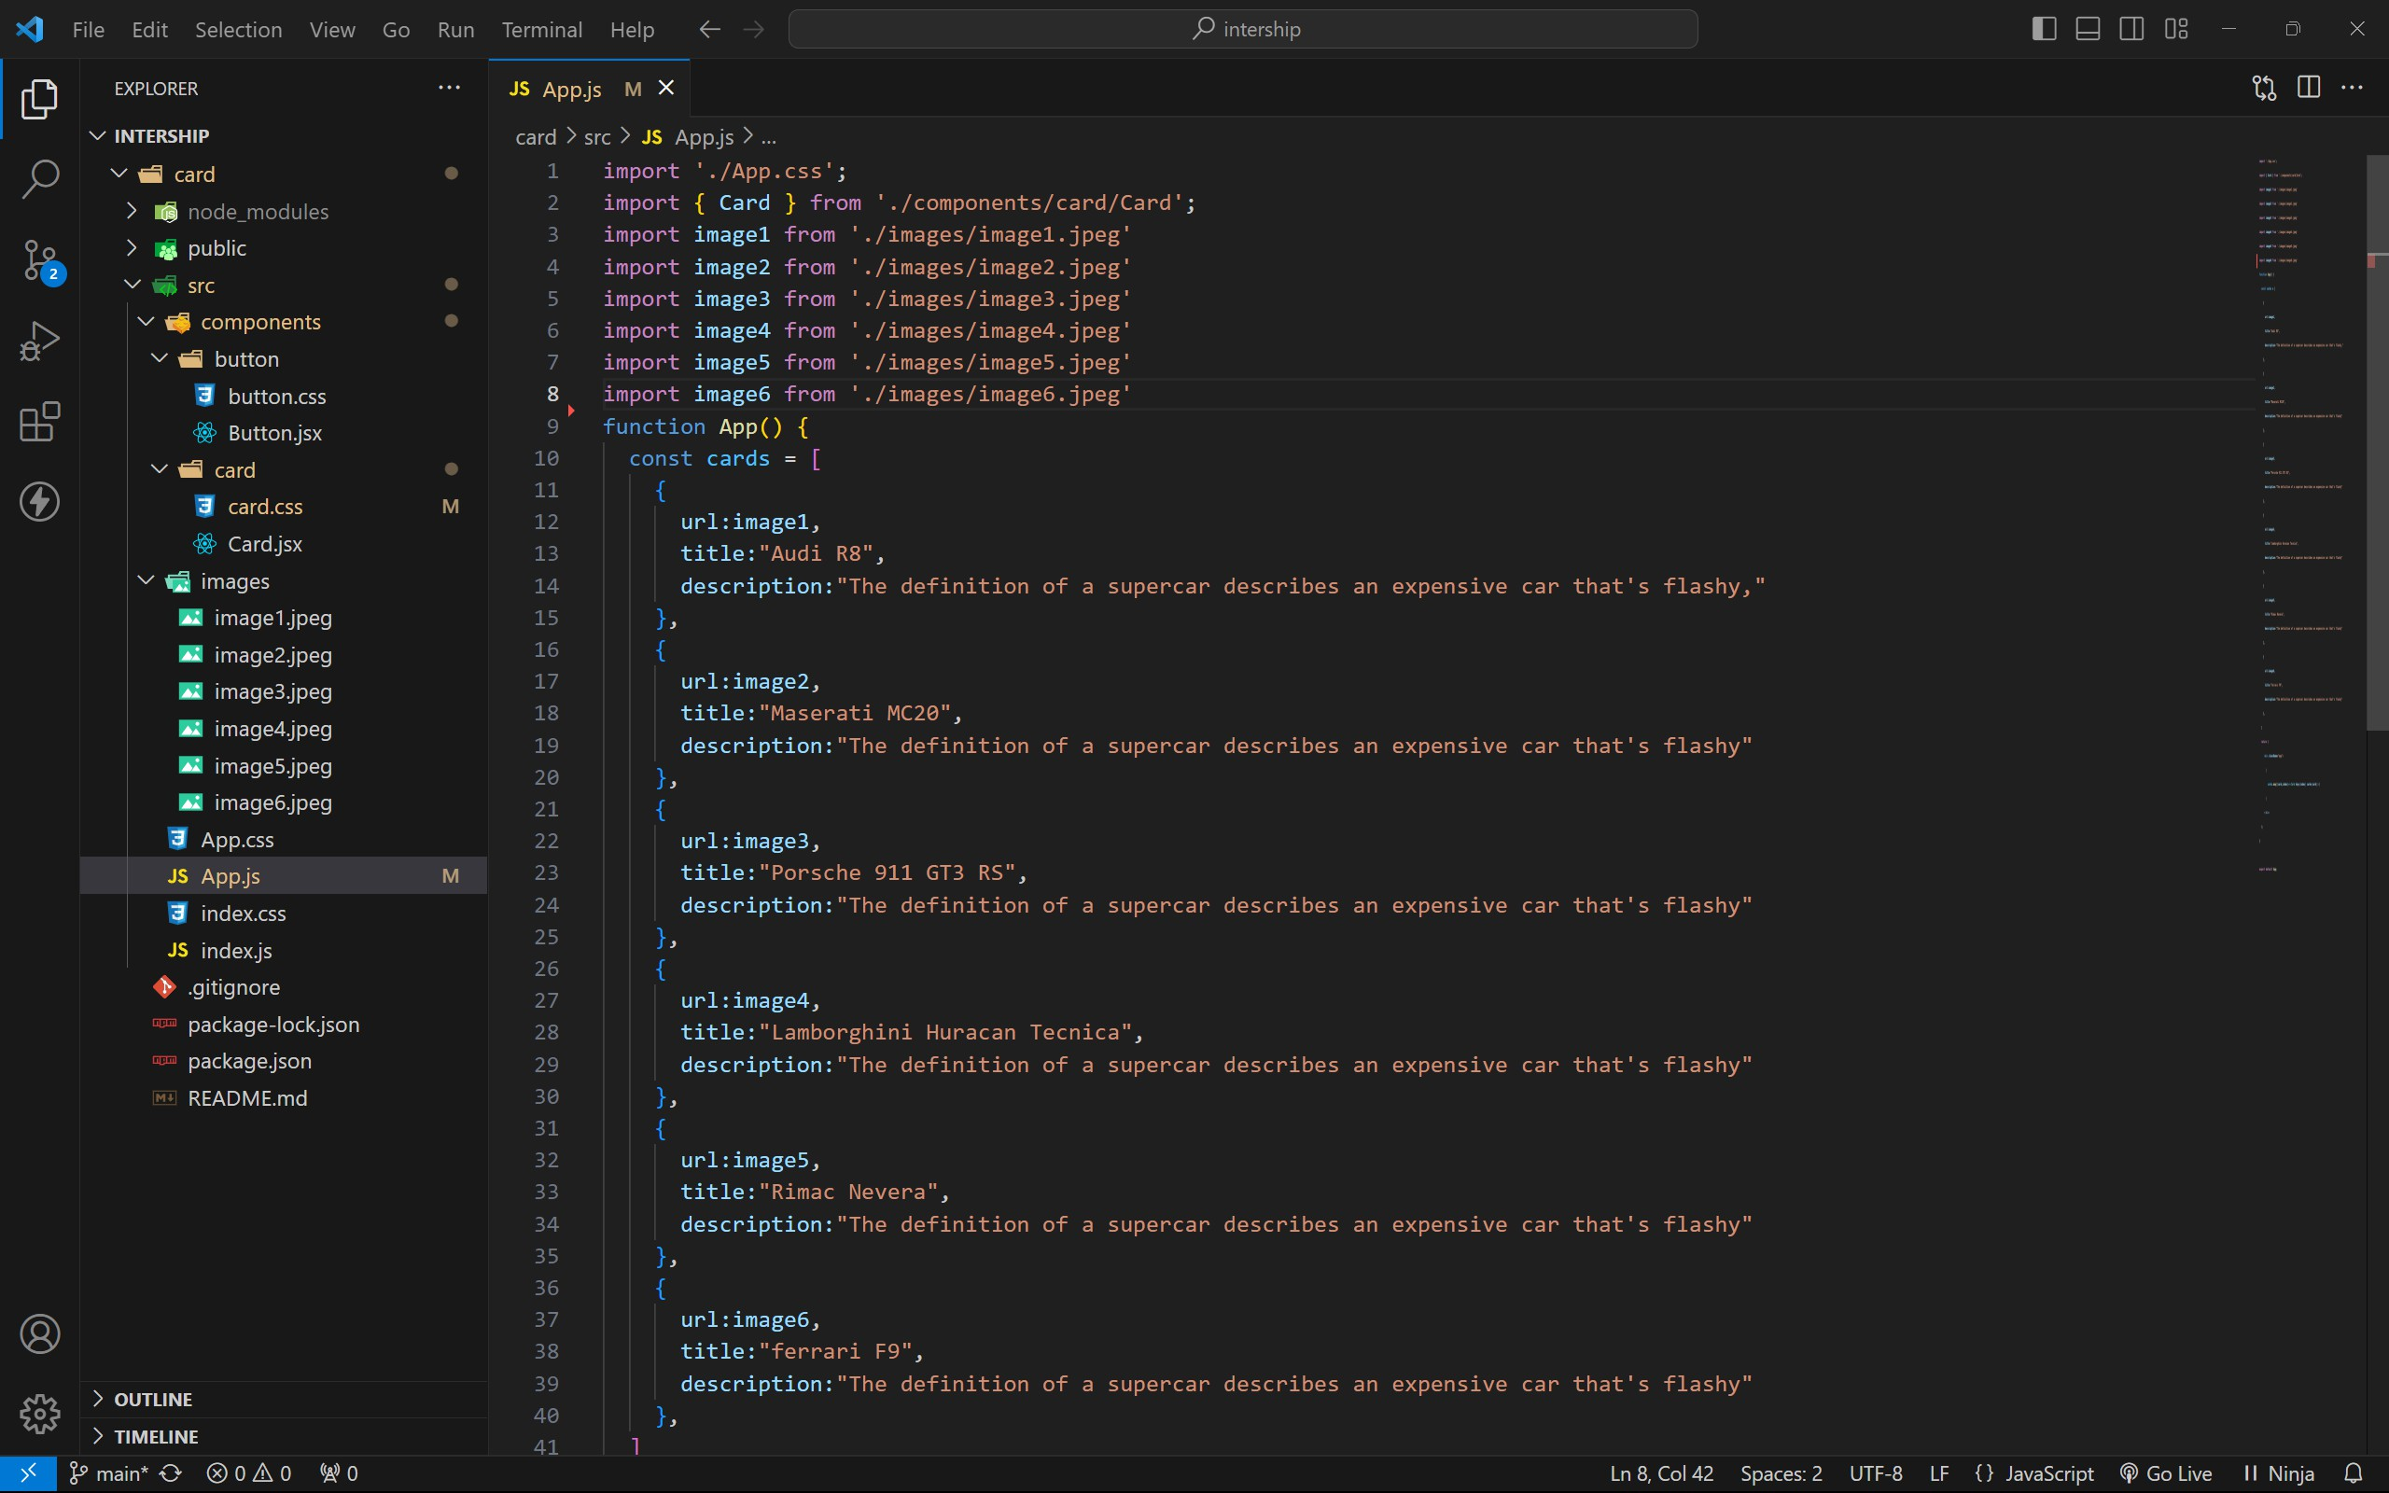

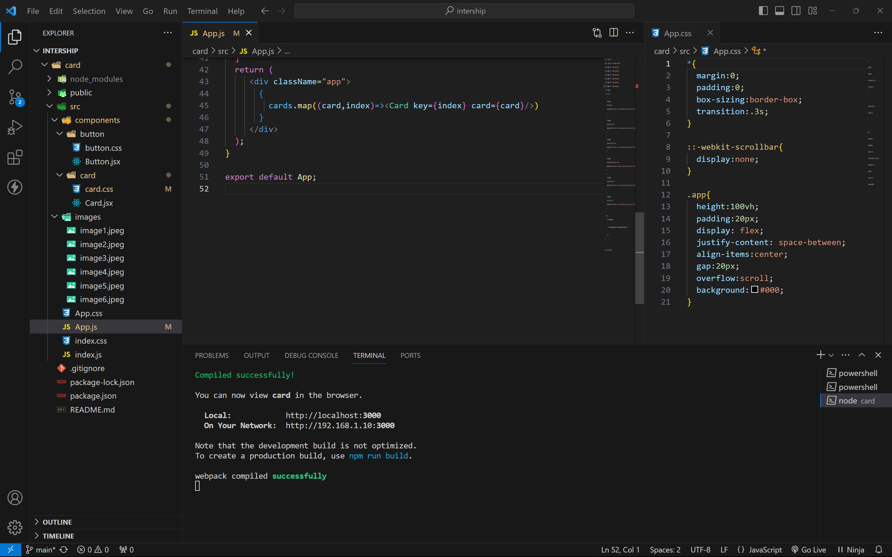

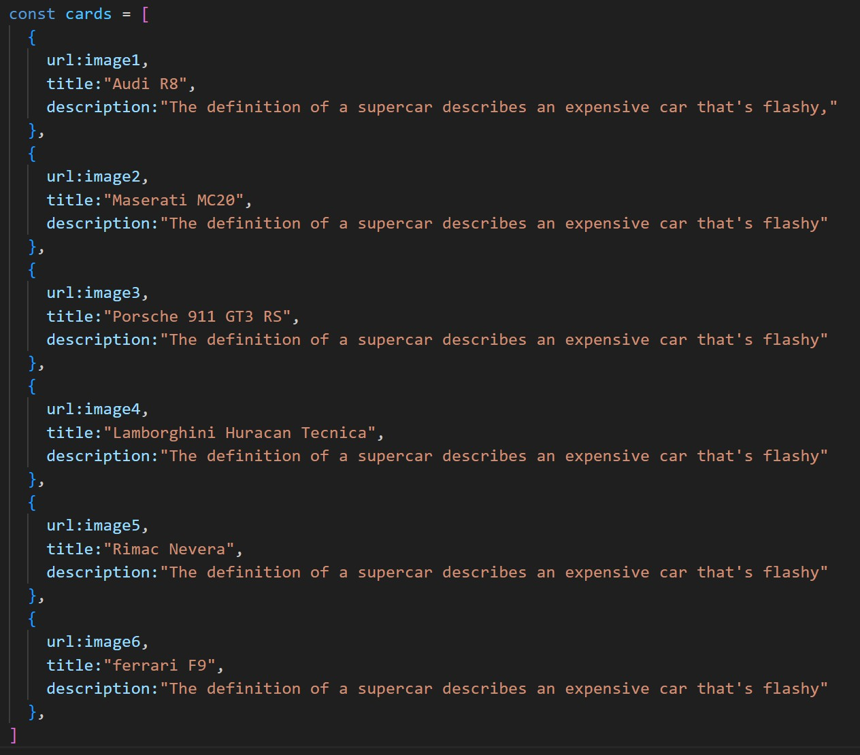

OUTPUT :



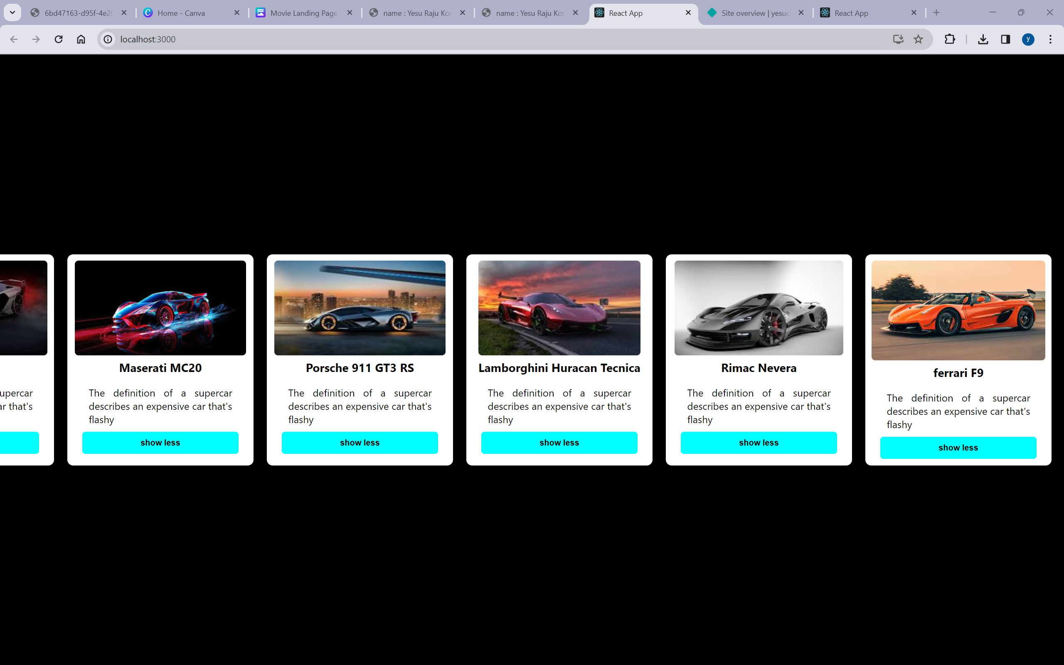AFTER BUTTON CLICKS :

