**KITCHEN MONITORING ALERT SYSTEM ( KMAS )**

**AIM :** To setup a project such that it can able to detect Gas leakage and Fire Detection in kitchen and can alert people using Buzzer.

**COMPONENTS REQUIRED**

* Arduino Uno
* Bread Board
* Gas Sensor MQ2 135
* Flame Sensor HW484
* 3 LED’s (Green, Yellow, Red)
* Buzzer
* Jumper Wires

**INTRODUCTION**

**Arduino Uno**

The popular microcontroller board, called Arduino UNO, is used to create a variety of projects and prototypes. With the addition of several features, this little development board has all the capabilities of its native IC, the Atmega328p. There is an on-board programmer (cp2102) built into this device, thus an external programmer is not required. A 12V DC barrel jack on the Arduino Uno board can receive up to 12V but is only used for 9V maximum. It contains internal Lights that show power. If the Atmega IC is not functioning, it can be replaced with another one because the Atmega328p IC is removable.

**Gas Sensor**

The MQ-135 Gas Sensor can identify dangerous gases and smoke, including ammonia (NH3), Sulphur (S), benzene (C6H6), and CO2. This sensor, like the others in the MQ series of gas sensors, has a pin for both digital and analogue output. The digital pin turns high when the amount of these gases in the air exceeds a predetermined threshold. The on-board potentiometer can be used to adjust this threshold value. An analogue voltage that is produced by the analogue output pin can be used to approximatively determine the concentration of various gases in the atmosphere. The MQ135 air quality sensor module requires about 150mA and runs at 5V. Prior to producing reliable results, it needs to be heated up.

**Measure PPM Value using Analog Pin in Gas Sensor**

The Analog output pin of the sensor can be used to measure the PPM value of the required gas. To do this we need to use an external microcontroller like Arduino. The microcontroller will measure the value of Analog voltage and perform some calculations to find the value of Rs/Ro where Rs is the sensor resistance when gas is present and Ro is sensor resistance at clean air. Once we find this ratio of Rs/Ro we can use it to calculate the PPM value of required gas using the graph below which is taken from the datasheet of MQ135 Sensor.

**Flame Sensor**

The idea behind a flame sensor or fire sensor module is that while a fire or flame is burning, it emits IR signals. The IR receiver on the fire sensor module then picks up this IR signal to find the flame or fire. The sensor has both digital and analogue output, and its operating voltage ranges from 3V to 5.5V. The on-board potentiometer can be used to modify the digital output's sensitivity. The sensor's detection angle is 60 degrees, and while its theoretical range is 100 cm, it actually only goes up to 20 to 30 cm.

**Bread Board**

With the help of this contemporary solderless breadboard, components can be connected without the use of solder. It streamlines the circuit prototyping process. It is necessary for fundamental electronics. There are 400 contact points on this breadboard, along with two power rails on each side. These contact points are breadboard holes that can accept wires and components.

**Jumper Cables**

They can be used for interconnecting electronic components on [breadboard](https://quartzcomponents.com/products/colored-breadboard-mb-102-830-point) or [berg strips](https://quartzcomponents.com/products/40-pin-straight-female-berg-strips).

**CIRCUIT DIAGRAM**

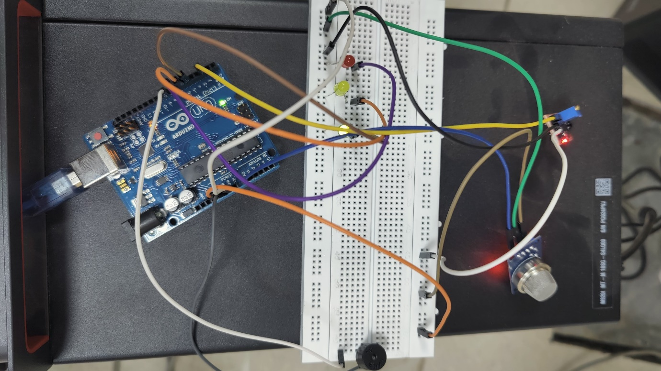

**PROCEDURE**

You can set up the KMAS using following steps :

1. Connect Gas Sensor, Flame Sensor, Arduino UNO, LED’s, Buzzer as shown in Circuit diagram.
2. Once if Gas sensor is connected properly as shown in circuit diagram it can able to read the values from A0 Pin in the form of Analog Voltage.
3. Similarly if Flame sensor is connected properly as shown in circuit diagram it can able to read values from 2 Pin in the form Digital Value.
4. Later connect Buzzer to 8 Pin to indicate Gas leakage.
5. After that setup Max and Min range of values to work system according to needs Kitchen Environment with help of Arduino Program Code.
6. Then Connect 3 LED’s to Arduino pins 5,6,7 to indicate environment status. Setup according to circuit such that Green indicates Safer environment, Red Indicates Fire detection in Kitchen and Yellow Indicates Gas leakage in Kitchen.
7. If at all if we require values of each sensor we can able get them through serial monitor.

**CODE**

void setup() {

pinMode(2,INPUT);

pinMode(A0,INPUT);

pinMode(5,OUTPUT);

pinMode(6,OUTPUT);

pinMode(7,OUTPUT);

pinMode(8,OUTPUT);

Serial.begin(9600);

}

void loop() {

int gas = analogRead(A0);

int fire = digitalRead(2);

if (gas >180 || fire ==0){

digitalWrite(5,0);

}else{

digitalWrite(5,1);

}

if(gas > 180){

Serial.print(gas);

Serial.println(" Gas Smoke Detected");

tone(8,1000);

digitalWrite(6,1);

}else{

Serial.print(gas);

Serial.println(" No Gas Smoke Detected");

noTone(8);

digitalWrite(6,0);

}

if (fire==0){

Serial.println("Fire Detected");

digitalWrite(7,1);

}else{

digitalWrite(7,0);

Serial.println("No Fire Detected");

}

delay(1000);

}

**RESULTS**

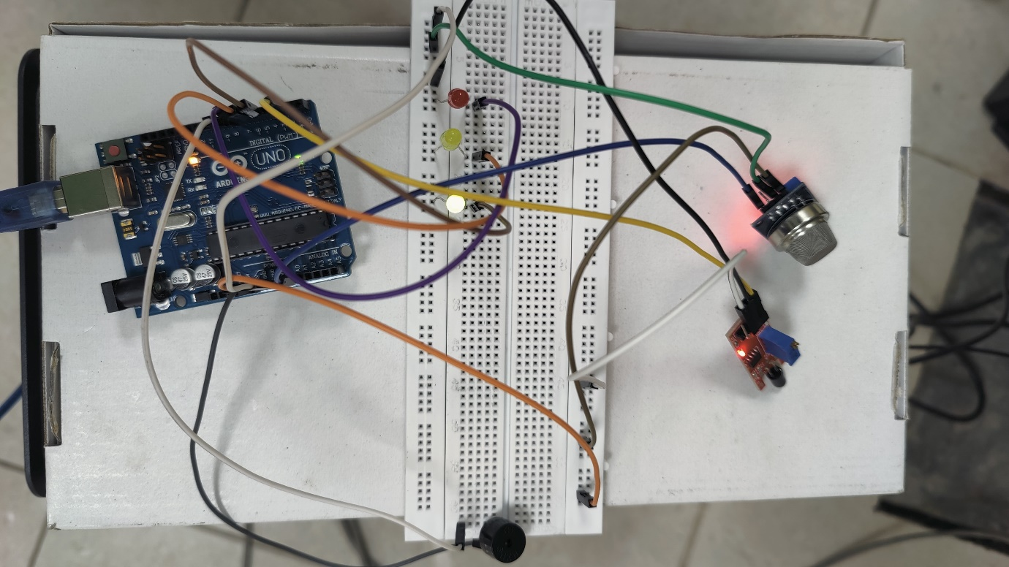

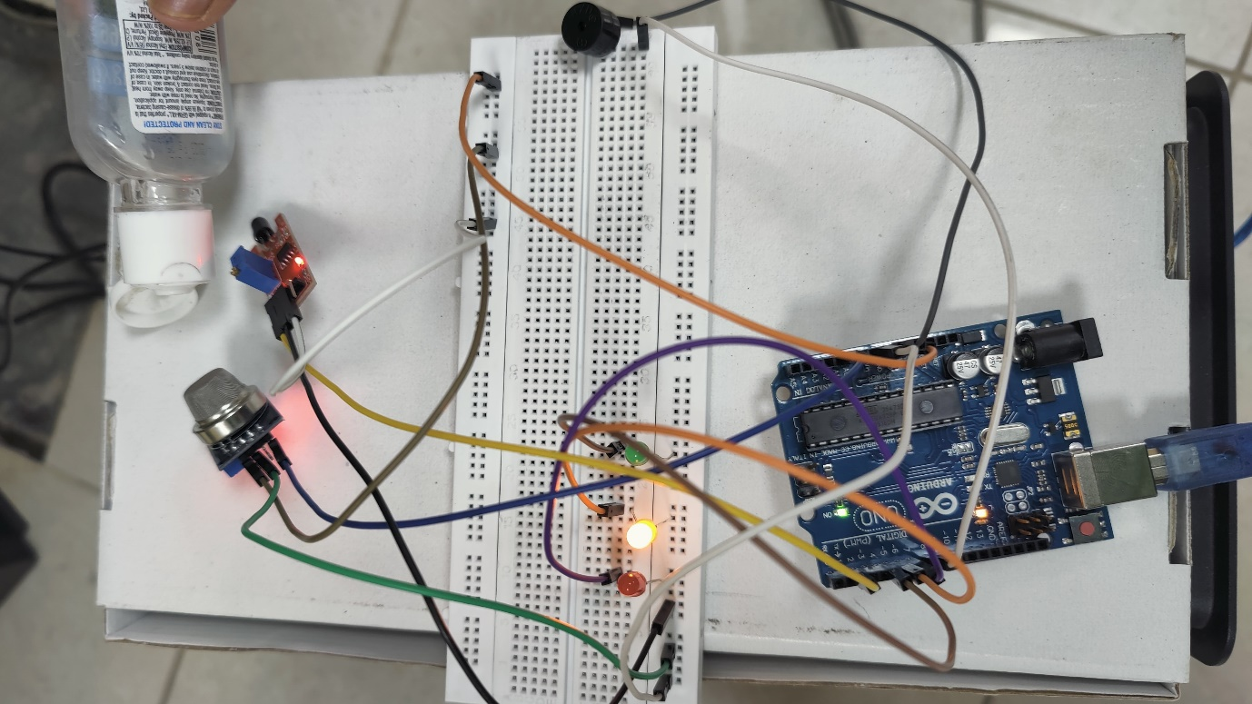

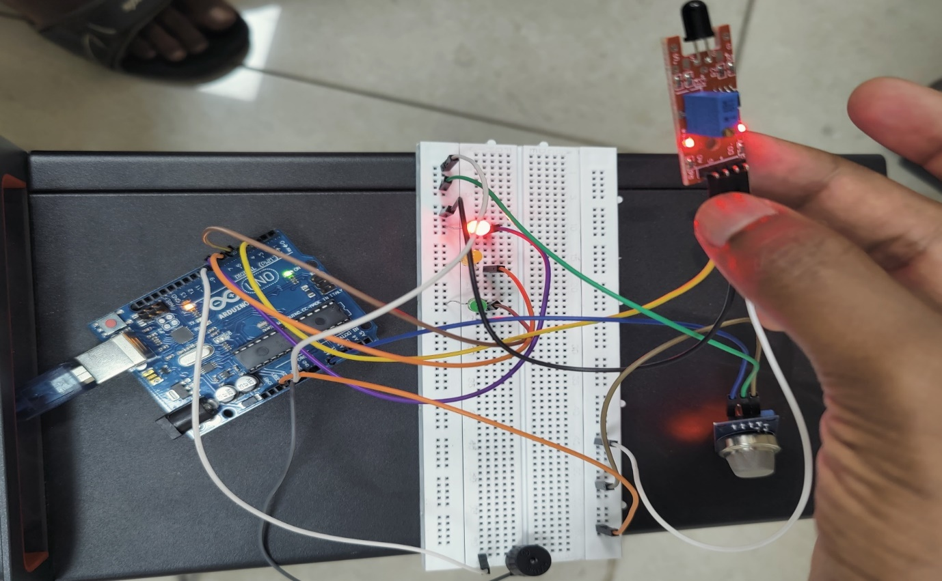

**CONCLUSION**

This project enables us to understand working of Gas senosor, Flame sensor, Buzzer, LED and how these can be integrated with Arduino UNO to set up Kitchen Monitoring Alert System (KMAS) in order to alert people during leakage of Gas or any Fire accident in Kitchen.

|  |  |
| --- | --- |
| **DONE BY** | |
| THULLURU PREM CHAND | - 19341A12B7 |
| SAVIRIGAPU LAXMAN RAO | - 19341A05F2 |