**Design an interface that is inclusive and accessible to a diverse user group, including users with disabilities.**

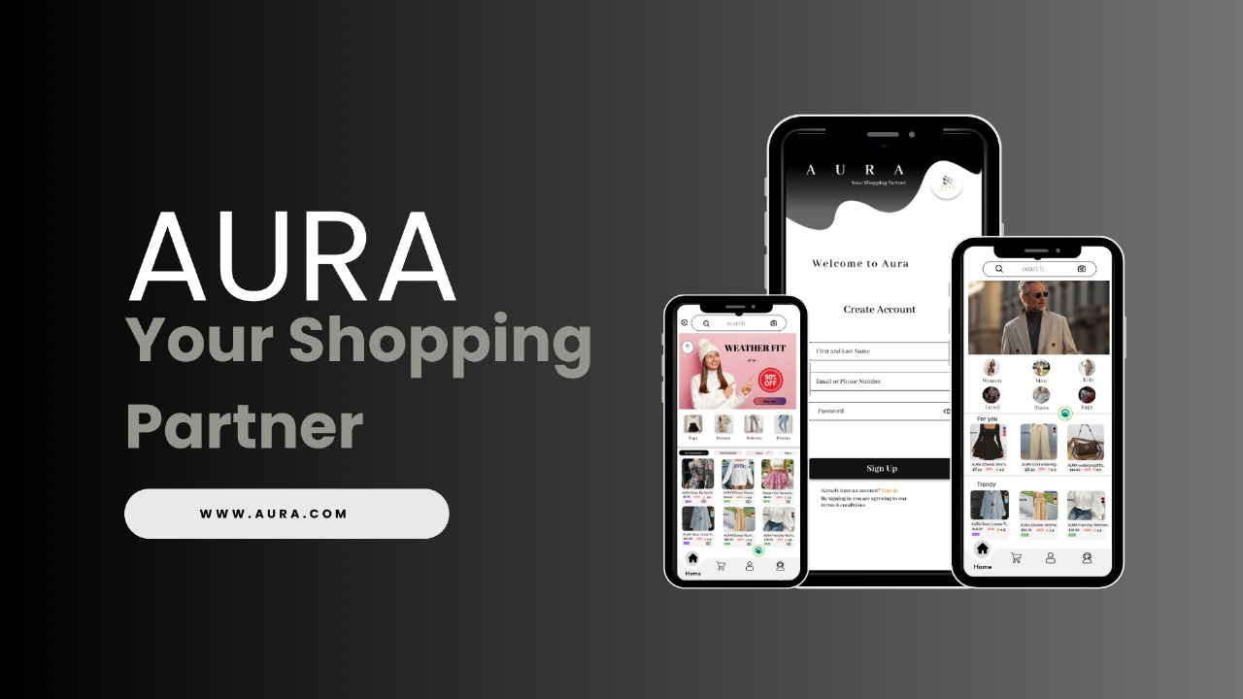

<http://bit.ly/4fjh4dO>