Unit 13
Chris Hadden
1
P5 Social media channels to be used in a digital marketing
campaign
We have been asked to develop a social
media campaign for a local
pet shop,
Pampered Pets.
They
have set themselves up in direct competition with Pets at Home but they are a family run business
and so really care about their customers.
They sell
everything pets need,
but they take an ethical
stand on not selling animals.
They want to make the most of the profitable Spring / Summer trade
and make sure that pet treats and care pack for new pets bought from themselves will lead to ongoing
online sales.
We have produced this report to explain what channels Pampered Pets will need to use as a part
of their digital marketing campaign.
We also outline our plans for the content of that campaign.
1.1
What channels are prevalent
[2]
1.2
Narrowing our focus
There is a plethora of different types of social media channels, never mind specific social media sites.
As our client are an independent business,
they do not have the money or staff to be able to cover
every type of social media.
Because of this we are going to have to consider where they will be able to
make the largest impact from the smallest outlay.
To narrow down the list of channels we will
concentrate on the main points we need to consider,
which are:
• How often does the client want to publish updates
• Which channels are popular
• What does the client want to get out of a campaign
1
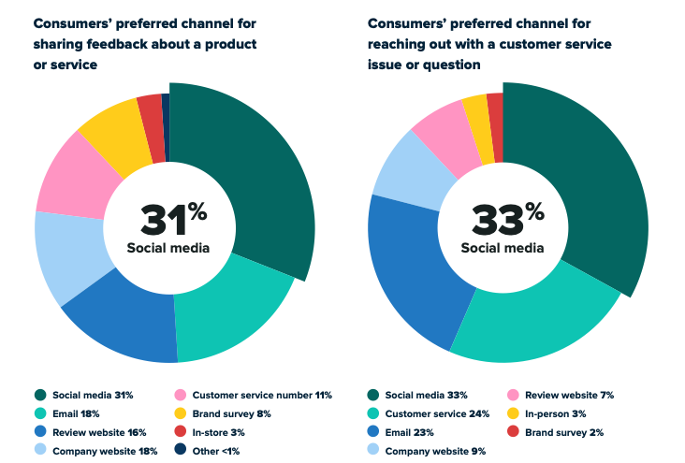
1.3
What channels are popular
As we can see from the SproutSocial,
a social media management firm,
in figure 1[2] that consumers
much prefer social media over other forms of contact with brands
Figure 1:
Pie graph of preferred brand contact
At the very least we can say that social media is the right place to start.
1.3.1
What does the client want to get out of a campaign
According to the site SproutSocial, they found that for marketing ”88% of marketers report that their
social media strategy positively influenced their sales and 90% agree that social media helps them stay
ahead of their competitors.”[2].
Having talked to Pampered Pets, what they said they wanted to get
out of their campaign was increased online sales over Spring / Summer and the SproutSocial
report
would seem to indicate that a social media campaign could deliver what they wanted.
2
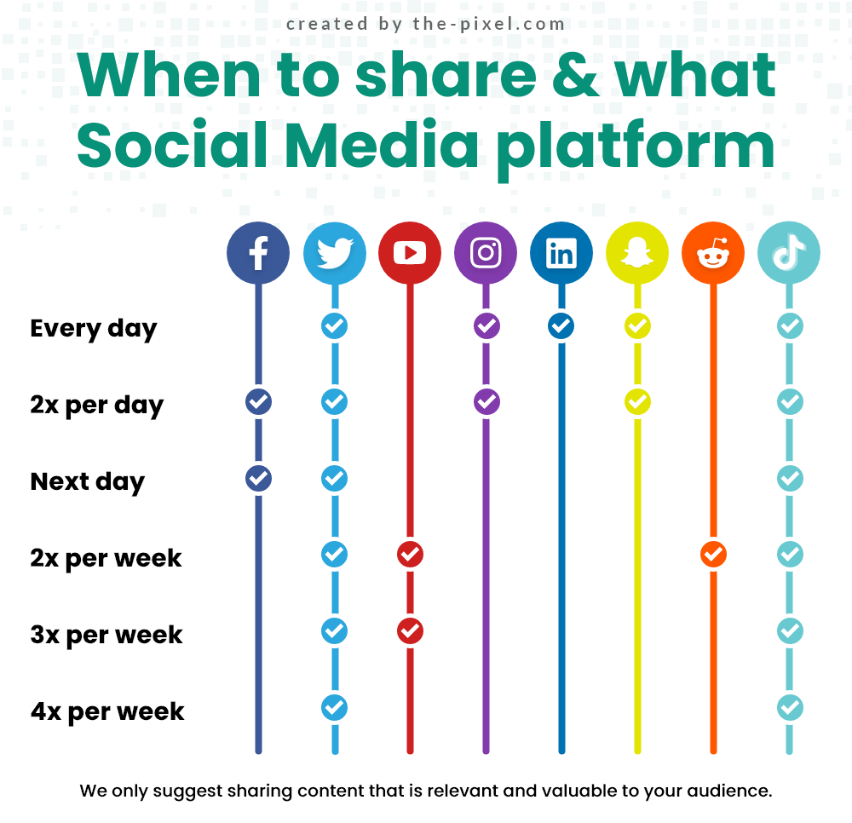
1.3.2
How often does Pampered Pets want to post
Pampered Pets are a small company with no dedicated social media manager, or the money to pay for
a 3rd party to take on that work.
This means that they really only have the capacity to post at most
every day or so with new offers, etc.
Figure 2:
When to share
As figure 2 from Pixel
[1]
shows,
posting at this rate would seem to indicate that the likes of
Facebook, Twitter (X) or Instagram may be good matches.
/sectionConclusion It would seem that the channel with the greatest impact and the channel that
most consumers actually want to use is social media.
We have identified a numer of possible platforms
that would be good for Pampered Pets to make a presence on.
From this we will need to further delve
in to who Pampered Pets should be targeting.
References
[1]
:
Social
Media
Channels
Explained.
2016.
–
URL
https://www.the-pixel.com/
social-media-channels-explained/
[2]
:
Choosing the right social media channels for your business. 2021. – URL https://sproutsocial.
com/insights/social-media-channels/
3

