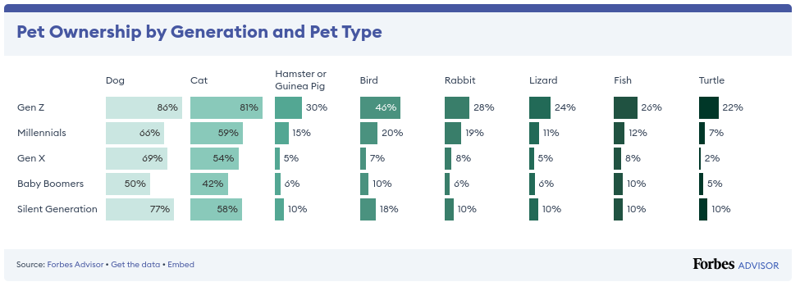
Unit 13
Chris Hadden
1
P6 Target Audience for the Pampered Pets Campaign
Pampered Pets have identified what channels would give them the most impact,
and what channels
customers also want to use to reach out to brands.
From this we now want to focus in on the target
audience Pampered Pets should be looking at.
2
Market Segmentation Analysis
There are a number of ways of splitting up your target audience and researching what how sections
respond to your market area.
We will work through this.
2.1
Age
It is always worth seeing how your target market may break down by age.
Looking at SproutSocial’s breakdown of social media user age range [3]
Age
Top
Middle
Bottom
18-29
Snapchat (41%)
TikTok (35%)
Instagram (32%)
30-39
LinkedIn (34%),
X/Twitter (34%)
Snapchat (33%)
40-49
LinkedIn (25%)
Facebook (22%)
X/Twitter (21%)
50-59
Facebook (29%)
LinkedIn (24%)
Pinterest (24%)
We can see that Facebook covers the majority of people in the age range 40 to 59 and Snapchat
covers most people in the age range 18-39.
This gives us quite a good place to start.
Another way of looking at age is to see what pets each age range owns.
As we can see from figure
1 from Forbes [2] there isn’t a lot in the age differences, which is reassuring in a way, at least there’s
no specific age range to target and from what we have seen from the social media platforms it seems
like there a few that cover most age ranges.
Figure 1:
Pet Ownership by Pet
2.2
Other factors
A study by Inforgroup in America found that ”60% of pet owners are female,
75% have a household
net worth greater than $220,000, and 77% are 50 years of age or older ...
the analysis also found that
1
more than 58% of pet owners are college graduates” [1].
This gives us a really good insight in to age,
income,
gender and education.
While this is only one report it does highlight a trend of older more
affluent people who are willing to spend more on their pets.
References
[1]
:
Data:
Pet
Owners
Far
More
Likely
to
Be
Female,
Affluent,
Older.
2020.
–
URL
https://www.prnewswire.com/news-releases/
data-pet-owners-far-more-likely-to-be-female-affluent-older-301035570.html
[2]
:
Pet
Ownership
Statistics
2024.
2024.
–
URL https://www.forbes.com/advisor/
pet-insurance/pet-ownership-statistics/
[3]
:
Social
media demographics to inform your 2024 strategy.
2024. – URL https://sproutsocial.
com/insights/new-social-media-demographics/
2

