This document covers instruction on how to run the integration of gene co-expression network and metabolic model method in MATLAB.

REQUIREMENTS

1. Matlab (version 2018a or better)

2. Cobra Toolbox

2. Gurobi solver (version 9.0.1 or better, free academic)

3. Gene expression profile

PROCEDURES

Step 1. Open Matlab program and enter initCobraToolbox at Matlab command line

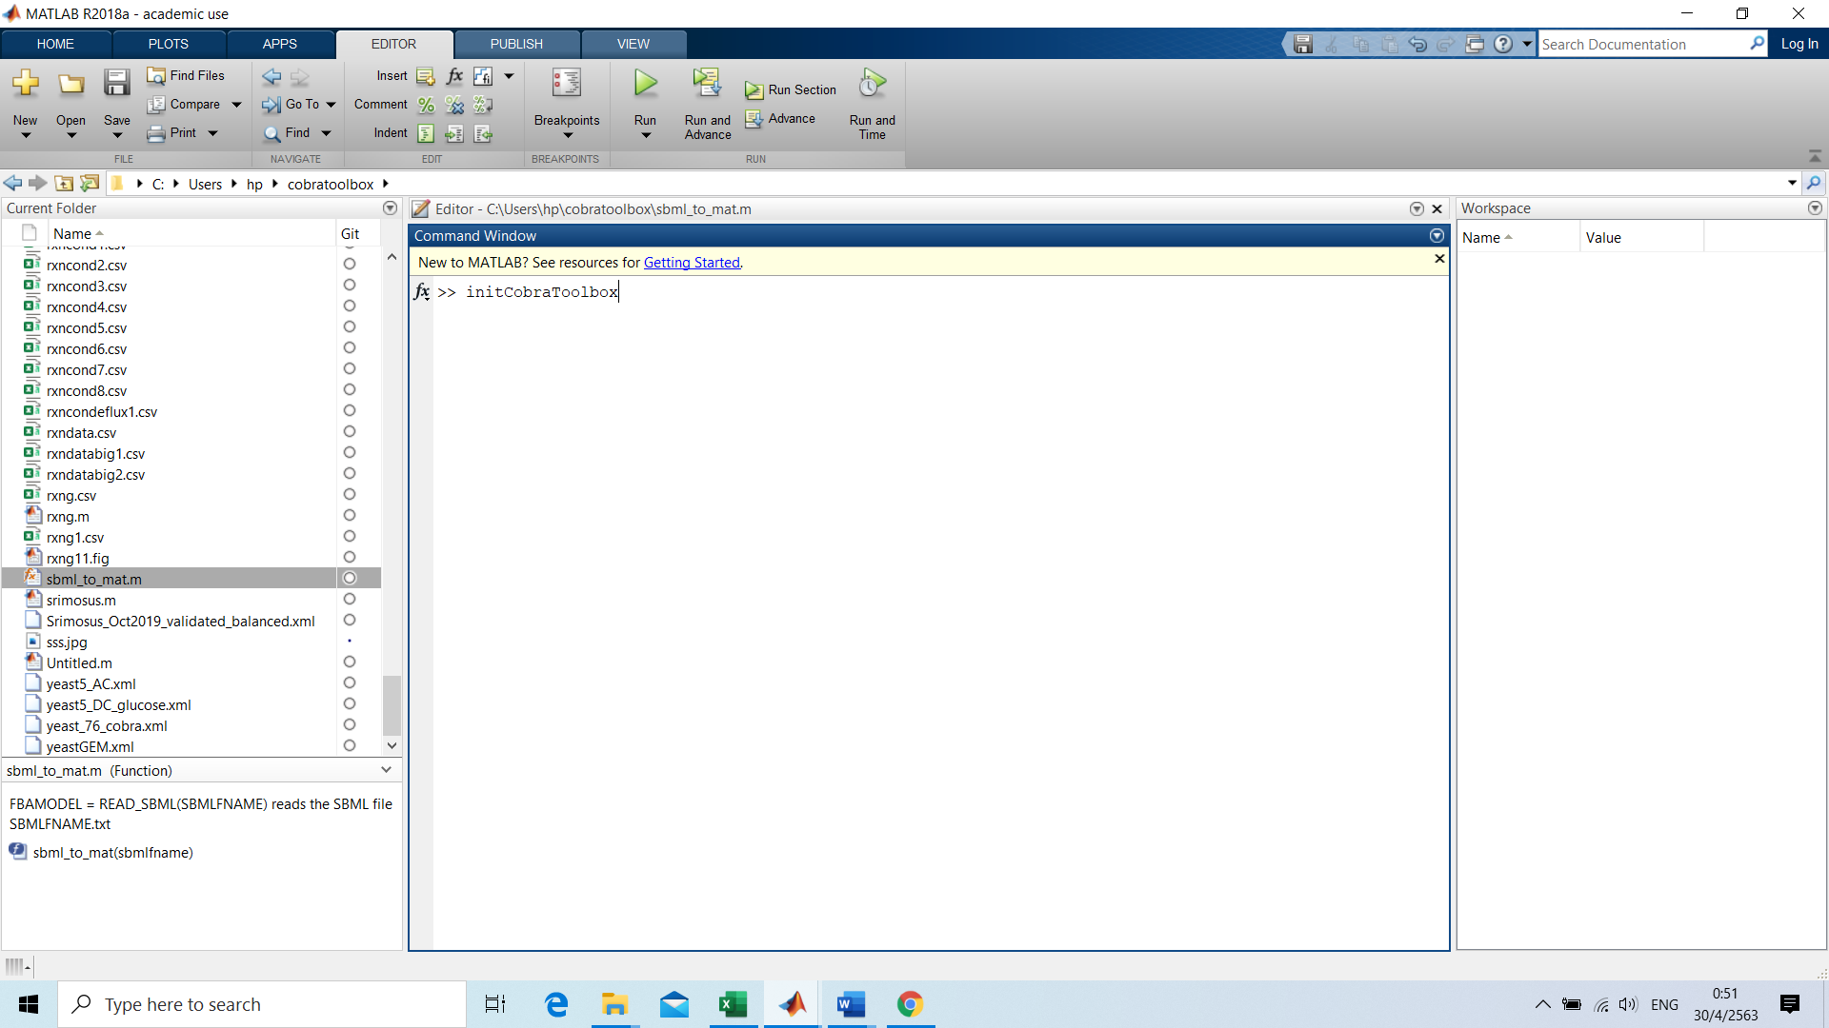

Step 2. Read SBML model

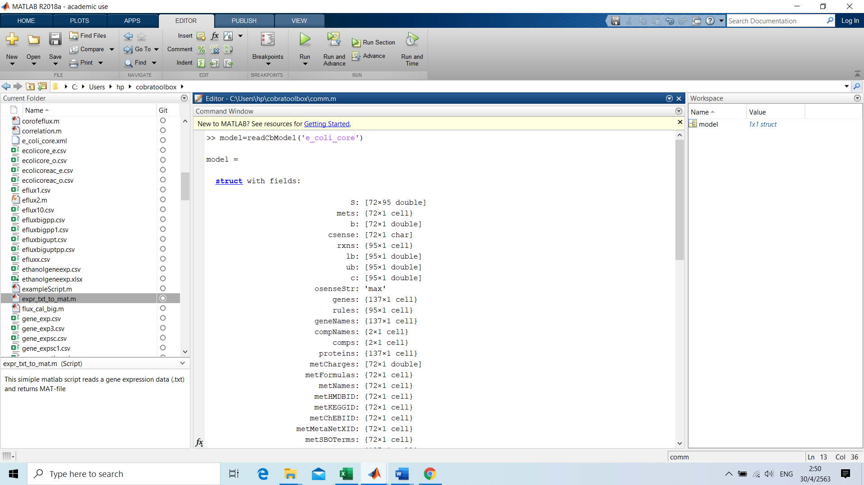

**Step 3.** Prepare and read gene expression data

Note that the first column of gene expression data should have gene symbols/names used in the GPR association of the genome scale metabolic model. First row of gene expression data should have condition names.

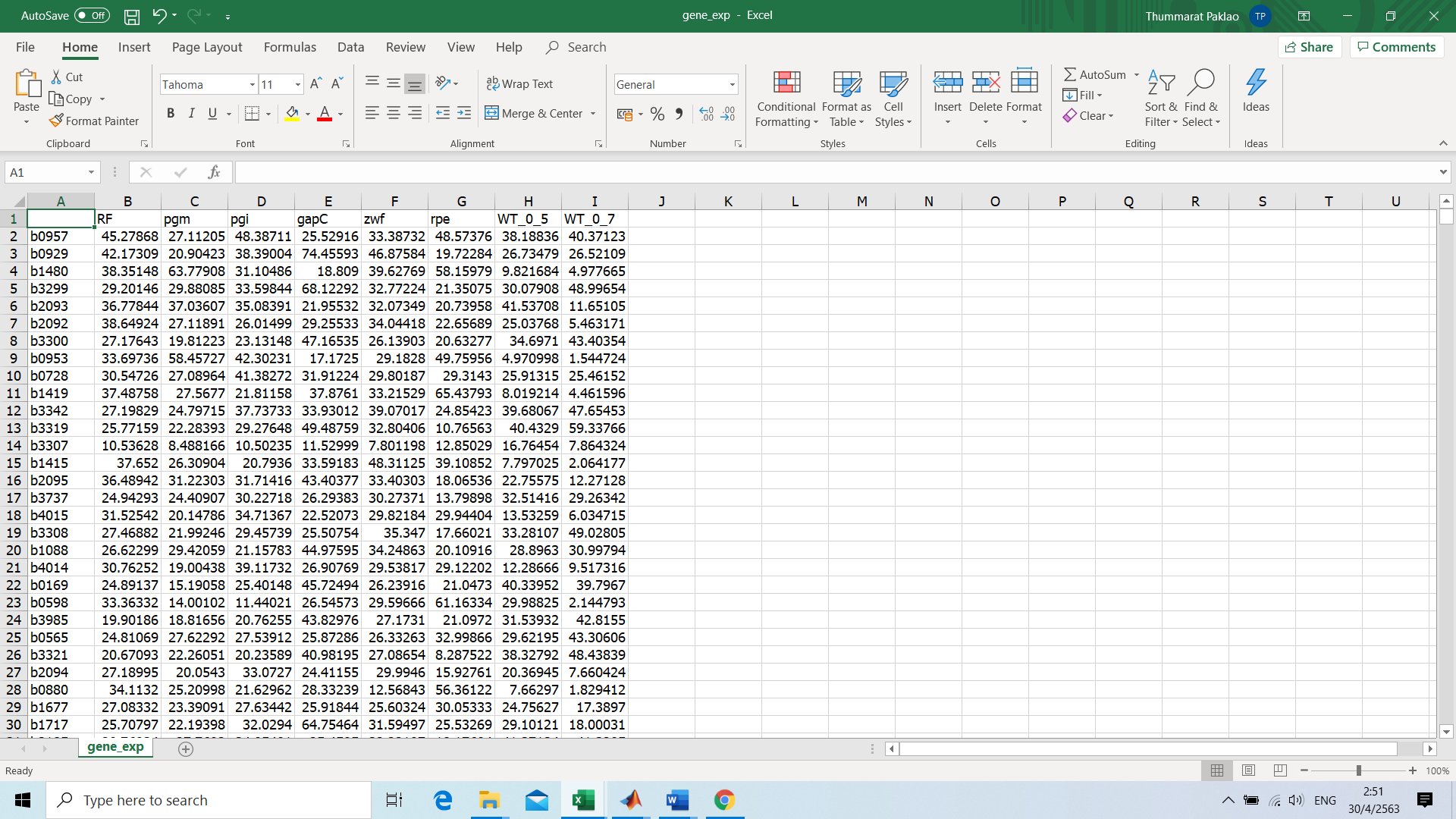

After gene expression data is prepared, read gene expression data in csv file at Matlab command line.

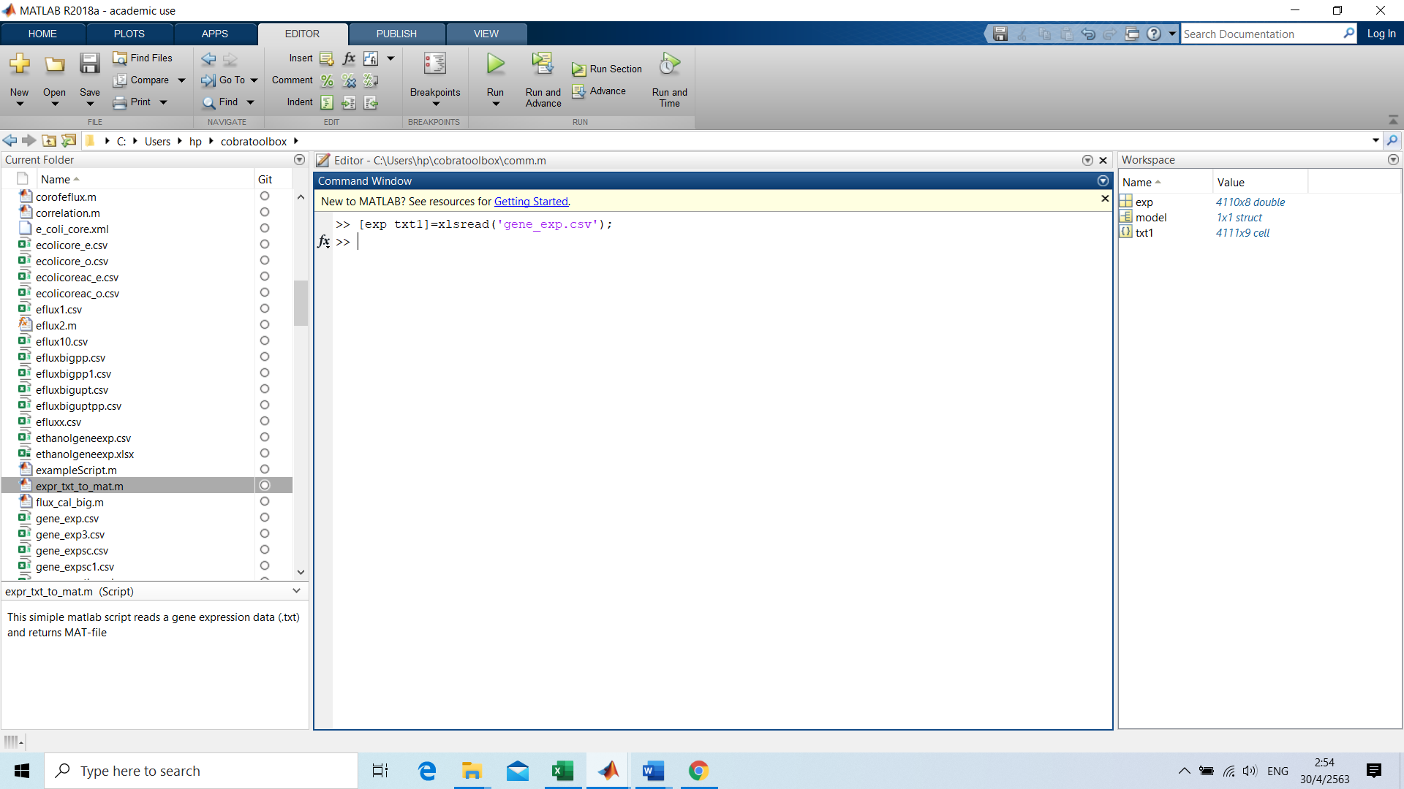

Where exp is the numeric value of gene expression data in gene_exp.csv file and txt1 is text data in gene_exp.csv file. Numeric values in inner spreadsheet rows and columns appear as empty character vectors in txt1.

**Step 4. Perform analysis**

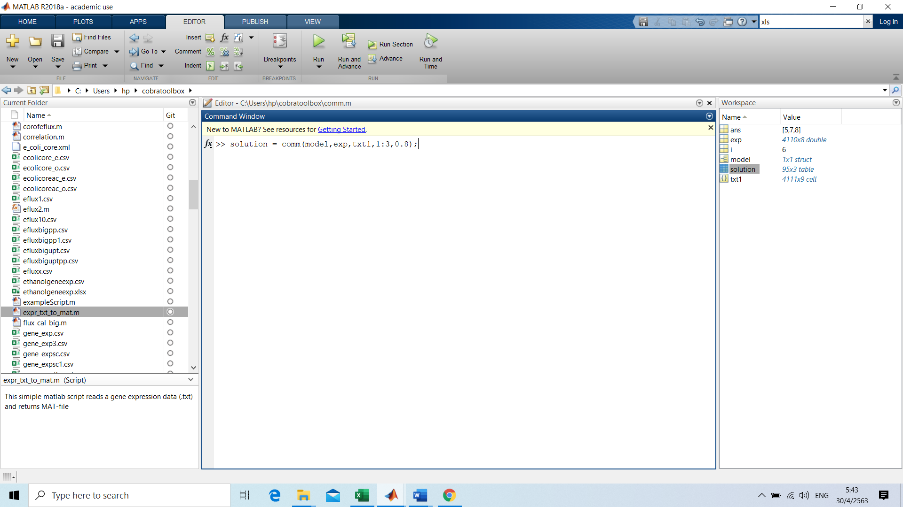

The algorithm of integration of co-expression network and metabolic model is completed by using function comm where the input is model file in step2, exp and txt1 in step 3 and row vector of condition that are wanted to calculate flux distribution (default is all conditions) and threshold for constructing co-expression network (default value is 0.9).

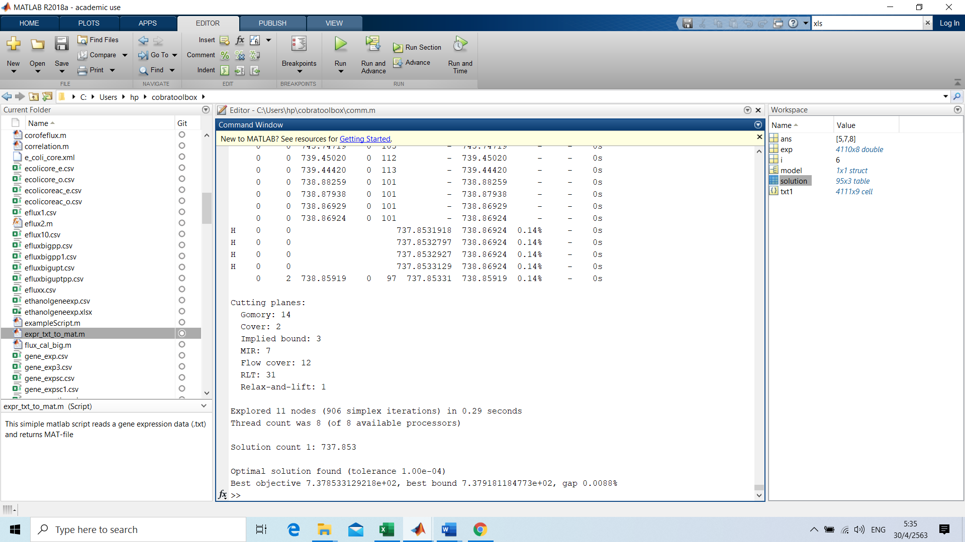

After the algorithm is finished, solution for the predicted metabolic fluxes will be added to the Workspace (See the picture above). Numerical flux values can be examined in more detail by double-clicking solution. Moreover, the output of this algorithm is reported in result.csv file.