**Program Structure**

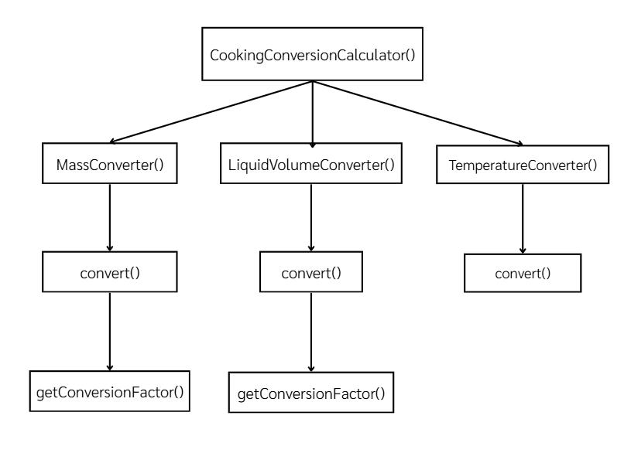

**Top-down Integration**

|  |  |  |  |  |  |  |  |
| --- | --- | --- | --- | --- | --- | --- | --- |
| Unit under test | List of Stubs/Drivers | result | Stub’s return value | Expected results | input | Actual results | Pass/Fail/No run |
| CookingConversionCalculate()+MassConverter()+convert() | getConversionFactor() | 125 | 125 | 125 | 1,“cup”,”gram” | 125 | Pass |
| CookingConversionCalculate()+LiquidVolumeConverter()+convert() | getConversionFactor() | 15 | 15 | 15 | 1, “tablespoon”  ,“ml” | 15 | Pass |
| CookingConversionCalculate()+TemparatureConverter() | convert() | 212 | 212 | 212 | 100, ”celsius", “fahrenheit” | 212 | Pass |

**Bottom-up Integration**

|  |  |  |  |  |  |  |  |
| --- | --- | --- | --- | --- | --- | --- | --- |
| Unit under test | List of Stubs/Drivers | result | Stub’s return value | Expected results | input | Actual results | Pass/Fail/No run |
| MassConverter+convert+getConversion | CookingConversionCalculator () | 28.349 | - | 28.349 | 1.0, “mass”, “oz”, “gram” | 28.349 | Pass |
| LiquidVolumeConverter+ convert + getConversion | CookingConversionCalculator () | 8.0 | - | 8.0 | 1.0, “liquid” , “cup”, “oz” | 8.0 | Pass |
| TemperatureConverter+convert | CookingConversionCalculator () | 100 | - | 100.0 | 212.0 ,“temparature”,"fahrenheit", “celsius” | 0.0 | Fail |